Part A • Grammar, Vocabulary and How to …
GRAMMAR
1 Choose the correct option (a, b or c).
1 Here’s the book ___ I told you about.
a what b who c that
2 She’s the girl ___ won the competition.
a who b which c whose
3 There’s the man ___ wife was on the news.
a who b whose c which
4 Fatima is the woman ___ I met at the conference.
a – b which c whose
5 This is the room ___ he keeps his books.
a which b – c where
6 That was the day ___ we went to the beach.
a when b where c which
7 Are they the children ___ found the cat?
a which b who c whose
/7

2 Complete the reported sentences.
1 ‘I never go to bed before ten o’clock.’
She said she __________ to bed before ten o’clock.
2 ‘We’re cooking pasta for dinner.’
They said they __________ pasta for dinner.
3 ‘Martin can tidy up the living room.’
She said Martin __________ the living room.
4 ‘I’ve never been to a foreign country.’
He said he __________ to a foreign country.
5 ‘I spoke to Ali at about five o’clock.’
She said she __________ to Ali at about five o’clock.
6 ‘We’ll bring our games console to your house.’
They said they __________ their games console to our house.
7 ‘You have to take your shoes off when you come in.’
He said I __________ my shoes off when I came in.
/7

3 Put the words in the correct order to make sentences.
1 day / be / a / It’s / to / lovely / going
___________________________________________.
2 Uma / might / job / her / leave / think / I
___________________________________________.
3 She’s / flat / going / probably / to / buy / a
___________________________________________.
4 need / You / an / definitely / umbrella / won’t
___________________________________________.
5 going / I’m / sure / help / us / to / they’re
___________________________________________.
6 He’ll / give / money / the / you / definitely
___________________________________________.
/6
VOCABULARY
4 Complete the sentences with news and social media words.
1 The h _ _ _ _ _ _ e is normally the first thing you see in a newspaper.
2 It’s not always easy to f _ _d o _ t the truth on the internet.
3 I like to read internet b _ _ g p _ _ _s about travel.
4 I didn’t agree with a lot of the c _ _ _ _ _ t in the book.
5 They didn’t p _ _ _ _ _ h the article because some of it wasn’t true.
6 There has always been f _ _ e n _ _ s – people have always invented stories.
/6

5 Complete the sentences with the words and phrases in the box. There is one word or phrase you do not need.
activist campaign charity donate environment levels of pollution recycle waste
1 We should try to __________ our plastic bags and use them more than once.
2 Our __________ included different events to inform people about the world’s problems.
3 High __________ in the city can be bad for your health.
4 Monika is an __________ who wants to make the world a better place.
5 They are asking people to __________ money to help hungry children.
6 We should be more careful when we buy food so we don’t create so much __________.
7 My uncle works for a __________ which gives medicine to people in poor places.
/7

6 Match the sentence halves.
1 I get angry when people leave
2 The road was blocked by a traffic
3 I’m worried that climate
4 The hurricane was a natural
5 In some areas, factory
6 We probably won’t use natural
7 Not many people use public

a disaster which destroyed many buildings.
b resources like gas and oil in the future.
c change will continue to be a problem.
d transport in my city.
e their rubbish on the beach.
f smoke is still a big health problem.
g jam which was ten miles long.
/7
HOW TO …
7 Complete the conversations with the words in the box.
awesome guess know news shame so something well what’s won’t
1 A: Hey, Jenna. There’s ¹__________ I need to tell you.
B: ²__________ that?
A: You ³__________ I borrowed your jacket? ⁴__________, I left it on the bus.
A: What a ⁵__________. I love that jacket!

2 A: ⁶__________ what! I’ve got some good ⁷__________ to tell you.
B: Really? Tell me!
A: You ⁸__________ believe this, but Dani and I are getting engaged!
B: Wow, I’m ⁹__________ pleased for you. That’s ¹⁰__________!
/10

Total: /50

Part B • Listening, Reading and Writing
LISTENING
1 [Audio UT5.01] Listen to a podcast about some local solutions to problems. Complete the notes with a word or short phrase.
1 Richard says Lena will talk about three different __________ which have helped people in Clifton.
2 There have been __________ problems in Clifton because there is little public transport.
3 An app helps people get a __________ in someone else’s car.
4 The recycling project was organised to help people recycle clothes and __________.
5 People can share __________ and photos of things on the email group.
6 One person uses the email group to get clothing for their __________.
7 People volunteered at the library because they were __________ about how little it opened.
8 Children can go to the library to do some __________ together.
/8

2 [Audio UT5.01] Listen again. Are the statements True (T) or False (F)?
1 Lena thinks the people in Clifton are kind to each other. T / F
2 Buses travel from Clifton to the city every day. T / F
3 The app has done little to reduce the amount of traffic in Clifton. T / F
4 You can use the email group to ask for things. T / F
5 Lena is not sure whether the email group is good for the environment. T / F
6 Clifton’s library has a different problem to other town libraries. T / F
7 Lena thinks the library has achieved its goal of finding volunteers. T / F
/7

READING
3 Read the article about young journalists. Number the topics (A–E) in the order they are mentioned.
1 ___
2 ___
3 ___
4 ___
5 ___

A Different experiences in journalism
B Why young journalists are important
C What motivates young journalists
D A young newspaper journalist
E A young digital journalist
/5
Young Journalists
Celia is a fifteen-year-old schoolgirl from the south of France. Like most children her age, Celia goes to school, hangs out with her friends and uploads photos to social media. But in her free time, she also writes articles for her local newspaper. She looks for interesting stories, interviews people and writes an article for her editor. If it’s good enough, the editor helps her choose a headline, and the article will appear in the newspaper.

Mohammed is a young journalist who lives on the other side of the world. He’s from Pakistan where he’s taking part in a project to introduce children to the world of online news. They have the opportunity to try out different areas of digital journalism, such as video reporting, content creation and web design. Mohammed and his teammates decide what they want to report before publishing it in an online magazine. They’re currently preparing a special edition of the magazine which focuses on traffic problems in their city.

Celia and Mohammed aren’t the only children getting experience as journalists. In many countries, there are informal and formal opportunities for children to get involved in journalism. In some cases, local newspapers, like Celia’s, are happy for young people to shadow, or follow, more experienced journalists and learn how to do the job. There are also more formal projects like Mohammed’s, which are organised by big media companies. Some children even publish their own magazines and online newspapers.

These children often have very different reasons for giving up their time to be journalists. Some are interested in becoming professional journalists and they realise how important it is to get experience. Others are worried about issues like climate change or the protection of animals. For them, it’s a chance to find out the truth and publish it for the world to see.

Journalism has changed a lot in recent years. Television and newspapers are still important, but most news is now shared on social media and the internet. We have access to more information than ever and anyone can publish news these days. This might seem like a good thing, but we are also seeing more fake news. In the future, we’ll need journalists who know how to check facts and create reliable content. Luckily, children like Celia and Mohammed are getting the experience that will help them become those journalists.
4 Read the text again. Are the statements True (T) or False (F)?
1 Celia publishes her articles on social media. T / F
2 Celia finds out information by talking to people. T / F
3 Mohammed chose one area of digital journalism to work in. T / F
4 The young people on Mohammed’s project are responsible for their content. T / F
5 Children around the world can get experience in journalism. T / F
6 Children can only publish articles for big media companies. T / F
7 Most young journalists have the same motivation. T / F
8 Some young journalists publish articles which interest them personally. T / F
9 Traditional journalism is not important anymore. T / F
10 We will need journalists to help us avoid fake news in the future. T / F
/10

WRITING
5 Complete the sentences with the words in the box.
also could problem suggestion unfortunately
1 __________, they spend all their time playing on their devices.
2 The __________ is that young people spend all their time indoors.
3 We __________ ask young people what they would like to do in their free time.
4 It would __________ be a good idea to build more sports centres.
5 Another __________ is to stop them spending all their time on electronic devices.
/5

6 Read part of an article on a website. Write an online comment offering a solution to the problem.
These days children spend too much time on electronic devices. They spend most of their free time playing games, watching TV and sending messages in their bedrooms. Because of this, they’re losing their social skills and it’s not good for their health. If we don’t do something, this will be a problem in the future. What can we do?
Write your online comment in about 100 words.
/15

Total: /50

Part C • Speaking
SPEAKING
1 Make questions and ask your partner.
1 Have / done / anything exciting / recently?
2 How / going to / celebrate / your next birthday?
3 When / the last time / won something?
4 How often / share news / on social media?
5 Do / think / fake news / is / a problem?
/5

2 Answer your partner’s questions.
/5

3 Describe the picture to your partner.
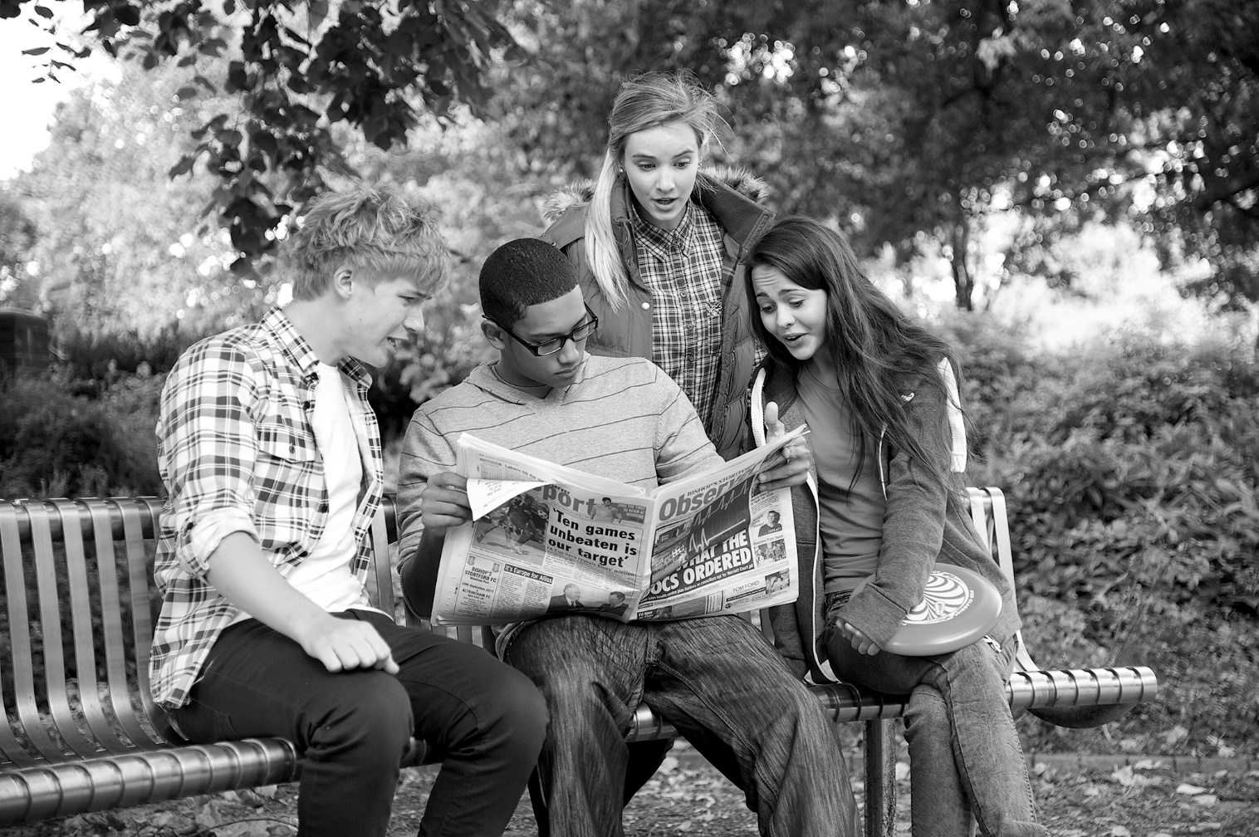
/10

Total: /20

