Part A • Grammar, Vocabulary and How to …
GRAMMAR
1 Complete the sentences and questions with used to and the words in brackets.
1 She __________ (love) painting when she was a child, but she doesn’t do it anymore.
2 They __________ (not / spend) much time together, but now they’re together all the time.
3 __________ (you / get) a lot of homework when you were at school?
4 I __________ (worry) a lot, but now I’m more relaxed.
5 We __________ (never / talk) much, but now we’re pretty good friends.
6 __________ (you / help) your parents when you were younger?
7 She __________ (never / be) interested in the environment.
/7

2 Choose the correct option (a, b or c).
1 She looks ___ than she did yesterday.
a as happy b happier c happiest
2 Julian isn’t ___ as he was this morning.
a more stressed b as stressed c most stressed
3 Federico is ___ swimmer I know.
a fastest b the faster c the fastest
4 The meal wasn’t as ___ as I expected.
a cheap b cheaper c cheapest
5 I can understand Irina because she speaks ___ than Valentina.
a slower b slowest c more slowly
6 Rupert won’t help you. He’s the ___ person I know.
a less helpful b least helpful c most helpful
7 Well done team! You’ve played much ___ today.
a better b good c well
/7

3 Complete the sentences with for, since or yet.
1 We’ve been looking for a new house __________ about six months.
2 Are you saying your brother’s plane hasn’t landed __________?
3 She hasn’t played the piano __________ she left the orchestra.
4 I haven’t heard from my manager __________ a few days.
5 Have you tidied your bedroom up __________?
6 Felix hasn’t driven a car __________ 2014.
/6

VOCABULARY
4 Complete the sentences with the words in the box.
composers images performer recordings subjects the arts works
1 These __________ of art were created by a computer.
2 I’m quite creative so I’d rather work in __________ than in science.
3 He’s an amazing __________. He can sing and dance really well, but I don’t think he writes the music.
4 The author discusses different __________ in her books, including technology, the environment and work.
5 We found some old __________ of jazz music from the 1920s that still sound great today.
6 The brothers were talented __________ who wrote music for cinema and television.
7 Some of the __________ they showed us were very sad. It was hard to look at them.
/7

5 Complete the sentences with words related to the arts.
1 Some of the a _ _ _ _ _ _ _ _ s of the 1960s designed very boring buildings.
2 They recorded the album in a Colombian s _ _ _ _ o.
3 It’s a great v _ _ _ e for concerts because it’s not too big and not too small.
4 I usually do some s _ _ _ _ _ _s with a pencil before painting the picture.
5 There weren’t many people in the a _ _ _ _ _ _ e. In fact, most of the seats were empty.
6 I’m sure she’s a p _ _ _ _ _ _ _ _ _ _ r because she’s never without her camera.
/6

6 Complete the sentences with the correct form of the words in brackets.
1 I know they’re popular, but they don’t seem very __________ (talent) to me.
2 The children wrote some __________ (imagine) stories for the story-writing competition.
3 My uncle’s a __________ (skill) pianist who plays beautifully.
4 We want someone with good __________ (photograph) skills to take our wedding pictures.
5 You need to use your __________ (create) for this task.
6 She’s never been __________ (art), but she’s quite interested in science.
7 I thought I saw Sula, but it was just my __________ (imagine).
/7

HOW TO …
7 Complete the conversations with the words in the box.
about because fantastic guess makes terrible view what why would
1 A: ¹__________ did you think of the show?
B: In my ²__________, it could have been better.
A: What ³__________ you say that?
B: I don’t think the dancers were very good. How ⁴__________ you?
A: I thought they were ⁵__________. Really good!
B: Well, I ⁶__________ we all like different things.

2 A: Did you like the meal?
B: Yes. I ⁷__________ say it’s one of the best meals I’ve ever had.
A: Really? I thought it was ⁸__________.
B: ⁹__________ do you say that?
A: It’s ¹⁰__________ the food was cold.
B: It was sushi. It’s supposed to be cold!
/10

Total: /50

Part B • Listening, Reading and Writing
LISTENING
1 [Audio UT6.01] Listen to five people talking about art. Match the speakers (1–5) with the ideas (A–E).
1 Mia ___
2 Theo ___
3 Leanne ___
4 Gregory ___
5 Daisy ___

A I don’t feel anything special when I look at art.
B I developed artistic skills as an adult.
C I grew up surrounded by art.
D I started creating my own art as a child.
E I like some types of art more than others.
/5

2 [Audio UT6.01] Listen again. Choose the correct option (a or b).
1 Mia says that comics
a made her want to draw.
b don’t interest her now.
2 Mia is disappointed that
a her children don’t like drawing.
b she doesn’t draw anymore.
3 Theo didn’t use to
a go to many art galleries.
b like going to art galleries.
4 Theo thinks he should
a be more interested in art.
b not worry about other people’s views.
5 Leanne recently visited an art gallery which was
a better than many others.
b worse than she expected.
6 Leanne says that modern art is
a more interesting than traditional art.
b not as inspiring as traditional art.
7 Gregory was pleased about
a the art classes which he went to.
b the art which his parents owned.
8 Gregory thinks it’s a shame that
a he’s not very good at making things.
b his mother made him go to art classes.
9 Daisy thinks
a it was rude of her teacher to say she wasn’t talented.
b it’s strange that she didn’t use to be artistic.
10 Daisy says that learning to paint
a was easier than she thought it would be.
b was harder than she expected it to be.
/10

READING
3 Read the article about Toni Morrison, an American writer. Match the paragraphs (1–5) with the headings (A–E).
A Remembered for her writing
B Growing up in difficult times
C First success as a novel writer
D Learning to enjoy language
E Life as a young adult
/5
Toni Morrison
1 ___
Morrison was only two years old when the house she lived in was burned down. Her family hadn’t been able to pay the rent so the owner of the house started a fire. Most people would be terrified in that situation, but her family just tried to laugh about it. Black families like hers faced many difficulties in 1930s America, but Morrison’s parents taught her to be proud of being a Black American.

2 ___
As a child, Morrison’s parents used to tell her stories and Morrison especially loved their ghost stories. This was the beginning of her love of language and novels. She used to love reading as a child and was also starting to become a skilled writer. Once, at school, she wrote an essay which her teacher thought was outstanding. He used it to show other students an example of good writing.

3 ___
Morrison later went to university in Washington to study English. While she was there, she experienced segregation, which meant that black people couldn’t use the same buses or restaurants as white people. Differences in skin colour were also a big issue at university, but Morrison completed her studies and went on to teach English. She later became an editor working with many well-known writers.

4 ___
While Morrison was teaching, she had the idea for her first novel, The Bluest Eye. However, she had become a mother by this time, so it took many years to finish it. She used to get up at four o’clock in the morning so she could write before waking up her children and going to work. The Bluest Eye was finally published in 1970. Although it didn’t sell many copies at first, it got positive book reviews. She produced three more novels before leaving her editing job to concentrate on writing in the 1980s.

5 ___
Morrison died in 2019 after a fifty-year writing career which included plays, poetry and many novels. Race was an important subject in her work and she was never afraid to talk about things she thought were wrong. She made a huge contribution to American literature and she was given the Pulitzer Prize and the Nobel Prize in Literature, which are among the most important prizes for writing. Not only that, but she even has a day named after her in Ohio: Toni Morrison Day.
4 Read the text again. Choose the correct answer, A, B, C or D.
1 What does the writer say about Morrison’s early life?
A Her parents owned a house.
B Her family was in a difficult situation.
C She was terrified of her parents.
D She used to laugh a lot.

2 Why were ghost stories important to Morrison?
A She liked telling them to her family.
B She used to write them for school.
C She heard them from other students.
D She enjoyed listening to them.

3 What was Morrison’s experience at university?
A She found it difficult to complete her studies.
B She saw that some people weren’t treated equally.
C She wasn’t able to use buses or restaurants.
D She realised that differences didn’t matter.

4 What does the writer say about The Bluest Eye?
A Morrison took many years to complete it.
B Morrison left her job to finish it.
C It was Morrison’s most successful novel.
D It was the last of Morrison’s novels.

5 What is the writer doing in the final paragraph?
A Explaining how Morrison died
B Describing one of her novels
C Talking about what she’s achieved
D Saying which of her novels is best
/10

WRITING
5 Complete the sentences with the words in the box.
also although because of if unless
1 They had to stop the race __________ the bad weather.
2 __________ we had a nice time, it wasn’t the cleanest of beaches.
3 Don’t climb the mountain __________ you go with a guide.
4 I liked the food at the restaurant. __________, the waiters were really nice.
5 Buy tickets in advance __________ you’re planning on going when it’s busy.
/5

6 Write a review of your favourite TV programme. You should say:
- why you enjoy it.
- in what ways it was original or creative.
- why it is better than other TV programmes you have seen.
Write your review in about 100 words.
/15

Total: /50

Part C • Speaking
SPEAKING
1 Make questions and ask your partner.
1 How long / studied English?
2 Do / do / anything creative?
3 What activities / use to / do / after school?
4 What / best film / ever seen?
5 Who / funniest person / know?
/5

2 Answer your partner’s questions.
/5

3 Describe the picture to your partner.
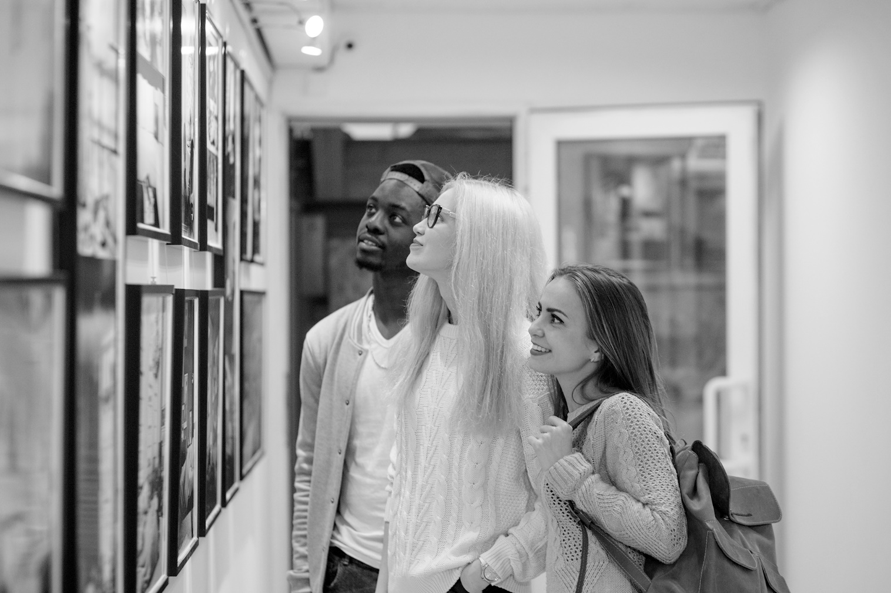
/10

Total: /20

