Part A • Grammar, Vocabulary and How to …
GRAMMAR
1 Complete the sentences and questions with used to and the words in brackets.
1 I __________ (play) rugby, but I stopped when I hurt my back.
2 __________ (watch) cartoons after school when you were a child?
3 She __________ (not / sleep) well at nights, but she has no problems these days.
4 We __________ (never / go) on long holidays. We usually just went away for weekends.
5 Did __________ (you / invent) games when you were younger?
6 Our neighbours __________ (come) round for a coffee sometimes, but we never see them now.
7 He __________ (never / help) me very much because he was always so tired.
/7

2 Choose the correct option (a, b or c).
1 This video game is much ___ than the other one.
a easy b easier c easiest
2 Cindy is ___ teacher I’ve ever had.
a more patient b most patient c the most patient
3 The film wasn’t as ___ as I thought it would be.
a long b longer c longest
4 The students remember ___ today than they did yesterday.
a less b least c the least
5 You need to drive more ___ or we’ll miss the train.
a quick b quickly c quicker
6 Sanchez didn’t play badly yesterday, but I think he’ll play ___ today.
a bad b worse c worst
7 Their bedroom is nearly ___ my apartment.
a bigger b the biggest c as big as
/7

3 Complete the sentences with for, since or yet.
1 He’s worked here __________ several months.
2 I haven’t spoken to Belinda __________ last week.
3 She’s played the saxophone __________ she was fourteen.
4 Have you been to that new cinema __________?
5 We need some rain because it hasn’t rained __________ months.
6 Has she sent off her passport application __________?
/6

VOCABULARY
4 Complete the sentences with the words in the box.
images painter performers recording styles subject the arts
1 The band has uploaded a __________ of its latest concert to its website.
2 He was a well-known __________ in the 1950s who produced some unusual pictures.
3 The main __________ at the conference was the future of education.
4 The new government is planning to spend a lot of money on __________, including theatre and cinema.
5 Different __________, like dancers and singers, are on the TV show every week.
6 For me, the __________ are as important as the words in a magazine article.
7 She can sing different __________ of music, from jazz to opera.
/7

5 Complete the sentences with words related to the arts.
1 There’s a new art g _ _ _ _ _ y in my town that shows the work of young artists.
2 Andrew always carries a pencil and notebook because he loves doing d _ _ _ _ _ _ s of the things he sees.
3 My auntie’s got a small s _ _ _ _ o where she paints.
4 The speaker was very funny so the a _ _ _ _ _ _ e didn’t mind when she made mistakes.
5 I prefer going to concerts in small, friendly v _ _ _ _ s rather than big, noisy ones.
6 We’ve asked an a _ _ _ _ _ _ _ t to suggest some designs for our new office building.
/6

6 Complete the sentences with the correct form of the words in brackets.
1 You need to use your __________ (imagine) for this activity.
2 Liz is going to do a course in __________ (photograph) because she wants to get better at taking pictures.
3 Some of the children in the football team are quite __________ (talent).
4 Danny is an __________ (imagine) writer with some unusual ideas.
5 I’m afraid I’m not very __________ (art). I’m better with maths problems.
6 Joti suggested quite a __________ (create) solution to the problem.
7 She’s a __________ (skill) footballer so she’ll definitely be on the team.
/7
HOW TO …
7 Complete the conversations with the words in the box.
because for guess horrible how makes outstanding say think view
1 A: What do you ¹__________ of Sam’s new jeans?
B: I don’t like them. I think they’re ²__________.
A: Why do you ³__________ that?
B: It’s ⁴__________ they look old and dirty. I hate that style.
A: Really? In my ⁵__________, they look nice.

2 A: Did you like the show?
B: Oh yes, I thought it was ⁶__________.
⁷__________ about you?
A: ⁸__________ me, it was a bit boring.
B: What ⁹__________ you say that?
A: I just don’t think the actors looked very interested.
B: Well, I ¹⁰__________ we all like different things.
/10

Total: /50

Part B • Listening, Reading and Writing
LISTENING
1 [Audio UT6.01] Listen to five people talking about art. Match the speakers (1–5) with the statements (A–E).
1 Mia ___
2 Theo ___
3 Leanne ___
4 Gregory ___
5 Daisy ___

A I didn’t like going to art galleries with my parents.
B I recently visited an excellent art show.
C I’ve recently developed good artistic skills.
D I used to create art to decorate my house.
E I come from a family of skilful artists.
/5

2 [Audio UT6.01] Listen again. Choose the correct option (a or b).
1 Mia says that she learnt to draw
a after seeing other people’s art.
b after her children were born.
2 Mia used to
a watch superhero cartoons on TV.
b have more time for her hobby.
3 Theo finds it difficult to
a get inspiration from art.
b talk to his parents about art.
4 Theo thinks
a his feelings about art might seem unusual.
b some art is more interesting than others.
5 Leanne accepts that
a she’s not a talented artist.
b her art isn’t interesting.
6 Leanne believes that traditional art
a is more imaginative than modern art.
b is less interesting than modern art.
7 Gregory
a didn’t enjoy having art around his house.
b was pleased about his parents’ art collection.
8 Gregory started art classes because
a he listened to the advice of his mother.
b he wanted to be as good as his parents.
9 Daisy used to be
a more artistic than she is now.
b a worse artist than she is now.
10 Daisy learnt to paint by
a buying herself a set of paints.
b seeing other people painting.
/10

READING
3 Read the article about Rabindranath Tagore, an Indian poet. Match the paragraphs (1–5) with the headings (A–E).
A Tagore’s early education
B Remembered for his work
C Local influences on Tagore’s work
D A family with a long history
E Going away to study
/5
Rabindranath Tagore
1 ___
Rabindranath Tagore was born into a rich Indian family in 1861. His family had been important in Bengal for many years and they led the fight against British control. They wanted a more modern India where people were free and didn’t have to be poor. They were proud of where they lived and used the arts and education to make others as proud as them.

2 ___
Tagore’s mother died when he was young and his father was often away on business, so he spent much of his time with other family members. Tagore tried going to school, but he only went there for one day. He preferred being outside, finding out about nature, rather than sitting in a classroom. His brother used to take him out walking in the mountains or swimming, while professional musicians used to come to his house to teach him classical music.

3 ___
As he grew up, Tagore developed an interest in poetry and, by the age of sixteen, he had produced his first collection of poems. However, his father had plans for him to become a lawyer and Tagore was sent to England to study. Tagore wasn’t interested in his law degree, though. Instead, he used to spend his time studying Shakespeare and listening to traditional folk music. He returned to India without a university degree, but with strong ideas about the arts and education.

4 ___
Back in Bengal, Tagore spent his time looking after his family’s businesses and writing poems, stories and plays. To Tagore, the lives of ordinary people living in Bengal were fascinating, and they were often the inspiration for his work. He also became an important song writer, inspired by the traditional music of the region. He wrote thousands of songs, including Jana Gana Mana, which became the national song of India.

5 ___
During his life, Tagore travelled to many countries and met many important people, including writers, artists and politicians. His views were popular with a lot of people, but also upset others. However, his work in the arts was outstanding, and, for that reason, he was given the Nobel Prize in Literature in 1913. To this day, he is thought to be the greatest Indian poet ever and his works are celebrated in schools, museums and festivals in India and abroad.
4 Read the text again. Choose the correct answer, A, B, C or D.
1 What does the writer say about Tagore’s family?
A They moved to Bengal in 1861.
B They were unhappy with the British.
C They were proud of being poor.
D They fought for the British.

2 What did Tagore enjoy doing as a child?
A Travelling with his father
B Going to musical performances
C Spending time in the classroom
D Learning about things outdoors

3 What does the writer say about Tagore’s time in England?
A Tagore went there to study poetry.
B Tagore published his first poems there.
C Tagore was interested in English arts.
D Tagore learnt to play folk music.

4 According to the writer, what did Tagore do when he returned to Bengal?
A He tried to create a new business.
B He became more involved in the arts.
C He went to live with ordinary people.
D He decided to start a family.

5 What is the writer doing in the final paragraph?
A Talking about what Tagore achieved
B Describing one of Tagore’s works of art
C Explaining why Tagore upset people
D Saying which of Tagore’s works are best
/10

WRITING
5 Complete the sentences with the words in the box.
also because of if unless while
1 You should buy this video game __________ you haven’t got it yet.
2 __________ this song’s pretty good, it’s not one of my favourites.
3 The museum is fascinating. __________, it’s free for children and older people.
4 We couldn’t get there by car __________ the traffic jams.
5 The steak is huge so don’t order it __________ you’re really hungry.
/5
6 Write a review of your favourite TV programme. You should say:
- why you enjoy it.
- in what ways it was original or creative.
- why it is better than other TV programmes you have seen.
Write your review in about 100 words.
/15

Total: /50

Part C • Speaking
SPEAKING
1 Make questions and ask your partner.
1 How long / lived / in your flat or house?
2 Do / have / any talents?
3 What / use to / do / in the summer holidays?
4 What / most interesting book / ever read?
5 Who / most creative person / know?
/5

2 Answer your partner’s questions.
/5

3 Describe the picture to your partner.
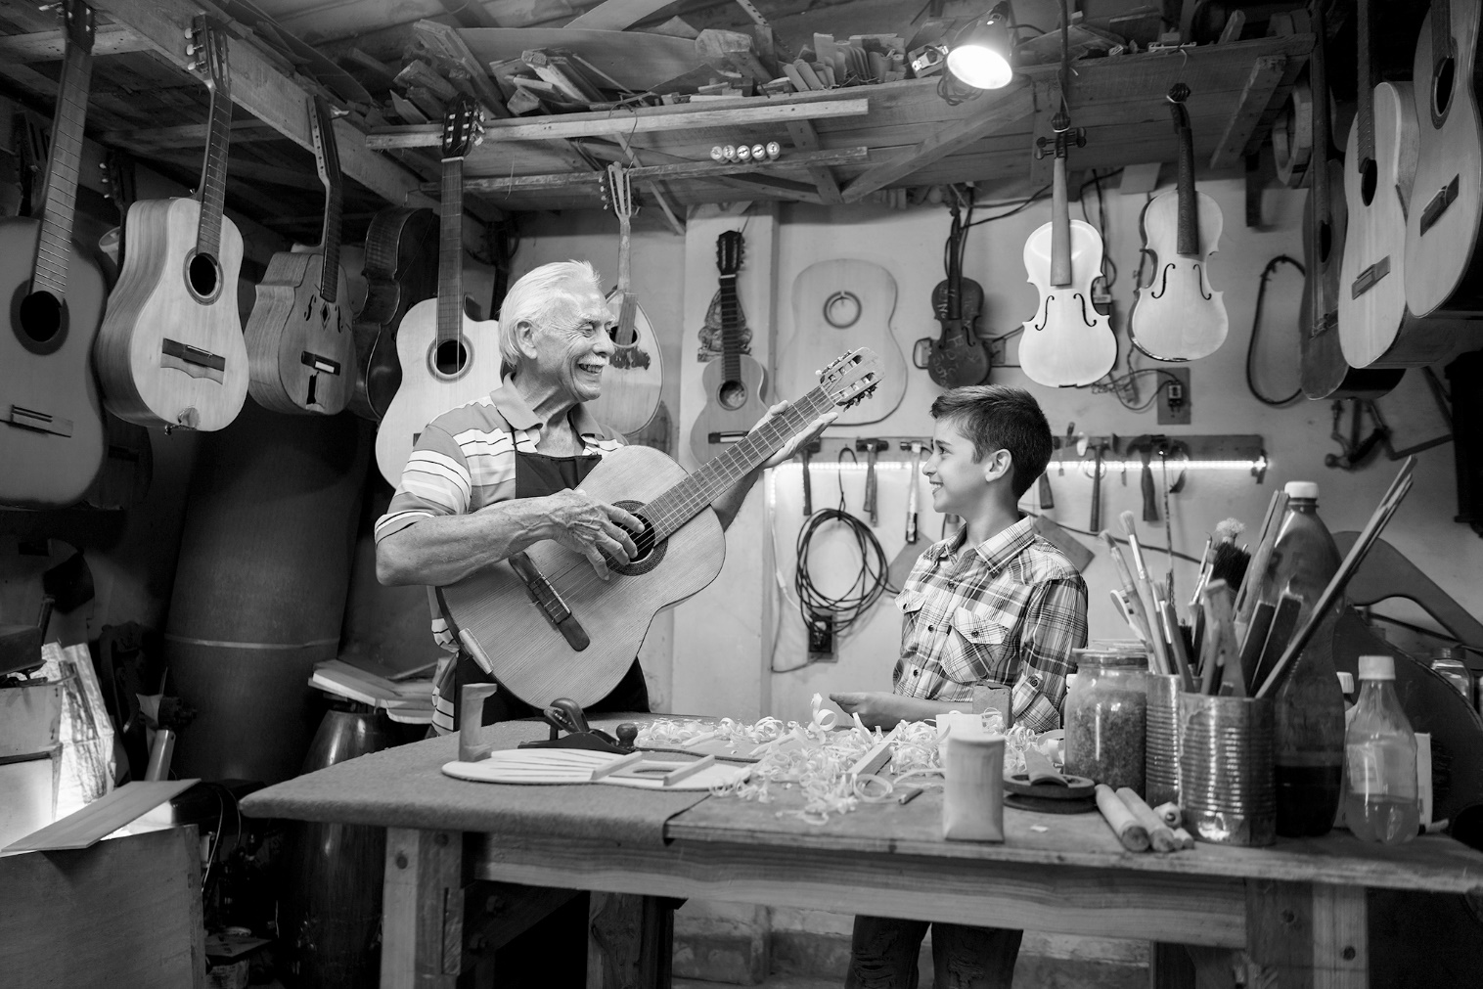
/10

Total: /20

