Part A • Grammar, Vocabulary and How to …
GRAMMAR

- Complete the sentences and questions with used to and the words in brackets.
0 She ____used to love____ (love) painting when she was a child, but she doesn’t do it anymore.
1 They _____________________ (not / spend) much time together, but now they’re together all the time.
2 Did _____________________ (you / get) a lot of homework when you were at school?
3 I _____________________ (worry) a lot, but now I’m more relaxed.
4 We _____________________ (never / talk) much, but now we’re pretty good friends.
5 Did _____________________ (you / help) your parents when you were younger?
___ / 5

- Circle the answer (A, B or C) that best completes each sentence.
0 She looks ___ than she did yesterday.
^{A} as happy | ^{B} happier | ^{C} happiest

1 Julian isn’t ___ as he was this morning.
^{A} more stressed | ^{B} as stressed | ^{C} more stressed

2 Federico is ___ swimmer I know.
^{A} fastest | ^{B} the faster | ^{C} the fastest

3 I can understand Irina because she speaks ___ than Valentina.
^{A} slower | ^{B} slowest | ^{C} more slowly

4 Rupert won’t help you. He’s the ___ person I know.
^{A} less helpful | ^{B} least helpful | ^{C} most helpful

5 Well done team! You’ve played much ___ today.
^{A} better | ^{B} good | ^{C} well
___ / 5

3 Circle the correct words.
0 We’ve been looking for a new house for / since / yet about six months.
1 She hasn’t played the piano for / since / yet she left the orchestra.
- I haven’t heard from my manager for / since / yet a few days.
3 Have you tidied your bedroom up for / since / yet?
4 Felix hasn’t driven a car for / since / yet 2014.
___ / 4

VOCABULARY

4 Complete the sentences with the words and phrases (A–G). There are TWO words you do not need.
0 These _G_ of art were created by a computer.
A composers
B images
C perfomer
D recordings
E subjects
F the arts
G works
1 He’s an amazing ___. He can sing and dance really well, but I don’t think he writes the music.
2 The author discusses different ___ in her books, including technology, the environment and work.
3 The brothers were talented ___ who wrote music for cinema and television.
4 Some of the ___ they showed us were very sad. It was hard to look at them.
___ / 4

5 Circle the correct words.

0 Some of the sketches / architects of the 1960s designed very boring buildings.
1 They recorded the album in a Colombian studio / audience.
2 It’s a great studio / venue for concerts because it’s not too big and not too small.
3 I usually do some photographer / sketches with a pencil before painting the picture.
4 There weren’t many people in the audience / architects. In fact, most of the seats were empty.
5 I’m sure she’s a photographer / sketches because she’s never without her camera.
___ / 5

- Complete the sentences with the correct form of the words in brackets.
0 The children wrote some __imaginative _ (imagine) stories for the story-writing competition.
1 My uncle’s a _______________ (skill) pianist who plays beautifully.
2 We want someone with good __________ (photograph) skills to take our wedding pictures.
3 You need to use your __________ (create) for this task.
4 She’s never been __________ (art), but she’s quite interested in science.
5 I thought I saw Sula, but it was just my __________ (imagine).
___ / 5

HOW TO …

7 Complete the conversations with the words (A–G).
1 A: What did you think of the show?
A fantastic
B guess
C makes
D terrible
E view
F why
G would

B: In my ⁰ _E_, it could have been better.
A: What ¹ ___ you say that?
B: I don’t think the dancers were very good.
How about you?
A: I thought they were ² ___. Really good!
B: Well, I ³ ___ we all like different things.

- A: Did you like the meal?
B: Yes. I ⁴ ___ say it’s one the best meals I’ve ever had.
A: Really? I thought it was ⁵ ___.
B: ⁶ ___ do you say that?
A: It’s because the food was cold.
B: It was sushi. It’s supposed to be cold!

___ / 12

TOTAL: ___ / 40
x 1.25 = ___ / 50

Part B • Listening, Reading and Writing
LISTENING

1 [Audio UT6.01] Listen to five people talking about art. Match the speakers (1–5) with the ideas (A–E).
0 Mia _D_
A I don’t feel anything special when I look at art.
B I developed artistic skills as an adult.
C I grew up surrounded by art.
D I started creating my own art as a child.
E I like some types of art more than others.
1 Theo ___
2 Leanne ___
3 Gregory ___
4 Daisy ___
___ / 8

2 [Audio UT6.01] Listen again. Circle the correct answer, A or B.
0 Mia is disappointed that
^{A} she doesn’t draw anymore. | ^{B} her children don’t like drawing.

1 Theo didn’t use to
^{A} go to many art galleries. | ^{B} like going to art galleries.

2 Leanne says that modern art is
^{A} more interesting than traditional art. | ^{B} not as inspiring as traditional art.

3 Gregory thinks it’s a shame that
^{A} he’s not very good at making things. | ^{B} his mother made him go to art classes.

4 Daisy says that learning to paint
^{A} was easier than she thought it would be. | ^{B} was harder than she expected it to.
___ / 4

READING

3 Read the text about Toni Morrison, an American writer. Match the headings (1–4) with the paragraphs (A–E).
0 Remembered for her writing. _E_
1 Growing up in difficult times. ___
2 First success as a novel writer. ___
3 Learning to enjoy language. ___
4 Life as a young adult. ___
___ / 4

Toni Morrison
A
Morrison was only two years old when the house she lived in was burned
down. Her family hadn’t been able to pay the rent so the owner of the
house started a fire. Most people would be terrified in that situation, but her
family just tried to laugh about it. In 1930s America, black families
faced many difficulties, but her parents taught her to be proud of being a
Black American.
B
As a child, Morrison’s parents used to tell her stories and she especially
loved their ghost stories. This was the beginning of her love of
language and novels. She used to love reading as a child and was also
starting to become a skilled writer. Once, at school, she wrote an
essay which her teacher thought was outstanding and used as an example
of good writing.
C
Morrison later went to university in Washington to study English. While she
was there, she experienced segregation, which meant that black
people couldn’t use the same buses or restaurants as white people.
Differences in skin colour were also a big issue at university, but
Morrison completed her studies and went on to teach English. She later
became an editor.

D
While Morrison was teaching, she had the idea for her first novel,
The Bluest Eye. However, she had become a mother by this time, so it took many years to finish it. She used to get up at four o’clock in the morning so she could write before waking up her children and going to work. The Bluest Eye was finally published in 1970. She produced three more novels before leaving her editing job to concentrate on writing in the 1980s.

E
Morrison died in 2019 after a fifty-year writing career. Race was an
important subject in her work and she was never afraid to talk about
things she thought were wrong. She made a huge contribution to American literature and was given the Pulitzer Prize and the Nobel Prize in Literature, which are among the most important prizes for writing.
She even has a day named after her in Ohio: Toni Morrison Day.

4 Read the text again. Circle the correct answer (A or B).

0 What does the writer say about Morrison’s early life?
^{A} She used to laugh a lot. | ^{B} Her family was in a difficult situation.

1 Why were ghost stories important to Morrison?
^{A} She enjoyed listening to them. | ^{B} She used to write them for school.

2 What was Morrison’s experience at university?
^{A} She saw that some people weren’t treated equally. | ^{B} She wasn’t able to use buses or restaurants.

3 What does the writer say about The Bluest Eye?
^{A} Morrison took many years to complete it. | ^{B} Morrison left her job to finish it.

4 What is the writer doing in the final paragraph?
^{A} Explaining how Morrison died. | ^{B} Talking about what Morrison achieved.
___ / 8

WRITING

5 Circle the correct words.

0 They had to stop the race because of / although the bad weather.
1 Although / Unless we had a nice time, it wasn’t the cleanest of beaches.
2 Don’t climb the mountain if / unless you go with a guide.
3 I liked the food at the restaurant. Also / Unless, the waiters were really nice.
4 Buy tickets in advance unless / if you’re planning on going when it’s busy.
___ / 4

6 Write a review of your favourite TV programme.
MY FAVOURITE TV PROGRAMME
You should say:
- Why you enjoy it.
- In what ways it was original or creative.
- Why it is better than other TV programmes you have seen.
Write your review in about 100 words.
___ / 12

TOTAL: ___ / 40
x 1.25 = ___ / 50

Part C • Speaking
SPEAKING

1 Put the words in the correct order to make questions.
Ask your partner your questions.
0 long / you / have / How / English / studied
____How long have you studied English_________________?

1 do / creative / Do / you / anything
___________________________________________________?
2 you / What / use / did / after / to do / school / activities
___________________________________________________?
3 is / ever / the best / seen / What / have / film / you
___________________________________________________?
4 person / Who / funniest / is / you / the / know
___________________________________________________?
___ / 4

2 Answer your partner’s questions.
___ / 4
3 Describe the picture to your partner.
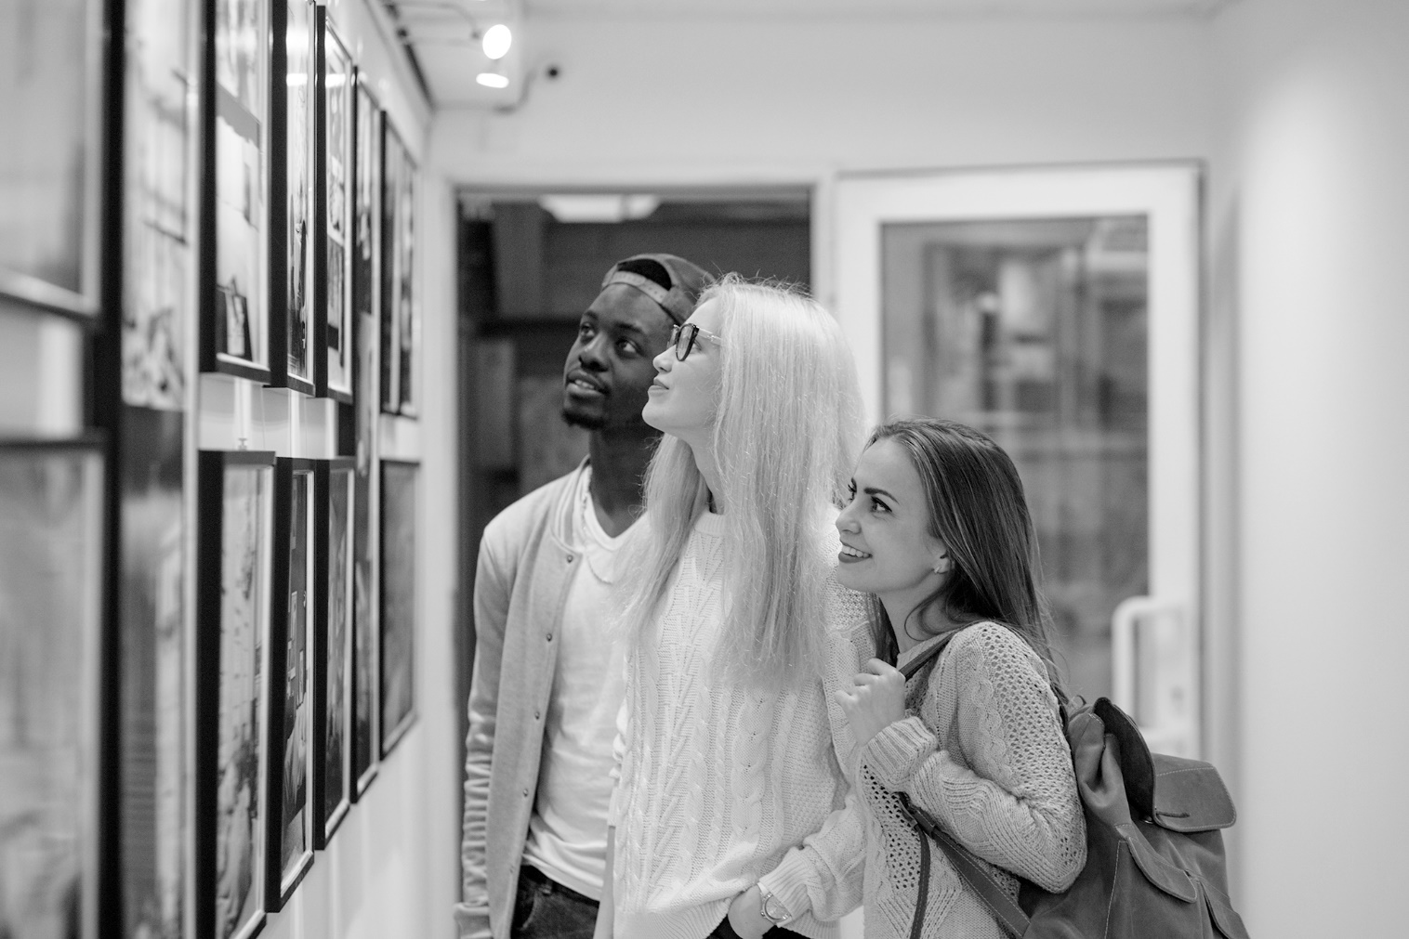
___ / 12

TOTAL: ___ / 20

