Part A • Grammar, Vocabulary and How to …
GRAMMAR
1 Complete the sentences with the correct form of the word in brackets.
1 If I don’t have to work this weekend, I __________ (take) you to the cinema.
2 If you __________ (not have) a jacket, I’ll lend you mine.
3 I’ll buy a sandwich when I __________ (get) to the airport.
4 If they offer you the job, __________ (you / accept) it?
5 They’d probably help you if you __________ (ask) them nicely.
6 If I __________ (not speak) Japanese, life in Tokyo would be very difficult.
7 If you worked less, you __________ (feel) more relaxed.
/7

2 Choose the correct option (a, b or c).
1 This room is ___ warm. Shall I open a window?
a too b too much c too many
2 Have we got ___ food? I don’t want our guests to be hungry.
a hardly any b too much c enough
3 We’ve got ___ time so we won’t be late.
a little b much c plenty of
4 Have we got ___ money in our bank account?
a many b much c plenty
5 She hasn’t lived here long but she’s made ___ friends.
a a few b a little c hardly any
6 I haven’t got ___ of time now. Can we talk later?
a a lot b much c plenty
7 There weren’t ___ people at the match because of
the weather.
a a few b many c much
/7

3 Complete the sentences with reflexive pronouns.
1 She’s too young to go to school by __________.
2 I hope you enjoy __________ at the concert!
3 The two men introduced __________ as our new neighbours.
4 My alarm went off by __________ in the middle of the night.
5 I hope you and Nancy are behaving __________!
6 What do you think of the table? I made it __________.
/6

VOCABULARY
4 Choose the correct words to complete the sentences.
1 We didn’t go into the exhibition because there was a huge queue / resort of people outside.
2 Travelling is a good way to learn about the custom / culture of a place.
3 We got more dollars than we expected because the exchange break / rate was good.
4 I used to enjoy the monuments / nightlife in my city but now I prefer to go to bed early.
5 You can fly to a lot of European check-ins / destinations from my local airport.
6 It’s best to book / rent the sightseeing tour before you go because it’s very popular.
7 It’s a festival / tradition to eat twelve grapes on New Year’s Eve in my country.
/7

5 Complete the sentences with the correct form of the words in the box.
accept come expect explore hear realise strange
1 We __________ across a lovely little souvenir shop when we were walking around the old town.
2 I’ve never __________ of that artist. Is she well-known?
3 Although they didn’t know me, the local people __________ me and let me eat with them.
4 When I got to the airport, I __________ that I had left my passport at home.
5 It was really cold so it was __________ to see a man wearing shorts and a T-shirt.
6 We didn’t __________ to see our friends at the restaurant.
7 When I’m on holiday, I love __________ new places.
/7

6 Complete the sentences with words to describe the natural world.
1 I used to live near the s _ _ _ _ _ e so I spent a lot of time playing on the beach.
2 The v _ _ _ _ y has got big hills on both sides of it.
3 A lot of different trees and plants grow in the j _ _ _ _ e.
4 We jumped off the w _ _ _ _ _ _ _ l into a clear blue pool.
5 My friend lives on a small island off the c _ _ _ t of Ireland.
6 It’s a n _ _ _ _ _ _ l p _ _ k so the land is protected by the government.
/6

HOW TO …
7 Complete the conversations with the words in the box.
absolutely great idea must place sounds sure things without wow
A: If you’re going to Dublin, there are a few things you ¹__________ have to do.
B: OK.
A: You ²__________ visit Phoenix Park. It’s a lovely ³__________ to go for a walk and enjoy the scenery.
B: That ⁴__________ interesting.
A: Don’t leave the park ⁵__________ visiting the zoo.
B: OK, that’s a good ⁶__________.
A: Make ⁷__________ you go to Temple Bar as well.
B: What’s that?
A: It’s a ⁸__________ place to hang out. The nightlife is amazing.
B: Oh, ⁹__________! How exciting!
A: And finally, you should go on the sightseeing bus. It’s one of the best ¹⁰__________ to do because you can see all the sights of the city.
/10

Total: /50

Part B • Listening, Reading and Writing
LISTENING
1 [Audio UT7.01] Listen to Serena talking about a long walk she has done. Number the topics (A–E) in the order you hear them.
1 ___
2 ___
3 ___
4 ___
5 ___

A Preparation for the journey
B Greetings from the locals
C Describing the challenge
D Arriving at our destination
E An act of kindness
/5

2 [Audio UT7.01] Listen again. Are the statements True (T) or False (F)?
1 Serena started her walk in the north of Scotland. T / F
2 Serena’s group planned to walk about 1,000 miles. T / F
3 They had no idea what the walk would be like. T / F
4 They made sure their bags weren’t too heavy. T / F
5 The walk through the national park was tiring. T / F
6 It felt normal to stay in the family’s house. T / F
7 A famous person came to meet them in Scotland. T / F
8 People found out about their journey on social media.
T / F
9 Serena never expected to fail the challenge. T / F
10 Serena has never done anything as difficult as that walk. T / F
/10

READING
3 Read the article about cycling holidays. Match the paragraphs (1–5) with the headings (A–E).
A Choosing your destination
B Deciding what to take
C Going alone or with a friend?
D Being ready to deal with emergencies
E Planning where to stay
/5
A different kind of holiday
If you like fresh air and seeing new places, why not go on a cycling holiday? In this article, we’ll help you plan the perfect holiday on two wheels.

1 ___
Firstly, decide whether you want to travel on your own or with someone else. If you go by yourself, you can do exactly what you want. For example, you can change your plans more easily, but it can be more fun to travel with someone else. If you’d rather share the experience, make sure you choose the right person. You’ll need to get on well with them and, of course, they’ll have to enjoy cycling!

2 ___
You’ll also need to decide where you want to go. There are plenty of great destinations for cycling holidays, but they’re not all suitable for everyone. For example, the Atlas mountains are a popular choice, but you might find it hard. If you haven’t got much experience, choose somewhere like The Netherlands. It’s good for beginners because most of the country is flat and cycling is part of the culture.

3 ___
One of the advantages of cycling holidays is that you can usually avoid crowded tourist destinations. However, you should still think about accommodation when you’re planning your route. If you’re travelling out of season, you might find accommodation easily. But in the school holidays, you might not find anything if you haven’t booked. After a hard day’s cycling, you’ll probably be too exhausted to look for hotels or campsites!

4 ___
You’ll also need to think about your equipment, and the most important thing is the bike. If you’ve already got one, you can use that but, if you haven’t, you can usually rent bicycles quite cheaply. You should also think carefully about the things you’ll need. If you pack too much, your bike will be too heavy. Only take enough clothes for a couple of days because you can wash them and wear them again.

5 ___
Lastly, don’t go anywhere without travel insurance, which is a type of document that protects you if you have an accident. In some countries, you have to pay your hospital bills yourself and it might cost thousands of pounds. Travel insurance is also useful if somebody robs you. The insurance company will replace the things that are stolen. It isn’t usually expensive and you’ll be a lot more relaxed if you’ve got it.
4 Read the text again. Choose the correct answer, A, B, C or D.
1 What does the writer say about travelling with other people?
A It’s not as much fun as travelling alone.
B It’s nice to share things with them.
C It’s important to have a good relationship.
D It’s easier to change your plans.

2 What is the writer’s advice about choosing where to go?
A Most holiday destinations are suitable for cyclists.
B The Atlas mountains can be difficult for cyclists.
C The Netherlands are popular with most cyclists.
D Your holiday destination is not important.

3 Why is it important to reserve accommodation?
A Many hotels and campsites do not accept cyclists.
B Most campsites and hotels are closed out of season.
C It will help you avoid busy tourist destinations.
D It is sometimes difficult to find somewhere to stay.

4 What does the writer say about the things you take?
A It’s better not to have too much luggage.
B It’s cheaper to rent a bike than to buy one.
C It’s best to take plenty of spare clothes.
D It’s easy to pack too much for your trip.

5 What is the writer’s opinion of travel insurance?
A It’s too expensive and it doesn’t help you.
B It’s necessary for travel in some countries.
C It can help you enjoy your holiday more.
D It’s a good way to replace your old things.
/10

WRITING
5 Put the words in the correct order to make sentences.
1 We / went / to / it / museum / boring / but / a / was
___________________________________________.
2 about / I / local / enjoyed / out / customs / finding
___________________________________________.
3 She / sad / leave / was / country / to / the
___________________________________________.
4 We / the / very / friendly / people / found
___________________________________________.
5 snow / it / expected / it / to / but / hot / was / I'd
___________________________________________.
/5

6 Imagine you have moved to a new country. Write an email to a friend telling them about your new experience.
Write your email in about 100 words.
/15

Total: /50

Part C • Speaking
SPEAKING
1 Make questions and ask your partner.
1 What / main tourist attractions / your country?
2 What festivals / enjoy / taking part in?
3 How / many / times / been / abroad?
4 What / accommodation / like / to / stay in / on holiday?
5 If / had the chance, / live / in / another country?
/5

2 Answer your partner’s questions.
/5

3 Describe the picture to your partner.
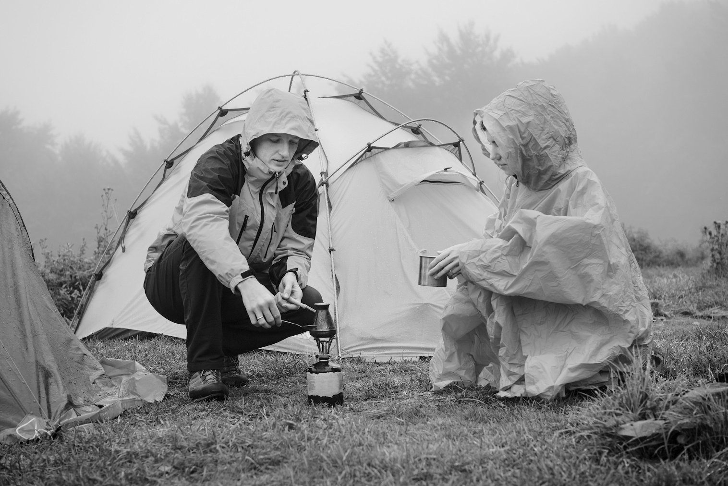
/10

Total: /20

