Part A • Grammar, Vocabulary and How to …
GRAMMAR

1 Circle the correct words.
0 If I don’t have to work this weekend, I will take / would take you to the cinema.

1 If you don’t have / didn’t have a jacket, I’ll lend you mine.
2 I’ll buy a sandwich when I will get / get to the airport.
3 They’d problably help you if you would ask / asked them nicely.
4 If I didn’t speak / will speak Japanese, life in Tokyo would be very different.
5 If you worked less, you will feel / would feel more relaxed.
___ / 5

- Circle the answer (A, B or C) that best completes each sentence.
0 This room is ___ warm. Shall I open a window?
^{A} too much | ^{B} too | ^{C} too many

1 Have we got ___ food? I don’t want our guests to be hungry.
^{A} hardly any | ^{B} too much | ^{C} enough

2 We’ve got ___ time so we won’t be late.
^{A} little | ^{B} much | ^{C} plenty of

3 Have we got ___ money in our bank account?
^{A} many | ^{B} much | ^{C} plenty

4 She hasn’t lived here long but she’s made ___ friends.
^{A} a few | ^{B} a little | ^{C} hardly any

5 I haven’t got ___ of time now. Can we talk later?
^{A} a lot | ^{B} much | ^{C} plenty
___ / 5

- Complete the sentences with reflexive pronouns.
0 She’s too young to go to school by ____herself_____.
1 The two men introduced _______________ as our new neighbours.
2 My alarm went off by _______________ in the middle of the night.
3 I hope you and Nancy are behaving _______________!
4 What do you think of the table? I made it _______________.
___ / 4

VOCABULARY

4 Circle the correct words.
0 Travelling is a good way to learn about the custom / culture of a place.
1 We got more dollars than we expected because the exchange break / rate was good.
2 I used to enjoy the monuments / nightlife in my city but now I prefer to go to bed early.
3 You can fly to a lot of European check-ins / destinations from my local airport.
4 It’s best to book / rent the sightseeing tour before you go because it’s very popular.
5 It’s a festival / tradition to eat twelve grapes on New Year’s Eve in my country.
___ / 5

5 Complete the sentences with the words and phrases (A–G). There are TWO words you do not need.
A accepted
B came
C expect
D exploring
E heard
F notice
G realised

0 We _B_ across a lovely little souvenir shop in the old town.
1 I’ve never ___ of that artist. Is she well-known?
2 Although they didn’t know me, the local people ___ me and let me eat with them.
3 When I got to the airport, I ___ that I had left my passport at home.
4 We didn’t ___ to see our friends at the restaurant.
___ / 4

6 Circle the answer (A or B) that best completes each sentence.
0 The ___ has got big hills on both sides of it.
^{A} valley | ^{B} waterfall

1 I used to live near the ___ so I spent a lot of time playing on the beach.
^{A} waterfall | ^{B} seaside

2 A lot of different trees and plants grow in the ___.
^{A} jungle | ^{B} coast

3 We jumped off the ___ into a clear blue pool.
^{A} seaside | ^{B} waterfall

4 My friend lives on a small island off the ___ of Ireland.
^{A} coast | ^{B} national park

5 It’s a ___ so the land is protected by the government.
^{A} jungle | ^{B} national park
___ / 5

HOW TO …

7 Complete the conversation with the words (A–G).
A absolutely
B great
C must
D sounds
E sure
F things
G wow
A: If you’re going to Dublin, there are a few things you
⁰ _A_ have to do.
B: OK.
A: You ¹ ___ visit Phoenix Park. It’s a lovely place to for a walk.
B: That ² ___ interesting.
A: Make ³ ___ you go to Temple Bar as well.
B: What’s that?
A: It’s a ⁴ ___ place to hang out. The nightlife is amazing.
B: Oh, ⁵ ___! How exciting!
A: And finally, you should go on the sightseeing bus. It’s one of the best ⁶ ___ to do because you can see all the sights of the city.
___ / 12

TOTAL: ___ / 40
x 1.25 = ___ / 50

Part B • Listening, Reading and Writing
LISTENING

1 [Audio UT7.01] Listen to Serena talking about a long walk she has done.
Number the topics (A–E) in the order you hear them.
0 _C_
A Preparation for the journey.
B Greetings from the locals.
C Describing the challenge.
D Arriving at our destination.
E An act of kindness.
1 ___
2 ___
3 ___
4 ___
___ / 4

2 [Audio UT7.01] Listen again. Are the statements True (T) or False (F)?
0 Serena started her walk in the north of Scotland. _F_
1 Senera’s group had no idea what the walk would be like. ___
2 The walk through the national park was tiring. ___
3 A famous person came to meet them in Scotland. ___
4 Serena has never done anything as difficult as that walk. ___
___ / 8

READING

3 Read the text about cycling holidays. Match the headings (1–4) with the paragraphs (A–E).
0 Choosing your destination. _B_
1 Deciding what to take. ___
2 Going alone or with a friend. ___
3 Being ready to deal with emergencies. ___
4 Planning where to stay. ___
___ / 4

A different kind of holiday
If you like fresh air and seeing new places, why not go on a cycling holiday?
In this article, we’ll help you plan the perfect holiday on two wheels.
A
Firstly, decide whether you want to travel on your own or with someone else.
If you go by yourself, you can do exactly what you want, but it can be
more fun to travel with someone else. If you’d rather share the experience,
make sure you choose the right person. You’ll need to get on well with
them and, of course, they’ll have to enjoy cycling!
B
You’ll also need to decide where you want to go. There are plenty of great
destinations for cycling holidays, but they’re not all suitable for
everyone. For example, the Atlas Mountains are a popular choice, but you
might find it hard. If you haven’t got much experience, choose
somewhere like The Netherlands. It’s good for beginners because most of
the country is flat.
C
One of the advantages of cycling holidays is that you can usually avoid
crowded tourist destinations. However, you should still think about
accommodation when you’re planning your route. If you’re travelling out of
season, you might find accommodation easily. But in the school
holidays, you might not find anything if you haven’t booked.

D
You’ll also need to think about your equipment. If you’ve already got a bike,
you can use that but, if you haven’t, you can usually rent them quite
cheaply. You should also think carefully about the things you’ll need. If you
pack too much, your bike will be too heavy. Only take enough clothes
for a couple of days because you can wash them and wear them again.

E
Lastly, don’t go anywhere without travel insurance, which is a type of
document that protects you if you have an accident. In some countries, you
have to pay your hospital bills yourself and travel insurance is also
useful if somebody robs you. The insurance company will replace the things
that are stolen. It isn’t usually expensive and you’ll be a lot more
relaxed if you’ve got it.

4 Read the text again. Circle the correct answer (A or B).
0 What does the writer say about travelling with other people?
^{A} It’s nice to share things with them. | ^{B} It’s important to have a good relationship.

1 What is the writer’s advice about choosing where to go?
^{A} The Altas Mountains can be difficult for cyclists. | ^{B} The Netherlands are popular with most cyclists.

2 Why is it important to reserve accommodation?
^{A} It is sometimes difficult to find somewhere to stay. | ^{B} It will help you avoid busy tourist destinations.

3 What does the writer say about the things you take?
^{A} It’s easy to pack too much for your trip. | ^{B} It’s better to not have too much luggage.

4 What is the writer’s opinion of travel insurance?
^{A} It’s a good way to replace your old things. | ^{B} It can help you enjoy your holiday more.
___ / 8

WRITING

5 Put the words in the correct order to make sentences.
0 We / went / to / it / museum / boring / but / a / was
____We went to a museum but it was boring_____________.

1 about / I / local / enjoyed / out / customs / finding
___________________________________________________.
2 She / sad / leave / was / country / to / the
___________________________________________________.
3 We / the / very / friendly / people / found
___________________________________________________.
4 snow, / it / expected / it / to / but / hot / was / I'd
___________________________________________________.
___ / 4
6 Imagine you have moved to a new country. Write an email to a friend telling them about your new experience.
Write your email in about 100 words.
___ / 12

TOTAL: ___ / 40
x 1.25 = ___ / 50
Part C • Speaking
SPEAKING

1 Put the words in the correct order to make questions.
Ask your partner your questions.
0 What / the main / tourist / are / your / in / attractions / country
____What are the main tourist attractions in your country__?

1 festivals / part in / What / you / enjoy / taking / do
___________________________________________________?
2 you / How many / been / have / times / abroad
___________________________________________________?
3 What / to stay / do / like / accommodation / on holiday / in / you
___________________________________________________?
4 would / country / another / had / live in / If you / the chance, / you
___________________________________________________?
___ / 4

2 Answer your partner’s questions.
___ / 4
3 Describe the picture to your partner.
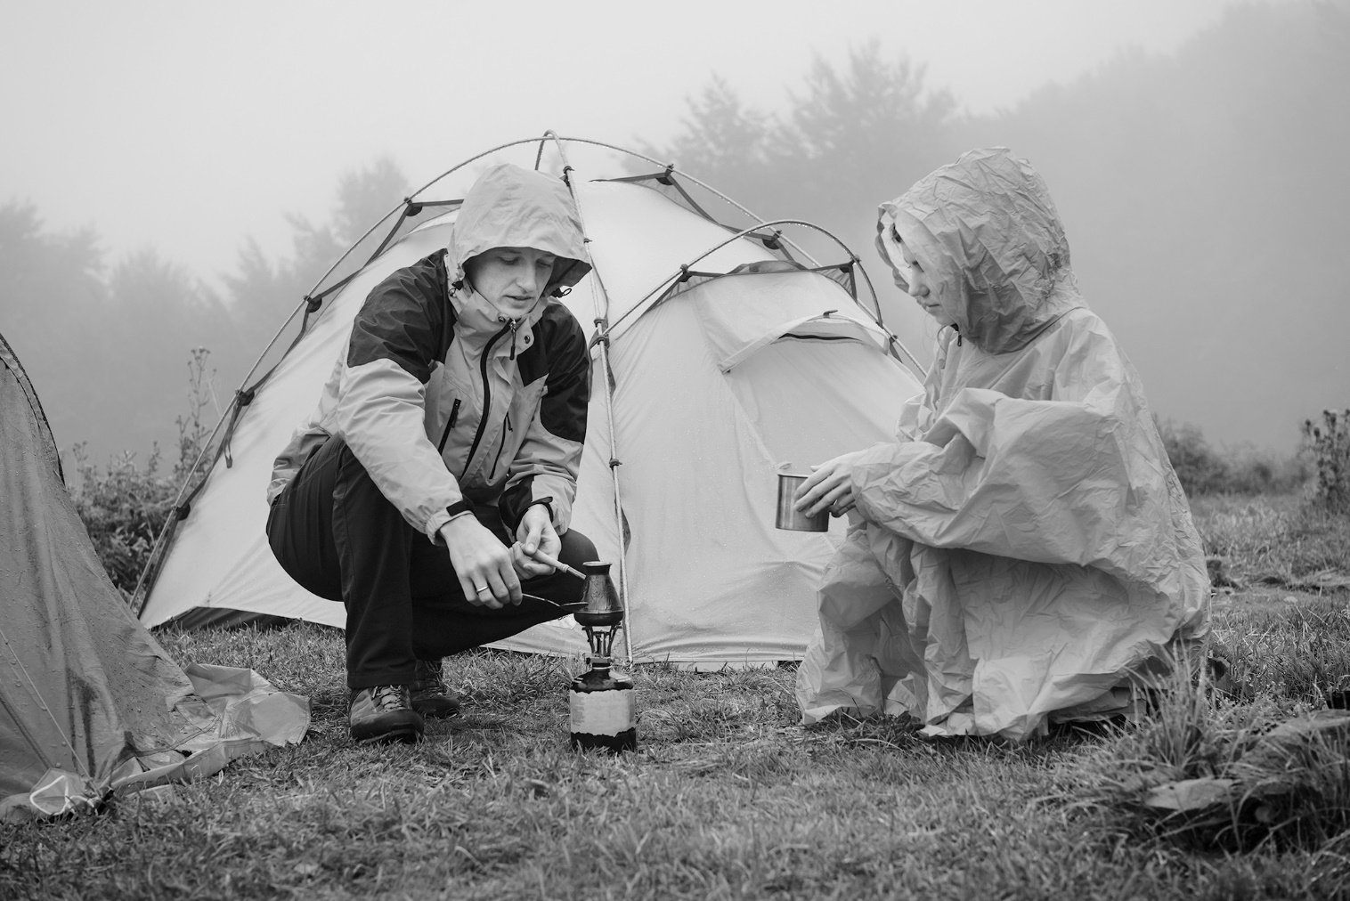
___ / 12

TOTAL: ___ / 20

