Project on an Online Library Management System

**This is my first project in Java EE(Jsp/Servlet) . In this project I have used as-**

**1.Front End:** JAVA, SERVLET, JSP, JDBC, Javascript

**2.Back End:** MYSQL

**3.Ide:** Netbeans IDE 8.0.2

**How My Online Library Works?**

**Home Page**

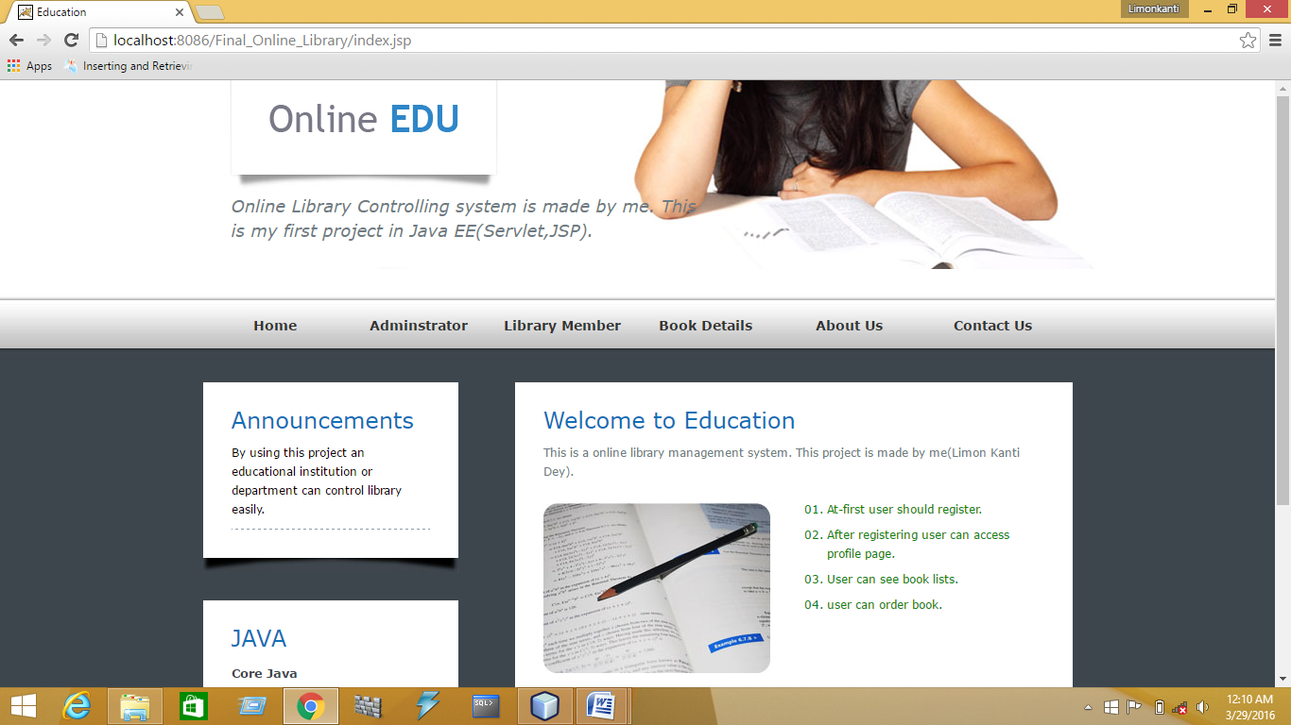

**Steps:**

**1.For Admin**

On filling incorrect information:

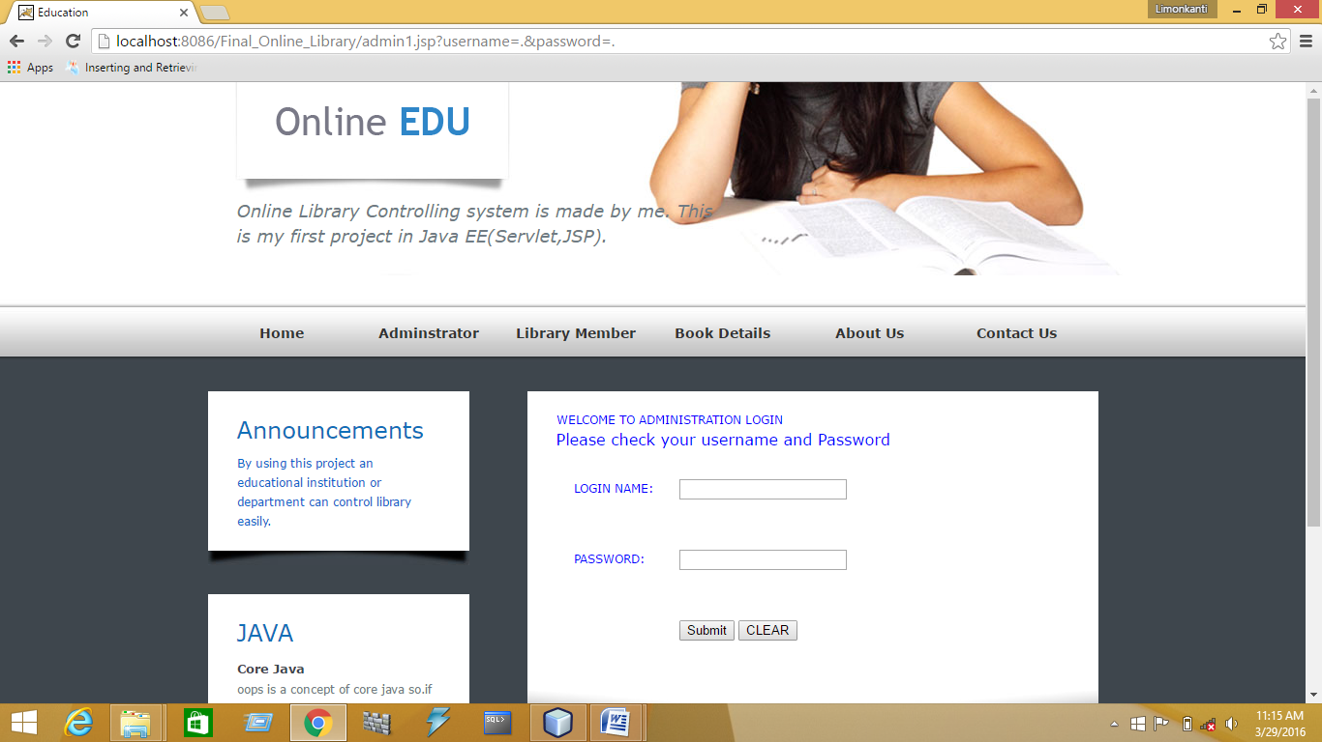

On filling correct information : Admin profile.

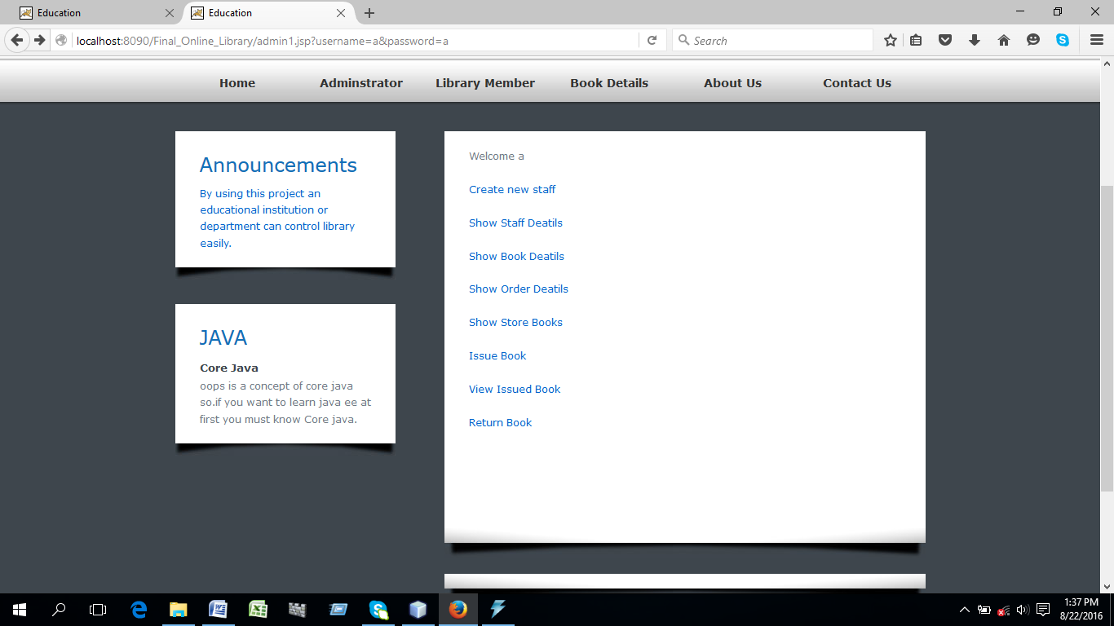

Admin can create staff as follows:

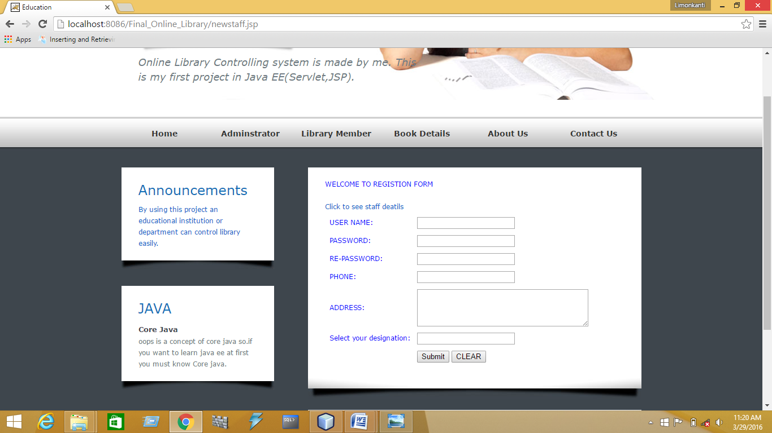

**Admin can browse staff details as follows:**

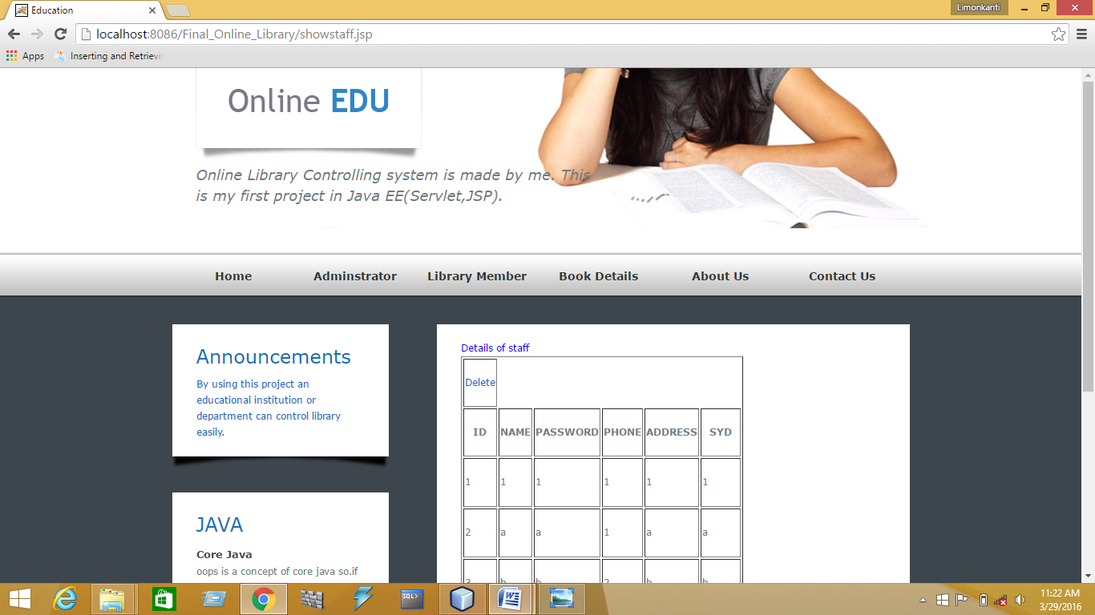

**Admin can delete staff as follows:**



Can add new book as follows:

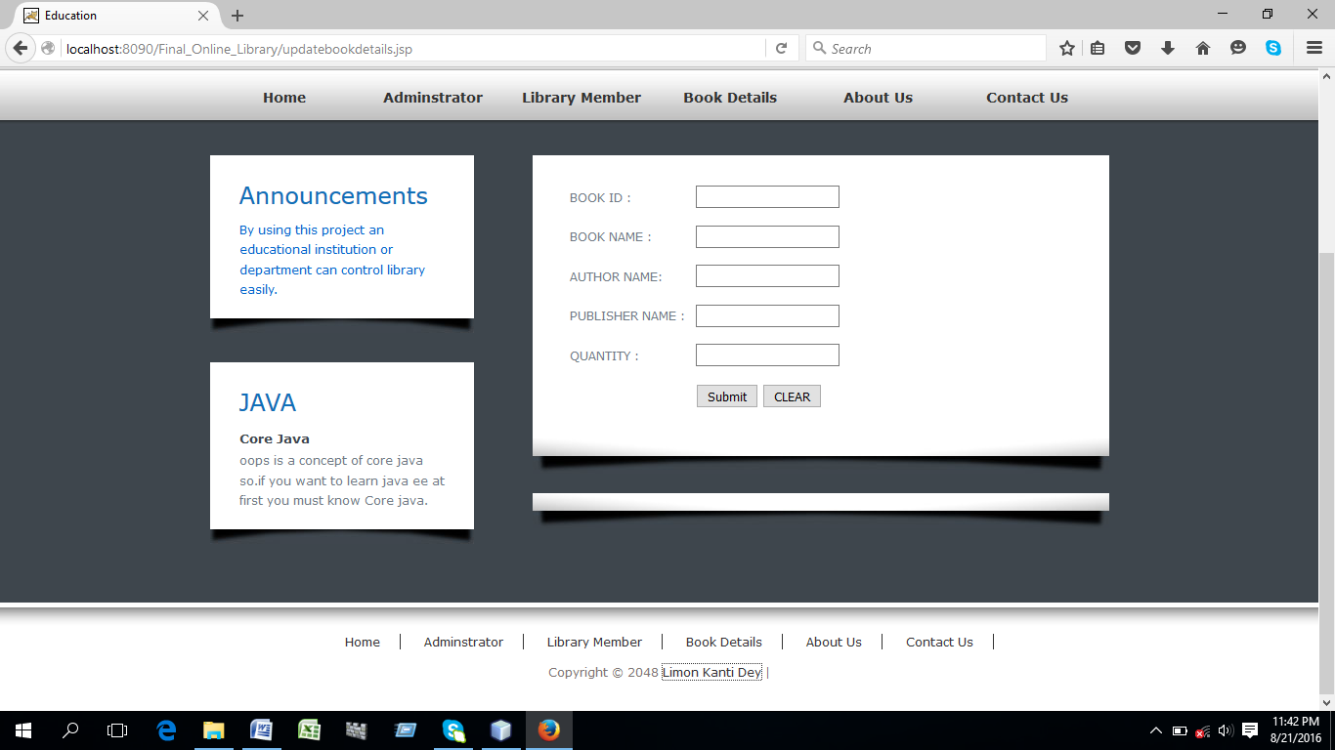

Can browse books as follows:

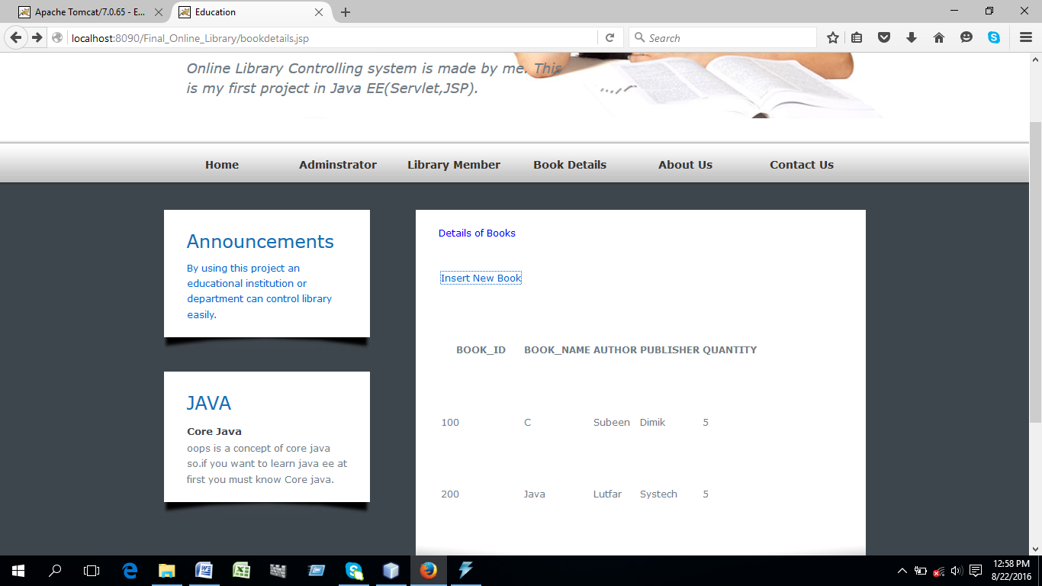

**Can browse order details as follows:**

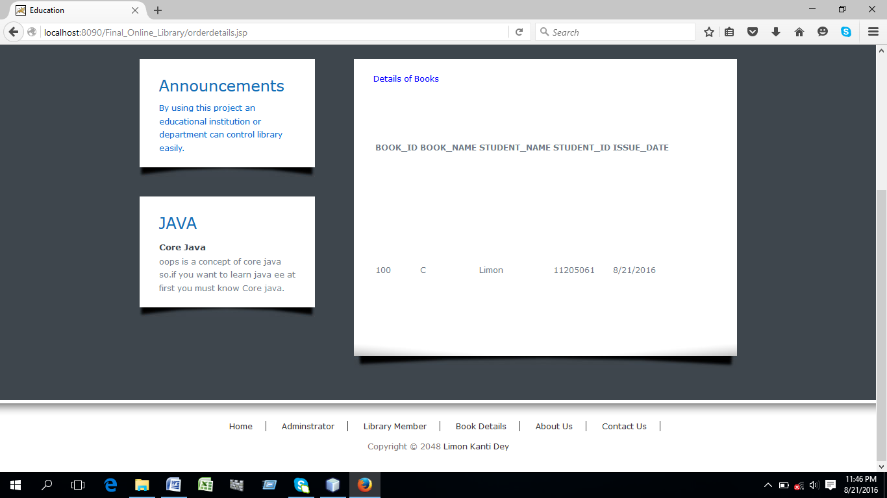

Can browse store books as follows:

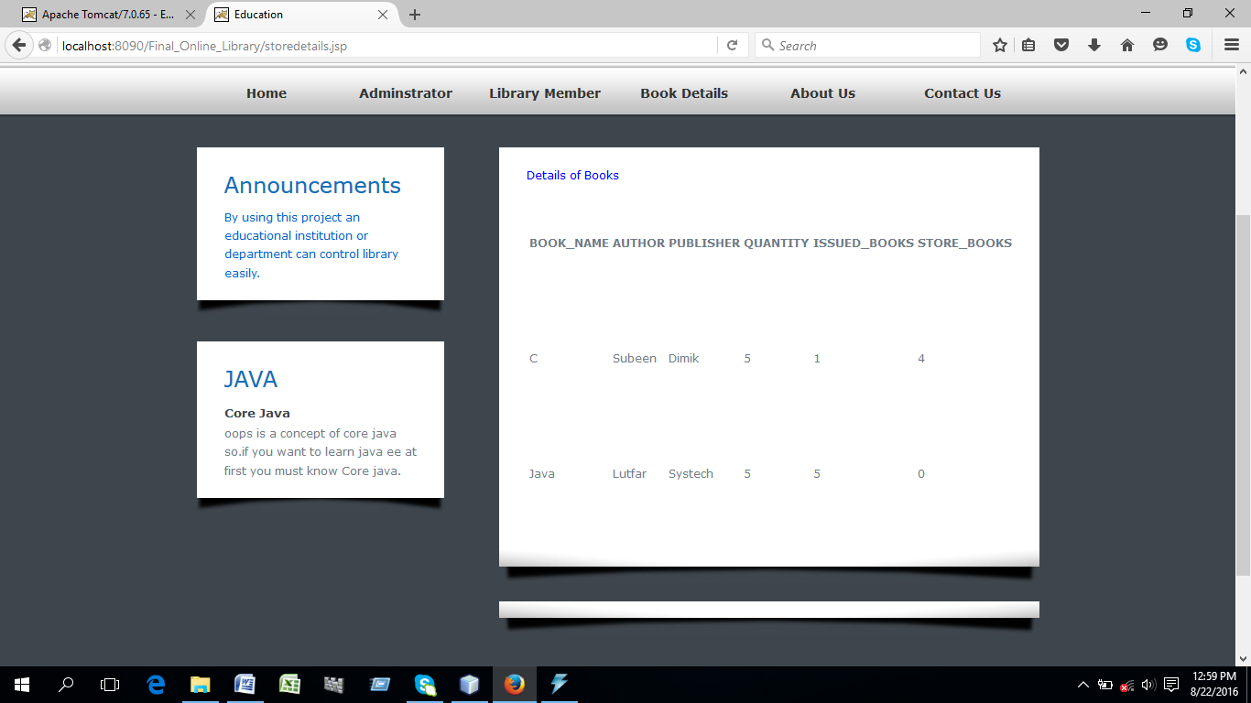

can issue book as follows

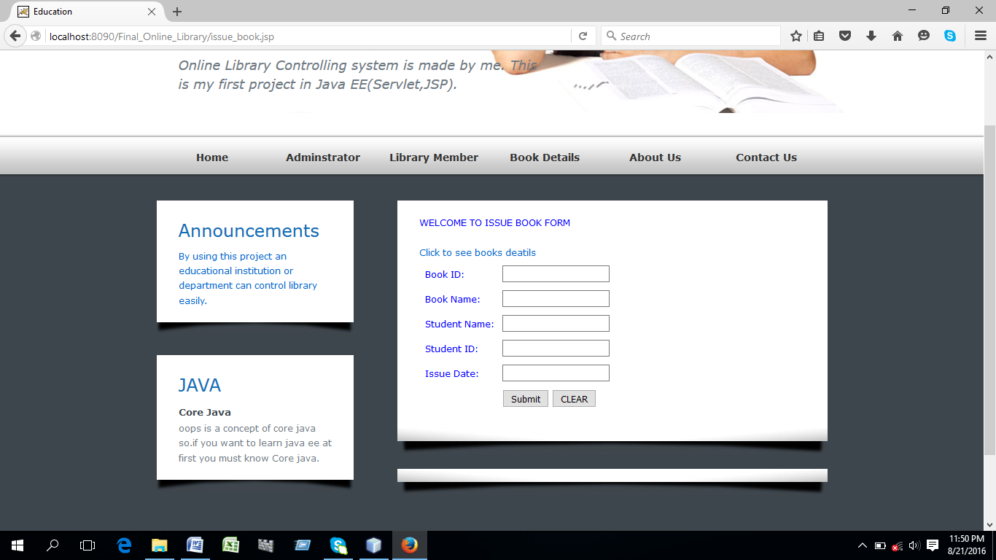

can return book as follows

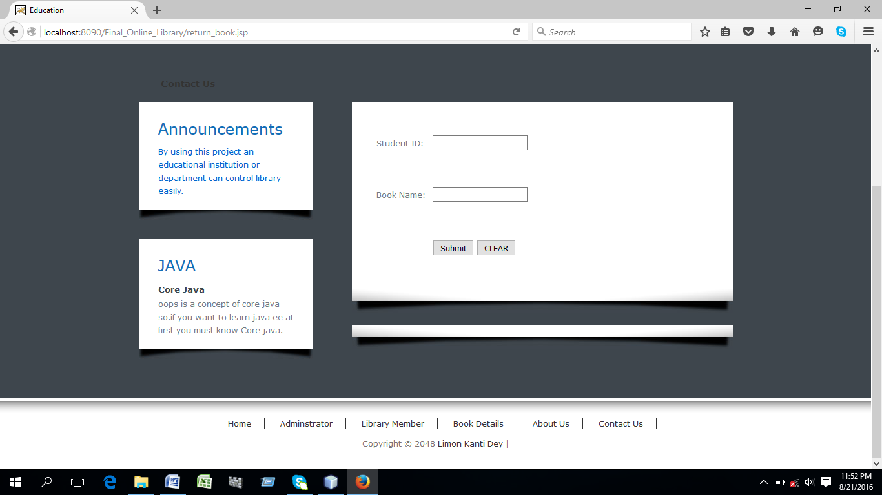

and so on.

2.For User

New user registration form:

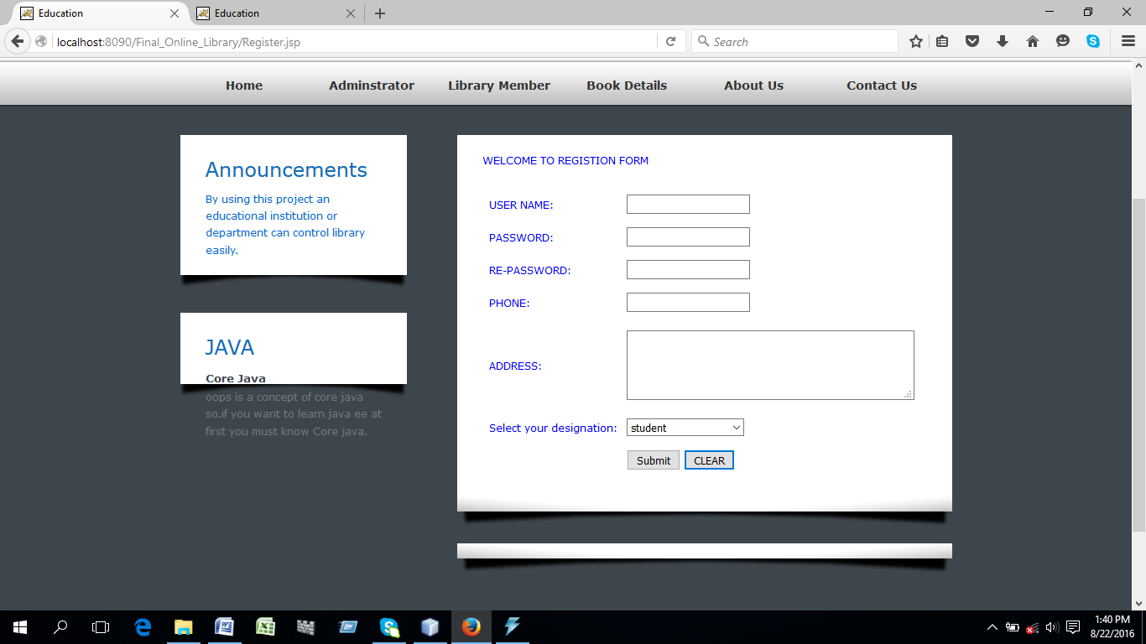

User can login as follows:

Leaving fields blanks.

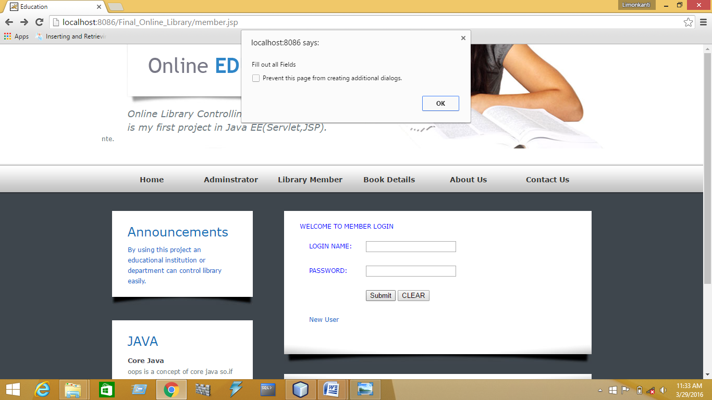

User home page after logging correctly:

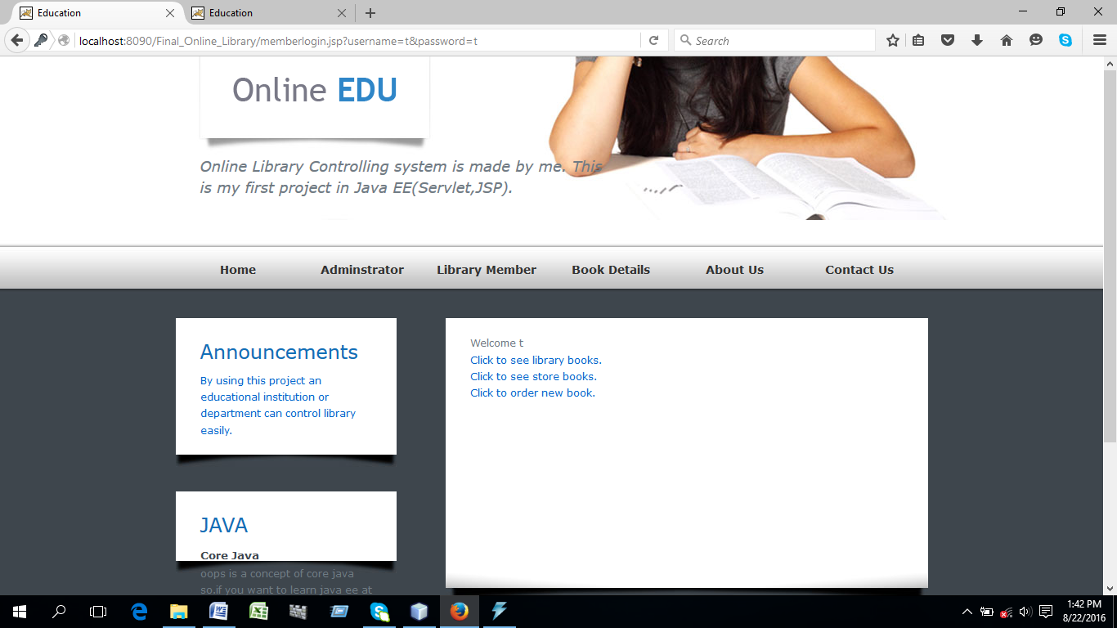

Member can see library books as follows:

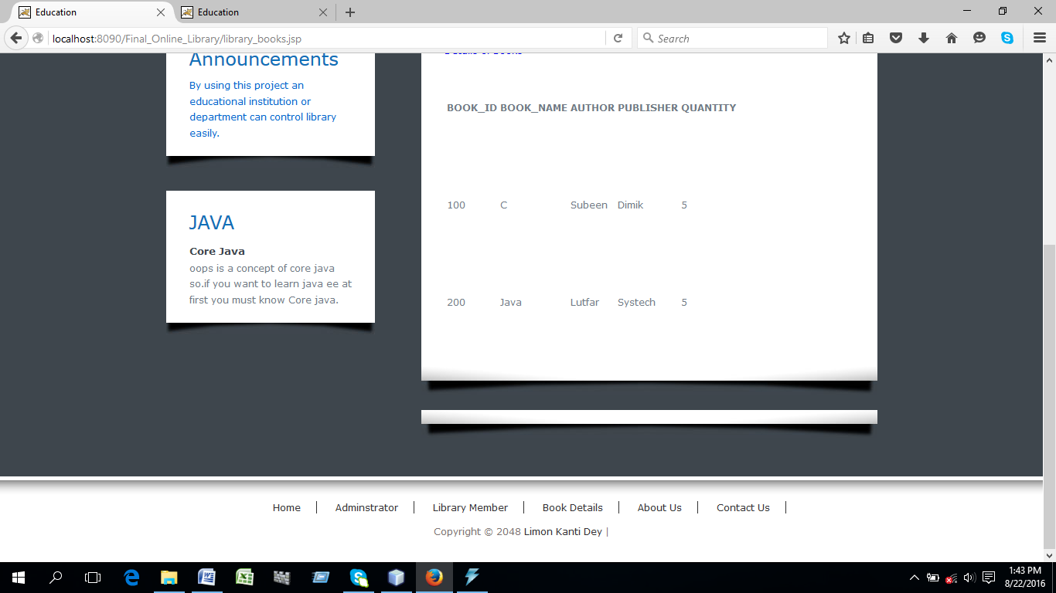

Member can see store books as follows:

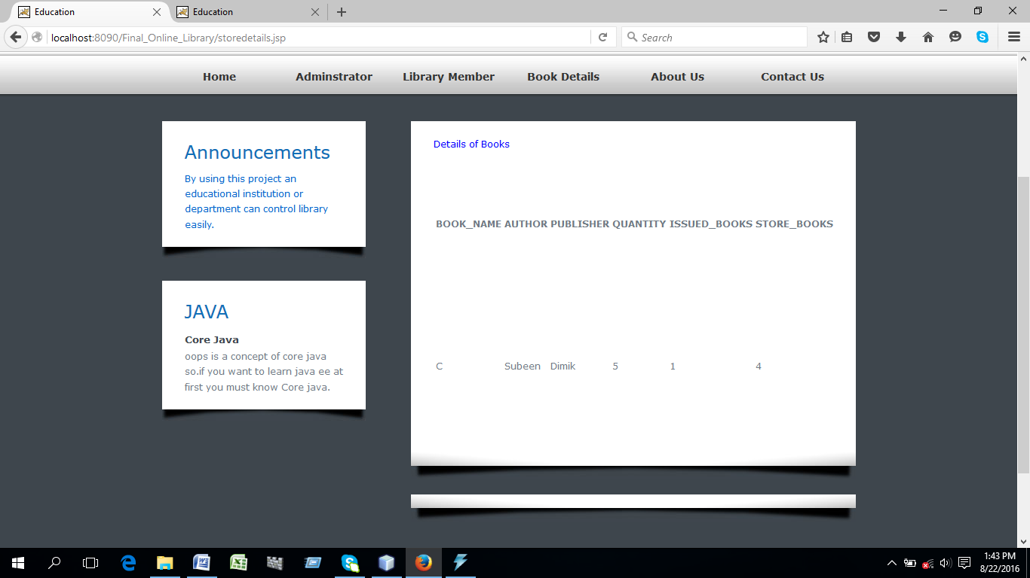

Member can order book as follows:

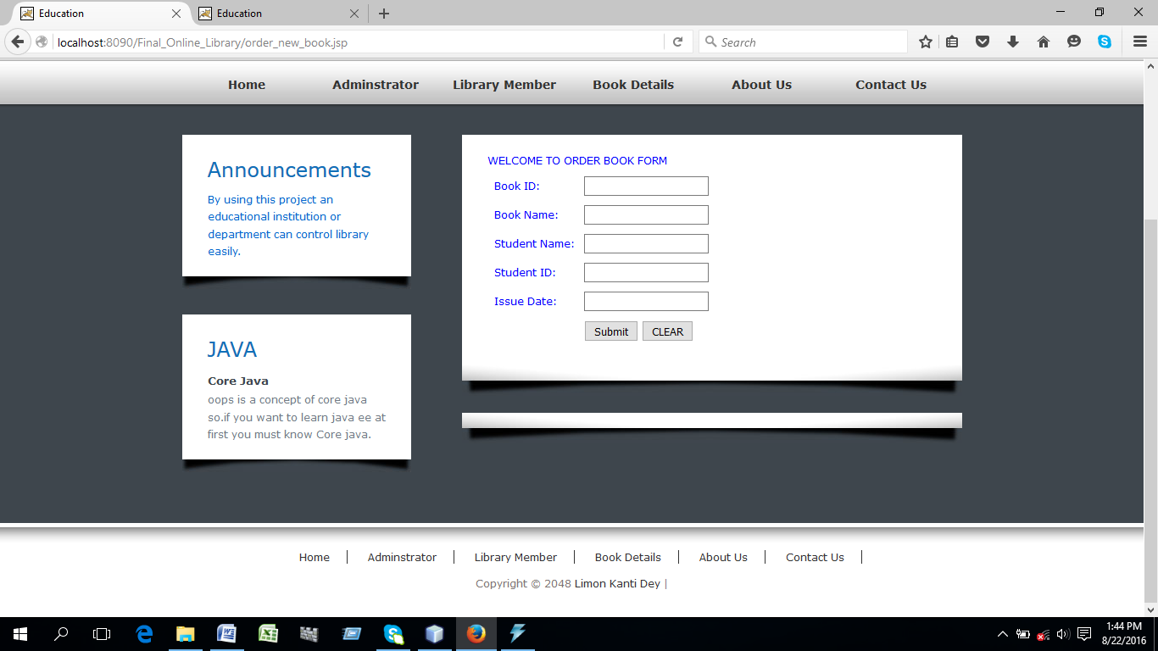

and so many.