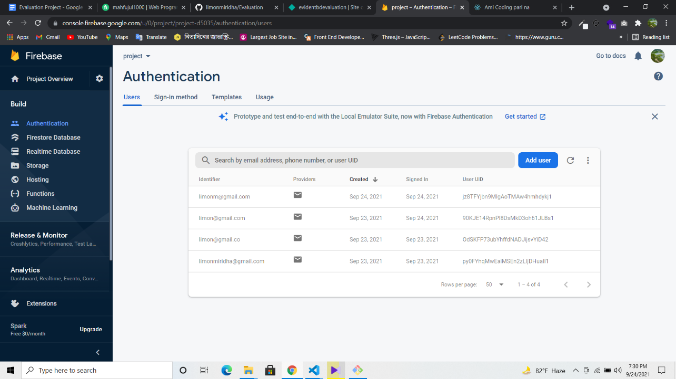

1. Sign Up details saved in database.

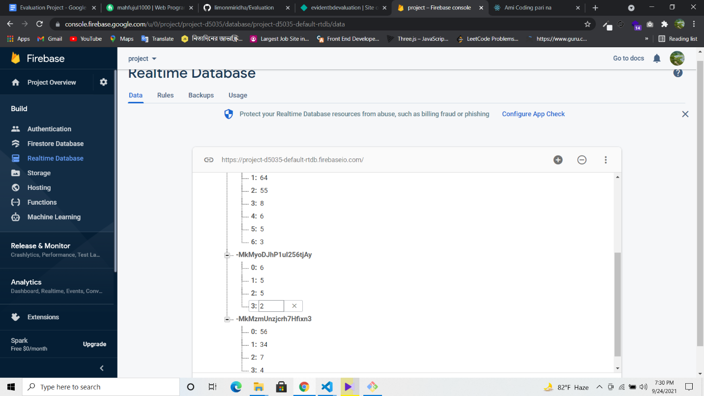

2.Input value in descending sort.

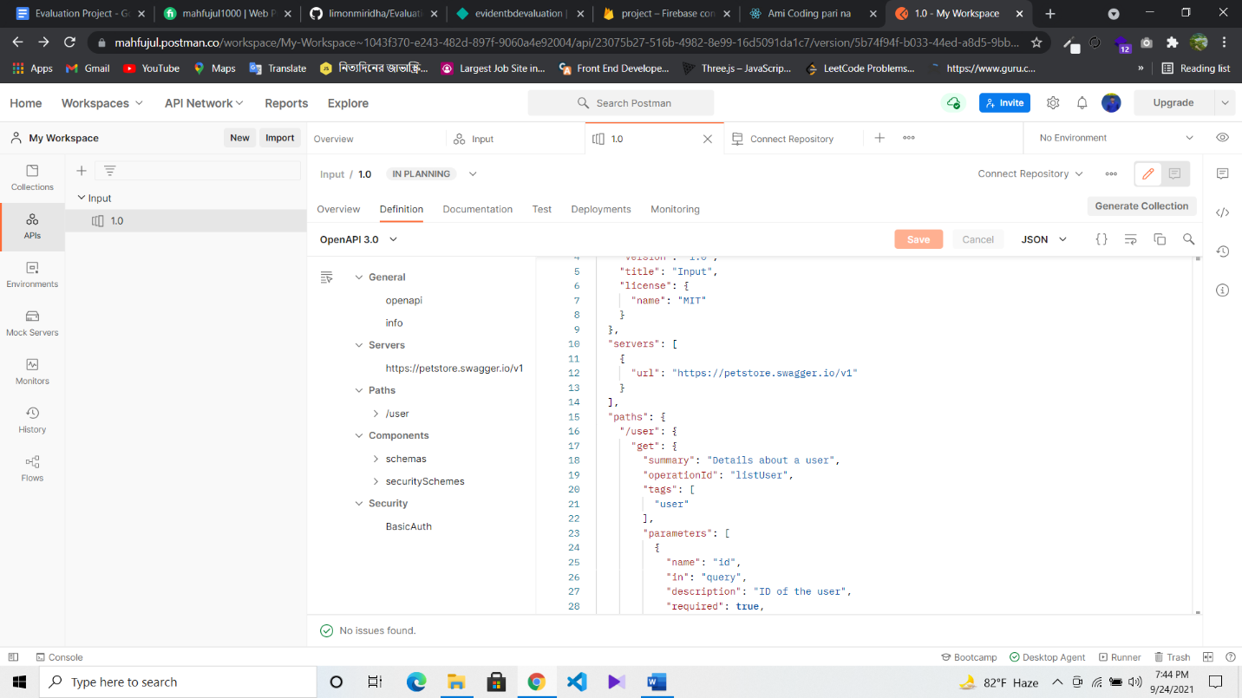

1. And I tried api endpoints in PostMan but I feel some difficulties..

Thank you..