1. Motivation
   1. goal: Create a model that can generate images that accurately depict album covers
   2. Context:
   3. Motivation: this project was created in order to help artists with being able to properly depict their
2. Data
   1. We used the spotify api to get our song data
   2. we collected playlists containing the top songs from 1990s-present form these 5 genres
      1. rap
      2. pop
      3. indie
      4. heavy metal
      5. edm
   3. these album covers were fed with the following text tokens
      1. “for genre {genre} for album titled {title} from the year {year}
   4. in total we had 500 images and corresponding labels
      1. ideally a larger set would have been better
   5. <https://huggingface.co/datasets/rishthak/albums-mixed>
3. Models
   1. We tried two ways of fine tuning
   2. We first tried to just gauge if this fine tuning would work
      1. started with a small dataset of rap and used that to finetune
      2. got some solid results just 10 images
      3. <https://huggingface.co/datasets/rishthak/album-genres>
      4. 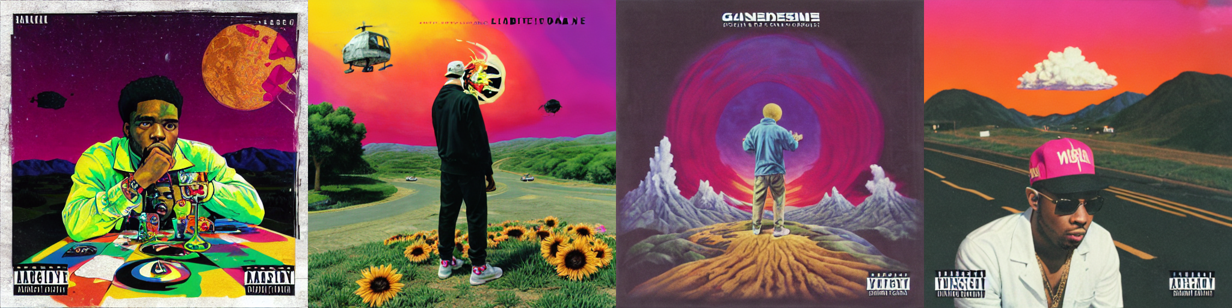
   3. First was traditional fine tuning on a Stable Diffusion Model
      1. instead of specify the object
   4. Second was using Dreambooth and Lora
      1. ask zhien about this one
4. Results (just ping me about this i have all the pictures on my computer so i can put em here)
   1. Created a survey. Generated prompts of various styles. all prompts included genre some included a chatgpt generated title and/or a random year
   2. Did Qualitative testing, results are in sheets in the folder
      1. qualtrics survey to test 4 categories:
      2. Prompt Matching
      3. Ranking
      4. Genre Mixing
      5. Favorites
   3. the choices were randomized and metadata stripped from all images
   4. we also calculated clip scores for our model and compared to those generated by the original model for the same prompts
      1. ask jacob about this
   5. Model successes
      1. Some generated images received high scores in the test (ie everyone voted for that image)
         1. 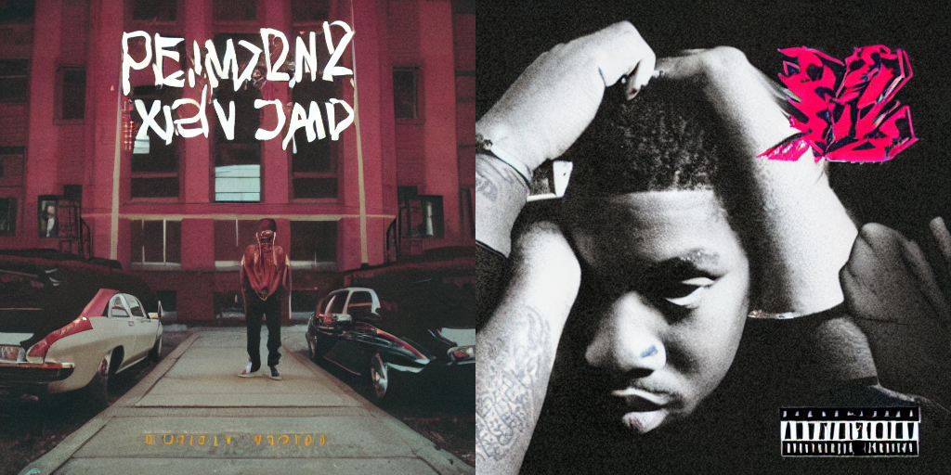
         2. prompt “album cover for genre rap”
      2. Sometimes it did well with abstract concepts like this one
      3. Other images missed the prompt or failed to generate correctly
         1. the model very quickly picked up on the explicit content warning but would sometimes put more than one or on the wrong genre
      4. Do note that the original model would depict a bunch of people in some of its pictures (as in taking the definition of an album like a photo album) which our model never did
5. Conclusion
   1. this application is better suited when there is a more consistency for what your finetuning
      1. if you had a brand or style then you can consistently generate on that to create original content that reflects your brands style
      2. but across many genres and different styles the applications are difficult without a large enough dataset for the model to identify features and still produce unique results
      3. talk something about how it can be hard to abstract album names and their concepts into art. that in itself requires some kind of abstraction/creative thinking since the title rarely correlates with the album cover itself