1.

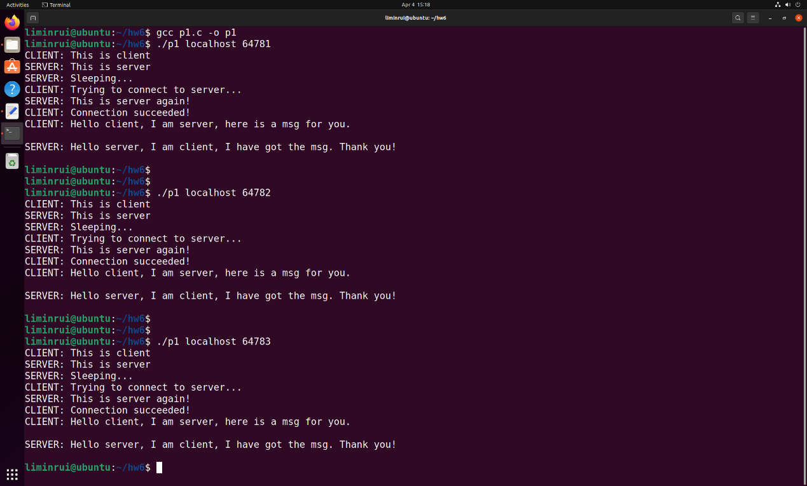

2.

a) socket(), connect(), bind(), listen(), accept(), close() and write() are unblocking, they will return as soon as possible. read() is a blocking call, it will return until it reads something from the buffer (waiting for write()).

b) It’s indirect communication.

c) The return value from connect() is less than 0 indicates the server is not ready.

d) On one machine, run the server process and assign a port number for the server. On another machine, providing the IP address (127.0.0.1(localhost) in this assignment) of the server and the port number, then run the client process. In this way, processes in different machines can communicate.