A.

In fixed sized partitioning, a process will be assigned a block of contiguous memory.

In paging, a process could have multiple non-contiguous blocks of memory.

B.

1) In paging, program is divided into several fixed size blocks. In segment, program is divided into several variable size blocks;

2) Paging has internal fragmentation problem. Segment has external fragmentation problem and may need compaction.

C.

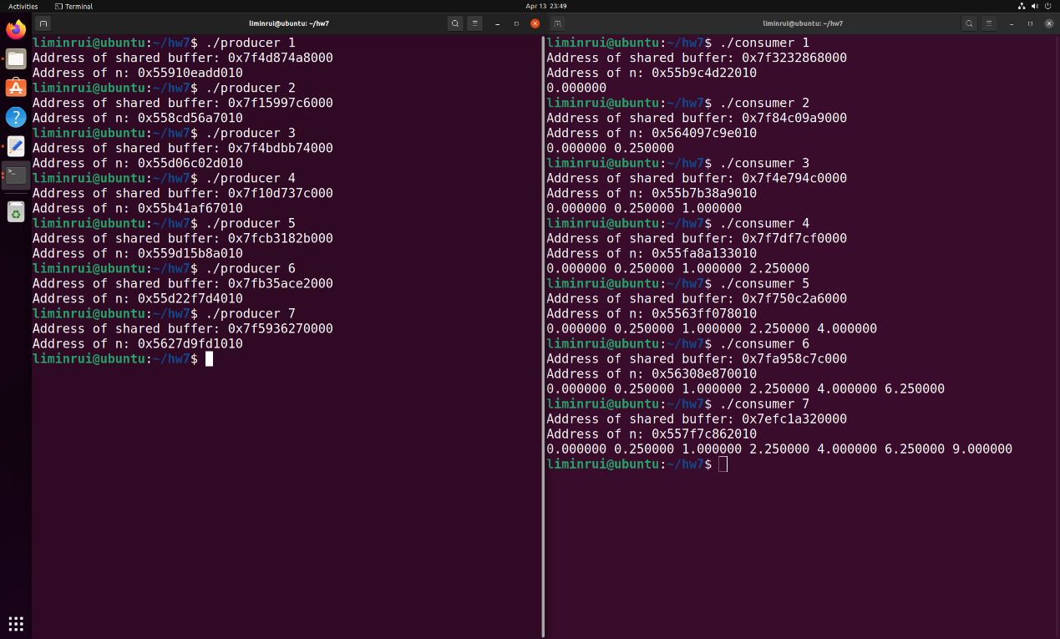

liminrui@ubuntu:~/hw7$ readelf -s producer: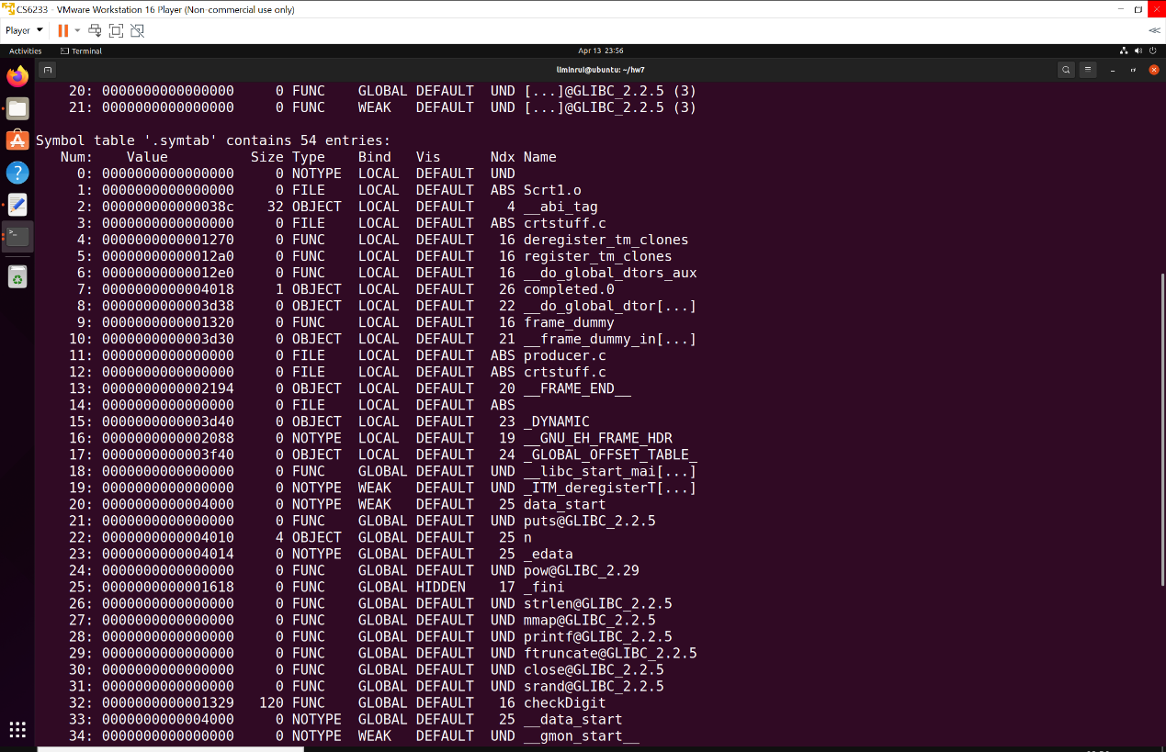

liminrui@ubuntu:~/hw7$ readelf -s consumer:

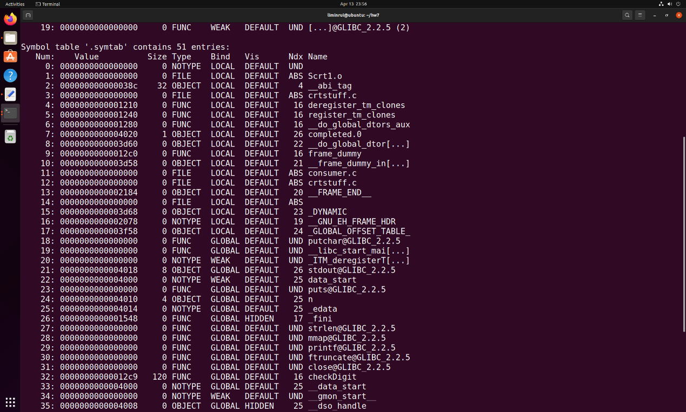

1.

i) They should be different, because the printed addresses are always virtual addresses. They point to the same physical address but the physical addresses are hidden to us.

ii) The printed addresses are virtual addresses.

2.

i) They don’t match, the addresses printed from running program are virtual addresses, however, the addresses in elf file are the offsets (they are relocatable).

ii) They are relocatable object file. Because they start from address 0.