

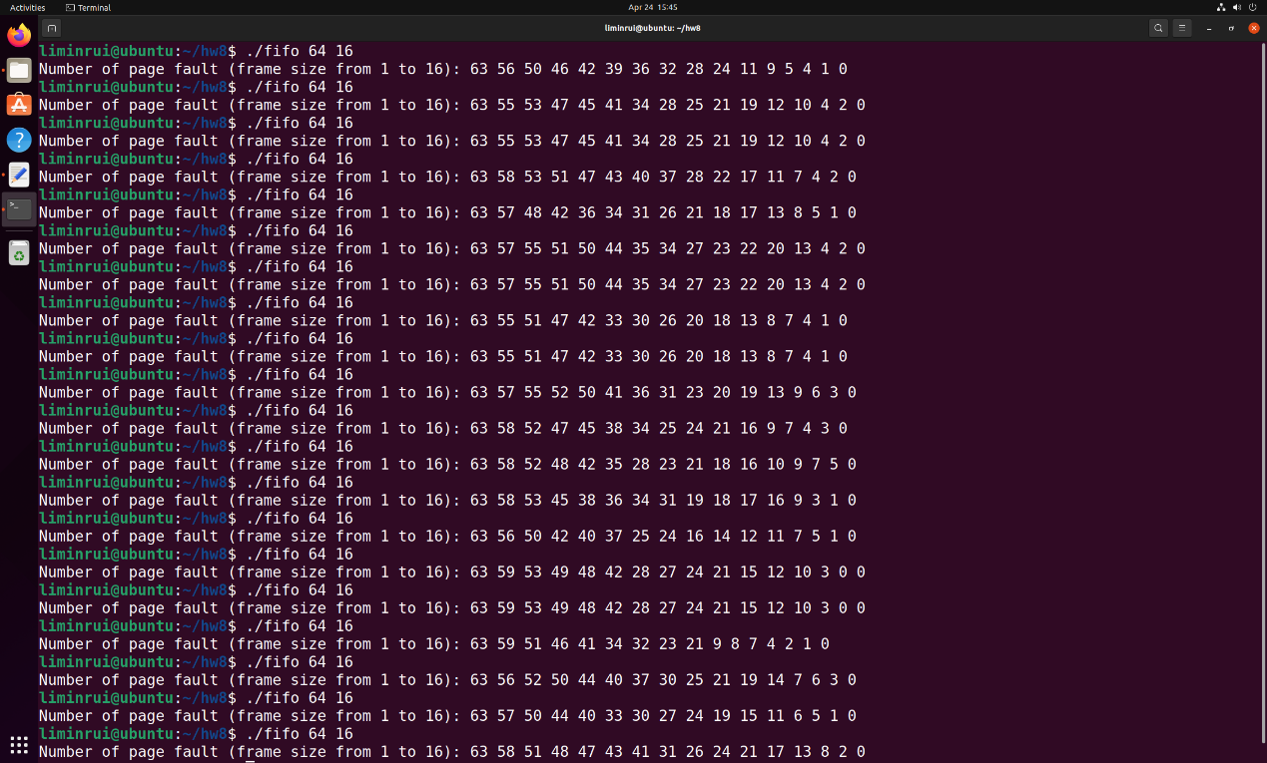

I didn’t see Belady’s anomaly from the above results. Belady’s anomaly only happens with some particular page trace patterns, it not very often to see.