Problem1

Additional assumption: each professor must teach at least one course per semester.

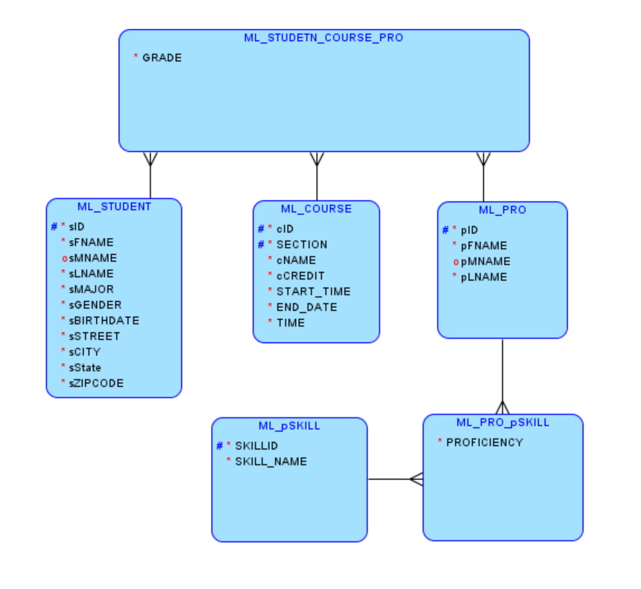

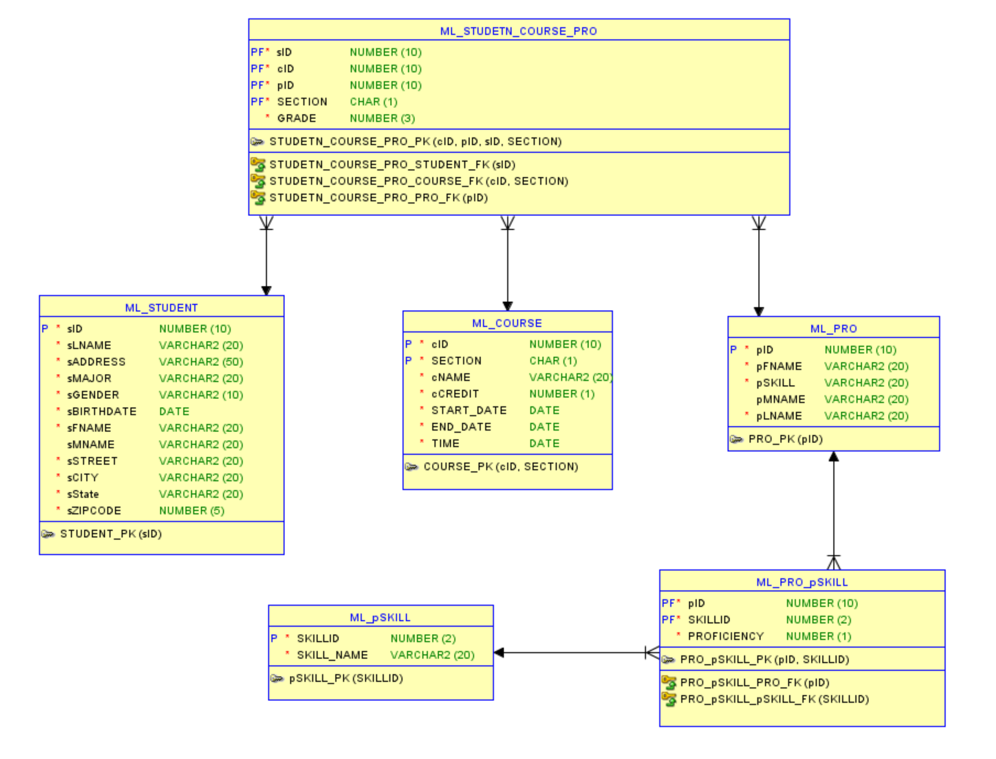

Problem2

Additional assumptions: 1) one lease could be signed by multiple customers; 2) one lease must corresponds to one and only one unit, but one unit could have no lease (has not been rent yet).

