**Q1**

Additional Assumption: 1) each individual will be assigned a unique number called individualID; 2) each alumnus has an unique alumnusID; 3) a student may or may not have an instructor; 4) a faculty member must have one or more students; 5) an employee can be a faculty or staff or neither, but not both.

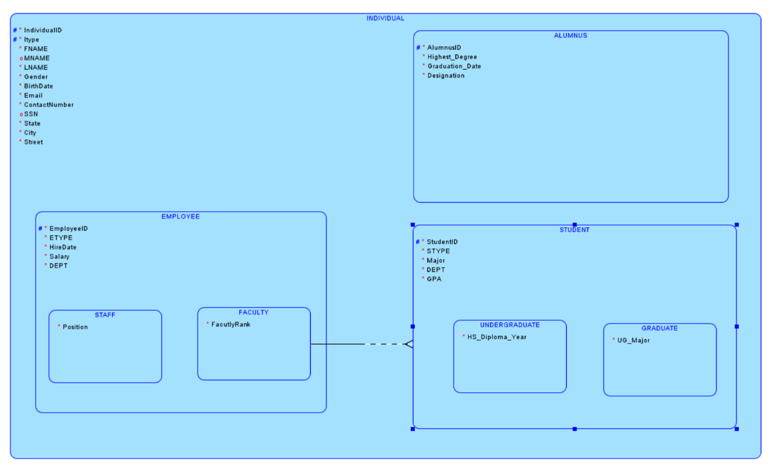

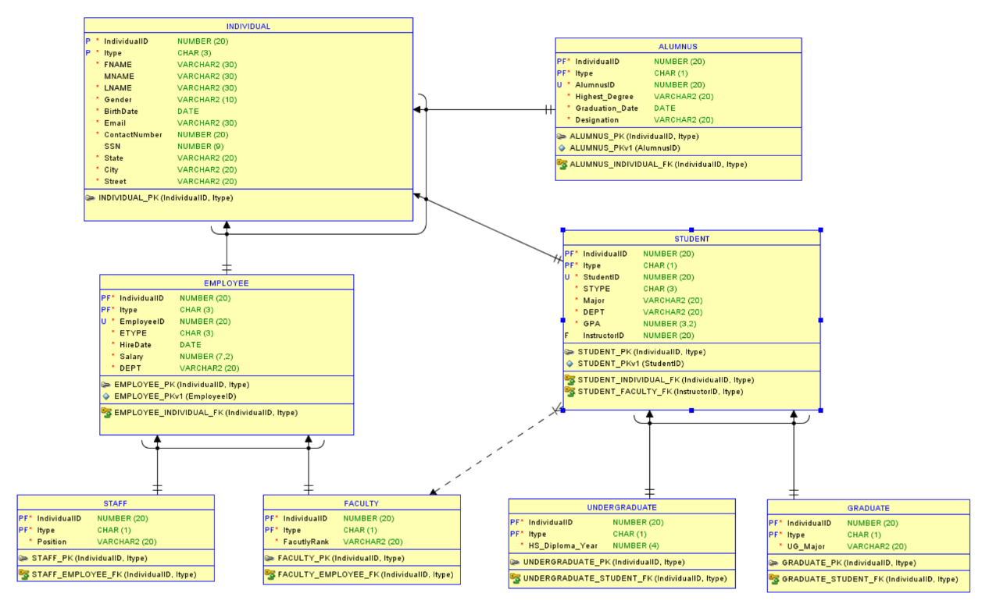

**Q2**

A)

i) There are 5 entities: CUSTOMER, ORDER, PRODUCT, INVOICE and PAYMENT.

ii) Some information cannot be recorded:

1) a new product which has not been ordered by any customer yet, will not be recorded in this dataset;

2) a new customer which has not made any order yet, will not be recorded in this dataset.

iii) The same information can be recorded on multiple rows. A partly successful update will result in logical inconsistencies. For example: if customer *Value Furniture* changed its name to *Value Furnitures*, we need to change all *Value Furniture* into *Value Furnitures*. Even if we only miss one, there will be problems.

iv) For example, If we want to delete all of the invoices about customer *Value Furniture*, then all the information about customer *Value Furniture* will be deleted as well.

v) This dataset is not normalized.

B)

Additional Assumption: 1) a new customer may not have orders; 2) a new invoice may not have payment to it; 3) a product may not have corresponding orders.

