Minrui Li, ml7136

CS-GY 6083 B

11/19/2021

***Problem1***

***I.***

select b.dname "DEPARTMENT", sum(sal) "SALARY"

from ml_emp a join ml_dept b on a.deptno=b.deptno

group by b.dname

having sum(sal) > (select sum(sal) from ml_emp a join ml_dept b on a.deptno=b.deptno where b.dname='SALES' group by a.deptno)

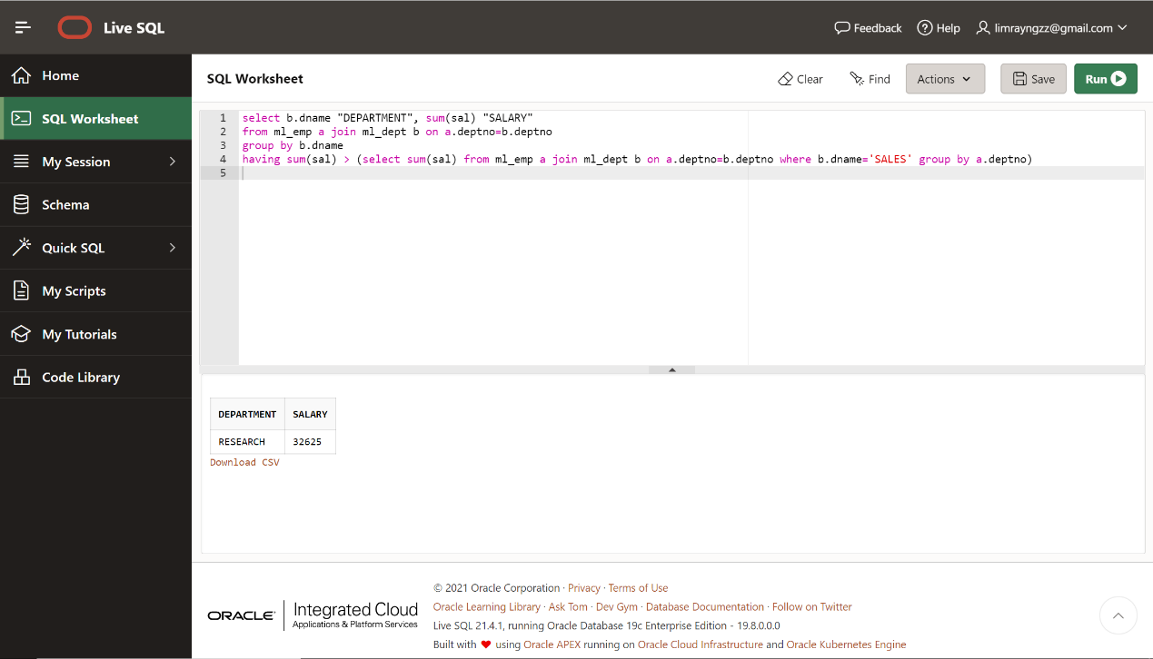

***II.***

select a.efname "FIRST NAME", a.elname "LAST NAME", a.hiredate, b.efname "MGR FIRST NAME", b.elname "MGR LAST NAME", b.hiredate "MGR HIREDATE"

from ml_emp a join ml_emp b on a.mgr=b.empno

where a.hiredate<b.hiredate;

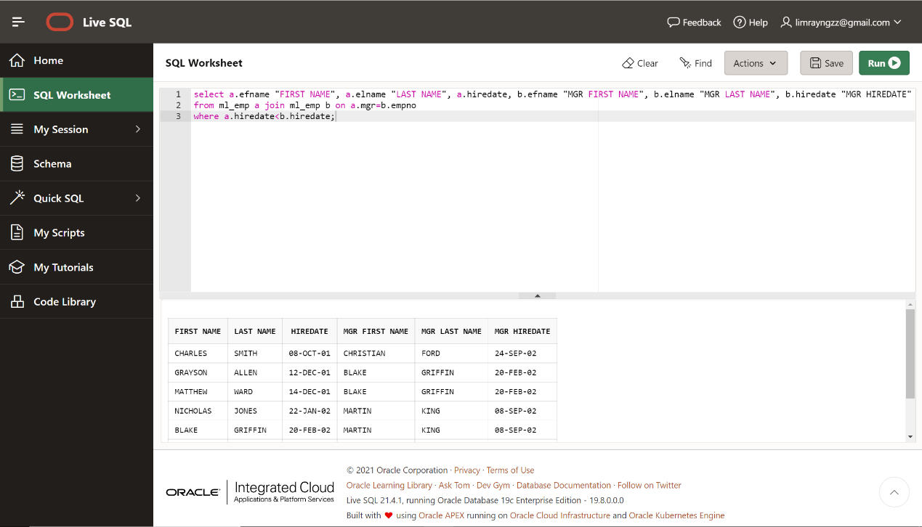

***III.***

select efname, elname, sal, dname, (select max(sal) from ml_emp a join ml_dept b on a.deptno=b.deptno where loc = 'NEW YORK')-sal "DIFFERENCE"

from ml_emp a join ml_dept b on a.deptno=b.deptno

where loc = 'NEW YORK' and sal = (select max(sal)

from ml_emp a join ml_dept b on a.deptno=b.deptno

where loc = 'NEW YORK' and sal < (select max(sal)

from ml_emp a join ml_dept b on a.deptno=b.deptno

where loc = 'NEW YORK'))

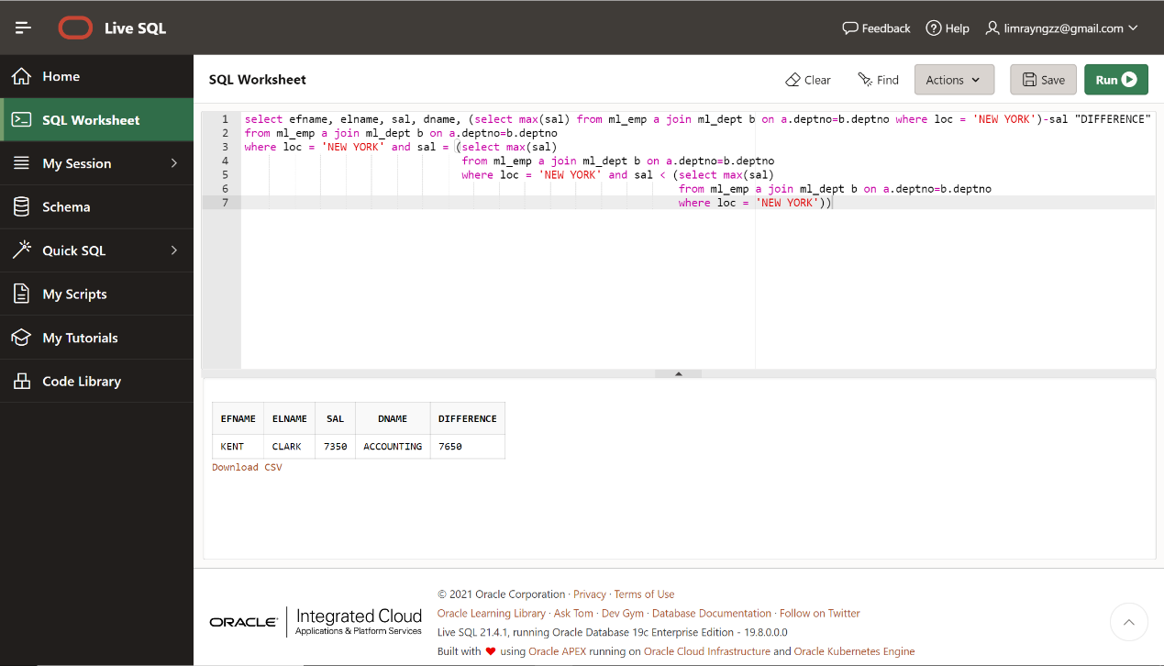

OR

select efname, elname, sal, dname, (select max(sal) from ml_emp a join ml_dept b on a.deptno=b.deptno where loc = 'NEW YORK')-sal "DIFFERENCE"

from (select efname, elname, sal, dname, dense_rank() over(order by sal desc) sal_rank

from ml_emp a join ml_dept b on a.deptno=b.deptno

where loc = 'NEW YORK')

where sal_rank = 2

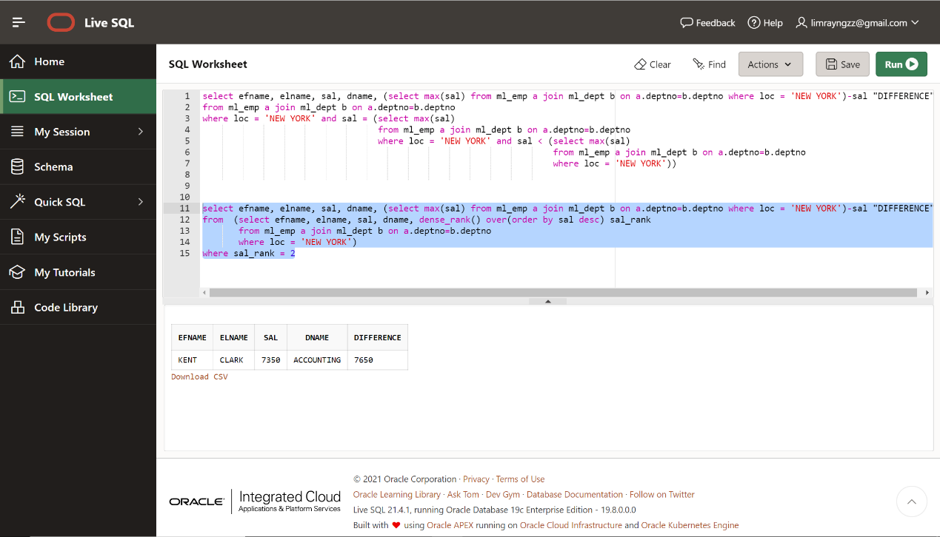

***IV.***

select efname, elname

from (select efname, elname, sal, dname, job, dense_rank() over(partition by job order by sal desc) sal_rank

from ml_emp a join ml_dept b on a.deptno=b.deptno

order by job)

where sal_rank <= 2

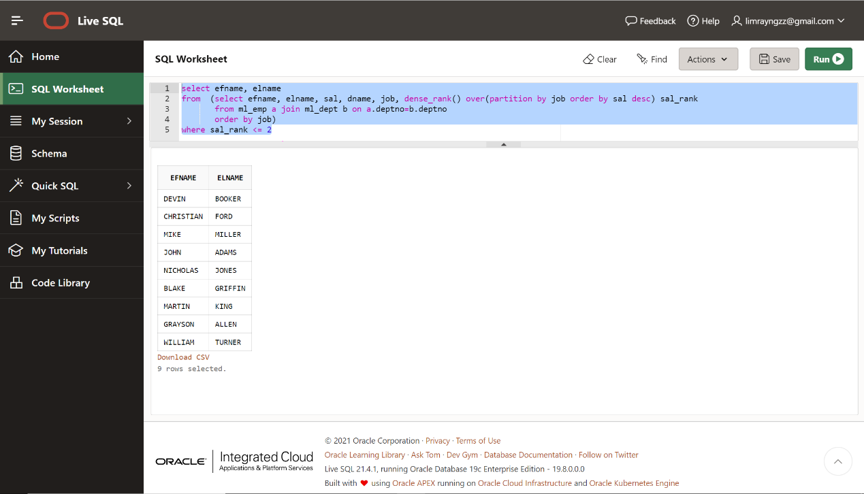

***V.***

select a.empno, a.efname, a.elname, b.dname, d.pname, c.hours

from ml_emp a join ml_dept b on a.deptno=b.deptno join ml_proemp c on a.empno=c.empno join ml_project d on c.projid=d.projid join

(select deptno, avg(sal) avg_sal from ml_emp group by deptno) e on e.deptno=a.deptno

where a.sal > e.avg_sal;

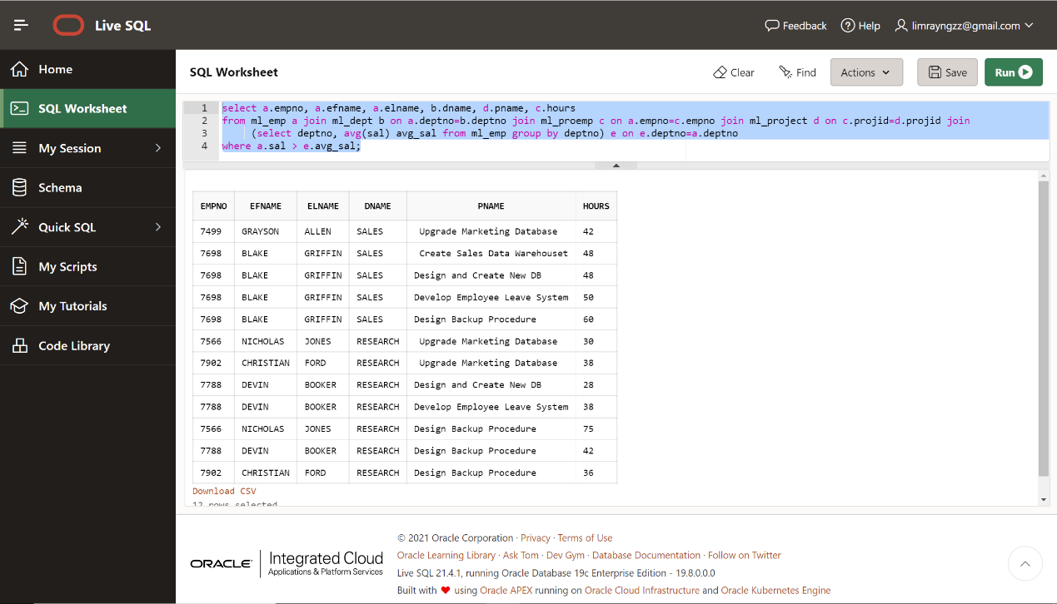

***Problem2***

***I.***

select count(dates)

from (select distinct(to_char(schedule, 'dd-mon-yy')) "DATES", flight_id

from ml_flight

order by DATES)

group by dates

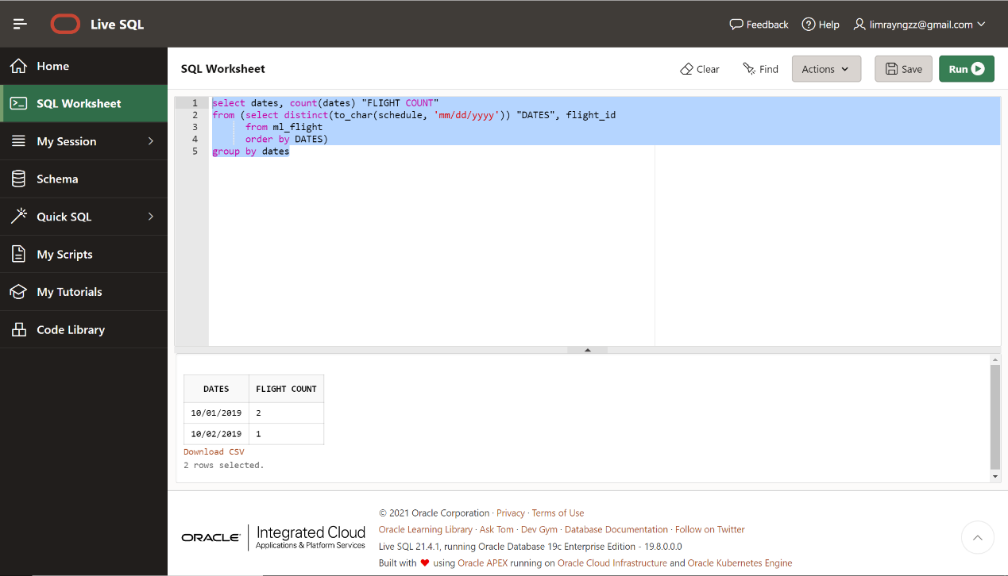

***II.***

select dates, sum(capacity)/1000 || 'k' "TOTAL_CAPACITY"

from (select distinct(to_char(a.schedule, 'mm/dd/yyyy')) "DATES", a.flight_id, b.capacity

from ml_flight a join ml_size b on a.flight_id=b.flight_id

Order by DATES)

group by dates;

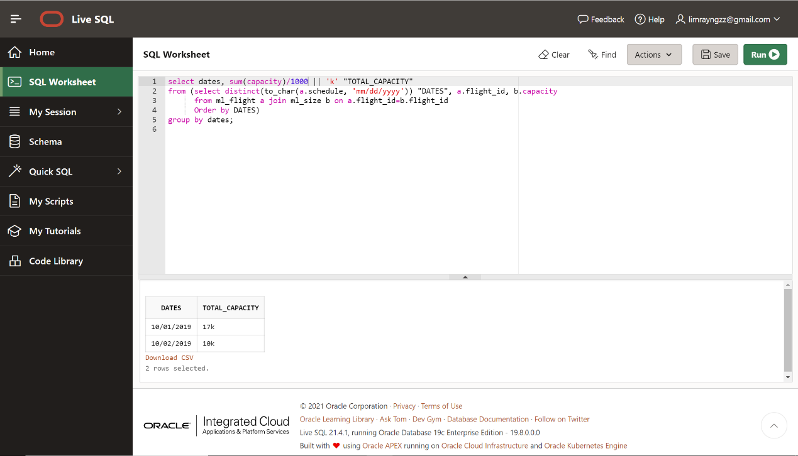

***Problem3***

***I.***

create or replace view myview

as

select a.cust_id, a.fname, a.lname, b.order_id, b.order_date, d.prod_id, d.descr, c.quant, d.unit_price,

c.quant*d.unit_price "TOTAL_PRICE", e.shade

from ml_cust a join ml_order b on a.cust_id=b.cust_id join ml_ord_prod c on c.order_id=b.order_id

join ml_prod d on d.prod_id=c.prod_id join ml_finish e on e.finish_id=c.finish_id

where c.quant*d.unit_price >= 1000

order by total_price

with read only;

select * from myview;

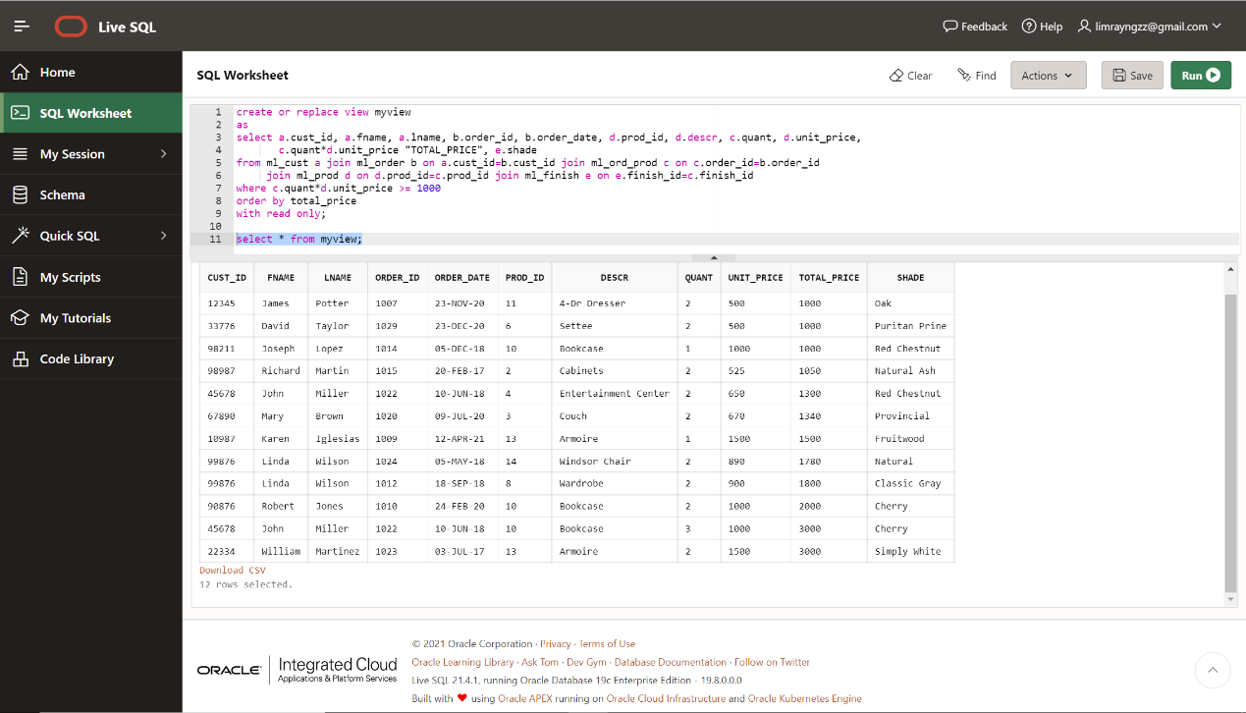

***II.***

select prod_id, descr, shade, total_quantity_sold

from (select prod_id, descr, shade, total_quantity_sold, dense_rank() over(order by TOTAL_QUANTITY_SOLD desc) SOLD_RANK

from (select b.prod_id, descr, shade, sum(b.quant) TOTAL_QUANTITY_SOLD

from ml_prod a join ml_ord_prod b on a.prod_id=b.prod_id join ml_order c on c.order_id=b.order_id join ml_finish d on b.finish_id=d.finish_id

where months_between(sysdate, order_date) <= 6

group by b.prod_id, descr, shade))

where sold_rank<=3;

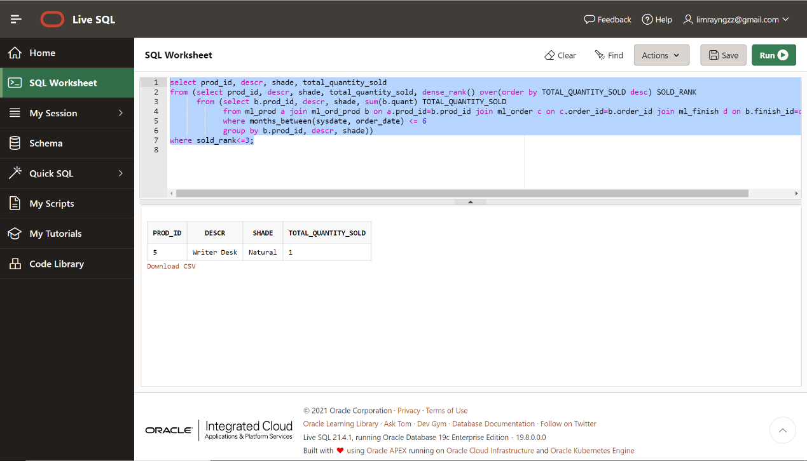

***III.***

select a.prod_id, c.shade

from ml_ord_prod a join ml_order b on a.order_id=b.order_id join ml_finish c on c.finish_id=a.finish_id

where b.order_date not between to_date('2020-10-1', 'YYYY-MM-DD') and to_date('2020-12-31', 'YYYY-MM-DD');

