

**CS-GY 6083 - B, FALL 2021**

**Principles of Database Systems**

**Assignment: 4 [100 points]**

**Please submit your assignment to NYU Brightspace with a single PDF document attachment. Please mention Student ID, Name, Course, Section Number, and date of submission on the first page of your submission. This is an individual assignment and you should create your own work. All table names in your submission should have your prefix as your initial, e.g. AP_EMP, where AP is the initial of the student.**

1. **To write a database procedure (Oracle or MySQL) [30 points]**

**Consider following employee table in your practice schema. The table should have your initial as prefix.**

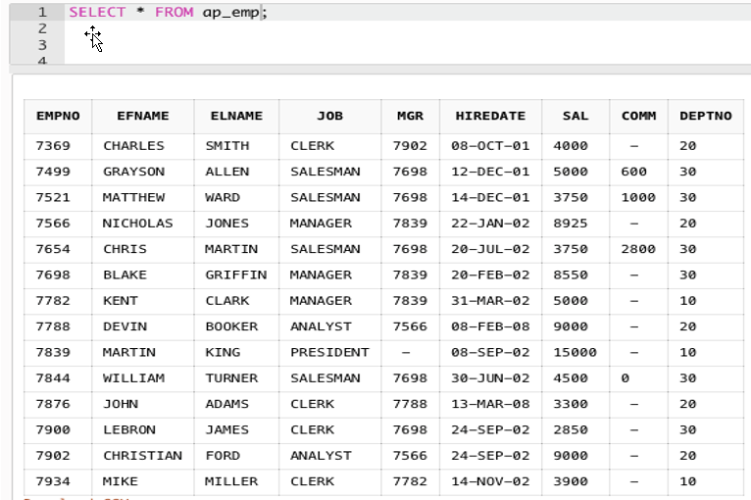

**The HR department intend to give salary increment to all employees at every six months with specific base increment amount, for example $300. Each time HR department gives salary increment, the base increment amount is not same**

**and it varies. So, application team intend to write a database procedure, that takes base salary increment amount as input to the procedure, for example N.**

**The procedure should update everyone’s salary with following criteria,**

* **Everyone’s salary is increased by at least, the value N (e.g. 300 if N=300)**
* **Number of years of service >= 5, then salary is increased with 10% more of amount N (e.g. 330 if N=300)**
* **Number of years of service >=10, then salary is increased with 15% more of amount N (e.g. 345 if N=300)**
* **Number of years of service >=15 then salary is increased with 20% more of amount N (e.g. 360 if N=300)**

**Write a database procedure that do work as mentioned above. Your procedure name should have your initial as prefix, e.g. AP_RAISE_SAL.**

**Submit the procedure code, execute procedure for at least 4 salary change, and screenshot of table data after the salary changes.**

1. **To write a database function (Oracle or MySQL) [30 points]**

**Consider the same employee table in question A.**

**Write a database function that takes Hiredate as input and calculate employment duration as of system date. The employment duration should be returned in format of string that looks as “12 YEARS 8 MONTHS 24 DAYS”. Your function name should have your initial as prefix, e.g. AP_HIRE_DURATION**

**Submit the function code, use the function and show data of employee number, hire date and hire duration using function. Arrange the result in order of employee number.**

1. **To write a database function (Oracle or MySQL) [30 points]**

**Create patient table, your table name should have your initial as prefix**

create table AP_PATIENT

(patient_id number(10),

gender char(1),

marital_status char(1),

race char(1),

primary key (patient_id));

**Populate data to your patient table, with exact data as follow.**

insert into ap_patient (patient_id,gender,marital_status,race) values (10001, 'F','S','A');

insert into ap_patient (patient_id,gender,marital_status,race) values (10002, 'F','S','W');

insert into ap_patient (patient_id,gender,marital_status,race) values (10003, 'F','S','B');

insert into ap_patient (patient_id,gender,marital_status,race) values (10004, 'F','M','A');

insert into ap_patient (patient_id,gender,marital_status,race) values (10005, 'F','D','B');

insert into ap_patient (patient_id,gender,marital_status,race) values (10006, 'F','W','A');

insert into ap_patient (patient_id,gender,marital_status,race) values (10007, 'F','M','W');

insert into ap_patient (patient_id,gender,marital_status,race) values (10008, 'F','W','B');

insert into ap_patient (patient_id,gender,marital_status,race) values (10009, 'M','S','A');

insert into ap_patient (patient_id,gender,marital_status,race) values (10010, 'M','S','W');

insert into ap_patient (patient_id,gender,marital_status,race) values (10011, 'M','S','B');

insert into ap_patient (patient_id,gender,marital_status,race) values (10012, 'M','M','A');

insert into ap_patient (patient_id,gender,marital_status,race) values (10013, 'M','D','B');

insert into ap_patient (patient_id,gender,marital_status,race) values (10014, 'M','W','A');

insert into ap_patient (patient_id,gender,marital_status,race) values (10015, 'M','M','W');

insert into ap_patient (patient_id,gender,marital_status,race) values (10016, 'M','W','B');

**In this dataset,**

**Gender are M (male), F (female)**

**Marital_Status are S (single), M (married), D (divorced), and W (Widow or Widower)**

**Race are A (Asian), B (Black), W (White)**

1. **Identify columns suitable of creating bitmap indexes, and write bitmaps of each of such bitmap indexes. (10 points). Submit bitmaps of each distinct value of each of such bitmap indexes.**
2. **Using bitmaps created in step i, solve the business question “List patient IDs of those patients who are Female and not Asian, and their marital status is either Single or Married”. Submit intermediate results and final result of bitmap. List Patient Id of the final result. [10 point]**
3. **Write a SQL query that solves business question in Q2 [10 points]**
4. **Write DDL code to create bitmap indexes for which bitmaps are created in step i [10 points]**