A)

Procedure:

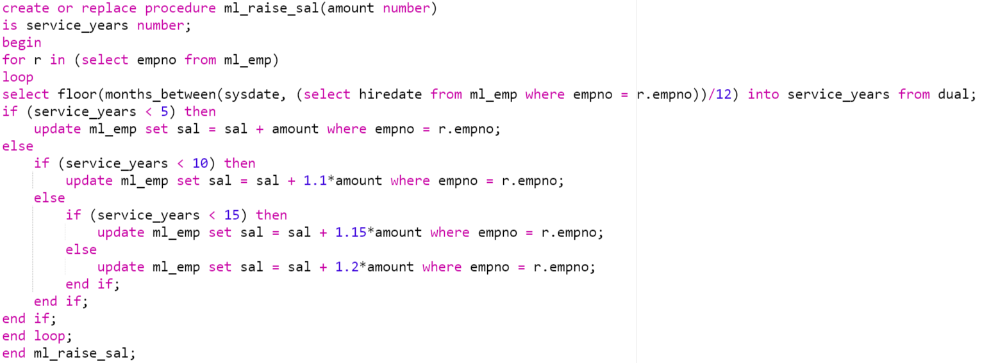

Execute procedure:

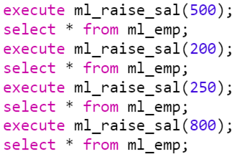

Data before change:

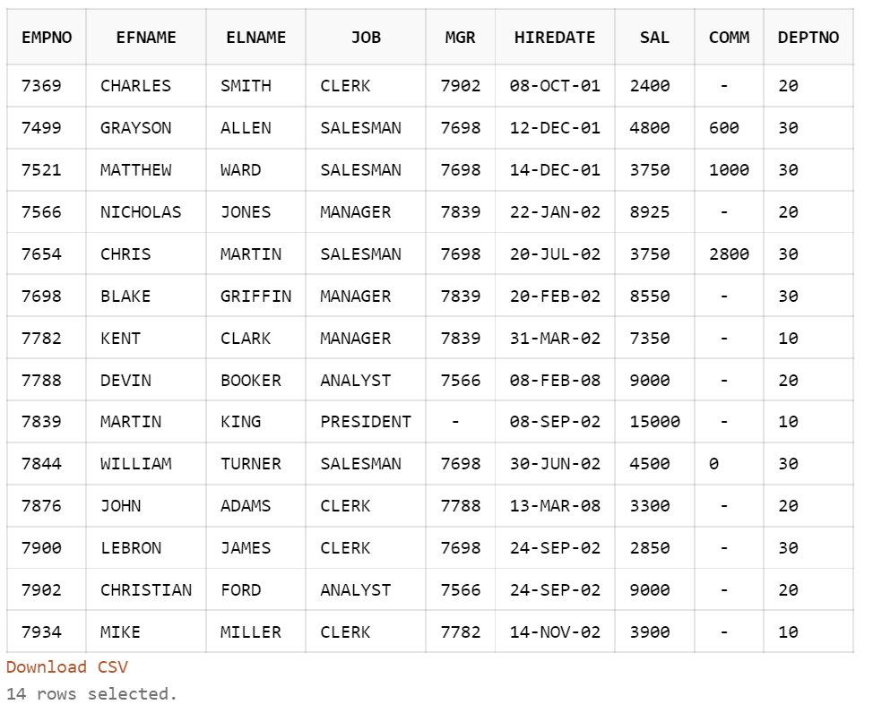

Data after first change:

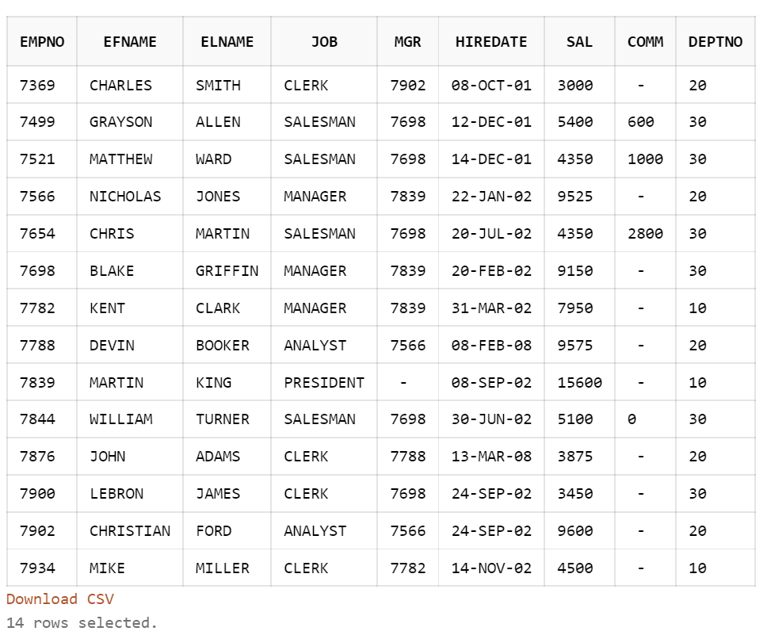

Data after second change

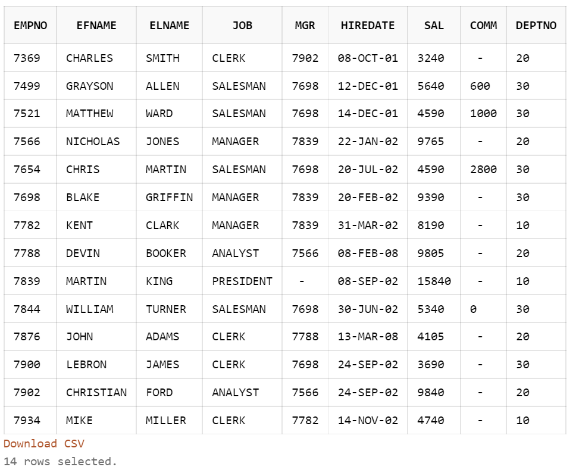

Data after third change

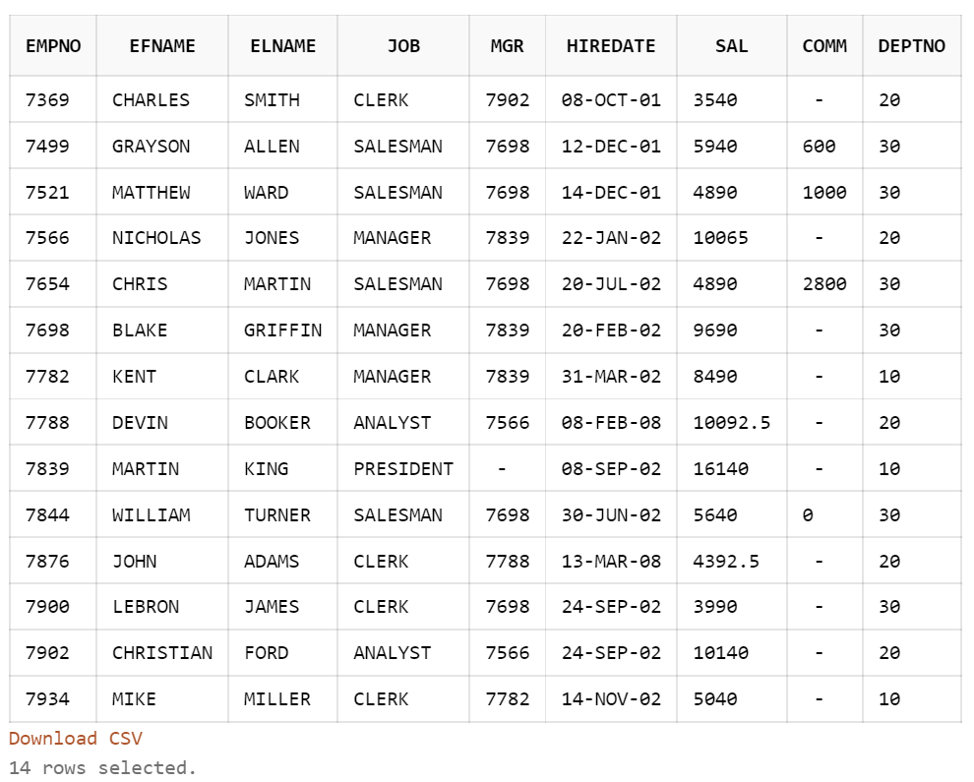

Data after fourth change

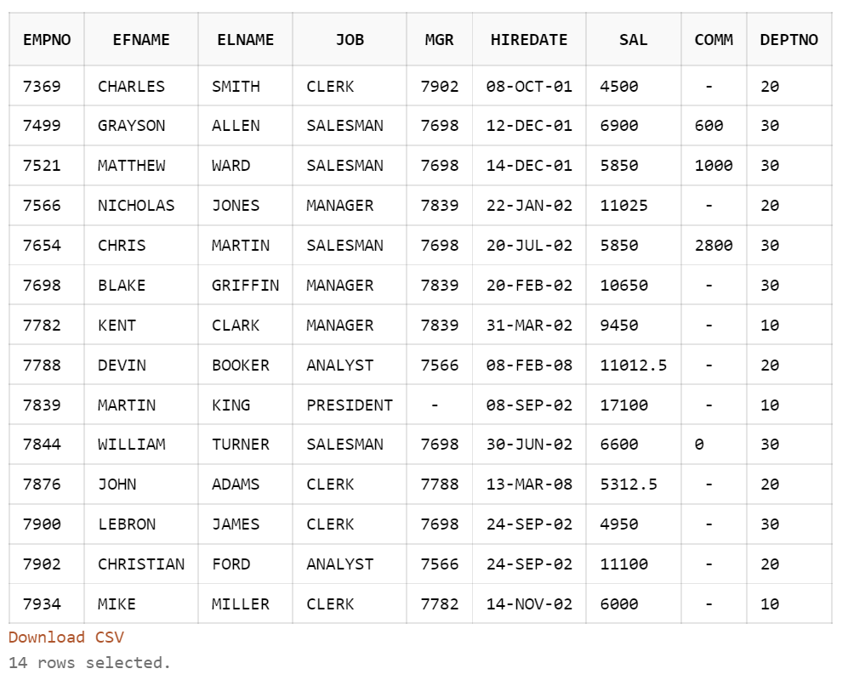

B)

Function:

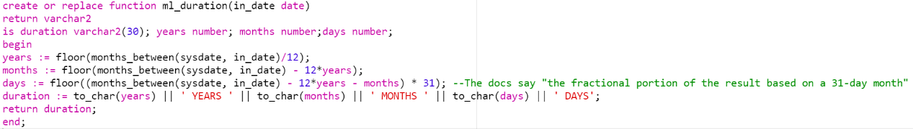

Result:

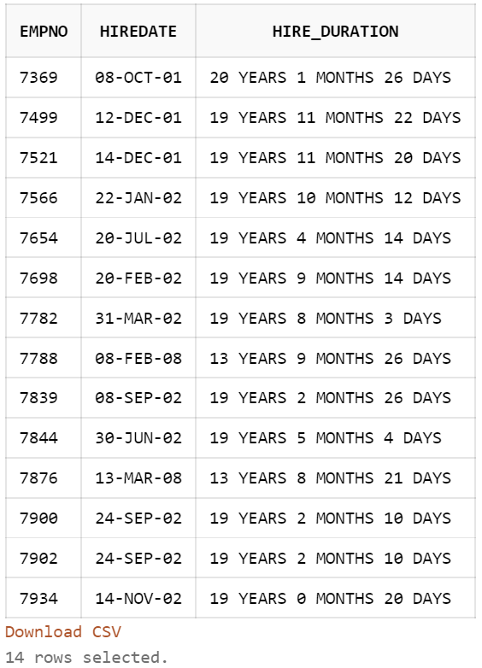

C)

i)GENDER, MARITAL STATUS and RACE are suitable for creating bitmap indexes.

Bitmap for gender:

F: 1111111100000000

M: 0000000011111111

Bitmap for marital status:

S: 1110000011100000

M: 0001001000010010

D: 0000100000001000

W: 0000010100000101

Bitmap for race:

A: 1001010010010100

B: 0010100100101001

W: 0100001001000010

ii)

Female = 1111111100000000

Not Asian = 0110101101101011

Single or Married = 1111001011110010

(Female) and (not Asian) and (Single or Married) = 0110001000000000

List of patient_id:

10002

10003

10007

iii)



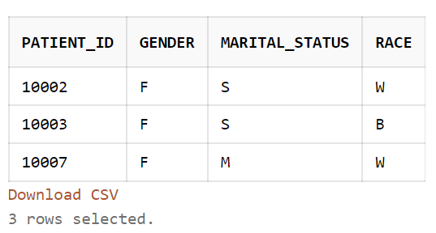

iv)



