GSGY6083B F21

ML7136

OZ3499

Final Project Part 1

11/12/2021

**Summary**

Customer is a subtype passenger, but passenger doesn’t have to be the customer, So the passenger to customer is a partial completeness relation.

Members and the booking agent are subtypes of the customer, but the customer can be neither a member or booking agent, so there is partial completeness constraint for the customer, member and booking agent table.

Customer will purchase the insurance for her/himself or for other passengers in the flight, we assume that a passenger can’t have multiple insurance plans, so the insurance plan is one to many relationship to the passenger. In addition, it is optional for the passenger, because not every passenger will get the insurance.

In the purchase table, purchaseID  is the primary key. A customer can have multiple purchaseIDs, since customers can buy insurance for many passengers. The purchase table has the plan purchased and coverage person name to keep the record, so it is easy to check who has purchased the ticket.

Then one or many purchases will generate an invoice for the customer. One invoice can have multiple payments, since the customer might split the payment with different cards, so there is one to many relationship between invoice and payment table. It also required that the payment date should be three days before the flight.

The passenger and the flight have many to many relationship, so we need an associate entity in between . The meal plan and cabin class will be included in the passenger_flight entity to connect the passenger and flight entity.

There are two relationships from the flight table to the airport, one is for departure airport, another is for arrival airport. The airline and the flight have the relationship of one to many because every airline can have multiple flights, but one flight only belongs to one airline.

Airline and airplane model should have many-to-many relationship because one airline can have different models, and one model of airplane is usually owned by multiple airlines, so there is an airline_model table to demonstrate the quantity of each airplane model in each airline.

The relationship between Passenger and SpeicialRequest is many-to-many. To solve this an associated entity is created.

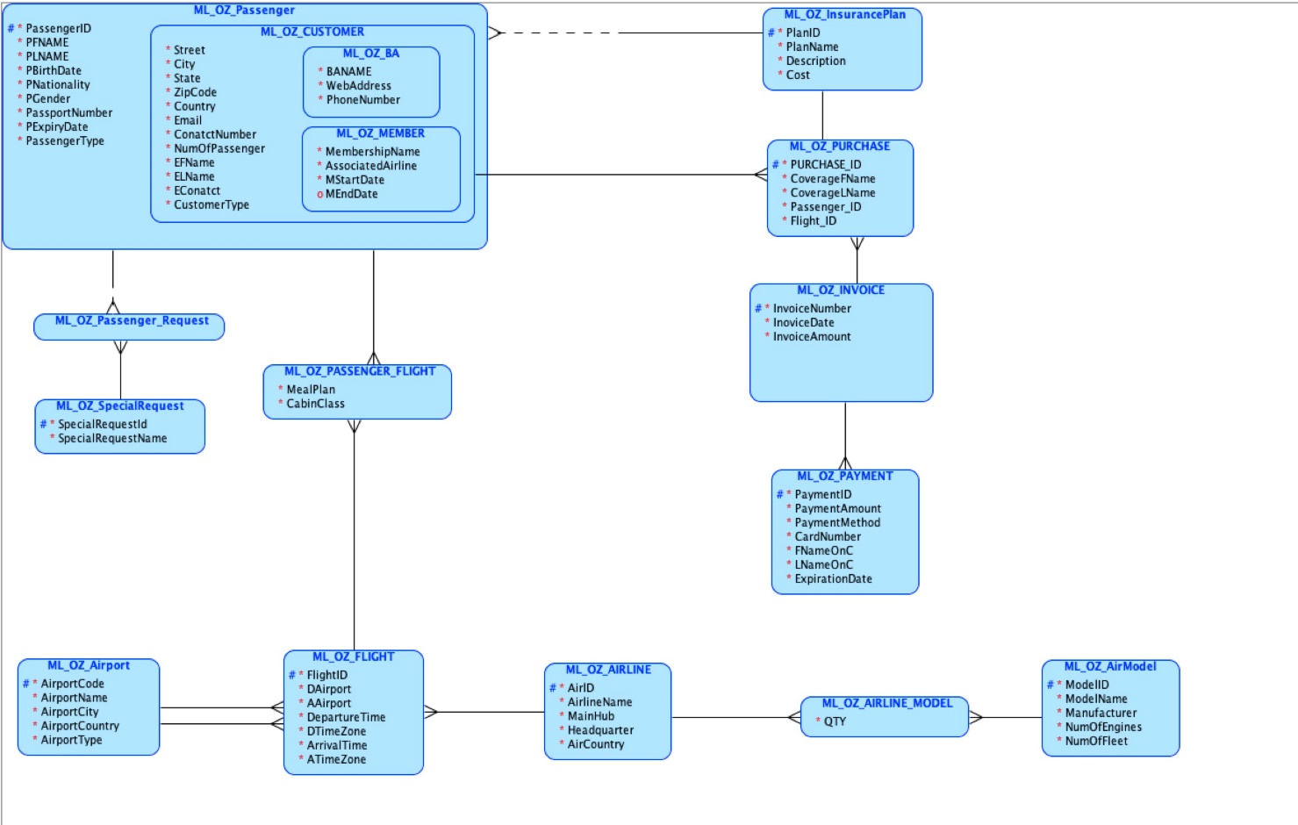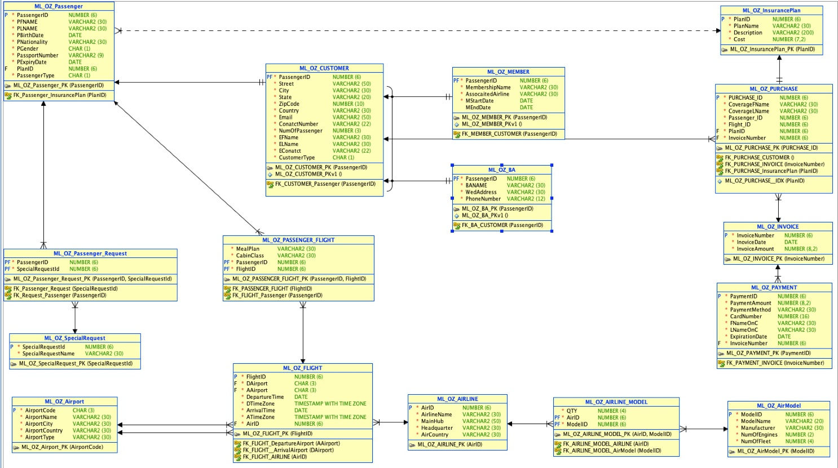

**Constraints**

-- ml_oz_passenger

alter table ml_oz_passenger add constraint c_passengerid check (passengerid between 100000 and 999999);

alter table ml_oz_passenger add constraint c_passengergender check (pgender in ('M', 'F'));

alter table ml_oz_passenger add constraint c_pfname check (pfname = initcap(pfname));

alter table ml_oz_passenger add constraint c_pname check (plname = initcap(plname));

-- ml_oz_purchase

alter table ml_oz_purchase add constraint c_purchaseid check (purchaseid between 100000 and 999999);

alter table ml_oz_purchase add constraint c_passengerid_pur check (passengerid between 100000 and 999999);

alter table ml_oz_purchase add constraint c_flightid_pur check (flightid between 100000 and 999999);

alter table ml_oz_purchase add constraint c_invoicenumber_pur check (invoicenumber between 100000 and 999999);

-- ml_oz_insuranceplan

alter table ml_oz_insuranceplan add constraint c_planid check (planid between 100000 and 999999);

-- ml_oz_passenger_request

alter table ml_oz_passenger_request add constraint c_passengerid_pq check (passengerid between 100000 and 999999);

alter table ml_oz_passenger_request add constraint c_sq_sq check (specialrequestid between 100000 and 999999);

-- ml_oz_passenger_flight

alter table ml_oz_passenger_flight add constraint c_passengerid_pf check (passengerid between 100000 and 999999);

alter table ml_oz_passenger_flight add constraint c_flightid_pf check (flightid between 100000 and 999999);

-- ml_oz_invoice

alter table ml_oz_invoice add constraint c_invoicenumber check (invoicenumber betweeneen 100000 and 999999);

-- ml_oz_specialrequest

alter table ml_oz_specialrequest add constraint c_specialrequestid check (specialrequestid between 100000 and 999999);

-- ml_oz_payment

alter table ml_oz_payment add constraint c_paymentid check (paymentid between 100000 and 999999);

alter table ml_oz_payment add constraint c_invoicenumber_pay check (invoicenumber between 100000 and 999999);

-- ml_oz_flight

alter table ml_oz_flight add constraint c_flightid check (flightid between 100000 and 999999);

alter table ml_oz_flight add constraint c_airid_flight check (airid between 100000 and 999999);

-- ml_oz_airline

alter table ml_oz_airline add constraint c_airid check (airid between 100000 and 999999);

-- ml_oz_airline_model

alter table ml_oz_airline_model add constraint c_airid_am check (airid between 100000 and 999999);

alter table ml_oz_airline_model add constraint c_modelid_am check (modelid between 100000 and 999999);

-- ml_oz_airmodel

alter table ml_oz_airmodel add constraint c_modelid check (modelid between 100000 and 999999);

**Insert Data**

-- insert into ml_oz_airline

insert into ml_oz_airline (airid, airlinename, mainhub, headquarter, aircountry) values (200001, 'Emirates Airline', 'Dubai International Airport', 'Dubai', 'United Arab Emirates');

insert into ml_oz_airline (airid, airlinename, mainhub, headquarter, aircountry) values ( 200002, 'Qatar Airways', 'Doha International Airport', 'Doha', 'Qatar');

insert into ml_oz_airline (airid, airlinename, mainhub, headquarter, aircountry) values ( 200003, 'AirAsia', 'Kuala Lumpur International Airport', 'Kuala Lumpur', 'Malaysia');

insert into ml_oz_airline (airid, airlinename, mainhub, headquarter, aircountry) values ( 200004, 'Air China', 'Beijing Capital International Airport', 'Beijing', 'China');

insert into ml_oz_airline (airid, airlinename, mainhub, headquarter, aircountry) values ( 200005, 'Jet Airways', 'Chhatrapati Shivaji International Airport', 'Mumbai', 'India');

insert into ml_oz_airline (airid, airlinename, mainhub, headquarter, aircountry) values ( 200006, 'JAL Group', 'Narita and Tokyo International Airport', 'Tokyo', 'Japn');

insert into ml_oz_airline (airid, airlinename, mainhub, headquarter, aircountry) values ( 200007, 'Jetstar', 'Melbourne Airport', 'Melbourne', 'Australia');

insert into ml_oz_airline (airid, airlinename, mainhub, headquarter, aircountry) values ( 200008, 'Lion Air', 'Soekarno-Hatta International Airport', 'Jakarta', 'Indonesia');

insert into ml_oz_airline (airid, airlinename, mainhub, headquarter, aircountry) values ( 200009, 'Korean Air', 'Incheon International Airport', 'Seoul', 'South Korea');

insert into ml_oz_airline (airid, airlinename, mainhub, headquarter, aircountry) values ( 200010, 'Kingfisher Airlines', 'Bengaluru International Airport', 'Bangalore', 'India');

insert into ml_oz_airline (airid, airlinename, mainhub, headquarter, aircountry) values ( 200011, 'Singapore Airlines', 'Singapore Changi Airport', 'Singapore', 'Singapore');

insert into ml_oz_airline (airid, airlinename, mainhub, headquarter, aircountry) values ( 200012, 'Thai Airways International', 'Suvarnabhumi Airport', 'Bangkok', 'Thailand');

insert into ml_oz_airline (airid, airlinename, mainhub, headquarter, aircountry) values ( 200013, 'Vietnam Airlines', 'Noi Bai International Airport Tan Son Nhat International Airport', 'Hanoi Ho Chi Minh City', 'Vietnam');

insert into ml_oz_airline (airid, airlinename, mainhub, headquarter, aircountry) values ( 200014, 'Air Berlin Group', 'Sheremetyevo International Airport', 'Berlin', 'Germany');

insert into ml_oz_airline (airid, airlinename, mainhub, headquarter, aircountry) values ( 200015, 'Air France KLM', 'Paris-Charles de Gaulle Airport', 'Paris', 'France');

insert into ml_oz_airline (airid, airlinename, mainhub, headquarter, aircountry) values ( 200016, 'Alitalia', 'Leonardo da Vinci-Fiumicino Airport', 'Rome', 'Italy');

insert into ml_oz_airline (airid, airlinename, mainhub, headquarter, aircountry) values ( 200017, 'Austrian Airlines Group', 'Vienna International Airport', 'Vienna', 'Austria');

insert into ml_oz_airline (airid, airlinename, mainhub, headquarter, aircountry) values ( 200018, 'EasyJet', 'London Luton Airport', 'London', 'United Kingdom');

insert into ml_oz_airline (airid, airlinename, mainhub, headquarter, aircountry) values ( 200019, 'Ryanair', 'Dublin Airport', 'Dublin', 'Ireland');

insert into ml_oz_airline (airid, airlinename, mainhub, headquarter, aircountry) values ( 200020, 'Avianca', 'El Dorado International Airport', 'Bogota', 'Columbia');

-- insert into ml_oz_airmodel

insert into ml_oz_airmodel (modelid, modelname, manufacturer, numofengines, numoffleet) values (100001, '737-800', 'Boeing', 2,826);

insert into ml_oz_airmodel (modelid, modelname, manufacturer, numofengines, numoffleet) values (100002, '737-700', 'Boeing', 2,579);

insert into ml_oz_airmodel (modelid, modelname, manufacturer, numofengines, numoffleet) values ( , , , ,);

-- insert into ml_oz_airline_model

insert into ml_oz_airline_model (qty, airid, modelid) values (100, 300001, 400001);

insert into ml_oz_airline_model (qty, airid, modelid) values (100, 300002, 400002);

insert into ml_oz_airline_model (qty, airid, modelid) values (100, 300003, 400003);

insert into ml_oz_airline_model (qty, airid, modelid) values (100, 300004, 400004);

insert into ml_oz_airline_model (qty, airid, modelid) values (100, 300005, 400005);

insert into ml_oz_airline_model (qty, airid, modelid) values (100, 300006, 400006);

insert into ml_oz_airline_model (qty, airid, modelid) values (100, 300007, 400007);

insert into ml_oz_airline_model (qty, airid, modelid) values (100, 300008, 400008);

insert into ml_oz_airline_model (qty, airid, modelid) values (100, 300009, 400009);

insert into ml_oz_airline_model (qty, airid, modelid) values (100, 300010, 400010);

insert into ml_oz_airline_model (qty, airid, modelid) values (100, 300011, 400011);

insert into ml_oz_airline_model (qty, airid, modelid) values (100, 300012, 400012);

insert into ml_oz_airline_model (qty, airid, modelid) values (100, 300013, 400013);

insert into ml_oz_airline_model (qty, airid, modelid) values (100, 300014, 400014);

insert into ml_oz_airline_model (qty, airid, modelid) values (100, 300015, 400015);

insert into ml_oz_airline_model (qty, airid, modelid) values (100, 300016, 400016);

insert into ml_oz_airline_model (qty, airid, modelid) values (100, 300017, 400017);

insert into ml_oz_airline_model (qty, airid, modelid) values (100, 300018, 400018);

insert into ml_oz_airline_model (qty, airid, modelid) values (100, 300019, 400019);

insert into ml_oz_airline_model (qty, airid, modelid) values (100, 300020, 400020);

--insert into ml_oz_airport

insert into ml_oz_airport (airportcode, airportname, airportcity, airportcountry, airporttype) values ('JAC', 'Jackson Hole', 'Jackson', 'United States', 'International');

insert into ml_oz_airport (airportcode, airportname, airportcity, airportcountry, airporttype) values ('JAG', 'Shahbaz Air Base', 'Jacobabad', 'Pakistan', 'International');

insert into ml_oz_airport (airportcode, airportname, airportcity, airportcountry, airporttype) values ('JAI', 'Jaipur International', 'Jaipur', 'India', 'Both');

insert into ml_oz_airport (airportcode, airportname, airportcity, airportcountry, airporttype) values ('JAK', 'Jacmel', 'Jacmel', 'Haiti', 'Both');

insert into ml_oz_airport (airportcode, airportname, airportcity, airportcountry, airporttype) values ('JAX', ''Jacksonville International, 'Jacksonville', 'United States', 'Both');

insert into ml_oz_airport (airportcode, airportname, airportcity, airportcountry, airporttype) values ('JED', 'King Abdulaziz International', 'Jeddah', 'Saudi Arabia', 'Both');

insert into ml_oz_airport (airportcode, airportname, airportcity, airportcountry, airporttype) values ('JFK', 'John F Kennedy International', 'New york', 'United States', 'Both');

insert into ml_oz_airport (airportcode, airportname, airportcity, airportcountry, airporttype) values ('JAE', 'Shumba', 'Jaén', Perú'', 'International');

insert into ml_oz_airport (airportcode, airportname, airportcity, airportcountry, airporttype) values ('JAD', 'Perth Jandakot', 'Perth', 'Australia', 'International');

insert into ml_oz_airport (airportcode, airportname, airportcity, airportcountry, airporttype) values ('JAU', 'Francisco Carle', 'Jauja', 'Perú', 'International');

insert into ml_oz_airport (airportcode, airportname, airportcity, airportcountry, airporttype) values (JBQ, 'La Isabela International', 'La Isabela', 'Dominican Republic', 'International');

insert into ml_oz_airport (airportcode, airportname, airportcity, airportcountry, airporttype) values ('JAP', 'Chacarita', 'Puntarenas', 'Costa Rica', 'Domestic');

insert into ml_oz_airport (airportcode, airportname, airportcity, airportcountry, airporttype) values ('JAQ', 'Jacquinot Bay', 'Jacquinot Bay', 'Papua New Guinea', 'Domestic');

insert into ml_oz_airport (airportcode, airportname, airportcity, airportcountry, airporttype) values ('BAB', 'Beale Air Force Base', 'Marysville', 'United States', 'Domestic');

insert into ml_oz_airport (airportcode, airportname, airportcity, airportcountry, airporttype) values ('BAF', 'Westfield-Barnes Regional', 'Westfield/Springfield', 'United States', 'Domestic');

insert into ml_oz_airport (airportcode, airportname, airportcity, airportcountry, airporttype) values ('BAL', 'Batman', 'Batman', 'Turkey', 'Domestic');

-- insert into ml_oz_flight

insert into ml_oz_flight(flightid, dairport, aairport, departuretime, arrivaltime, airid) values (500001, 'JAC', 'JAG', TIMESTAMP '2021-01-31 09:26:56.66 +02:00', TIMESTAMP '2021-01-31 04:23:32.66 +05:00', 200001);

insert into ml_oz_flight(flightid, dairport, aairport, departuretime, arrivaltime, airid) values (500002, 'JBQ', 'JAU', TIMESTAMP '2021-01-31 09:26:56.66 +02:00', TIMESTAMP '2021-01-31 04:23:32.66 +05:00', 200002);

insert into ml_oz_flight(flightid, dairport, aairport, departuretime, arrivaltime, airid) values (500003, 'JAD', 'JAE', TIMESTAMP '2021-01-31 09:26:56.66 +02:00', TIMESTAMP '2021-01-31 04:23:32.66 +05:00', 100003);

insert into ml_oz_flight(flightid, dairport, aairport, departuretime, arrivaltime, airid) values (500004, 'JED', 'JFK', TIMESTAMP '2021-12-31 09:26:56.66 +02:00', TIMESTAMP '2022-01-01 04:23:32.66 +05:00', 100004);

insert into ml_oz_flight(flightid, dairport, aairport, departuretime, arrivaltime, airid) values (500005, 'JAX', 'JAE', TIMESTAMP '2021-11-31 09:26:56.66 +02:00', TIMESTAMP '2021-12-01 04:23:32.66 +05:00', 100005);

insert into ml_oz_flight(flightid, dairport, aairport, departuretime, arrivaltime, airid) values (500006, 'JAX', 'JAI', TIMESTAMP '2021-09-11 09:26:56.66 +02:00', TIMESTAMP '2021-09-12 04:23:32.66 +05:00', 100006);

insert into ml_oz_flight(flightid, dairport, aairport, departuretime, arrivaltime, airid) values (500007, 'JAP', 'GAQ', TIMESTAMP '2021-07-28 09:26:56.66 +02:00', TIMESTAMP '2021-07-29 04:23:32.66 +05:00', 100007);

insert into ml_oz_flight(flightid, dairport, aairport, departuretime, arrivaltime, airid) values (500008, 'BAL', 'BAF', TIMESTAMP '2023-07-28 09:26:56.66 +02:00', TIMESTAMP '2023-07-29 04:23:32.66 +05:00', 100008);

insert into ml_oz_flight(flightid, dairport, aairport, departuretime, arrivaltime, airid) values (500009, 'JAP', 'BAB', TIMESTAMP '2022-07-28 09:26:56.66 +02:00', TIMESTAMP '2022-07-29 04:23:32.66 +05:00', 100009);

insert into ml_oz_flight(flightid, dairport, aairport, departuretime, arrivaltime, airid) values (500010, 'JFK', 'GAQ', TIMESTAMP '2021-12-28 09:26:56.66 +02:00', TIMESTAMP '2021-12-29 04:23:32.66 +05:00', 100010);

-- insert into ml_oz_insuranceplan

insert into ml_oz_insuranceplan (planid, planname, description, cost) values (600001, 'Trip Cancellation', 'Get 3 times of refund when the trip is cancelled', 1234.92);

insert into ml_oz_insuranceplan (planid, planname, description, cost) values (600002, 'Trip Interruption', 'Get 2 times of refund when the trip is interrupt', 923.12);

insert into ml_oz_insuranceplan (planid, planname, description, cost) values (600003, 'Medical Insurance', 'Pay full medical bill if incident happen on the airplane', 1123.12);

insert into ml_oz_insuranceplan (planid, planname, description, cost) values (600004, 'Baggage Insurance', 'Pay up to 2000$ suitcase worth', 93.12);

insert into ml_oz_insuranceplan (planid, planname, description, cost) values (600005, 'Accidental Death Insurance', 'Get 1 million if death happen', 500.12);

insert into ml_oz_insuranceplan (planid, planname, description, cost) values (600006, 'All-inclusive Insurance', 'All the insurance included.', 2123.12);

-- insert into ml_oz_purchase

insert into ml_oz_purchase (purchaseid, coveragefname, coveragelname, planid, invoicenumber, flightid, passengerid) values ();

-- insert into ml_oz_passenger

insert into ml_oz_passenger (passengerid, pfname, plname, pbirthdate, pnationality, pgender, passportnumber, pexpirydate, passengertype)

values (100001, 'Peter', 'Parker', DATE '1998-12-25', 'United States', 'M', 'abcd12345', DATE '2026-12-25', 'P');

insert into ml_oz_passenger (passengerid, pfname, plname, pbirthdate, pnationality, pgender, passportnumber, pexpirydate, passengertype)

values (100006, 'Peter', 'Parker', DATE '1998-12-25', 'United States', 'M', 'abcd12345', DATE '2026-12-25', 'P');

insert into ml_oz_passenger (passengerid, pfname, plname, pbirthdate, pnationality, pgender, passportnumber, pexpirydate, passengertype)

values (100007, 'Tony', 'Kim', DATE '2001-2-5', 'United States', 'M', 'abrd12567', DATE '2026-9-20', 'C');

insert into ml_oz_passenger (passengerid, pfname, plname, pbirthdate, pnationality, pgender, passportnumber, pexpirydate, passengertype)

values (100008, 'Amy', 'Smith', DATE '1994-3-9', 'United States', 'F', 'eras2312', DATE '2022-12-20', 'C');

insert into ml_oz_passenger (passengerid, pfname, plname, pbirthdate, pnationality, pgender, passportnumber, pexpirydate, passengertype)

values (100009, 'Mike', 'Anderson', DATE '1988-6-6', 'Scotland', 'M', 'ebrd34567', DATE '20223-3-27', 'C');

-- insert into ml_oz_customer

insert into ml_oz_customer (passengerid, street, city, state, zipcode, country, email, contactnumber, numofpassenger, efname, elname, econtact, customertype)

values (100006, 'a', 'b', 'c', 111111, 'e', 'email', '2323-423', 2, 'harry', 'porter', '1212-3224', 'C');

insert into ml_oz_customer (passengerid, street, city, state, zipcode, country, email, contactnumber, numofpassenger, efname, elname, econtact, customertype)

values (100007, '100Ave', 'Boston', 'Massachusetts', 02215, 'United States', '100007@gmail.com', '+1 000-0000-001', 3, 'Lily', 'Anderson', '+1 123-634-743', 'M');

insert into ml_oz_customer (passengerid, street, city, state, zipcode, country, email, contactnumber, numofpassenger, efname, elname, econtact, customertype)

values (100009, ‘101Ave’, ‘New York’, ‘New York’, 11212, ‘United States’, 100009@gmail.com’, ‘+1 000-012-982’, 2, ‘Tom’, ‘Gay’, ‘+1 012-321-864’, B)

-- insert into ml_oz_ba

insert into ml_oz_ba(passengerid, bname, webaddress, phonenumber) values (100009, ‘Kayak’, ‘www.kayak.com’, ‘+1 636-123-865’);

-- insert into ml_oz_member

insert into ml_oz_member (passengerid, membershipname, assocaitedairline, mstartdate, menfdate) values (100007, ‘a’, ‘b’, DATE ‘2019-3-7’, NULL);

**List total number of records**

-- count

select count (*) from ml_oz_airline;

select count (*) from ml_oz_passenger;

select count (*) from ml_oz_customer;

select count (*) from ml_oz_member;

select count (*) from ml_oz_ba;

select count (*) from ml_oz_passenger_request;

select count (*) from ml_oz_specialrequest;

select count (*) from ml_oz_passenger_flight;

select count (*) from ml_oz_airport;

select count (*) from ml_oz_flight;

select count (*) from ml_oz_airline_model;

select count (*) from ml_oz_airmodel;

select count (*) from ml_oz_insuranceplan;

select count (*) from ml_oz_purchase;

select count (*) from ml_oz_invoice;

select count (*) from ml_oz_payment;

**Data Dictionary Queries**

select * from user_cons_columns;

select * from ALL_TAB_COLUMNS;