Chemogenetic test of the Post ensemble
Circle one option. Locked: TRAP2 × Ai14 · 4-OHT after Post day 12 · wait 14 days · DCZ · Active + Passive · ORBm first

What is locked vs what you decide
Locked | You decide
Tag at first Post (day 12 of the 18-day paradigm) | Which question this year
AAV-DIO-hM4Di into ORBm 3 weeks before tagging | A / B / C / F (E is next year)
First possible DCZ = day 26 (14 days after 4-OHT) | If F: which Run-2 phase gets DCZ
No DCZ during During (yoking stays intact) | Then BMAp, same design
One mouse = one seeking/taking test type per question

The five options (one page each)
 | Question | Mice (use / order) | Pick?
A | After rest: does silencing cut cue-seeking? (pump OFF) | 60 / 75 | ☐
B | After rest: does silencing cut water-PR? (your Withdrawal task) | 60 / 75 | ☐
C | Stretch first Post: silence while still on morphine | 60 / 75 | ☐
F | Second 18-day cycle: silence Post or Wd or Re-exp (not During) | 60 / 75 per phase | ☐
E | Next year: new line, silence inside the original 3-day Post | breeding first | ☐

Recommendation: A this year if the claim is relapse. F this year if the claim is “first-Post cells are needed in a second cycle.” Start E breeding now if the original 3-day Post still matters. Do not DCZ the same mouse on Post and Withdrawal and Reinstatement.

Option A · Late relapse test
Run the 18-day paradigm once. Tag day 12. Rest. One test on day 33. Pump OFF. Nothing delivered.

PRO Receptor ready (+21 d). Standard relapse claim. · CON New session type. Not your Withdrawal. Not Q1.
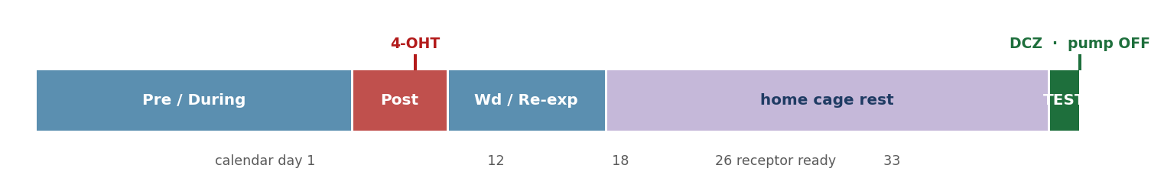
Groups (same for A, B, C, and F) n = 12 per cell use 60 order 75 for ORBm
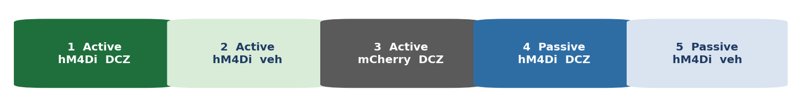
# | Mice | Virus | Drug on test days | n | Order
1 | Active | hM4Di-mCherry | DCZ 0.1 mg/kg | 12 | 15
2 | Active | hM4Di-mCherry | vehicle | 12 | 15
3 | Active | mCherry | DCZ 0.1 mg/kg | 12 | 15
4 | Passive | hM4Di-mCherry | DCZ 0.1 mg/kg | 12 | 15
5 | Passive | hM4Di-mCherry | vehicle | 12 | 15
1 vs 2 = hypothesis. 1 vs 3 = ligand. 4 vs 5 = Active-only? Open field 10 min after DCZ, before the test, is free locomotion control.

Option B · Late water-PR (your Withdrawal task)
Same calendar as A. Day 33 is water PR, pump ON. Matches day 14–16 of your protocol.

PRO Same task as existing TRAP Withdrawal data. · CON Water is available, so this is weak as “drug seeking.”
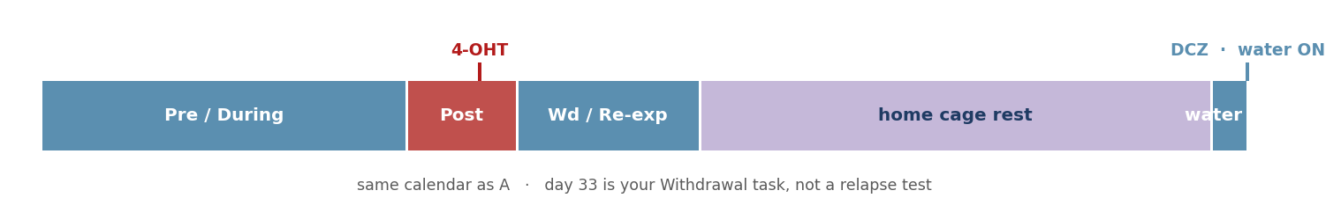
Groups (same for A, B, C, and F) n = 12 per cell use 60 order 75 for ORBm

# | Mice | Virus | Drug on test days | n | Order
1 | Active | hM4Di-mCherry | DCZ 0.1 mg/kg | 12 | 15
2 | Active | hM4Di-mCherry | vehicle | 12 | 15
3 | Active | mCherry | DCZ 0.1 mg/kg | 12 | 15
4 | Passive | hM4Di-mCherry | DCZ 0.1 mg/kg | 12 | 15
5 | Passive | hM4Di-mCherry | vehicle | 12 | 15
Use this only if the claim is “late Withdrawal-like licking,” not relapse.

Option C · Stretch Post on the first cycle
Do not rest. Keep morphine until day 26. Then DCZ while the mouse is still taking.

PRO Tests Q1 this year (silence while taking). · CON Extra ~2 weeks of morphine. Drug history ≠ the TRAP screen.
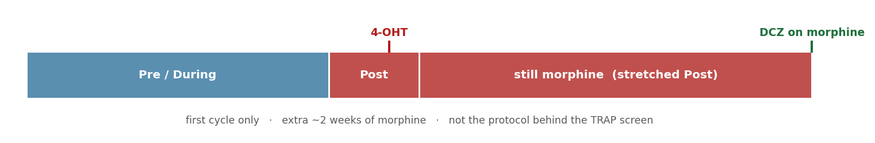
Groups (same for A, B, C, and F) n = 12 per cell use 60 order 75 for ORBm

# | Mice | Virus | Drug on test days | n | Order
1 | Active | hM4Di-mCherry | DCZ 0.1 mg/kg | 12 | 15
2 | Active | hM4Di-mCherry | vehicle | 12 | 15
3 | Active | mCherry | DCZ 0.1 mg/kg | 12 | 15
4 | Passive | hM4Di-mCherry | DCZ 0.1 mg/kg | 12 | 15
5 | Passive | hM4Di-mCherry | vehicle | 12 | 15
Yoking is not an issue here if DCZ is after During. This is not comparable to current whole-brain TRAP densities.

Option F · Second cycle — DCZ on ONE later phase
Run 1 = full 18 days, 4-OHT day 12, no DCZ. Rest. Run 2 = full 18 days. No DCZ in During (yoking intact). DCZ on exactly one of: Post / Withdrawal / Re-exposure.

PRO During of Run 2 is a clean no-DCZ baseline. Tests whether first-Post cells matter later. · CON Second cycle ≠ first-cycle data. Three phases in one mouse would contaminate each other.
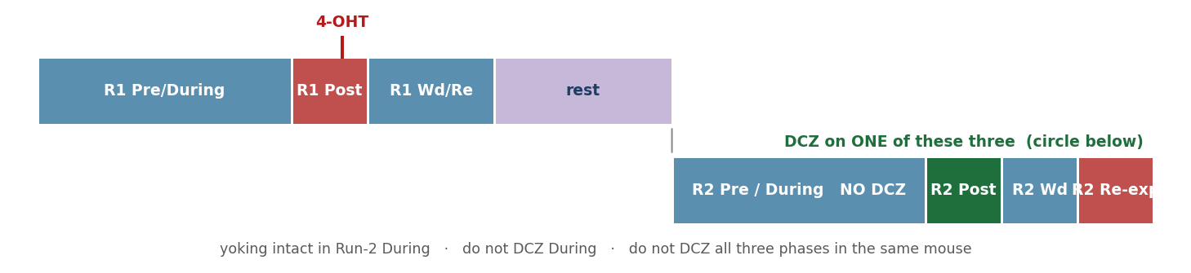
Groups (same for A, B, C, and F) n = 12 per cell use 60 order 75 for ORBm

# | Mice | Virus | Drug on test days | n | Order
1 | Active | hM4Di-mCherry | DCZ 0.1 mg/kg | 12 | 15
2 | Active | hM4Di-mCherry | vehicle | 12 | 15
3 | Active | mCherry | DCZ 0.1 mg/kg | 12 | 15
4 | Passive | hM4Di-mCherry | DCZ 0.1 mg/kg | 12 | 15
5 | Passive | hM4Di-mCherry | vehicle | 12 | 15
Circle the Run-2 phase for this cohort: ☐ Post (morphine PR) ☐ Withdrawal (water PR) ☐ Re-exposure (morphine PR). All 3 days of that phase = DCZ or all 3 = vehicle. No alternating days. A second phase = another 75 mice.

Option E · Phase 2 (not this cohort)
TRAP2 × R26-hM4Di + local DCZ. Receptor ready 48 h after 4-OHT. Original 3-day Post can be tested.

PRO True Q1 inside your existing 18-day map. CON Breed 4–6 months. Cannot also carry Ai14. Needs cannulae.

Do not wait to decide E. If Q1 still matters, start the cross in parallel with A or F.
Item | Detail
Line | TRAP2 (JAX 030323) × R26-LSL-hM4Di (JAX 026219)
Why not Ai14 | Both sit at Rosa26
Region | Local DCZ through cannulae in ORBm (transgene is brain-wide)
n when ready | Same 5 groups × 12 → order 75
Start | Breed now; first mice ~mid 2027

