**Udacity Artificial Intelligence Nanodegree**

**Project 2 – Isolation**

**Submission By: Lim Si Jie**

As part of the “Isolation” game project, the task is to develop an adversarial search agent to play the game “Isolation”.

**Background Of Isolation**

Isolation is a deterministic, two-player game of perfect information where each player takes turn to move a single piece from one cell to another on the board. Upon occupying a cell, the cell becomes blocked for the rest of the game. The first player that ends up with no remaining legal move loses. The opponent is then declared the winner.

In this version of the Isolation game, each player is restricted to the L-shaped movement (like a knight in chess) on a chess/checkerboard. Any player can move to an open cell on the board and can “jump” blocked/occupied spaces, similar to how a knight moves on chess.

Additionally, each player will have a fixed time limit on each turn to find the best move. If the time limit expires, the player will forfeit the match and the opponent will be declared a winner.

**Testing Of Heuristics**

To determine which type of heuristics work best in the Isolation game, I had to carry out tests against predefined sample players. There are seven predefined sample players (in tournament.py):

1. Random – An agent that randomly chooses a move each turn
2. MM_Open - MinimaxPlayer agent using the open_move_score heuristic with search depth 3
3. MM_Center - MinimaxPlayer agent using the center_score heuristic with search depth 3
4. MM_Improved - MinimaxPlayer agent using the improved_score heuristic with search depth 3
5. AB_Open - AlphaBetaPlayer using iterative deepening alpha-beta search and the open_move_score heuristic
6. AB_Center - AlphaBetaPlayer using iterative deepening alpha-beta search and the center_score heuristic
7. AB_Improved - AlphaBetaPlayer using iterative deepening alpha-beta search and the improved_score heuristic

**Performance Of Playing Agents**

In total, I created three distinct playing agents with different heuristics consideration.

**Playing Agent 1 (AB_Custom)**

Based on my empirical understanding of the game, my hypothesis is that the centre region is much more advantageous to gain a winning position. Thus, for agent 1 (custom_score), my focus was to move my piece closer to the centre. This is done by considering both players’ (own and opponent’s) piece and the relative position to the central region.

**Playing Agent 2 (AB_Custom_2)**

Like all experiments, there needs to be a control to determine how well the alternate tests are performing. Thus, playing agent 2 was used as a control for the two other playing agents. A simple playing agent was created.

*Interestingly, this playing agent performed much better against the MM_Center playing agent.

**Playing Agent 3 (AB_Custom_3)**

The third playing agent was designed to be a “smarter” player, i.e. one that simulates a human player. Playing agent 3 has a different aggression level depending on the progress of the game. In the early stages, it will aggressively capture central regions with increasing aggression as the game progresses. In the late stage (after 50% of the game is completed), this playing agent will ease its aggression.

**Analysis Of Playing Agents’ Performance**

Among the three playing agents, playing agent 3 (AB_Custom_3) had the best performance. Surprisingly, AB_Custom_3 was also the only one that fared better than ID_Improved, given the high win rate of ID_Improved.

AB_Custom vs ID_Improved: Worse (75% vs 76.67%)

AB_Custom_2 vs ID_Improved: Worse (68.33% vs 76.67%)

AB_Custom_3 vs vs ID_Improved: **Better** (80% vs 76.67%)

Compared to ID_Improved, AB_Custom and AB_Custom_3 were much more effective against opponents like MM_Center and AB_Center. However, ID_Improved performed better than AB_Custom and AB_Custom_3 when playing against opponent like MM_Open.

I believe that the strategy to have a varying level of aggression throughout the game allows playing agent 3 to take up more advantageous position. As the game progresses, playing agent 3 gains the edge as its moves are taken with a consistent game plan in “mind”.

|  |  |  |  |  |  |  |  |  |  |  |  |  |  |  |
| --- | --- | --- | --- | --- | --- | --- | --- | --- | --- | --- | --- | --- | --- | --- |
|  |  | ID_Improved | | | AB_Custom | | | AB_Custom_2 | | | AB_Custom_3 | | | |
| **Match ID** | **Opponent** | **Won** | **Lost** | **Win Ratio** | **Won** | **Lost** | **Win Ratio** | **Won** | **Lost** | **Win Ratio** | **Won** | **Lost** | **Win Ratio** |
| 1 | Random | 10 | 0 | 1 | 10 | 0 | 1 | 7 | 3 | 0.7 | 10 | 0 | 1 |
| 2 | MM_Open | 8 | 2 | 0.8 | 7 | 3 | 0.7 | 7 | 3 | 0.7 | 6 | 4 | 0.6 |
| 3 | MM_Center | 7 | 3 | 0.7 | 8 | 2 | 0.8 | 10 | 0 | 1 | 10 | 0 | 1 |
| 4 | MM_Improved | 8 | 2 | 0.8 | 6 | 4 | 0.6 | 6 | 4 | 0.6 | 9 | 1 | 0.9 |
| 5 | AB_Open | 6 | 4 | 0.6 | 6 | 4 | 0.6 | 6 | 4 | 0.6 | 5 | 5 | 0.5 |
| 6 | AB_Center | 7 | 3 | 0.7 | 8 | 2 | 0.8 | 5 | 5 | 0.5 | 8 | 2 | 0.8 |
|  |  |  |  | 76.67% |  |  | 75.00% |  |  | 68.33% |  |  | 80.00% |

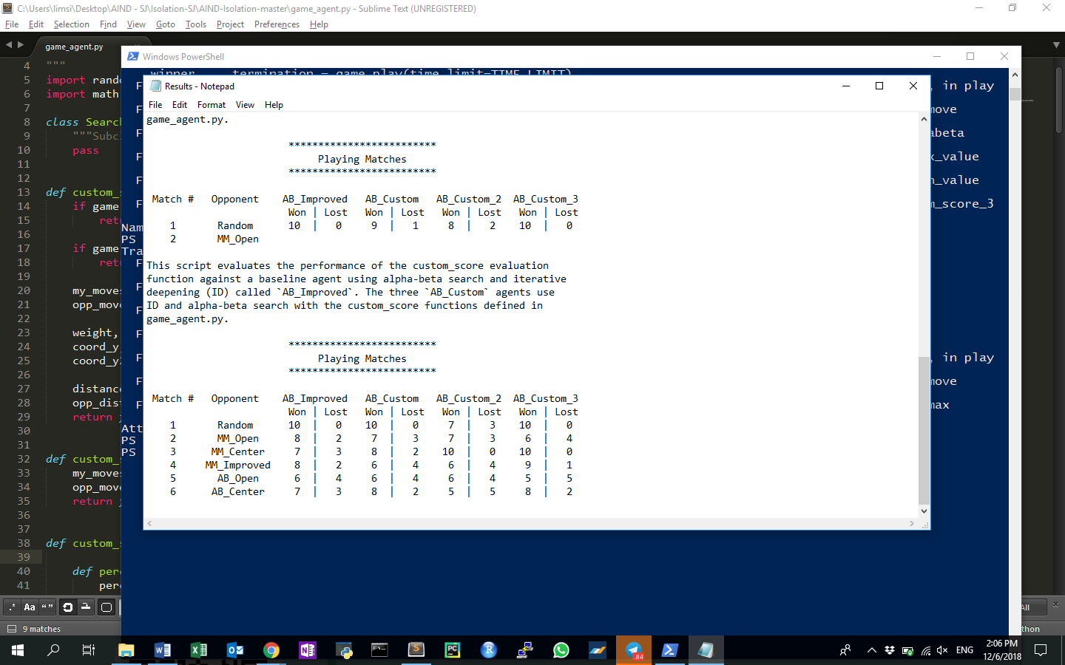

Pic 1: Results grabbed from command prompt.