**Udacity Artificial Intelligence Nanodegree**

**Project 3 – Planning Search**

**Submission By: Lim Si Jie**

As part of the Planning Search project, our task is to solve three deterministic logistics planning problems for an Air Cargo transport system using a planning search agent. In this task, domain-independent heuristics will be adopted.

**Background Of Planning Search Problems**

Three classical Planning Domain Definition Language (PDDL) problems were given to us. Each problem has the same action schema defined, but with different initial states and goals.

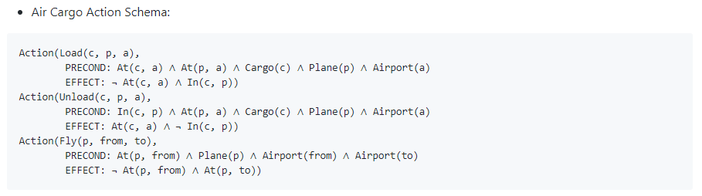

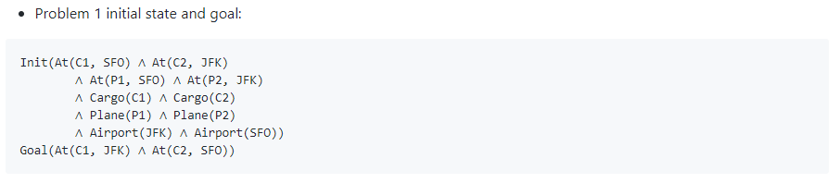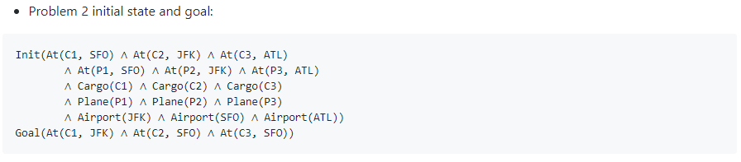

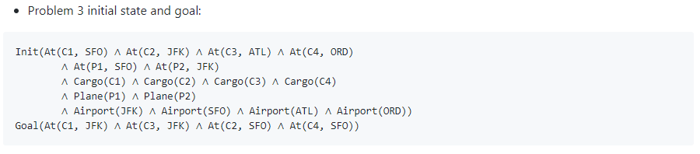

**Criteria For Evaluating Performance Of Planning Search Strategies**

There are two types of planning search strategies that were used in this project:

1. **Uninformed non-heuristics search strategy** and
2. **Automatic domain-independent heuristics with A* search**

There were three criteria used to objectively evaluate the performance of each planning search strategy.

The three criteria are:

1. **Solution optimality** – whether the search strategy is able to find the shortest number of actions to achieve the goal.
2. **Speed/Execution time** –Time taken to find the solution
3. **Memory usage** –Number of node expansions during search for the solution

**Problem 1**

For problem 1, the optimal plan length is 6. One such optimal solution is: Load(C1, P1, SFO), Load(C2, P2, JFK), Fly(P1, SFO, JFK), Fly(P2, JFK, SFO), Unload(C1, P1, JFK), Unload(C2, P2, SFO).

Among the search strategies, depth first graph strategy had the shortest execution time. However, this strategy was unable to obtain the optimal solution. It returned the best solution of 12 actions instead of the optimal solution with only 6 actions. The Greedy Best First Graph Search offered a much better search strategy with the **least time taken** as well as **least memory** **usage**.

Interestingly, Greedy Best First Graph Search also performed better than A* search strategies (with heuristics) with **lesser** **time taken** and **lower memory usage**.

|  |  |  |  |  |  |  |  |
| --- | --- | --- | --- | --- | --- | --- | --- |
|  | **Search Strategy** | **Expansions** | **Goal Tests** | **New Nodes** | **Plan Length** | **Optimal?** | **Time Taken (Seconds)** |
| **Uninformed** | Breadth First Search | 43 | 56 | 180 | 6 | Yes | 0.23233023 |
| Breadth First Search Tree Search | 1458 | 1459 | 5960 | 6 | Yes | 3.57346881 |
| Depth First Graph Search | 12 | 13 | 48 | 12 | No | 0.016257987 |
| Depth Limited Search | 101 | 271 | 414 | 50 | No | 0.254626694 |
| Uniform Cost Search | 55 | 57 | 224 | 6 | Yes | 0.089883068 |
| Recursive Best First Search | 4229 | 4230 | 17023 | 6 | Yes | 9.563046281 |
| Greedy Best First Graph Search | 7 | 9 | 28 | 6 | Yes | 0.018867404 |
| **Heuristics** | A* Search with h1 heuristic | 55 | 57 | 224 | 6 | Yes | 0.203518015 |
| A* Search with Ignore Precondition heuristic | 41 | 43 | 170 | 6 | Yes | 0.25654647 |
| A* Search with Level Sum heuristic | 11 | 13 | 50 | 6 | Yes | 6.063609035 |

**Problem 2**

Problem 2 offered a slightly more complicated problem for the search strategies. For problem 2, the optimal plan takes 9 actions for completion. One such optimal solution is: Load(C1, P1, SFO), Load(C2, P2, JFK), Load(C3, P3, ATL), Fly(P1, SFO, JFK), Fly(P2, JFK, SFO), Fly(P3, ATL, SFO), Unload(C3, P3, SFO), Unload(C2, P2, SFO), Unload(C1, P1, JFK).

Unlike problem 1 where all search strategies could come up with a solution, only some search strategies could solve problem 2. Breadth First Tree Search, Depth Limited Search and Recursive Best First Search were unable to find a satisfactory solution within 10 minutes.

Among the search strategies that could offer an optimal solution, A* Search with Ignore Precondition heuristic took the **least time**. However, in terms of **memory usage**, A* Search with Level Sum heuristic would have been the preferred search strategy.

|  |  |  |  |  |  |  |  |
| --- | --- | --- | --- | --- | --- | --- | --- |
|  | **Search Strategy** | **Expansions** | **Goal Tests** | **New Nodes** | **Plan Length** | **Optimal?** | **Time Taken (Seconds)** |
| **Uninformed** | Breadth First Search | 3343 | 4609 | 30509 | 9 | Yes | 57.93787932 |
| Breadth First Search Tree Search | - | - | - | - | - | - |
| Depth First Graph Search | 476 | 477 | 4253 | 466 | No | 9.13423469 |
| Depth Limited Search | - | - | - | - | - | - |
| Uniform Cost Search | 4852 | 4854 | 44030 | 9 | Yes | 172.0550782 |
| Recursive Best First Search | - | - | - | - | - | - |
| Greedy Best First Graph Search | 990 | 992 | 8910 | 21 | No | 12.77882513 |
| **Heuristics** | A* Search with h1 heuristic | 4852 | 4854 | 44030 | 9 | Yes | 146.2963658 |
| A* Search with Ignore Precondition heuristic | 1506 | 1508 | 13820 | 9 | Yes | 52.51326836 |
| A* Search with Level Sum heuristic | 86 | 88 | 841 | 9 | Yes | 496.3377861 |

**Problem 3**

Problem 3 had a more complex problem than problem 2. For problem 3, the optimal plan takes 12 actions for completion. (Note: As the problem becomes more complex, the **time taken** and **memory usage** increases exponentially, despite the optimal plan taking just 3 more actions than the previous problem.) One optimal solution is: Load(C1, P1, SFO), Load(C2, P2, JFK), Fly(P1, SFO, ATL), Load(C3, P1, ATL), Fly(P2, JFK, ORD), Load(C4, P2, ORD), Fly(P2, ORD, SFO), Fly(P1, ATL, JFK), Unload(C4, P2, SFO), Unload(C3, P1, JFK), Unload(C2, P2, SFO), Unload(C1, P1, JFK).

Similar to problem 2, some search strategies couldn’t find a satisfactory solution within 10 minutes. These search strategies include: Breadth First Search Tree Search, Depth Limited Search, Recursive Best First Search and A* Search with Level Sum heuristic.

Among the search strategies that could offer an optimal solution, A* Search with h1 heuristic took the **least time**. However, in terms of **memory usage**, A* Search with Ignore Precondition heuristic would have been the preferred search strategy. Overall, A* Search with Ignore Precondition heuristic should be the preferred search strategy given that it only took around 15 seconds more than A* Search with h1 heuristic.

|  |  |  |  |  |  |  |  |
| --- | --- | --- | --- | --- | --- | --- | --- |
|  | **Search Strategy** | **Expansions** | **Goal Tests** | **New Nodes** | **Plan Length** | **Optimal?** | **Time Taken (Seconds)** |
| **Uninformed** | Breadth First Search | 14663 | 18098 | 129631 | 12 | Yes | 373.5412284 |
| Breadth First Search Tree Search | - | - | - | - | - | - |
| Depth First Graph Search | 1511 | 1512 | 12611 | 1442 | No | 49.59636543 |
| Depth Limited Search | - | - | - | - | - | - |
| Uniform Cost Search | 18234 | 18236 | 159707 | 12 | Yes | 1655.25834 |
| Recursive Best First Search | - | - | - | - | - | - |
| Greedy Best First Graph Search | 5605 | 5607 | 49360 | 22 | No | 329.3902482 |
| **Heuristics** | A* Search with h1 heuristic | 18234 | 18236 | 159707 | 12 | Yes | 266.6937077 |
| A* Search with Ignore Precondition heuristic | 5118 | 5120 | 45650 | 12 | Yes | 281.8772537 |
| A* Search with Level Sum heuristic | - | - | - | - | - | - |