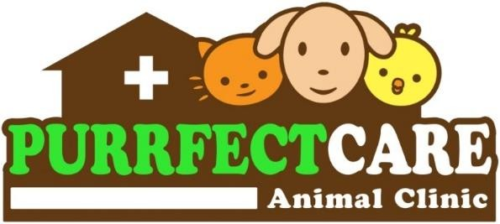


Barrientos Street, Layawan, Oroquieta City (Near St. Therese Hospital)
Contact no.: 0926 740 8552

CONSENT FOR SURGERY

Owner’s Name: {owner_name}
Address : {owner_address} Pet’s Name: {pet_name}
Color: {color} Sex: {sex} Species: {species} Breed: {breed}

I certify that I am the authorized agent of the animal described above, and I hereby give my consent to the doctors and staff of PURRFECT CARE ANIMAL CLINIC to perform {procedure_name} .
I authorize the use of appropriate anesthesia, pain medication, or other necessary medications before, during, and after the procedures. I have been informed that there are certain risks and complications associated with the procedure and the use of any medication. The veterinarian(s) are not liable for any death or complications arising from adverse reactions to anesthesia, drugs, and other medications.

I understand what will be done and that if complications do arise, the performance of additional procedures may be necessary. I have also been informed of alternative options to the above procedures.
Estimated Cost: {cost}

Surgical Procedure: {procedure_cost} Deposit: {deposit}
Medication: {medication} Balance: {balance}
Laboratory Test(s): {lab_tests}
TOTAL: {total}

I hereby acknowledge that I have been given an estimate of all charges and assume full financial responsibility for all services rendered. I further acknowledge the need for a deposit and that I shall pay the bill in full upon the patient’s discharge.
Barrientos Street, Layawan, Oroquieta City (Near St. Therese Hospital)
Contact no.: 0926 740 8552

CONSENT FOR SURGERY

Owner’s Name: {owner_name}
Address : {owner_address} Pet’s Name: {pet_name}
Color: {color} Sex: {sex} Species: {species} Breed: {breed}

I certify that I am the authorized agent of the animal described above, and I hereby give my consent to the doctors and staff of PURRFECT CARE ANIMAL CLINIC to perform {procedure_name} .
I authorize the use of appropriate anesthesia, pain medication, or other necessary medications before, during, and after the procedures. I have been informed that there are certain risks and complications associated with the procedure and the use of any medication. The veterinarian(s) are not liable for any death or complications arising from adverse reactions to anesthesia, drugs, and other medications.

I understand what will be done and that if complications do arise, the performance of additional procedures may be necessary. I have also been informed of alternative options to the above procedures.
Estimated Cost: {cost}

Surgical Procedure: {procedure_cost} Deposit: {deposit}
Medication: {medication} Balance: {balance}
Laboratory Test(s): {lab_tests}
TOTAL: {total}

I hereby acknowledge that I have been given an estimate of all charges and assume full financial responsibility for all services rendered. I further acknowledge the need for a deposit and that I shall pay the bill in full upon the patient’s discharge.

SIGNATURE OVER PRINTED NAME Johanna Benissa C. Abuton-Butalid, DVM Attending Veterinarian
SIGNATURE OVER PRINTED NAME Johanna Benissa C. Abuton-Butalid, DVM
Attending Veterinarian

