SAMPAH
CLEANER
Team handoff - saved 2026-10-24
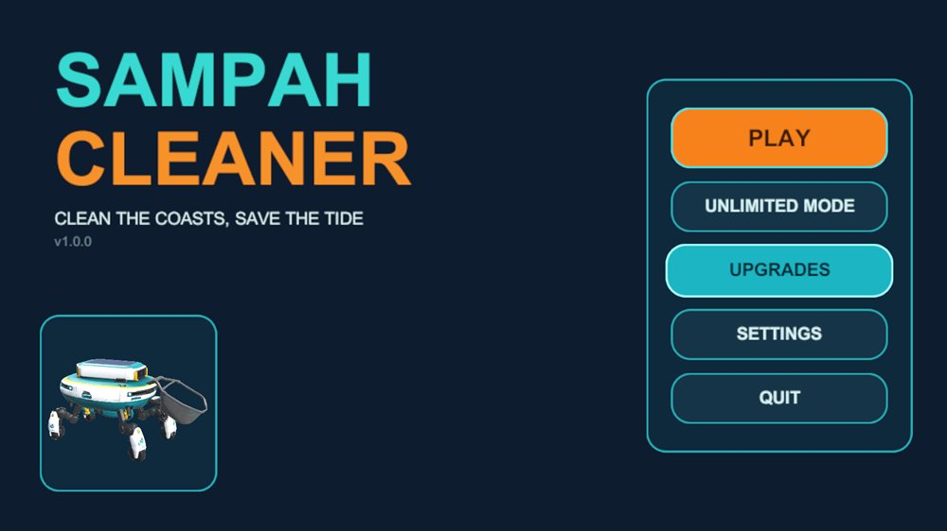
The main menu as built in Unity. Upgrades is shown while hovered.
Everything is now in one Unity project. The robots walk, the main menu is built, and the menu robot turns 360 degrees. This document lists what is done, how to open it, and what is still missing.

The project
- Game: Sampah Cleaner, from the "Trash Tide" concept. A cleaning robot collects trash on a Beach map and an Ocean map in 5-minute rounds, with upgrades, a photo mechanic and four endings.
- Engine: Unity 6000.5.8f1 (Unity 6.5), URP, new Input System.
- Scenes: MainMenuScene (the menu) and SampleScene (the game).

How to open it
Use only this folder: Desktop\xsollar new\SampahCleaner_WalkingRobot_Animation
- Open Unity Hub, click Add, and choose the folder above.
- Open it with Unity 6000.5.8f1.
- The first open takes a few minutes because the Library folder is rebuilt.
- Open Assets/Scenes/MainMenuScene and press Play.

What was done
- One combined project: the animated walking project from xsollar_gamejam\SampahCleaner was merged with the new menu work into the folder above. Nothing was deleted from the older copies.
- Robots walk forward: both robots walked backwards on W. The facing angle is now set in RobotController (-90 by default) and on the TrashRobot prefab (180). The LandRobot prefab was also set to -90.
- Main menu: built from the Doc1 mockup, with a navy background, SAMPAH in teal, CLEANER in orange, a button panel on the right and a robot card on the bottom left. Buttons change color, brighten their outline and grow slightly on hover.
- 360 degree robot: the robot in the card is a live 3D model turning at 45 degrees per second. To change the speed, edit Degrees Per Second on the Pivot object under RobotTurntableStage.

Menu buttons
Button | Status | What it does now
PLAY | Works | Loads SampleScene
QUIT | Works | Closes the game, or stops Play mode in the editor
UNLIMITED MODE | Placeholder | Only writes a message in the Console
UPGRADES | Placeholder | Only writes a message in the Console
SETTINGS | Placeholder | Only writes a message in the Console

What is in the project
Item | Status | Notes
LandRobot | Animated | Idle, Walk and Run, driven by the Animator Speed value
TrashRobot Levels 1 to 3 | Animated | Each has its own controller. E evolves the robot (EvolvingRobot)
SwimRobot | Static | A plain model with no rig and no animation, so it cannot walk or swim yet
Trash items | Ready | Bottle, box and can, with TrashItem and TrashSpawner
Controls | Ready | WASD to move relative to the camera, Shift to run

Still to do
- Check the LandRobot direction. The right-hand robot was changed and saved, but nobody has confirmed it in Play mode. If it still walks backwards, set Front Yaw Offset on its RobotController to 90 or 180.
- Menu polish: the mockup has a glow, gear icons, a play arrow and turn arrows. The menu uses Unity's default font.
- Unlimited Mode, Upgrades and Settings need real screens.
- The swim robot needs a rig and an animation before it can be used on the Ocean map.
- Do not open the old copies: xsollar new\SampahCleaner and xsollar_gamejam\SampahCleaner. They are older.

Warning before rebuilding the menu
The editor command Sampah Cleaner > Build Main Menu UI recreates the whole menu. It replaces the turntable robot with a flat image, so the 360 degree stage has to be set up again afterwards.
Menu scripts are in Assets/Scripts/UI: MainMenuController, MenuButtonFX and RobotTurntable. The editor builder is in Assets/Editor.

