
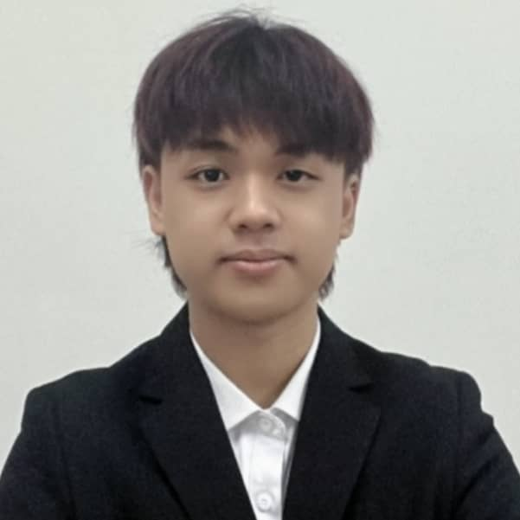 |  | Lim Wei jIAN
Summary  I am a highly motivated Final Year Artificial Intelligence student with a strong foundation in Generative AI, Multi-Agent systems, and Computer Vision. Technically proficient in developing RAG-grounded frameworks and implementing complex neural network architectures. Adept at leveraging advanced AI productivity tools like Claude Code and Gemini CLI to accelerate development cycles. Proven track record of leadership in university organizations and practical experience in technical customer support and sales.  Contact  PHONE:  +60 10–6661736  EMAIL:  Limw045@gmail.com  ADDRESS:  24, Jalan Rantai 2,  Taman Kobena,  81200, Johor Bahru, Johor.  LINKEDIN:  https://www.linkedin.com/in/jian-wei-65b342304/  Language Skills  Fluent in English  - Writing, Listening and Speaking  Fluent in Bahasa Malaysia  - Writing, Listening and Speaking  Fluent Mandarin  - Writing, Listening and Speaking |  | WORK EXPERIENCE  Technical Support & After-Sales Intern  Flexi Team Austin  July 2024 – Oct 2024  - Three-month internship focused on the ACC System.  - Provided technical troubleshooting and customer support for software-related inquiries.  - Collaborated with the development team to document recurring system bugs and improve user manuals.  Sales Representative  COCO@ paradigm mall  April 2022 – July 2022  - Assist in day-to-day tasks assigned by supervisor, such as data entry and sales target.  - Handling client enquiries.  - briefly explain to client about the clothes.  - Assist client to choose which clothes are more suitable for him/her.  - Concurrently held the position of cashier within the store, handling financial transactions and ensuring accuracy in cash handling procedures.  - During the Hari Raya period, achieved the title of sales champion within the store.  EDUCATION QuaLification  - Degree in artificial Intelligent  Multimedia University | Melaka Campus  October 2024 – September 2026  CGPA: 3.74  - Diploma in Information Technology  Multimedia University | Melaka Campus  October 2022 – September 2024  CGPA: 3.78  - Sijil Pelajaran Malaysia  SMK Dato Abdul Rahman Yassin  January 2017 – June 2022  Result: 1 A+ , 1 A , 1 A- , 2 B+ , 2 B , 2 C+ , 1 C

Technical Skills  - AI & Machine Learning:  - Multi-Agent Systems  - Retrieval-Augmented Generation (RAG)  - LLM Fine-tuning  - Computer Vision (YOLO, ResNet50V2, MobileNetV2)  - Deep Learning (LSTM, MLP, CNN)  - AI Productivity & Developer Tools:  - Claude Code  - Gemini CLI  - Agentic Workflows  - Prompt Engineering  - ChatGPT Advanced Data Analysis  - Programming Languages:  - Python (Expert)  - Java  - C++  - PHP  - JavaScript  - SQL  - C#  - Frameworks & Libraries:  - TensorFlow  - PyTorch  - Keras  - OpenCV  - LangChain.  - Tools & Platforms:  - Git/GitHub  - Docker  - Linux (Ubuntu)  - Cisco Packet Tracer  - Virtual Box  - Adobe Creative Cloud (Illustrator, Photoshop, Premiere)  - Databases:  - MySQL  - Microsoft Access  - Other:  - Camera shooting skills   |  | project experience  - Final Project in Degree  - Develop an automated framework for generating JKR-compliant Traffic Impact Assessment (TIA) reports.  - Implemented a Multi-Agent architecture to orchestrate specialized tasks, reducing manual report drafting time by over 70%.  - Integrated Retrieval-Augmented Generation (RAG) to ground model outputs in official regulatory documents, mitigating hallucinations and ensuring 100% compliance with JKR standards.  - Utilized Claude Code and Gemini CLI for rapid prototyping, automated code refactoring, and managing environment-specific configurations.  - Final Project in Diploma  - Develop an AI Toolbox Online Website.  - The website allows users to go through a subscription-based service where users can go through the services offered through the webpage based on the user group they are in. Services include a translator, AI chat box, text rewriting and text to image conversion tools.  - I was responsible for the design of the webpage and PHP, and as a team leader I was responsible for organizing the work of the team members.  - In this project, we implemented HTML, CSS, JavaScript, PHP and MySQL.  - Stock Market Prediction System  - Engineered a hybrid prediction model combining LSTM and MLP with Genetic Algorithms to forecast market trends.  - Conducted extensive data preprocessing and feature engineering on historical financial datasets to improve prediction accuracy.  - Personal Responsibility Project  - I organize and participate in beach clean-ups with team members.  - I am responsible for participating in the activities carried out.  - 23rd Orientation Camp  - I organized and participated in the 23rd Orientation Camp of Multimedia University Chinese Language Society together with my team members.  - I was responsible for planning and listing our activities at the camp with my teammates.  - We organized a series of activities to help new students integrate into university life.  - I was responsible for planning and listing the weekly events that we can do in the Centre.  - We have made a list of weekly services such as cleaning the place, taking care of the children.  - 24th Orientation Camp  - I organized and participated in the 24th Orientation Camp of Multimedia University Chinese Language Society together with my team members.  - I was leading a creative team to design and execute a comprehensive marketing strategy across social media platforms.  - We organized a series of activities to help new students integrate into university life.  - Cultural Carnival    - I organized and participated in the 26th Cultural Carnival of Multimedia University Chinese Language Society together with my team members.  - As Assistant Event Treasurer, I am responsible for managing and organizing the finances during the event with my partner.  - I effectively fostered open communication channels and facilitated seamless coordination among team members, ensuring everyone was aligned with the event objectives and responsibilities.  `  References  Dr. Goh Kah Ong Michael  Degree Final Year Project Supervisor and Lecturer  michael.goh@mmu.edu.my  60 11-1010 1268  Mr. Pau Kiu Nai  Diploma Final Year Project Supervisor and Lecturer  knpau@mmu.edu.my  6013-630 6396  Farah Izzati Binti Yusoff  Academic Advisor  FARAH.YUSSOFF@MMU.EDU.MY

