Large Language Models (LLMs) for Job Knowledge, Skill, Attribute (KSA) Estimation: An Evaluation

Kara L. Orvis, PhD
Aptima, Inc.

Greg Lockhart
Bear Track Coaching

Naiqing Lin, PhD
Rachel Taggart, PhD
U.S. Army Research Institute

Enzo Paradiso
Robert McCormack, PhD
Aptima, Inc.

Modern Army talent management systems such as the Army Talent Alignment Process (ATAP) rely on preferencing as the primary way by which staffing decisions are made. Knowledge, Skill, Attribute (KSA) matching is an additional way to ensure person-job (P-J) fit (Wong & Tetrick, 2017). Unfortunately, Orvis et al. (2024) found many challenges for the Army in using KSAs for matching people to jobs within the ATAP process, including the length of the KSA lists (making it time consuming to rate KSAs), conceptual overlap (hard to distinguish between different KSAs), and biases in self-professed KSAs (hesitancy to consider self-professed KSAs).
The overall objective of this research was to explore the use of machine learning (ML) methods and artificial intelligence (AI) to reduce biases in KSA assessments and reduce the load on Army hiring managers and job seekers. An analytical system was developed in which Large Language Models (LLMs) and Retrieval Augmented Generation (RAG) were used to transform a variety of structured and unstructured military documents into structured KSA assessments for job KSA requirements. The system can estimate both the current KSAs a person has and the KSAs required for a specific job. The system reports KSA estimations for the Army Talent Attribute Framework (ATAF), a scientifically grounded, unified taxonomy of 137 knowledge, skills, and abilities (KSAs) required for Army Soldiers and leaders (Royston & Glerum, 2023). For a given job, the system utilizes pre-defined documents to return a vector of three outputs for each of the 137 KSBs: a numerical proficiency requirement for each KSA (see Table 1 for the scale), a rationale output, and an evidence output (see Figure 1 for an example). The model rationale output explains the analytical reasoning behind each proficiency assignment, outlining how the evidence supports the assigned rating and addressing any limitations or assumptions in the assessment process. The model evidence output presents verbatim quotes drawn directly from the source document, annotated with the exact character-level position within the source text.
The current study evaluated the rationale and evidence outputs from the model. These two outputs are important in providing insight into the numerical proficiency assessments and are imperative for helping humans review the outputs of the model.
Table 1
KSA Assessment Proficiency Scale
Level | Label | Description | Evidence Indicators
0 | Not Present | No evidence the KSA is required | No mention or indication related to this KSA
1 | Awareness | Basic awareness or exposure only | Mentioned in passing; included in a list; brief reference
2 | Basic | Foundational requirement | Listed in basic responsibilities; mentioned in standard procedures
3 | Intermediate | Core competency required | Emphasized in multiple contexts; central to routine duties
4 | Advanced | Critical competency | Highlighted as essential; connected to mission success
5 | Expert | Mastery required | Defined as a primary job qualifier; central to MOS identity

Figure 1
High Proficiency Assessment of a Representative Job Description

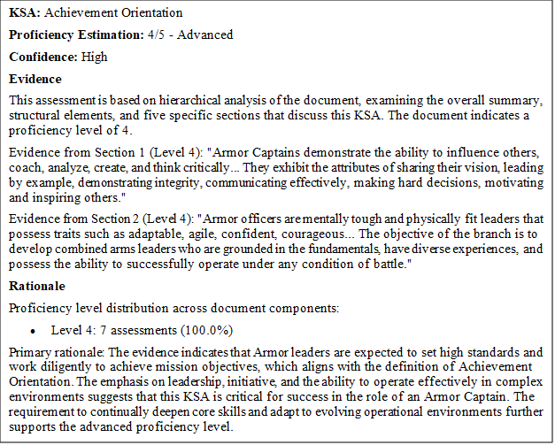

Method
Participants
Participants included four human raters. One was a retired armor officer with extensive knowledge of the ATAF KSAs and the source documents. The other three were research scientists familiar with the KSAs, with varying levels of familiarity with the source documents.
Materials and Procedure
For the evaluation, we used model outputs that estimated KSA requirements for an early to mid-career armor officer entering key development positions. The model provided both rationale and evidence outputs for each of the 137 KSAs, across six separate Army doctrine sources from which KSAs requirements could be extrapolated, resulting in 822 rationale and evidence statements (137 × 6) for each rater.
The raters used an Excel file to log their independent ratings. The file included the name of the source document, the name of the KSA, the KSA definition, the model numerical proficiency score (0-5), the associated proficiency score label (Table 1; not present to expert), the model confidence output (high, medium, low), the model evidence statement, the model rationale statement, and a comments field for the raters to log any observations or notes.
For each line, the rater first reviewed the KSA technical definition, to orient themselves to the KSA model outputs they were reviewing. The rater then reviewed the model numerical proficiency score output and associated label, as well as the confidence column. This allowed raters to get a sense of what numerical and categorical ratings the model was recommending for that specific KSA. If the proficiency score output was 1-5, the raters were asked to review the rationale and evidence model outputs. If the proficiency score output was zero, the model was instructed not to present a rationale and evidence statement, leaving no rationale and evidence outputs for the raters to evaluate.
For KSAs with a proficiency score of 1-5, raters were asked to make three assessments. First, they were asked to review the rationale statement and assess whether the rationale conceptually aligned with the KSA definition (1=yes, rationale aligns with KSA description, 0=no, rationale does not align with KSA description). Second, they were asked to review the evidence statement and make an assessment whether the specific evidence cited conceptually aligns with the KSA (1=yes, evidence aligns with KSA description, 0=no, evidence does not algin with KSA description). Third, raters were asked to search the source document for evidence statements to check whether hallucinations were present (1=no hallucinations present, 0=hallucinations present). If there is more than one evidence example in the output, raters were asked to evaluate them as one. Finally, there was a column for the raters to note any observations.
Results
For KSAs with a numerical proficiency score of zero (meaning that KSA is not present in the source), the model was instructed not to provide rationale and evidence statements. Rationale and evidence statements were provided for numerical proficiency scores of 1-5. In total, the model provided a total of 457 rationale and evidence statements across all KSAs and document sources. Figure 2 provides the distribution of numerical proficiency scores.
Figure 2
Numerical Proficiency Score Distribution Among the 811 Items

With each rater rating 457 items, it was expected there would be a total of 1,828 ratings. After the ratings were collected, a small number of missing rater entries were found. Specifically, seven entries for the rationale alignment question, two entries for the evidence alignment question, and two entries for the evidence hallucination question were identified. Finally, we noted that there was substantial agreement with the model across items, indicating a highly skewed rating distribution.
Inter-rater Agreement
Table 2 presents high interrater agreement for each of the three rated variables.
Table 2
Inter-Rater Reliability for Three Rating Variables Using Gwet's AC1
Rating Variable | Gwet's AC1 | 95% CI | p | Interpretation
Rationale aligns with KSA description | .82 | [.79, .86] | < .001 | Almost perfect
Evidence aligns with KSA description | .81 | [.78, .85] | < .001 | Almost perfect
Evidence was accurate (no hallucinations) | .89 | [.87, .91] | < .001 | Almost perfect

Model Accuracy and Hallucinations
Across all raters and ratings, the percentage of rationale statements that received a one, meaning the raters agreed the model rationale statement aligned with the KSA definition, was 92% (1663 out of 1821 items rated). The percentage of evidence statements that received a one, meaning the raters agreed the evidence statements from the sources aligned with the KSA definition, was 90% (1652 out of 1826 ratings). The percentage of hallucinations raters reported across all ratings was 5% (96 out of 1826 ratings).
Table 3
Agreement and Hallucination Frequency Across All Raters and Ratings
Rating Variable | Agree Ratings | Disagree Ratings | N | % Agreement
Rationale statements aligned with KSA definition | 1,663 | 158 | 1,821 | 91.3%
Evidence statements aligned with KSA definition | 1,652 | 174 | 1,826 | 90.5%
Hallucinations Present In Evidence Statement | 96 | 1,730 | 1,826 | 5.3%

Rater Qualitative Observations
In addition to the numerical scoring of , researchers were asked to provide qualitative comments on the performance of the LLM to capture specific feedback on where the LLM was successful, needed improvement, or areas of confusion. Raters provided 656 qualitative comments which were consolidated into a series of themes. Comments produced two overarching categories from the qualitative data. Category one consisted of model performance: positive and negative. Category two addressed perceived issues or improvements to the Army Talent Attribute Framework (ATAF) list itself. These will be discussed in the presentation. the KSA LLM’s performance
References

Orvis, K. L., Brown, J. E., McCormack, R. K., & Lin, N. (2024). Improving talent management: Army officer assignment system recommendations. (ARI Scientist Series Scientific Report ARI-SS-SR 2024-21). U.S. Army Research Institute for the Behavioral and Social Sciences. http://dx.doi.org/10.2139/ssrn.4924877
Royston, R. P. & Glerum, D. R. (2023). Army talent attribute framework: FY23 annual updates. (ARI Research Note 2023-11). U.S. Army Research Institute for the Behavioral and Social Sciences. https://apps.dtic.mil/sti/trecms/pdf/AD1210090.pdf
U.S. Department of the Army. (2019). 2019 Army modernization strategy: investing in the future. https://www.usarpac.army.mil/Portals/113/PDF%20Files/2019_army_modernization_strategy_final.pdf
Wong, C. M., & Tetrick, L. (2017). Job crafting: Older workers’ mechanism for maintaining person-job fit. Frontiers in Psychology, 8, 1-12. https://doi.org/10.3389/fpsyg.2017.01548

