To show the rotation and translation live on the video feed, you can use cv2.putText. It is helpful to convert the rotation vector (rvec) into Euler angles (Roll, Pitch, Yaw) because they are much easier for humans to read than the raw Rodrigues vectors.
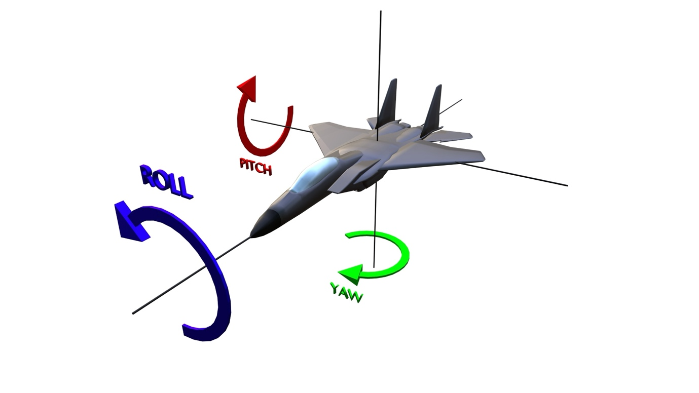

Imagine the ArUco marker is a small airplane:
- Pitch (P): The "nodding" motion.
  - It describes tilting up or down.
  - Think of a plane's nose pointing toward the sky or the ground.
- Yaw (Y): The "shaking head" motion.
  - It describes turning left or right.
  - Think of a plane changing its compass heading while staying level.
- Roll (R): The "tilting" motion.
  - It describes rotating around the center axis.
  - Think of a plane dipping its wings left or right.

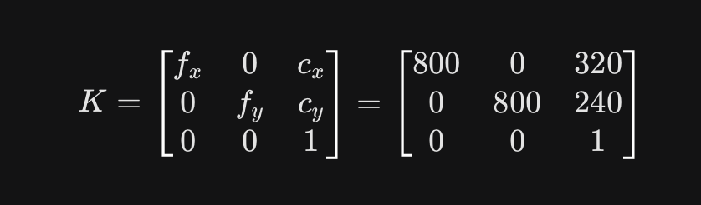

1. Matrix Structure
The camera matrix () is a grid that acts as the mathematical bridge between 3D world coordinates and 2D image pixels.

2. Component Breakdown
Row 1: Horizontal Parameters
- f_{x} (800): The Horizontal Focal Length. This determines the field of view. A higher value simulates a "zoom" lens, while a lower value simulates a "wide-angle" lens.
- Skew (0): Defines the angle between the x and y pixel axes. In modern digital cameras, pixels are perfectly square, so this is always .
- c_{y} (320): The Horizontal Principal Point. This is the pixel coordinate of the lens's optical center along the x-axis (e.g., is the center of a -pixel wide image).
Row 2: Vertical Parameters
- f_{y} (800): The Vertical Focal Length. Usually equal to , ensuring the aspect ratio of the objects remains consistent.
- c_{y} (240): The Vertical Principal Point. The pixel coordinate of the lens's optical center along the y-axis (e.g., is the center of a -pixel high image).
Row 3: Projection Parameters
- [0,0]: Alignment values indicating the image plane is flat and parallel to the sensor.
- 1: A Normalization Constant required for homogeneous coordinate math, allowing the transformation between 3D space and 2D planes.

3. Programming Specification: dtype=float
In the NumPy library, dtype (Data Type) defines how the computer stores information in memory.
- Definition: float (Floating Point) stores numbers as decimals (e.g., 800.0).
- Technical Necessity: Computer vision relies on high-precision trigonometry (Sines, Cosines, and Square Roots) to determine the tilt and distance of markers.
- Risk of Integers: Using integers (whole numbers) would cause the computer to "round off" fractions (e.g., becomes ). This leads to massive errors in pose estimation, causing the detected marker data to jitter or disappear.

import cv2
import numpy as np

# --- Setup ---
camera_matrix = np.array([[800, 0, 320], [0, 800, 240], [0, 0, 1]], dtype=float)
dist_coeffs = np.zeros((5, 1))
marker_length = 0.05

aruco_dict = cv2.aruco.getPredefinedDictionary(cv2.aruco.DICT_6X6_250)
parameters = cv2.aruco.DetectorParameters()
detector = cv2.aruco.ArucoDetector(aruco_dict, parameters)

# 3D points of marker
obj_points = np.array([[-marker_length/2, marker_length/2, 0],
[ marker_length/2, marker_length/2, 0],
[ marker_length/2, -marker_length/2, 0],
[-marker_length/2, -marker_length/2, 0]], dtype=np.float32)

cap = cv2.VideoCapture(0)

while True:
ret, frame = cap.read()
if not ret: break

corners, ids, _ = detector.detectMarkers(frame)

if ids is not None:
for i in range(len(ids)):
ret, rvec, tvec = cv2.solvePnP(obj_points, corners[i], camera_matrix, dist_coeffs)

if ret:
# 1. Draw 3D Axes and Square
cv2.drawFrameAxes(frame, camera_matrix, dist_coeffs, rvec, tvec, 0.03)
cv2.aruco.drawDetectedMarkers(frame, corners)

# 2. Convert rotation vector to degrees (Euler angles)
rmat, _ = cv2.Rodrigues(rvec)
# Extract angles from rotation matrix
pitch = np.degrees(np.arctan2(-rmat[2, 0], np.sqrt(rmat[2, 1]**2 + rmat[2, 2]**2)))
yaw = np.degrees(np.arctan2(rmat[1, 0], rmat[0, 0]))
roll = np.degrees(np.arctan2(rmat[2, 1], rmat[2, 2]))

# 3. Annotate Video Frame
x, y = int(corners[i][0][0][0]), int(corners[i][0][0][1])

# Format string for display
text = f"ID:{ids[i][0]} Dist:{tvec[2][0]:.2f}m"
rot_text = f"P:{pitch:.1f} Y:{yaw:.1f} R:{roll:.1f}"

cv2.putText(frame, text, (x, y - 40), cv2.FONT_HERSHEY_SIMPLEX, 0.5, (0, 255, 0), 2)
cv2.putText(frame, rot_text, (x, y - 15), cv2.FONT_HERSHEY_SIMPLEX, 0.5, (255, 255, 0), 2)

cv2.imshow('Live Tracking', frame)
if cv2.waitKey(1) & 0xFF == ord('q'): break

cap.release()
cv2.destroyAllWindows()

