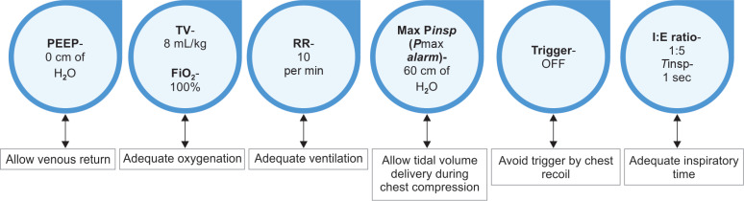

• Positive end-expiratory pressure (PEEP): ≥5 cm H₂O is reasonable, as low PEEP may help maintain alveolar recruitment without significantly impeding venous return. Some data suggest 5–10 cm H₂O is commonly used, but higher PEEP may compromise hemodynamics during CPR, so the lowest effective PEEP is preferred.^{[1-2]}
• Volume control mode tidal volume: 6–7 mL/kg predicted body weight or just enough to achieve visible chest rise is recommended to avoid overdistension and minimize the risk of barotrauma or gastric insufflation. The American Heart Association (AHA) recommends approximately 500–600 mL per breath for adults.^{[3-4]}
• Respiratory rate: 10 breaths per minute is recommended by the AHA during CPR with an advanced airway, to avoid hyperventilation and its adverse hemodynamic effects.^{[3-5]}
• Maximum inspiratory pressure: There is no universally established upper limit, but plateau pressures should be kept <30 cm H₂O to minimize barotrauma, consistent with lung-protective strategies. During CPR, transiently higher peak pressures may occur due to chest compressions, but excessive pressures should be avoided.^{[1][6-7]}
• Trigger settings: Inspiratory triggering should be turned off or set to the least sensitive setting (e.g., pressure-triggering at 20 cm H₂O) to prevent auto-triggering from chest compressions and avoid hyperventilation.^{[1][5]}
• Inspiratory time: ~1 second per breath is recommended to deliver each breath over about 1 second, minimizing interruptions to chest compressions.^{[3][7]}

