Definition of convex:

For a function *f*(*x*), if

 for  and for any possible *a*, *b*,   
then *f*(*x*) is a **convex** function.

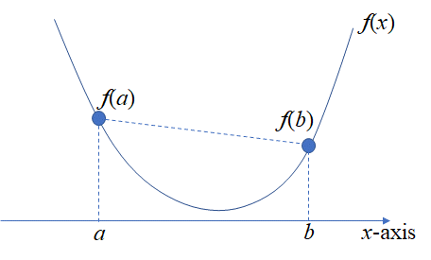

For the N-D case, if there is an N-D function , if

   
for  and for any possible 

where , 



then  is a **convex** function.

[Step search method for convex function optimization]

(For 1D case)

(1) Set Initial values of x0, x1, Δ, n = 1, 

(2) Determine



(3) Find *c* such that



Set 

(4) Set



 (for example, set S = 10 to make the step size 10 times smaller)

(5) Repeat (2), (3), (4) iteratively until



The threshold can be set manually. For example, we can set threshold = 0.001.

Finally, the values of *x* that can minimize *f*(*x*) is



(For N-D case)

We can first fix  and find *x*1 to minimize .

Then, we can fix  and find *x*2 to minimize .

Then, we can fix  and find *x*3 to minimize .

:

:

Then, we fix  and find *xN* to minimize .

Then, these processes are repeated iteratively.