|  |  |
| --- | --- |
|  | CS 1301: Principles of Programming I  Fall 2019  Homework #2  Due Thursday, September 30, 2:00 pm |

**Complete the following problems from codingbat.com (10 x 2 = 20 points)**

Logic-1 > teaParty

Logic-1 > inOrder

Logic-1 > redTicket

Logic-1 > shareDigit

Logic-1 > teenSum

Logic-1 > sumLimit

Logic-1 > inOrderEqual

Logic-2 > luckySum

Logic-2 > evenlySpaced

Logic-2 > blackjack

Create an account in codingbat.com. You need to submit a screenshot of your codingbat account showing you have completed these problems. The following screenshot shows I am logged in to my account and have completed Logic-2 > luckySum

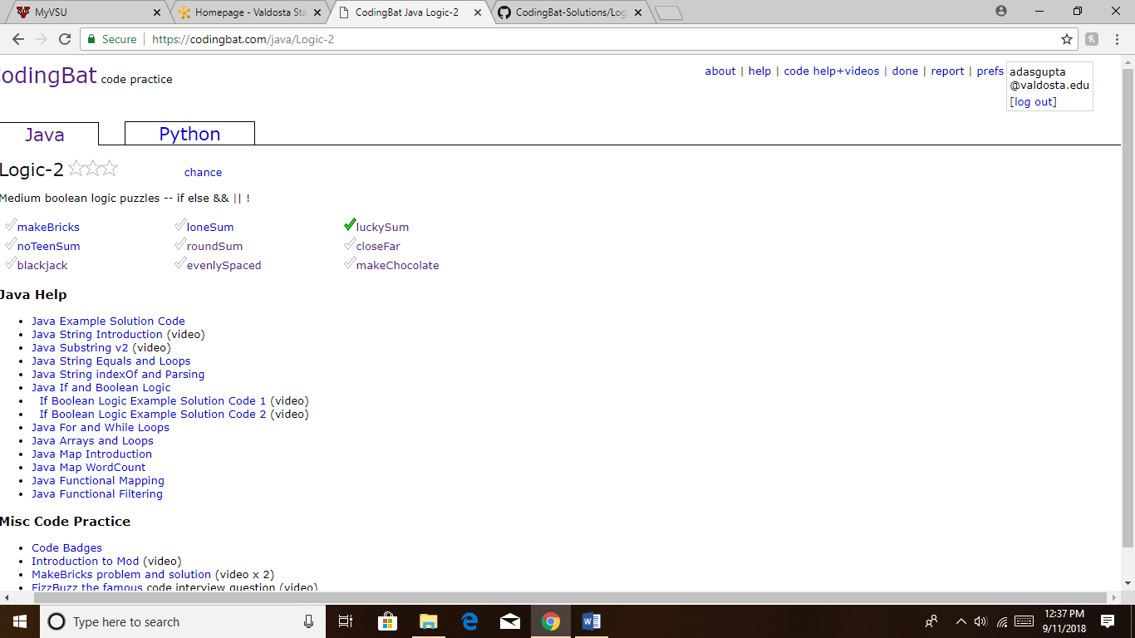

If you do not know how to take a screen shot, search for “using snipping tool” in YouTube.

Additionally, please copy and paste the code from all these codingbat problems into a single word document and submit the word document. So, you are submitting two things using BlazeView:

1. A screenshot of your codingbat account showing problem completion
2. A word document with all the code