|  |  |  |
| --- | --- | --- |
|  | CS 1301: Principles of Programming I  Spring 2020  Homework #3 | CS 1301-A: Principles of Programming I  Spring 2018  Homework #3  Due Monday March 19, 1:00 pm |

**Complete the following problems from codingbat.com**

String 2 – countCode

String 2 – endOther

String 2 – xyzThere

String 2 – bobThere

String 2 – repeatEnd

String 2 – repeatFront

String 2 – repeatSeparator

String 2 – prefixAgain

String 2 – xyzMiddle

String 2 - getSandwich

Create an account in codingbat.com. You need to submit a screenshot of your codingbat account showing you have completed these problems. The following screenshot shows I am logged in to my account and have completed Logic-2 > luckySum

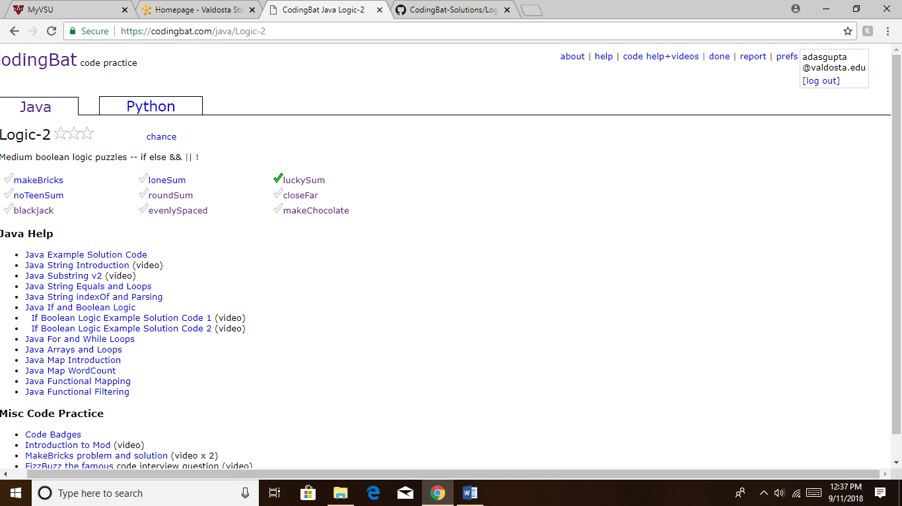

Additionally, please copy and paste the code from all these codingbat problems into a single word document and submit the word document. So, you are submitting two things using BlazeView:

1. A screenshot of your codingbat account showing problem completion
2. A word document with all the code