|  |  |  |
| --- | --- | --- |
|  | CS 1301: Principles of Programming I  Spring 2020  Homework #4 | CS 1301-A: Principles of Programming I  Spring 2018  Homework #3  Due Monday March 19, 1:00 pm |

**Complete the following problems from codingbat.com**

Array-1 – commonEnd

Array-1 – reverse3

Array-1 – middleWay

Array-1 – sum3

Array-1 – maxEnd3

Array-1 – makeEnds

Array-1 – rotateLeft3

Array-1 – sum2

Array-1 – has23

Array-1 – double23

Create an account in codingbat.com. You need to submit a screenshot of your codingbat account showing you have completed these problems. The following screenshot shows I am logged in to my account and have completed Logic-2 > luckySum

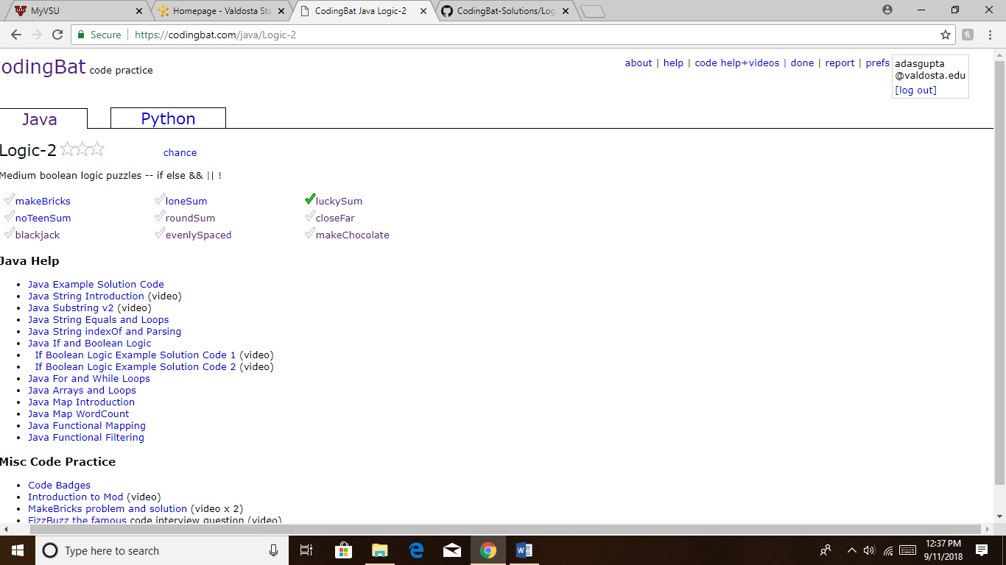

Additionally, please copy and paste the code from all these codingbat problems into a single word document and submit the word document. So, you are submitting two things using BlazeView:

1. A screenshot of your codingbat account showing problem completion
2. A word document with all the code