|  |  |
| --- | --- |
|  | CS 1301: Principles of Programming I  Spring 2020  Homework #5 |

**Complete the following problems from codingbat.com**

**Array2 (24 points)**

1. countEvens
2. bigDiff
3. sum13
4. sum67
5. has22
6. more14
7. only14
8. no14
9. modThree
10. tripleUp
11. shiftLeft
12. tenRun

**Array 3 (6 points)**

1. fix34
2. countClumps

Create an account in codingbat.com. You need to submit a screenshot of your codingbat account showing you have completed these problems. The following screenshot shows I am logged in to my account and have completed Logic-2 > loneSum

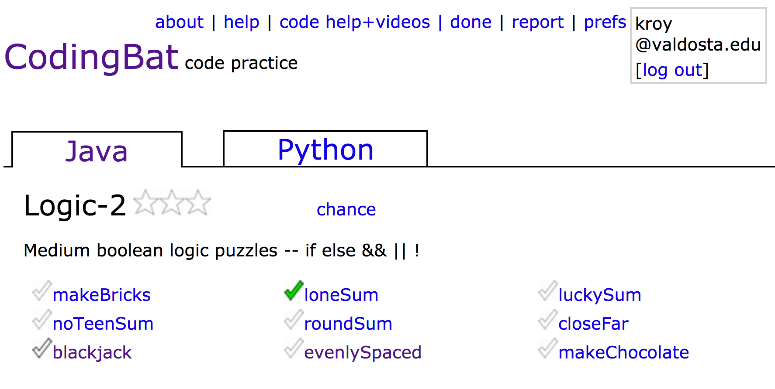

If you do not know how to take a screen shot, search for “using snipping tool” in YouTube.

Additionally, please copy and paste the code from all these codingbat problems into a single word document and submit the word document. So, you are submitting two things:

1. A screenshot of your codingbat account showing problem completion
2. A word document with all the code

**How to submit:**

* Everything must be submitted using BlazeVIEW assignment submission