CS Dungeon

Bugatti Proposal

Kevin Patel

Andrew Tucker

Hoyong Lee

William Lee

Dongwoon Jeong

Jeremy Craven

**Summary**

The Bugatti team will be working on making a game like Mega Man where there are levels that you have to pass to get to the finish line. The twist with the game will be that we will make the levels just like the classes we take in CS and you have to pass each class to get your degree. The harder the classes, the more difficult levels will be. The team can complete the project by April 31st and take around 200 hours to complete. The broader impact of the game will be making college look fun.

**Narrative**

The overall idea of the game is that there will be four levels to the game just like 4 years in college. Each level will have two sections to it where you have to pass both the sections to move on to your next level. We will use unity and visual studio to make all the levels and character. The graphis will be in 720p.

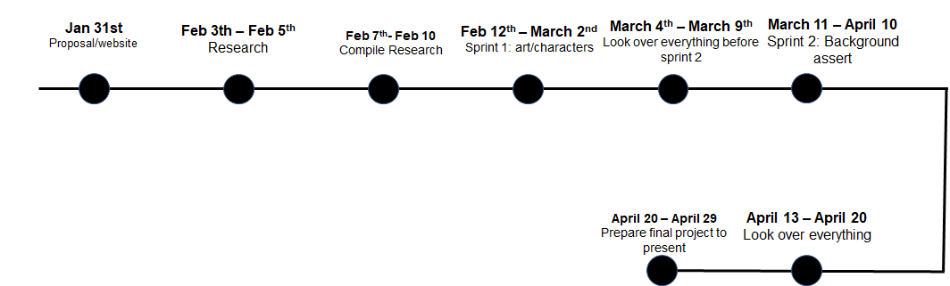

**Budget**

The cost the total cost of this project will be $10,000. Each staff member will get $35 an hour and each staff is going to spend around 33 hours with the project. There are 6 staff members the total to that is $6,930. The other $3,070 will be for the software or hardware and other any overhead cost the team will have.