# User testing

## Step 1: The Usability Test

User Feedback: Explain here in detail

1. No customized video
2. Missing the buttons to go back to previous section
3. Second page is not detail enough

### Proposed Changes as a result of feedback

1. Add customized video
2. Add more sections on the top column
3. Add more content to fill the page

## Step 2: Revision

Explanation of changes made

1. Add customized button
2. Add a go back button
3. Fill more thing….

Sketch with changes

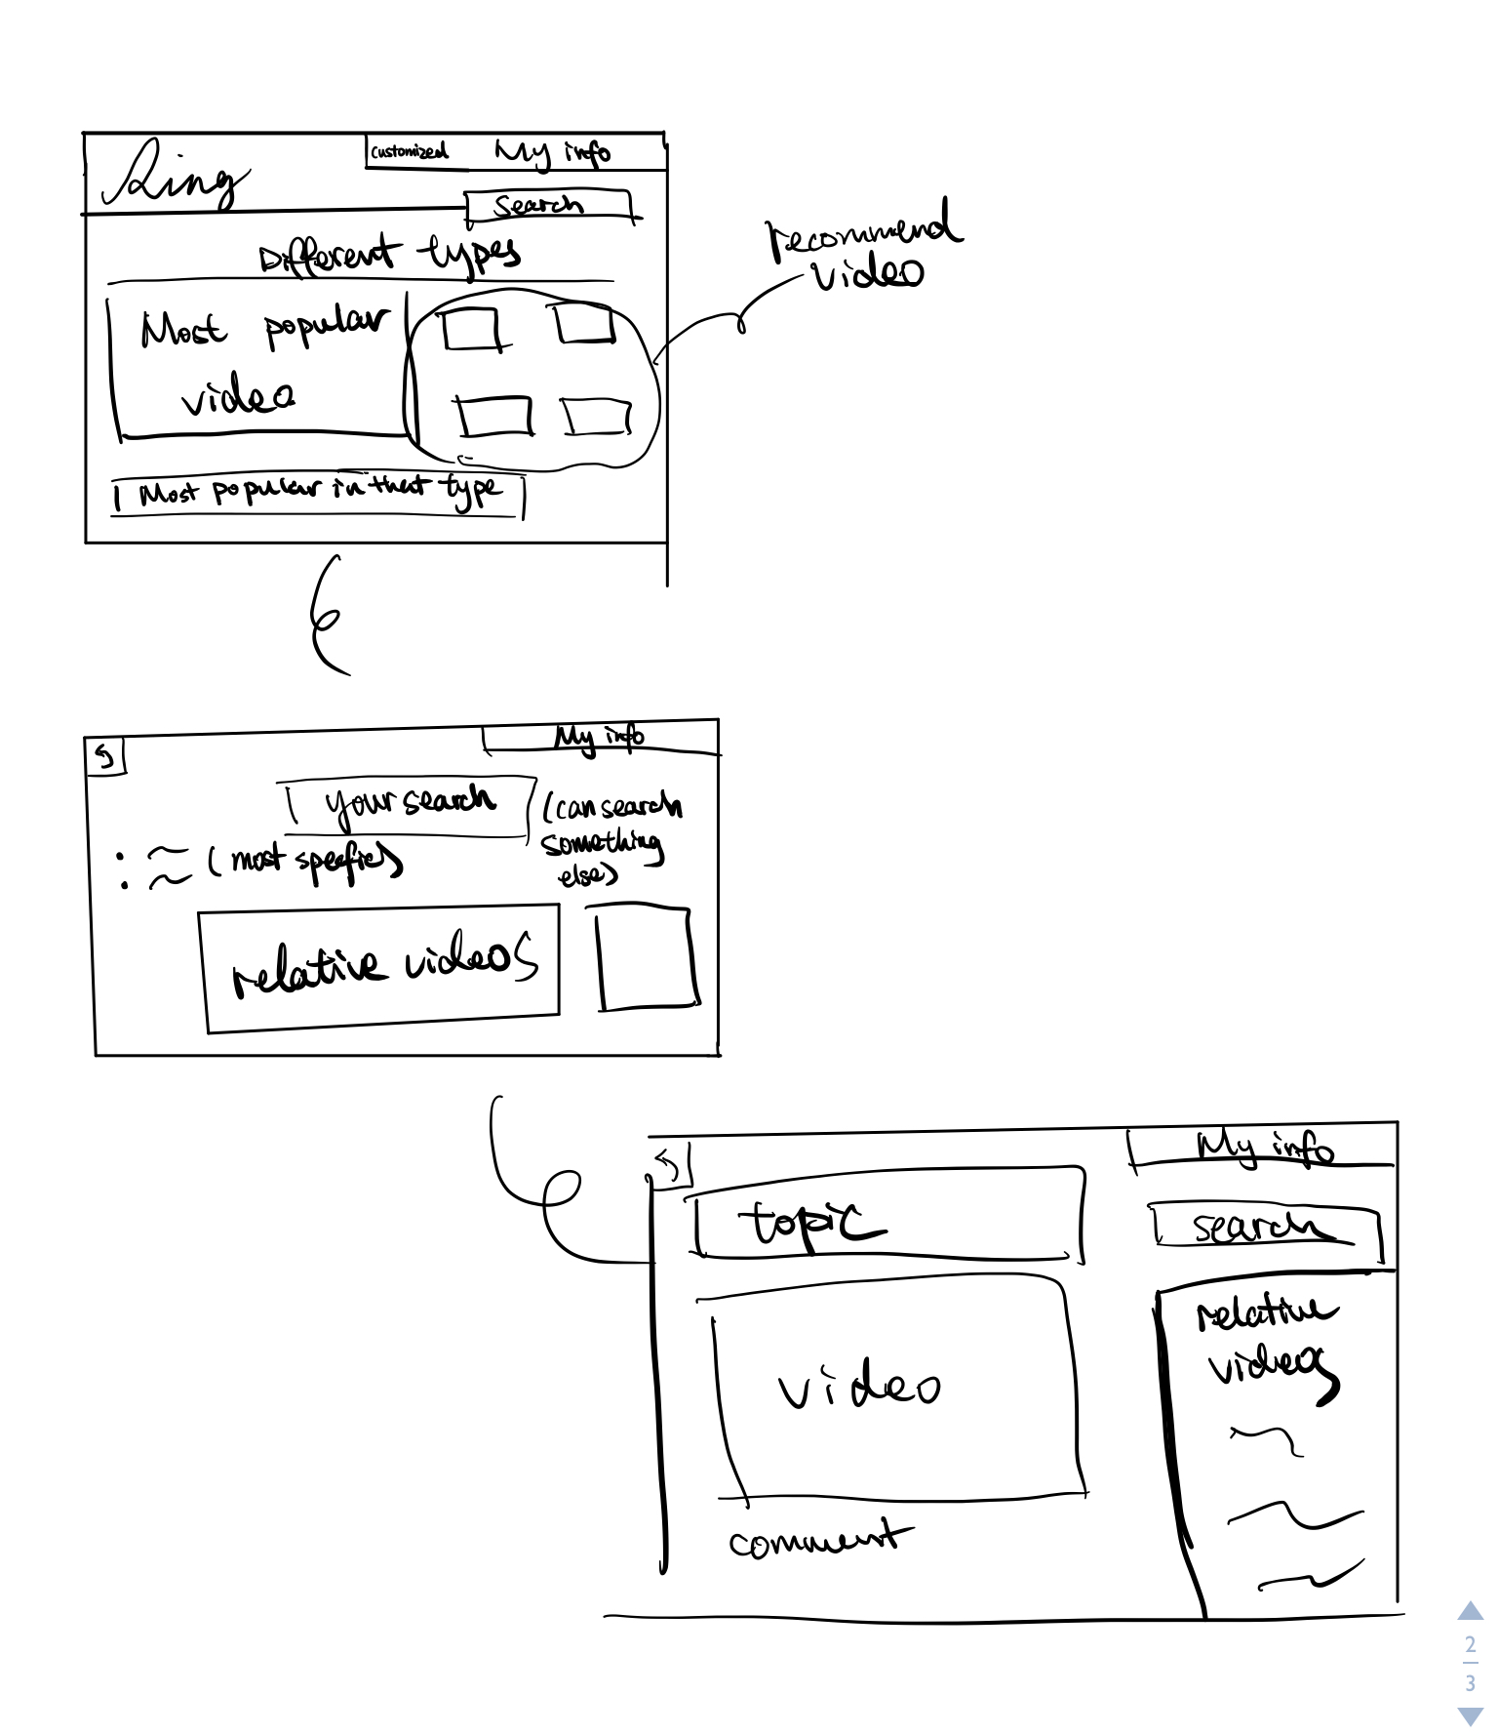

## Step 3: Second Usability Test

User Feedback: Explain here in detail

1. No place to show Welcome
2. recommend video is too much
3. only the most popular video, if someone don’t want to watch it

Proposed Changes as a result of feedback

1. want to feel more welcome
2. want to see recently watch related video
3. if someone don’t like to watch the most popular video

## Step 4: Revision

Explanation of changes made

1. add welcome at the top
2. instead of recommend video show the recently watch related
3. add small button under the most popular for you to choose different type

<paste screenshot of sketches with changes here>

Sketches with changes

