**CS 2104-01 Hardware Lab**

**Lab 10 May 5, 2015**

*Digital Lock*

**Lab report** (upload to iLMS before 5/12 3:30p.m.)

Your report should include the following:

* description and explanation of your work (including answers to all questions in the pre-lab)

藉由前幾次學過的keypad scanner以及buzzer，結合14 segment diplay的控制，即可做出此次的密碼鎖，我直接在keypad_scanner.v裏頭修改按下按鍵後的反應，藉此控制密碼的顯示和是否啟動警鈴，或者讓它回到最初始化的狀態。

**Pre-lab** (Finish it before coming to the class)

Prepare the following before class so you may complete this lab smoothly.

1. Draw a state transition diagram or algorithmic state machine chart for the digital lock.

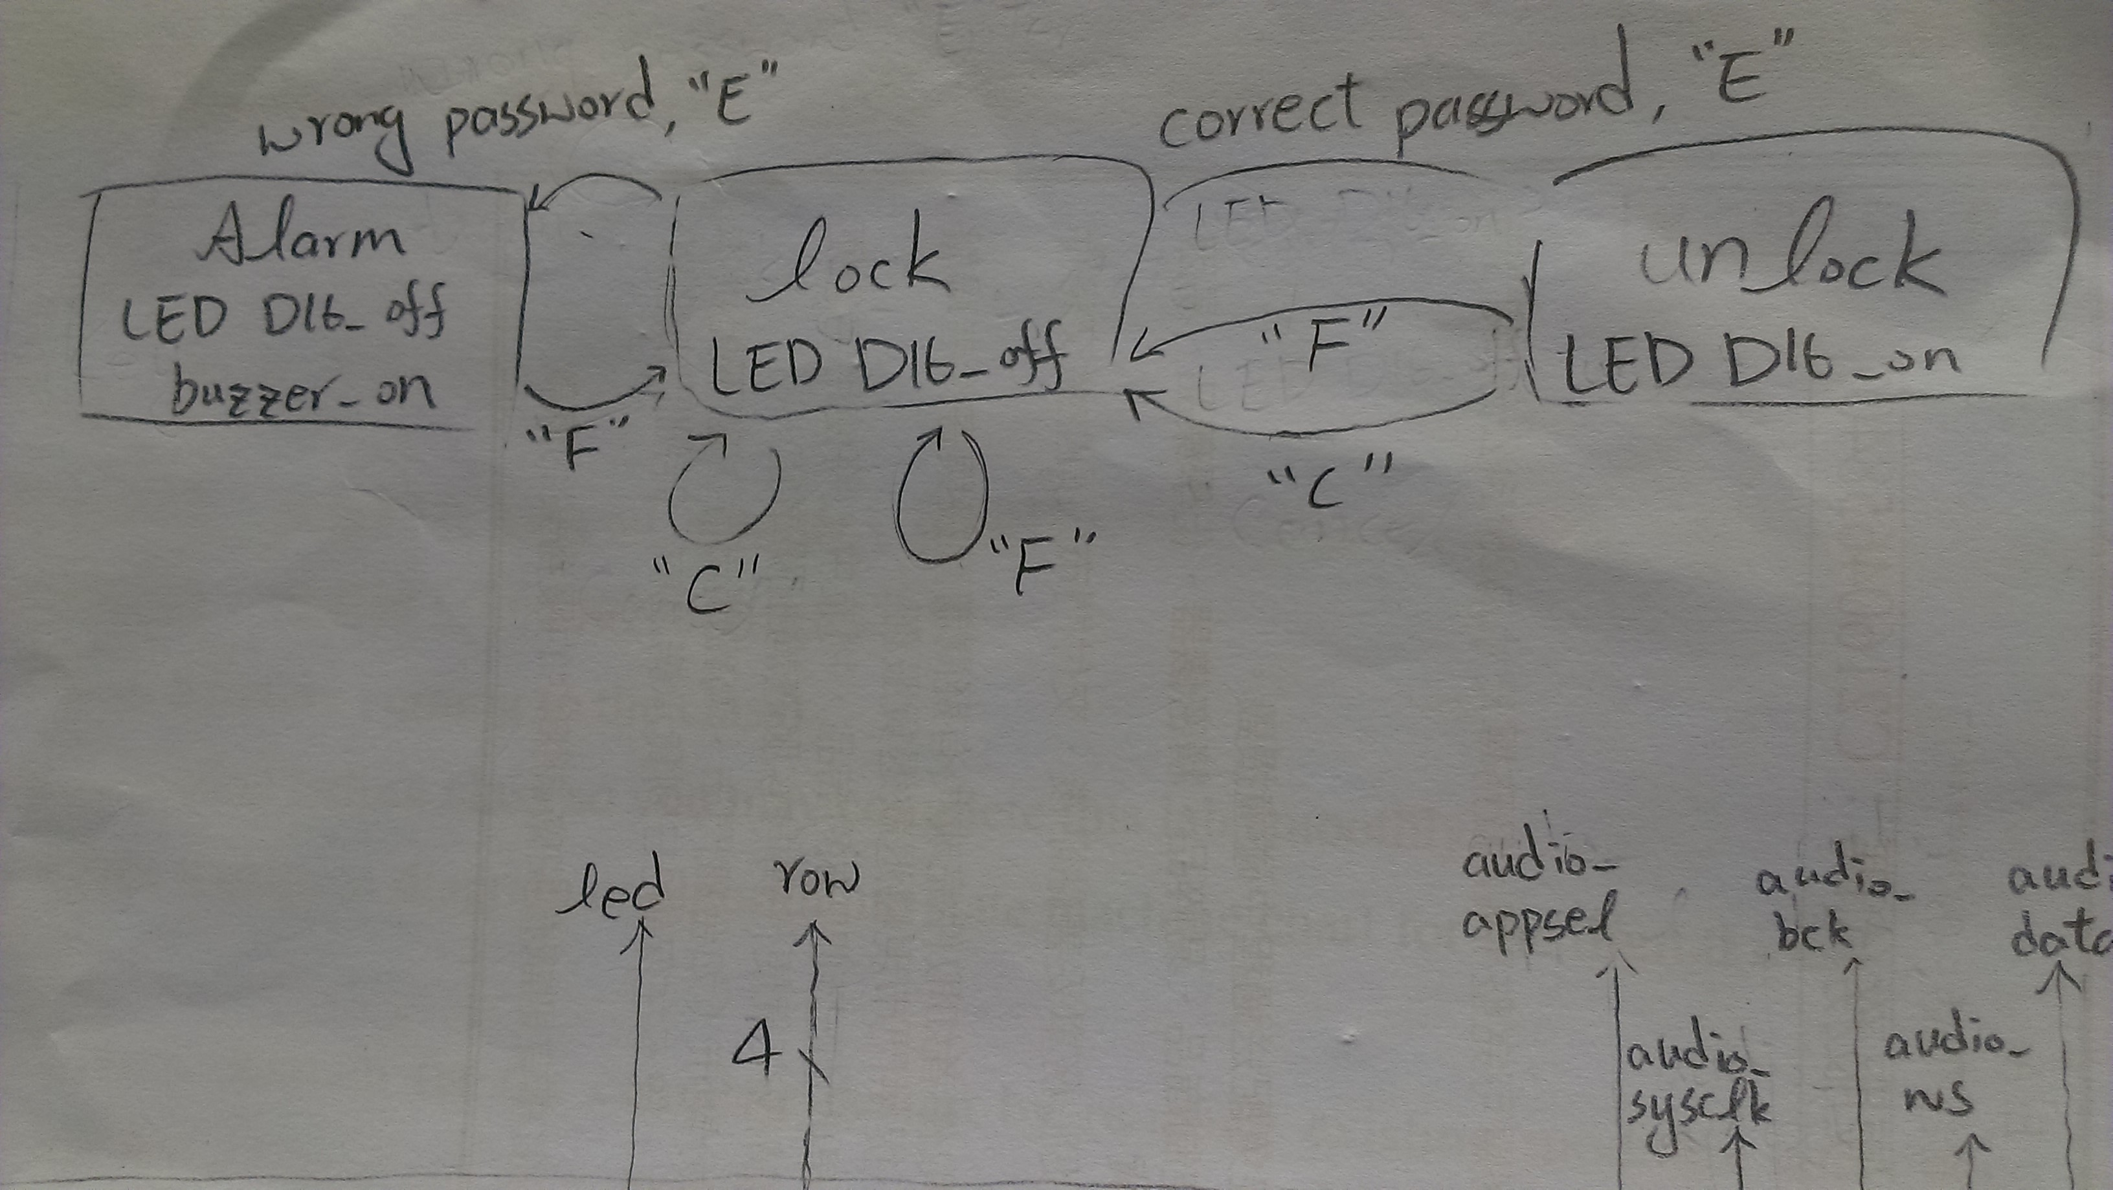

1. Draw a block diagram for the complete design by re-using existing modules introduced in the class previously and defining any new module.

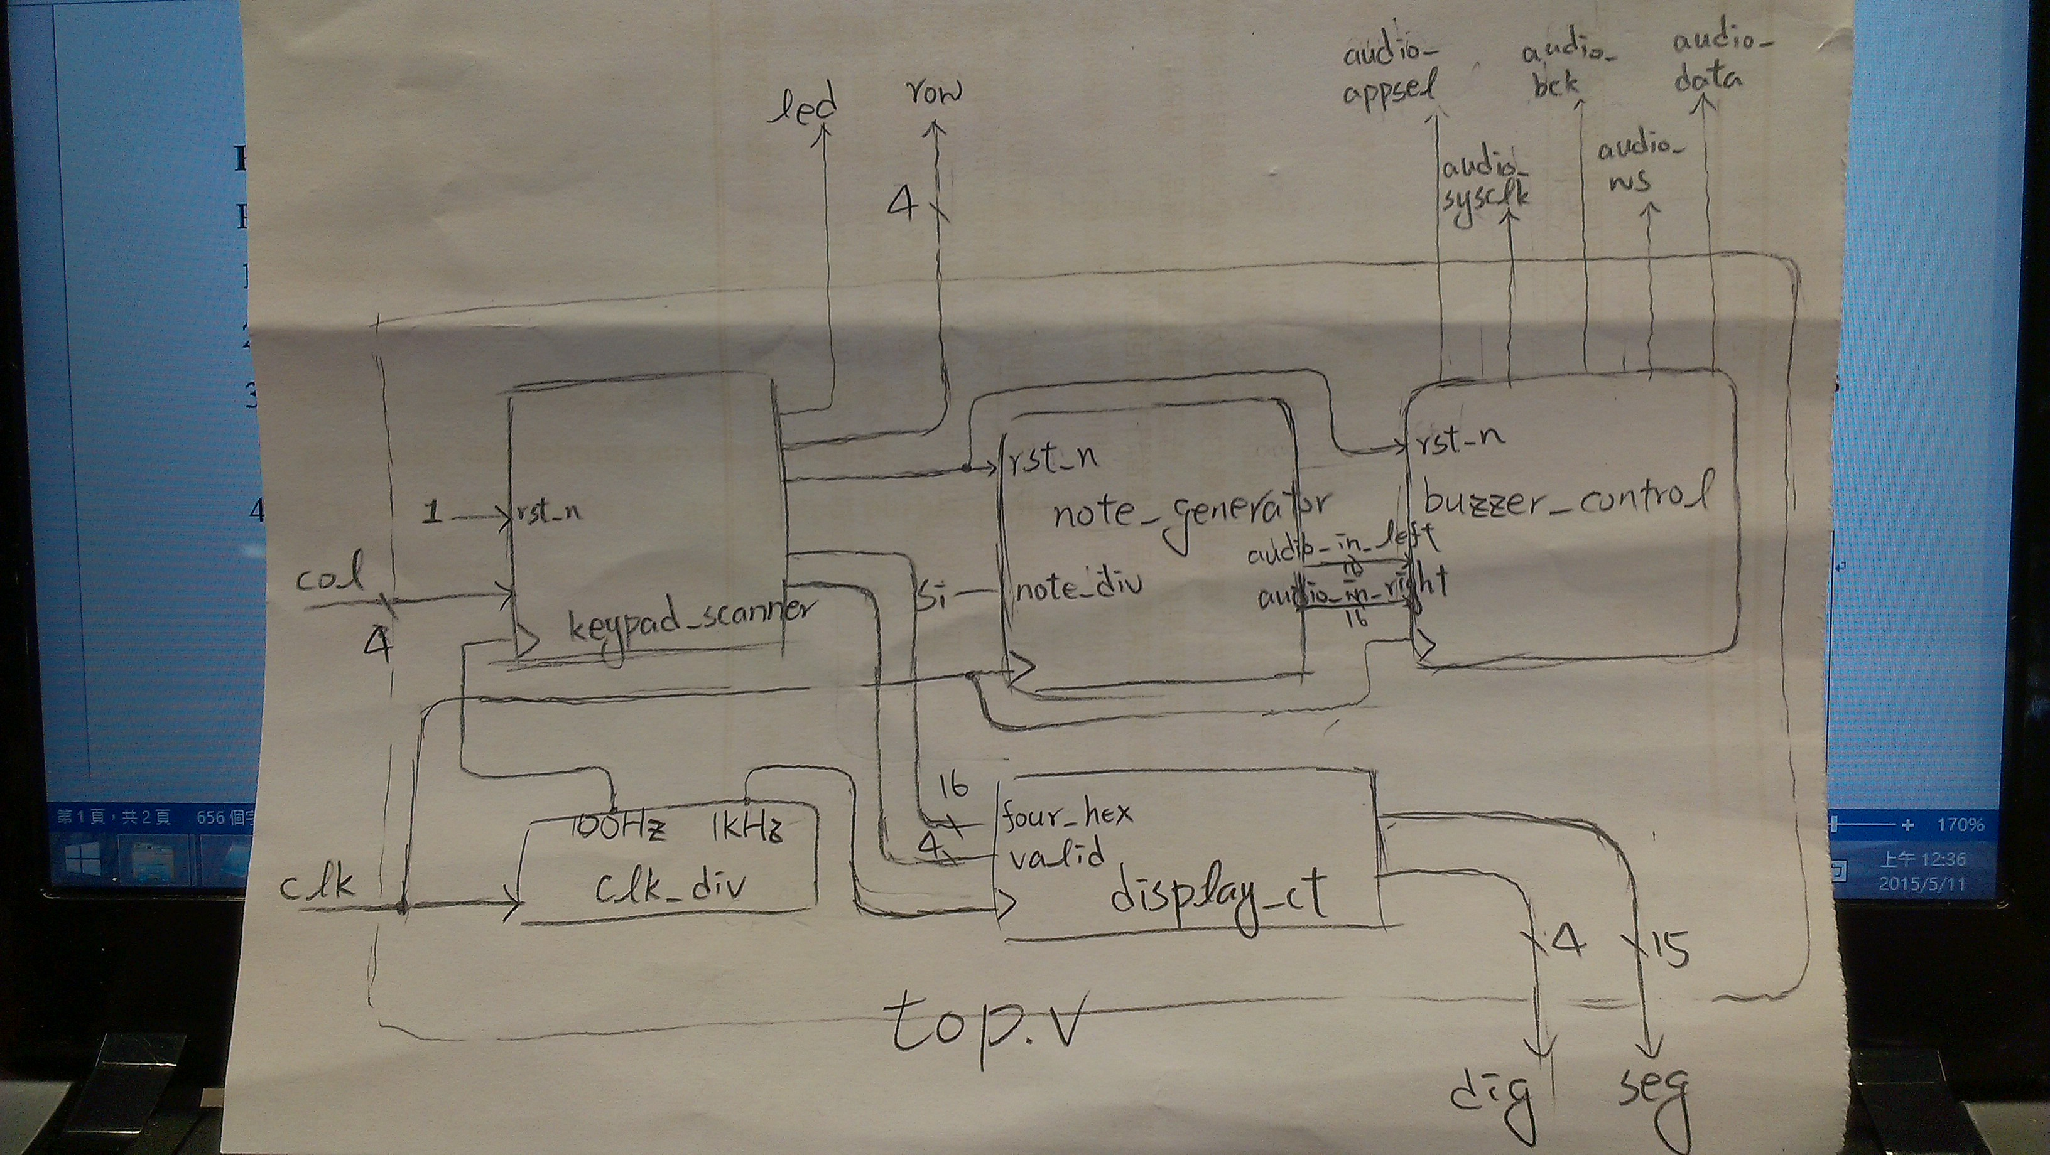

1. Prepare a UCF file for the input/output pin assignment.

|  |
| --- |
| 1. # output pins association 2. NET "seg[0]" LOC = P6; 3. NET "seg[1]" LOC = N4; 4. NET "seg[2]" LOC = V5; 5. NET "seg[3]" LOC = T5; 6. NET "seg[4]" LOC = U7; 7. NET "seg[5]" LOC = R3; 8. NET "seg[6]" LOC = N5; 9. NET "seg[7]" LOC = R5; 10. NET "seg[8]" LOC = T3; 11. NET "seg[9]" LOC = T4; 12. NET "seg[10]" LOC = V4; 13. NET "seg[11]" LOC = V7; 14. NET "seg[12]" LOC = R7; 15. NET "seg[13]" LOC = T7; 16. NET "seg[14]" LOC = U5 ; 17. NET "dig[0]" LOC = T6; 18. NET "dig[1]" LOC = V6; 19. NET "dig[2]" LOC = U8; 20. NET "dig[3]" LOC = V8; 21. NET "audio_appsel" LOC = H18; 22. NET "audio_sysclk" LOC = H17; 23. NET "audio_bck" LOC = K16; 24. NET "audio_ws" LOC = L15; 25. NET "audio_data" LOC = L16; 26. NET "led" LOC = H5; 27. # input pins association 28. NET "clk" LOC = R10; 29. #NET "dip[0]" LOC = T1; 30. #NET "dip[1]" LOC = P2; 31. #NET "push[0]" LOC = N3; 32. #NET "push[1]" LOC = P4; 33. NET "row[0]" LOC = L3; 34. NET "row[1]" LOC = L4; 35. NET "row[2]" LOC = K1; 36. NET "row[3]" LOC = K2; 37. NET "col[0]" LOC = H1; 38. NET "col[1]" LOC = H2; 39. NET "col[2]" LOC = J1; 40. NET "col[3]" LOC = J3; |

* discussion of any issue or problem worthy of note (yes, even mistakes that you made)

這次遇到的問題是，一開始想要特別寫一個module來控制所有東西，所以寫在keypad_scanner module的後面，但是這樣就必須記住前一個狀態的valid 和 four_hex狀態，甚至在buzzer響起時，避免使用者繼續輸入密碼做嘗試，還要另外接出一條控制線，所以後來決定直接寫在scanner裡面，而且助教已經把各個state分好，只要把判斷寫進去就行了。

* optional: any extra feature you added or any suggestion

這次的bonus要讓這個密碼鎖可以更改密碼，雖然感覺很簡單，但是實際進去改keypad scanner會發現很多地方都需要修改，因此在lab demo結束之後才做功能的新增。