**Program1.cpp - Sample Input / Output**

1. Start Menu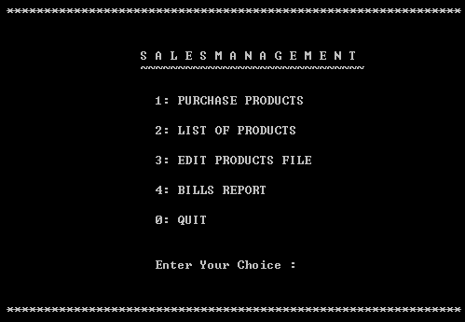
2. Enter Your Choice: 3 (EDIT PRODUCTS FILE)

// The product list will be saved as “PRODUST.DAT” file.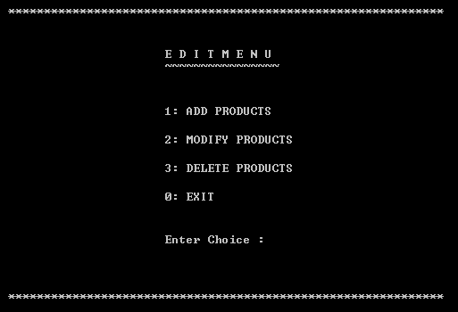

* 1. Enter Choice: 1 (ADD PRODUCTS 3 times)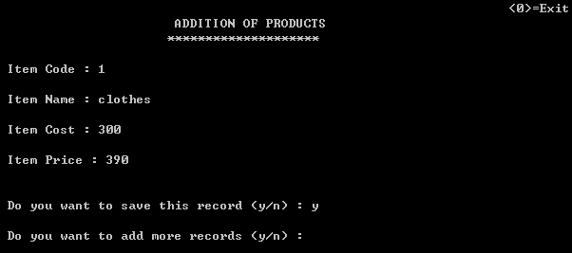

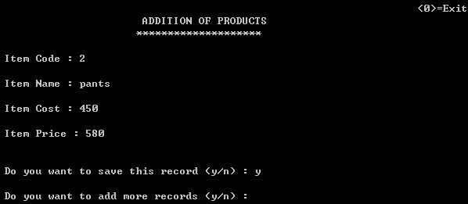

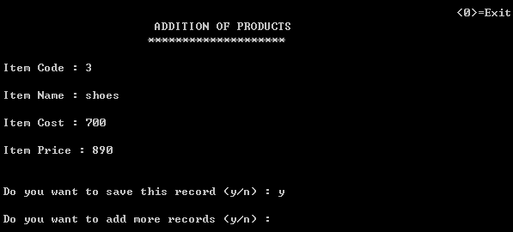

1. Enter Your Choice: 2 (LIST OF PRODUCTS)

// The system will read the list from “PRODUST.DAT” file.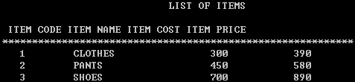

1. Enter Your Choice: 1 (PURCHASE PRODUCTS)
   1. 
   2. 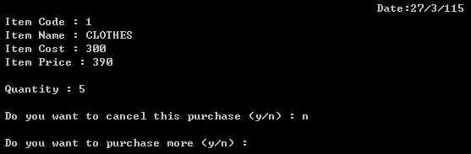

* 1. Do you want to purchase more (y/n): y

Enter Item Code of the item to be Purchase: 3

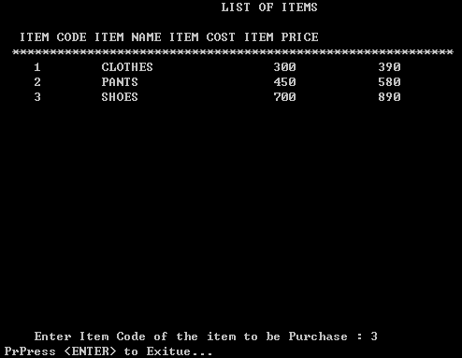

* 1. Do you want to purchase more (y/n): n

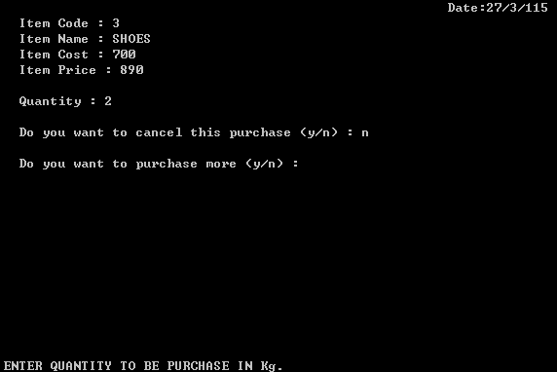

* 1. CUSTOMER BILL

// The customer bill will be saved as “BILL.DAT” file.

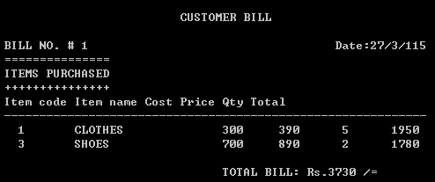

1. Enter Your Choice: 4 (BILLS REPORT)

