eUML2
- Advantage:
  - Dynamic generate UML diagram.
  - The diagram will absolutely match the source code.

- Plug-in: eUML2 (studio version)
Webpage: http://www.soyatec.com/euml2/installation

- How to install software?
  - Online update
  - Offline installation

Online update:
Step1:
Help -> Install New Software
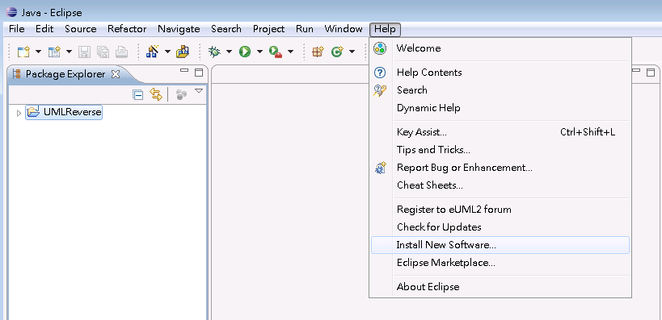
Step2:
Click add button
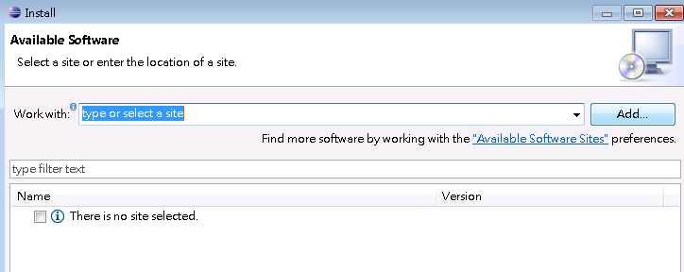
Step3:
Type : http://www.soyatec.com/update in Location Field 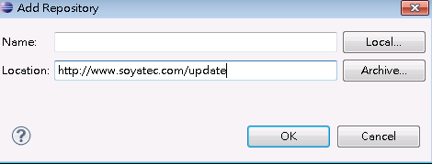
Step4: 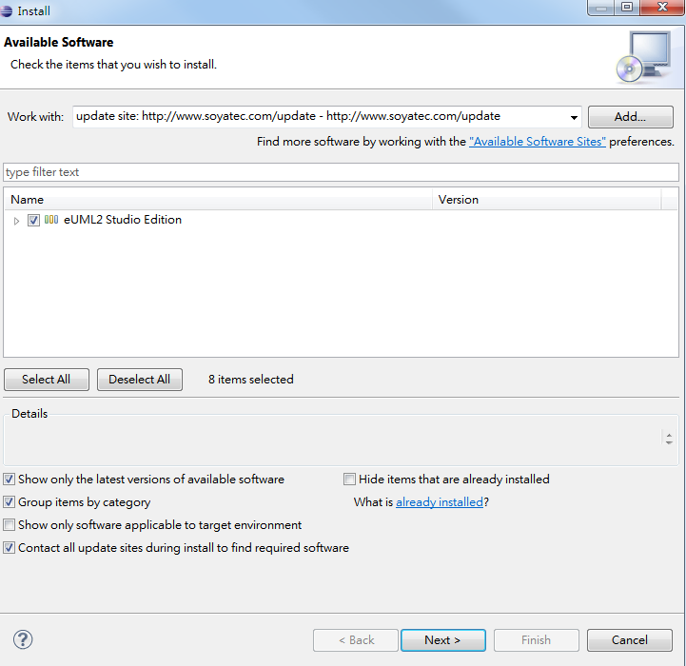
Step5:
How to use it ?
-right click on package > eUML2> Class diagram 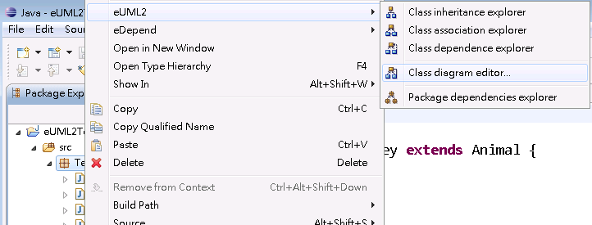
Step6:
Result:

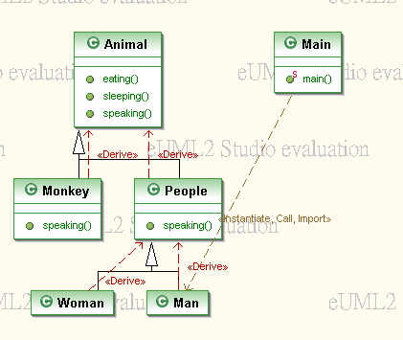

Offline installation:
Step1: Download the corrseponding eUML2 for your eclipse.
Webpage: http://www.soyatec.com/euml2/installation
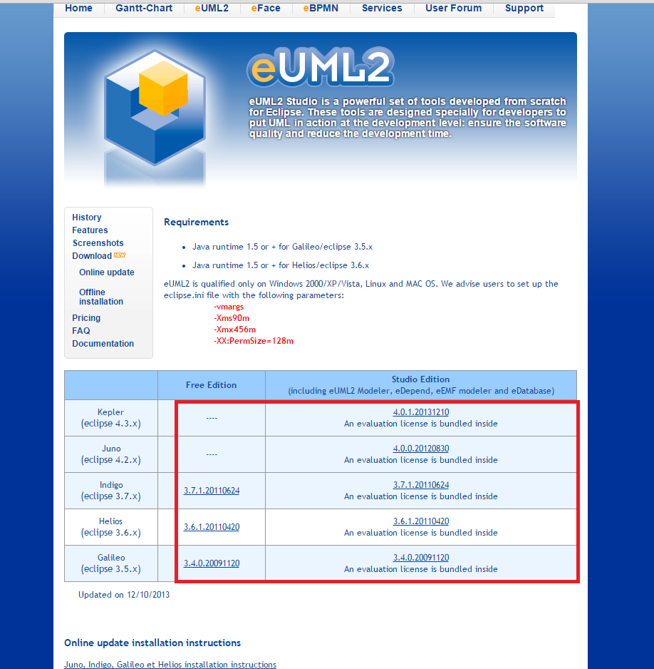
Step2: Help -> Install New Software
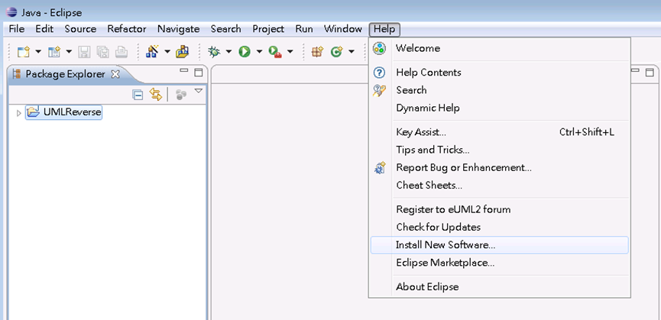
Step3: Click add button
Step4: click archive, select the euml2 zip file
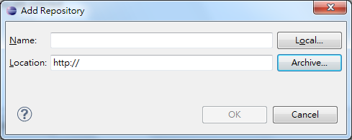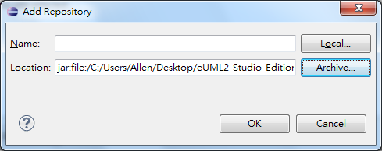
Step5: Select all, then click next
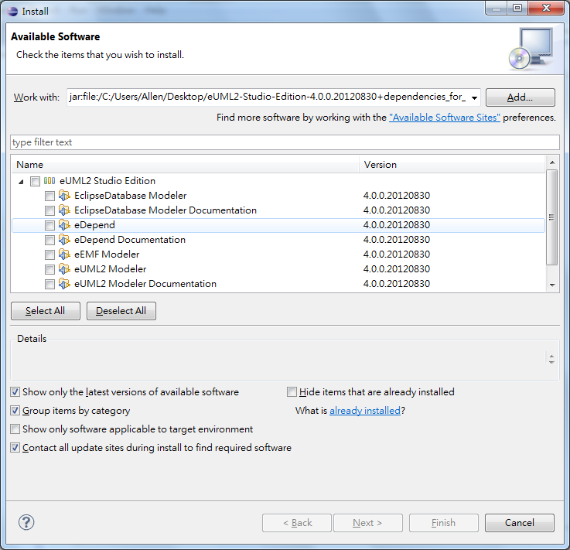
Step 6: After installation, restart eclipse
Step 6:
How to use it ?
-right click on package > eUML2> Class diagram
Step7:
Result:

