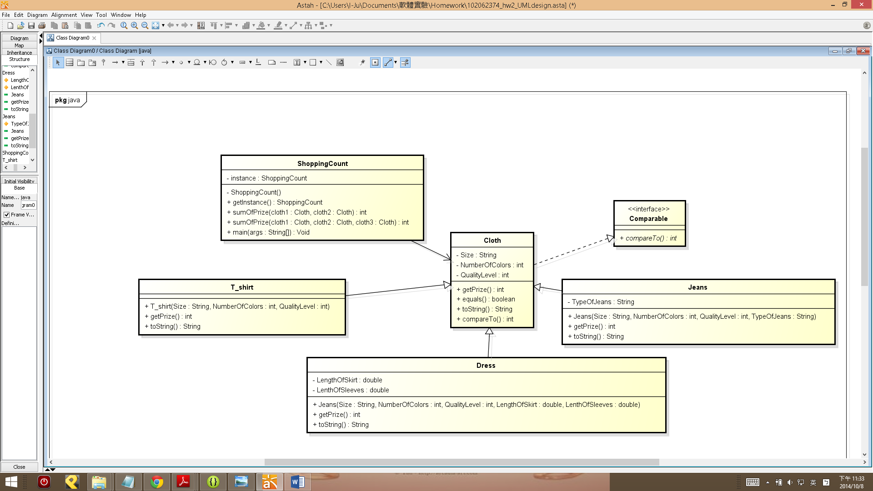

Class Cloth

(1) Closth is an abstract class and implement interface Comparable, including abstract methods getPrize(), toString() and implement compareTo().

(2) compareTo() is a method that if A's prize is more/less than or equal to B's prize, print "A's area is more/less than/equal to B's prize."

Class T_shirt, Dress & Jeans

(1) The three classes need to extend Cloth and override the methods getPrize(), toString() and compareTo().

(2) toString() is a method the return a string like " This is a T_shirt with the XL size and 2 colors. Otherwise, the quality level of it is 1."

(3) The prize of each cloth ( size XS=1,S=2,M=3,L=4,XL=5 )

T_shirt is (size*NumberOfColors*QualityLevel)

Dress is (size*NumberOfColors*QualityLevel*(LengthOfSkirt+LengthOfSleeves))

Jeans is (size*NumberOfColors*QualityLevel*TypeOfJeans)

( Tights=1,Collapse pants=2,Waist pants=3 )

Class ShoppingCount

(1) The class lets users compare and calculate the prizes of clothes.

(2) Overload methods sumOfPrize(Cloth cloth1, Cloth cloth2) and sumOfPrize(Cloth cloth1, Cloth cloth2, Cloth cloth3) to add the prize of these clothes.

(3) Use java.util.Arrays.sort() to sort the volume.