LinBMD2

A Linux based FreeBMD Transcribing Programme.

Table of Contents
Introduction 1
Licence 2
Requirements 2
Installation 3
First use 4
Architecture of linBMD2 5
Detailed Help 7
Dialogue Header 8
Dialogue Footer 9
Signout 9
Housekeeping and Interesting Facts 9
Dialogue message area 11
The Sign-on screen 12
Create New Identity Dialogue 13
Change your password 14
Select Header to work on 15
Create a new Transcription Header 18
Create New Allocation 19
Manage Allocations 20
Transcribe from Scan 22
The scan image 22
The Data Entry 24
Action Buttons 28
Transcribing History 29
Transcribing tips 30

Introduction
This document will help you to understand the structure and use of the linBMD2 FreeBMD Transcribing Programme. It is intimately linked to the FreeBMD system and its website, FreeBMD.com

Licence

Requirements
To use this programme you will need the following on your linux system,
- a linux system, eg. Debian, Fedora
- a LAMP (Linux, Apache, MariaDB, PHP)
- an active internet connection
- FEH, an image viewer
- Firefox web browser
- winctrl, a window management system
- evince – a PDF file viewer
- the linBMD2 software
- knowledge of the root password for your MySql or MariaDB system
If you don’t already have a LAMP installed you can find many tutorials on the web to help you install one for your distribution.
You should find FEH and winctrl in your distribution repository.
LinBLD2 software is available from the FreeBMD.com site.

Installation
Installation is simple. Follow these steps in the order given.
- install your Linux system
- make sure you have sudo privileges
- install your LAMP
  - for Debian based systems here is a good tutorial for this, https://www.tecmint.com/install-lamp-on-debian-10-server/
  - for Fedora, https://computingforgeeks.com/how-to-install-lamp-stack-on-fedora/
  - for Ubuntu, https://www.itzgeek.com/post/how-to-install-linux-apache-mariadb-php-lamp-stack-on-ubuntu-20-04/
- make sure you secure your mariadb database server and adjust your firewall as necessary
- install Firefox web browser
- install FEH, winctrl and evince using your package management system.
- download the linBMD2 software
- unpack the linBMD2 software to a directory of your choice
- Make the linBMD2.install programme executable.
- Run the programme linBMD2.install. This will,
  - Verify that the required software is installed
  - it will copy the linBMD2 software to its run directory
  - set up the database
  - initialise the database
  - create a desktop icon
- Once the above steps are done the system is ready to use.

First use
To use linBMD2 you must have an account on FreeBMD and belong to a syndicate. Go to FreeBMD.com to start the registration process. Once you are registered you will be allocated some scans to transcribe by your syndicate leader; this is called an allocation in linBMD2.
To start using linBMD2 make a note of your FreeBMD user name and password. These will be required on each signon to linBMD2.

Architecture of linBMD2
linBMD2 is designed around the concept of a scan “header”. See the diagram below,
Header
Allocation
User
Syndicate
Scans
Detail transcription records
Upload to FreeBMD

A user is you. The system asks you to register you name, email, FreeBMD user name and password. This is essential information required to interact with the FreeBMD system.
A syndicate is the syndicate you belong to. You can belong to more than one syndicate at the same time.
The allocation is the list of scans that have been allocated to use to transcribe by your syndicate leader. It will be something like, “1988 Births, pages 301 to 392, from the L surnames”. You can have multiple active allocations at any one time.
The header is created for each scan you start transcribing. It contains information about the scan, how many records you have transcribed so far from the scan; whether the transcribed data has been uploaded to FreeBMD and if so what was the upload status. You can have multiple headers open at any one time.
The detail line by line transcriptions are held in the detail transcription database.
The detail lines are used to upload the data to the FreeBMD server.
Once a header has been successfully uploaded to the FreeBMD server you can close it.

Detailed Help
Each of the linBMD2 dialogues has a header, a message area, a body and a footer.

Dialogue Header
The dialogue header looks like this,
Total records transcribed
Linbmd2 title, version and environment
Your name
Today’s date

Dialogue Footer
The dialogue footer looks like this,
Click to return to signin dialog
Go to FreeBMD

Go to housekeeping menu
Copyright
Help

Signout
The sign-out button takes you back to the sign-in screen. On the way it forgets all the information
you have provided including your identity. In order to continue using linBMD2 you have to sign-in again.

The system performs a final backup of the database and stores it here, ~/linBMD2/public/Backups.

To exit completely eaither press the X = close browser window or press the “Close Application” button and then ATL+F4.

Housekeeping and Interesting Facts
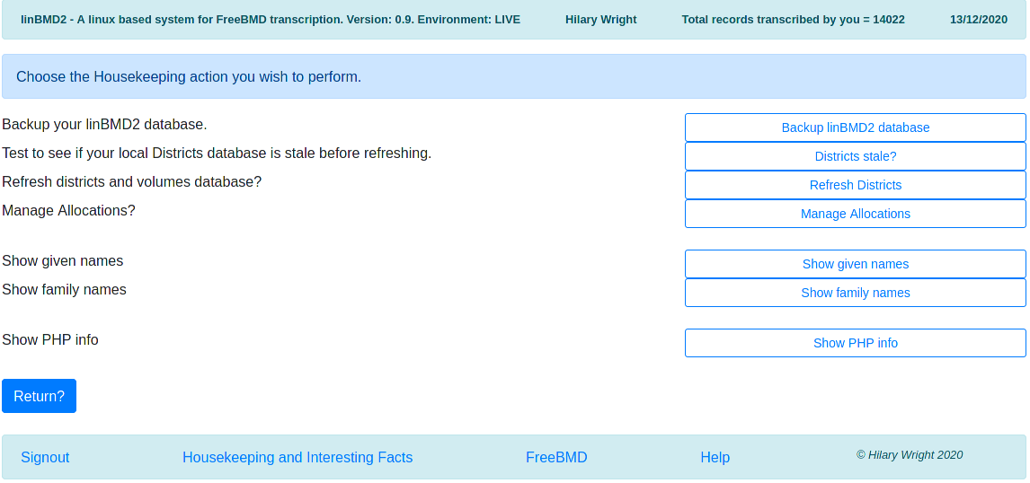
This screen allows to perform various housekeeping activities and look at some interesting facts.
Housekeeping
Backup - If you wish to backup the linBMD2 database manually you can do so here. Just click the “Backup linBMD2 database” button. Remember that linBMD2 automatically takes a backup after every five records keyed and when you press the “Signout” button.
Districts stale – Districts are stored on the FreeBMD server and downloaded to linBMD2 upon request. To find out if the districts database in linBMD2 needs to be refreshed, press the “Districts stale?” button.
Refresh Districts – You can refresh the districts database at any time whether it is stale or not by pressing the “Refresh Districts” button. LinBMD2 will connect to FreeBMD and download the latest version of the their districts database. You don't need to do this that often because the FreeBMD districts database doesn't change that often.
Manage Allocations – press this button to manage allocations – see below for a description of this functionality.
Interesting facts
Show given names – this button will show you a list of forenames that you have keyed in popularity order, ie,
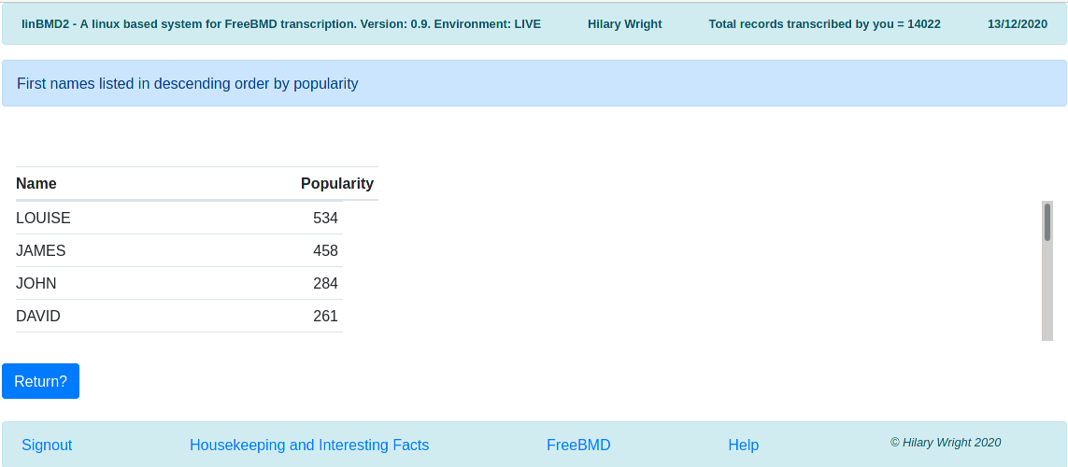
Use the scrollbar to reveal other names.
Show family names – this button will show you a list of family names that you have keyed in popularity order. The screen looks the same as above.
Show PHP info – information pertaining to the PHP version and modules installed. Only for developer use.

Dialogue message area
The dialogue message area has two parts, the dialogue purpose and any error messages, It looks like this,
Dialogue purpose and brief instructions

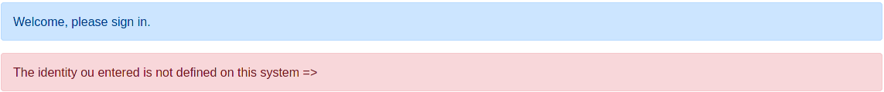
Error messages, these can be very detailed

The Sign-on screen
When you start the system you will be asked to sign-on. You need to enter you FreeBMD user name and password.
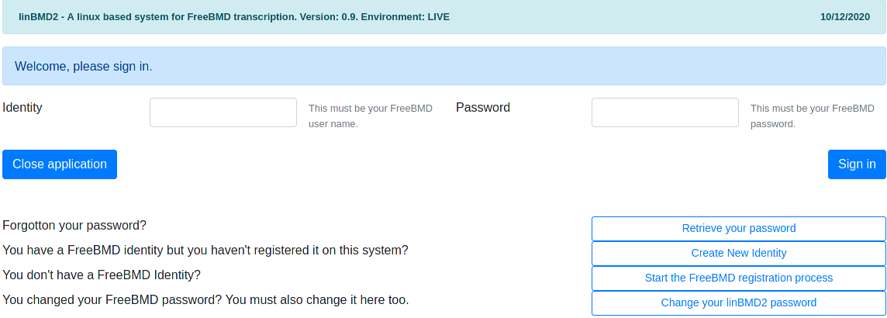
Identity = your FreeBMD user name
Password = your FreeBMD password
Press “Sign in” to complete the sign in process.
If you have forgotten your password, press the “Retrieve your password” button. You will be shown a dialogue asking you to enter your FreeBMD identity and your email. The email will be checked against the email held against the identity you created using the “Create New Identity” option. If the email entered is valid, you will be sent an email message with your password.
If this is the first time you use the system, you will need to register your identity. Do this by pressing the “Create New Identity” button.
If you changed your FreeBMD password on the FreeBMD site, you need to change it here too. To do that press the “Change your linBMD2 password” button.

Create New Identity Dialogue

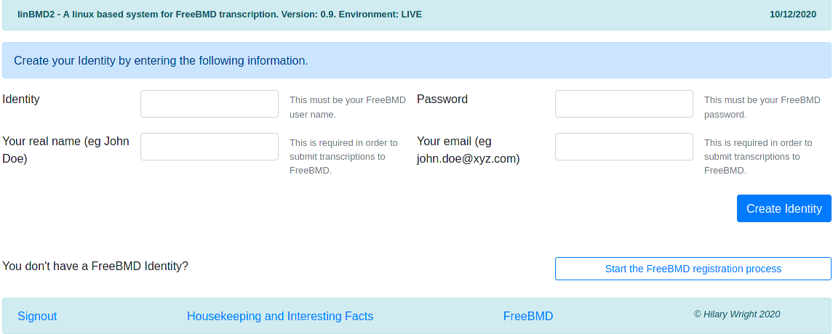
Enter your FreeBMD identity and password. These will be validated against the identity held on the FreeBMD server.
Enter your real name. This will be shown in the header and will be used to upload transcribed data to FreeBMD.
Enter your email. This is required for uploading to FreeBMD and for recovering your password.
If you don’t yet have a FreeBMD identity, press the “Start the FreeBMD registration process” button. You will be taken to the FreeBMD web site. You can also start this process from the sign on screen.

Change your password
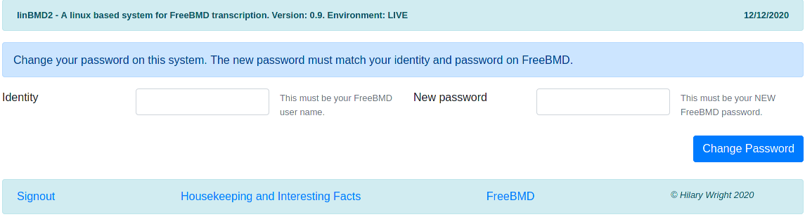
If you changed your FreeBMD password, you MUST change it in linBMD2 too. If you don’t you will not be able to sign-in to linBMD2.

Select Header to work on
When you have successfully signed in you will be asked to select a header to work on. If this is your first use of the system you will need to create a new header.
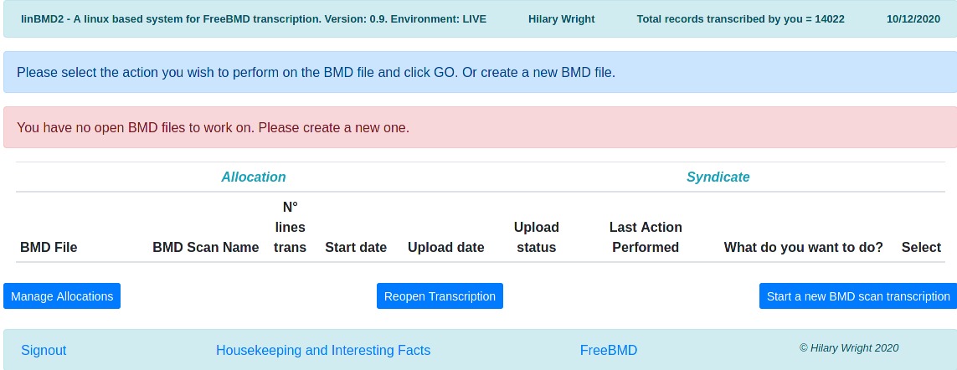
Click the “Start a new BMD scan transcription” button to create a new Header. You will also use this button to create a header for the next scan in your allocation.
Once you have created a header, you will see the following screen,
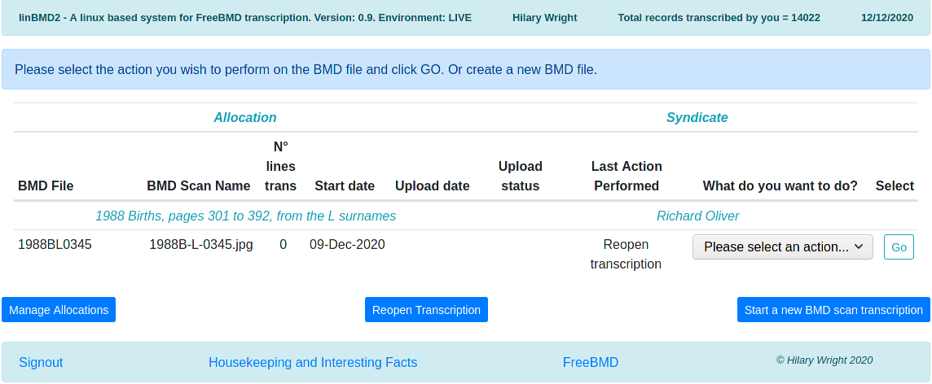
In light blue you will see the allocation and the syndicate that this header is attached to.
On the header line you will see,
- the header name (BMD file). This is built from information taken from the allocation with the page number you selected when you created the header. In the example above,
  - 1988 is the year
  - B = births
  - L = letter
  - 0345 = page number
- the name of the scan that you are transcribing. The scan was automatically downloaded to your machine if you accepted to download it automatically and is stored here, /home/your_user_name/path/to/linBMD2/linBMD2/public/Scans
- the number of records you have transcribed so far from this scan
- the date when you started this scan
- the upload date and upload status are filled in once you have uploaded the transcribed data to FreeBMD. The upload status and details are provided by FreeBMD when you initiate the upload from the “What do you want to do?” drop-down menu. The upload status can have several codes,
  - OK – the data was uploaded to FreeBMD successfully with no errors
  - failed – the data upload failed for some reason. You can see the reason by selecting the “See upload status details” in the “What do you want to do?” drop-down menu.
  - warnings – the file was uploaded to FreeBMD successfully but there were warnings. You can see the reason by selecting the “See upload status details” in the “What do you want to do?” drop-down menu.
- The last action performed shows you the last action you selected from the “What do you want to do?” drop-down menu. Use this a memory jogger to help you remember where you are in the transcription process.
- “What do you want to do?” is a drop-down menu where you select the action you want to perform related to this header. To use the menu select the action from the drop-down and press the “GO” button. The following actions are available,
  - Transcribe from scan = start or continue transcribing the scan attached to this header.
  - Verify Transcription = once you have completed transcribing a scan, it is a good idea to verify what you have typed before uploading it.
  - Upload BMD file = upload your transcribed data to FreeBMD. This can take a few seconds depending on the speed of your internet connection.
  - See upload status details = described above
  - Close transcription = once you are satisfied that the transcribed data has been uploaded successfully you can close the the header. If you do so, you will no longer see the transcription in the “Select header to work on” screen. If you need to reopen the header you can do so by selecting the “Reopen Transcription” button. You will be asked to enter the header file name and to confirm the reopen. Once reopened the header will be shown again and you can select the action you want to perform on it. You make changes to the transcription records and re-upload the data. If you re-upload and the upload is successful, the system will tell you that the file was replaced on the FreeBMD server.
- You manage allocations by clicking on the “Manage Allocations” button.
- You create a new header by clicking the “Start a new BMD transcription” button.

Create a new Transcription Header
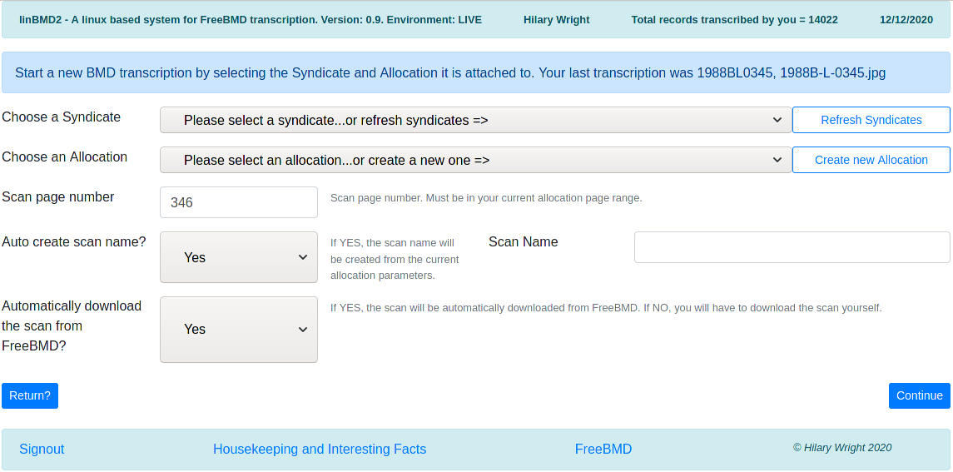
You cannot start transcribing a scan without creating the header first.
You will notice that the system tells you the last header which you successfully uploaded to FreeBMD and its scan name, if any.
First choose the syndicate that you are working for by clicking on the drop-down arrow on the right-hand side of the field. You can enter the first few letters of the syndicate in order to position the list. Syndicate names are downloaded from FreeBMD and stored locally for faster access. You can refresh the list of syndicates by selecting the “Refresh Syndicates” button. You cannot create a syndicate; to use one it must first exist in FreeBMD. Remember that you can be working for more than one syndicate at a time.
Now choose the Allocation this header is attached to. If you are starting a new allocation received from your syndicate leader, you will need to create it first. Press the “Create new Allocation” button to do this.
Enter the page number of the header you are starting.
Generally you should leave the “Auto create scan name” and “Automatically download the scan from freeBMD” alone. If you know that your scan name is in some way particular, you can enter it manually. In this case you should manually download the scan.
Once the required information is entered linBMD2 will create the header. It will verify that the scan is in the syndicate scope.
When you have successfully created an allocation you will be returned to the “Select Header to Work on” screen.

Create New Allocation
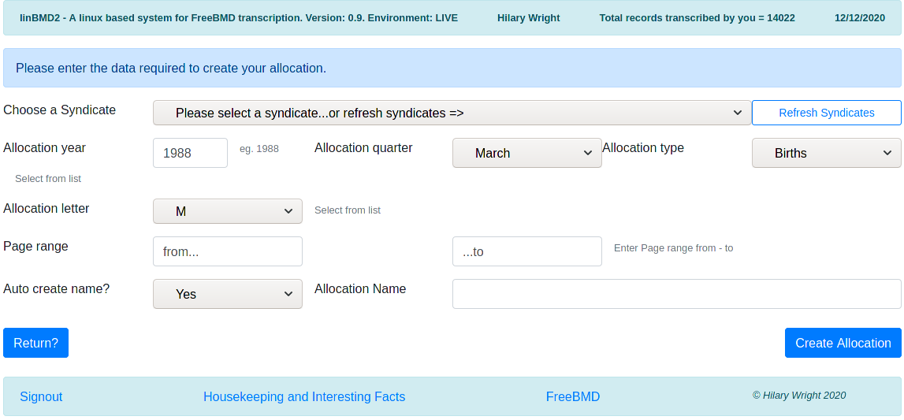
Just as every header must be attached to an allocation, every allocation must be attached to a syndicate, so choose the syndicate from the drop down list. You can also refresh the syndicates from here by pressing the “Refresh Syndicates” button.
Enter the year the allocation is from and the quarter.
Allocations are year based or quarter based (if in doubt ask your syndicate leader). Scans belonging to a year based allocation are all held by the year on FreeBMD. If your allocation is year based, choose December from the drop-down for the Allocation Quarter. Those that are quarter based are held by quarter on the FreeBMD server so choose the appropriate quarter from the drop-down.
Allocation types are Births, Deaths, Marriages. Select the one that applies.
Select the letter. Sometimes this can be, for example, AB. More often just a single letter.
The allocation page range.
The system can automatically create the allocation name. Generally you should let the system generate the name, but if for any reason you wish to create it yourself, just enter the name you want in the designated field.
Once the data entered the system will make sure that the allocation is in the scope of the syndicate and will identify the path to the scans on the FreeBMD server. If linBMD2 finds an ambiguity it will ask you to clarify from some choices. This can occur several times as linBMD2 navigates FreeBMD to the path for the scans for this allocation.
When the allocation has been created you will be returned to the Create Header dialogue.

Manage Allocations
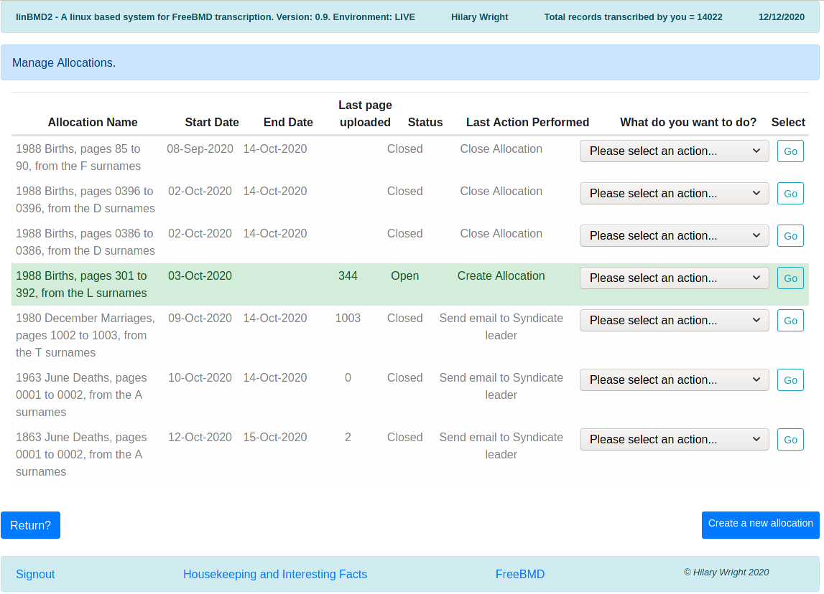
The Manage Allocations screen allows you see all the Allocations that you have created. You are shown,
- the Allocation name
- the date on which the Allocation was created
- its end date if you have closed the allocation
- the number of the last page (=header) you uploaded
- the status of the Allocation, Open or Closed
- the last action performed
- the “What do you want to do” menu and its “GO” button.
The “What do you want to do?” menu contains the following options,
- Close the Allocation – the Allocation will be closed. Consequence is that you will no longer be able to select it when creating a new header
- Re-open the Allocation – in case you closed it by mistake
- Send email syndicate leader – this sends an email to the leader of the sdicate to which this allocation is attached informing him that the Allocation has been finished and asking him to send you a new one. This is a standard email; you are send a copy of it to the email you entered on your identity record.

Transcribe from Scan
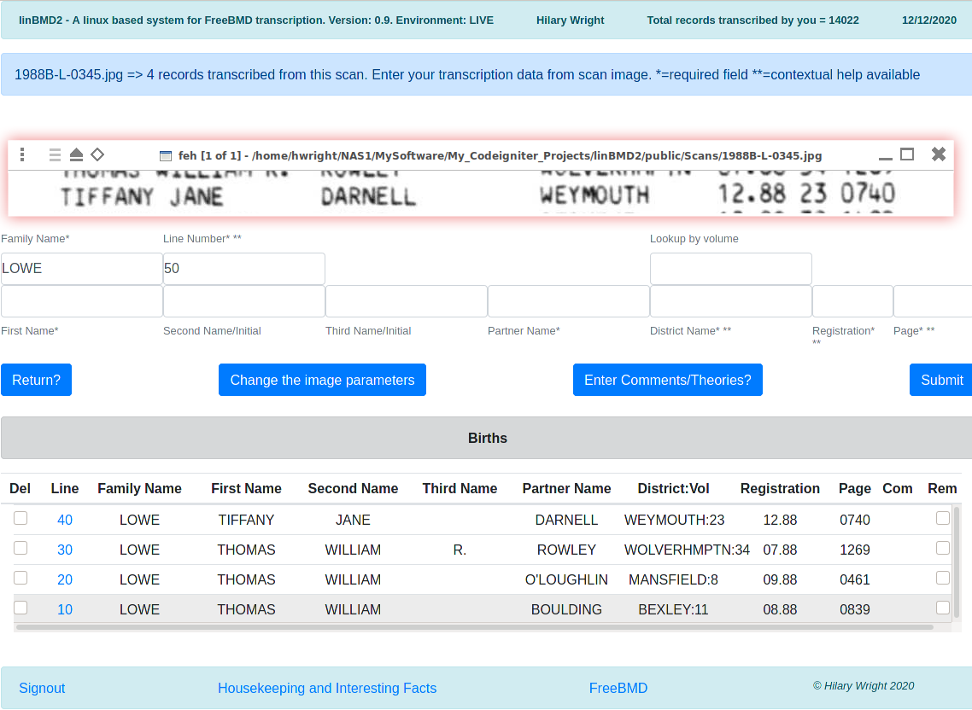
The scan image
Data entry
Transcribing History
Action Buttons
When you select the “Transcribe from Scan” option against the header the screen above is shown.
LinBMD2 tells you the scan you are transcribing from and the number of records you have transcribed.
There is a lot going on here but essentially there are three sections.

The scan image
The scan is shown using the FEH image viewer in an entirely independent window. It is shown as 'always on top'. If for any reason it isn't, right click on the image title bar and select the 'always on top' option.
You can move, resize the image as you wish by selecting the window edges and pulling as required or you can use the “Change the Image Parameters” button. This is useful if you want to change the zoom factor and to make the changes 'permanent' for this image. The system will remember the image parameters you enter and will always apply them to this scan even if you close and reopen the application.
To move to the next line in the image, move the image within the window by placing the cursor in the image window, hold down the left mouse button and move the image to where you want it.
Change the image parameters
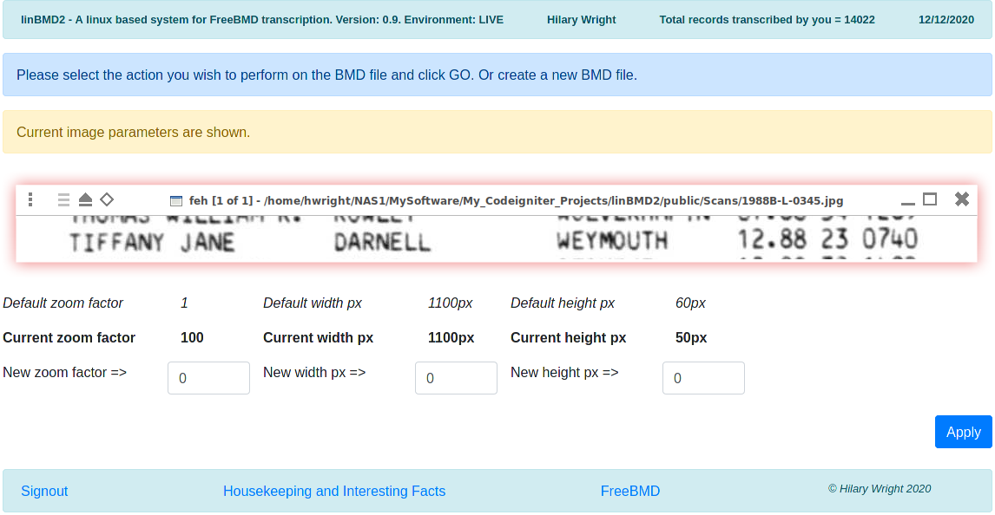
You can change,
- the zoom factor – affects the size of the text.
- The width of the image window – this can exceed the size of the screen so be careful,
- the height of the image window – same

The Data Entry
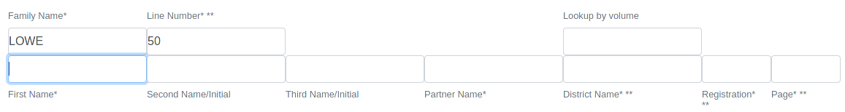
The data entry section will change depending on which type of scan you are transcribing; Births, Deaths, Marriages. The principles of keying the data are the same as described below.
The Family Name is empty when you first start transcribing a scan but it defaults to the last name entered as you start entering data. The line number is supplied automatically by linBMD2 and increases in steps of 10. More about the line number later.
As you select the next line in the image, remember to place the cursor in the first name field to start typing.
As you type data in all fields except the Registration and Page fields, a drop-down list of suggestions will be shown after you have typed at least two letters. As you type more letters the suggestions are narrowed down. Suggestions in all fields except the District Name are shown in most popular order. LinBMD2 keeps a database of forenames and surnames and with the number of times they have been seen. You can see the most popular names by using the “Housekeeping and Interesting facts” button. The District Name suggestions are shown in alphabetical order.
To select a suggestion move the cursor to it by using either the arrow down key or by selecting it with the mouse and pressing either enter or tab. Selecting with enter, puts the suggestion into the field leaves the cursor in the field; selecting by tab puts the selection into the field and moves the cursor to the next field.
You can repeat the last name keyed in the First and Second name fields by positioning the cursor in the field and pressing the Insert key.
You can repeat the whole line except the page field by pressing the Home key.
Sometimes it is useful to search for the district using its number. This is especially useful when transcribing hand written records. You will see a field above the District Name field to allow you to do this.
For the registration field you can either the the month and year manually, ie 12.88, or type just the month number. The system will add the year automatically using the Allocation year.
The page number is checked to see if it matches the length of the number for the type of record being transcribed. Son for births linBMD2 checks that the entry is 4 characters long. This means that you must key the leading 0 for three digit numbers. If you key an entry that is not 4 characters long, linBMD2 will ask you for confirmation before accepting the record. Here is the screen you will see in this case,
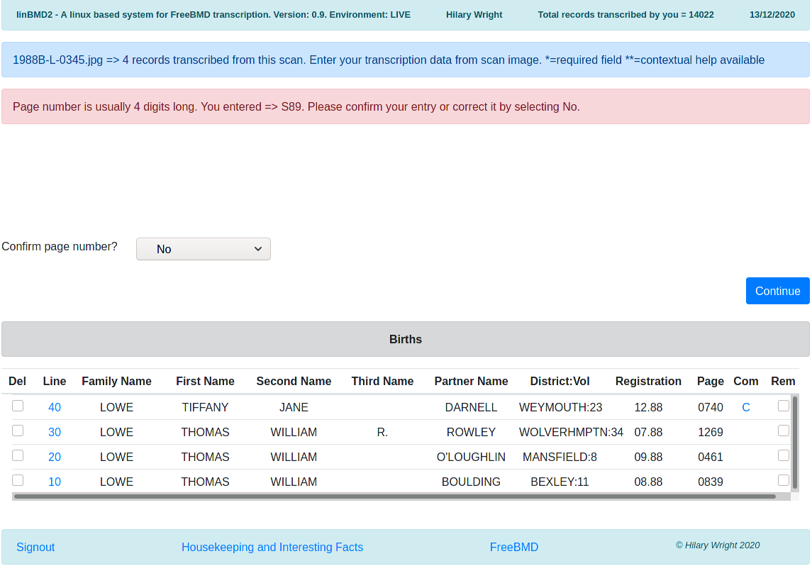
In the pink message field, you will see what you keyed.
If it is wrong, just press “Continue” button and you will return to the data entry screen to allow you to change the entry.
If is correct, you confirm the entry by selecting “Yes” in the drop-down and pressing “Continue” button and the record will be added to the history list.
The district you enter is checked against known districts in order to find its volume for the month and year you entered for the registration. If found you will see the district and its volume like this, MANSFIELD:8 in the history list.
The volume may not be found for the district you entered for two reasons,
- the district is not at all found in the database.
- The district is found in the database but there is no volume for the month/year you entered.
In the either case you will shown the following screen,
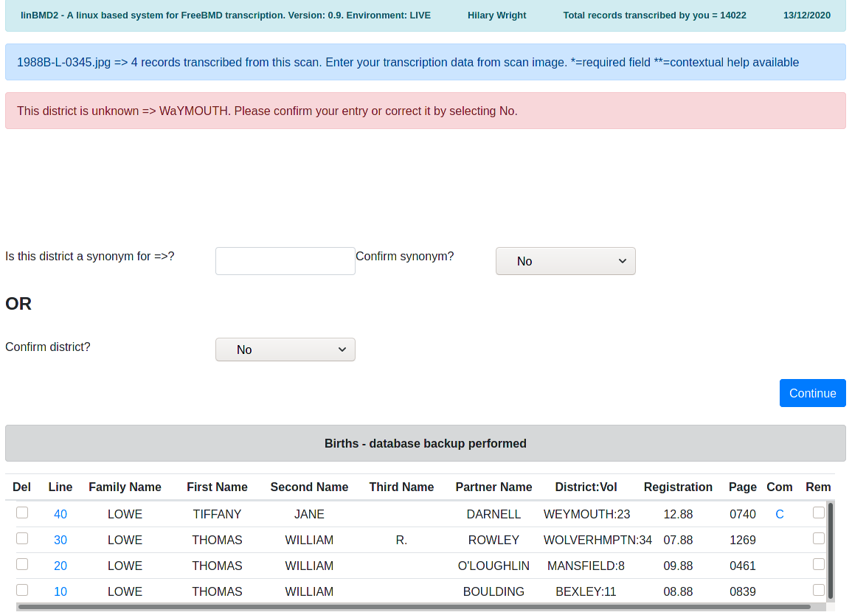
The error message shows what you keyed into the district field.
If it not correct as per the scan, you can correct it by just pressing the “Continue” button. Now you can change it in the data entry screen.
If it is correct as per the scan, it is most probably a 'synonym' for an existing district. If that is the case try to find the synonym by searching the database for the real district name. In the case above imagine that “WAYMOUTH” is a synonym for “WEYMOUTH”. You would enter “wey” into the search field, select the district, confirm the action by selecting “Yes” in the confirm synonym drop-down and pressing the “Continue” button. LinBMD2 will add “WAYMOUTH” to the database by cloning the records for “WEYMOUTH” so that, in future, “WAYMOUTH” would be considered correct. You have to be a bit imaginative to find the correct district, especially if you have, for example, “ST HELENS” on the scan. The district might be “ST.HELENS”, “ST. HELENS”, “HELSNS ST” etc. in the database. Try your hardest to find the district in the database. If you can, it will save you lots of time in the future.
If you really can't find a district for the entry on the scan (you did try, didn't you?) then you can confirm the entry by changing the 'Confirm district' drop-down to “Yes” and pressing the “Continue” button. LinBMD2 will show you the following screen,
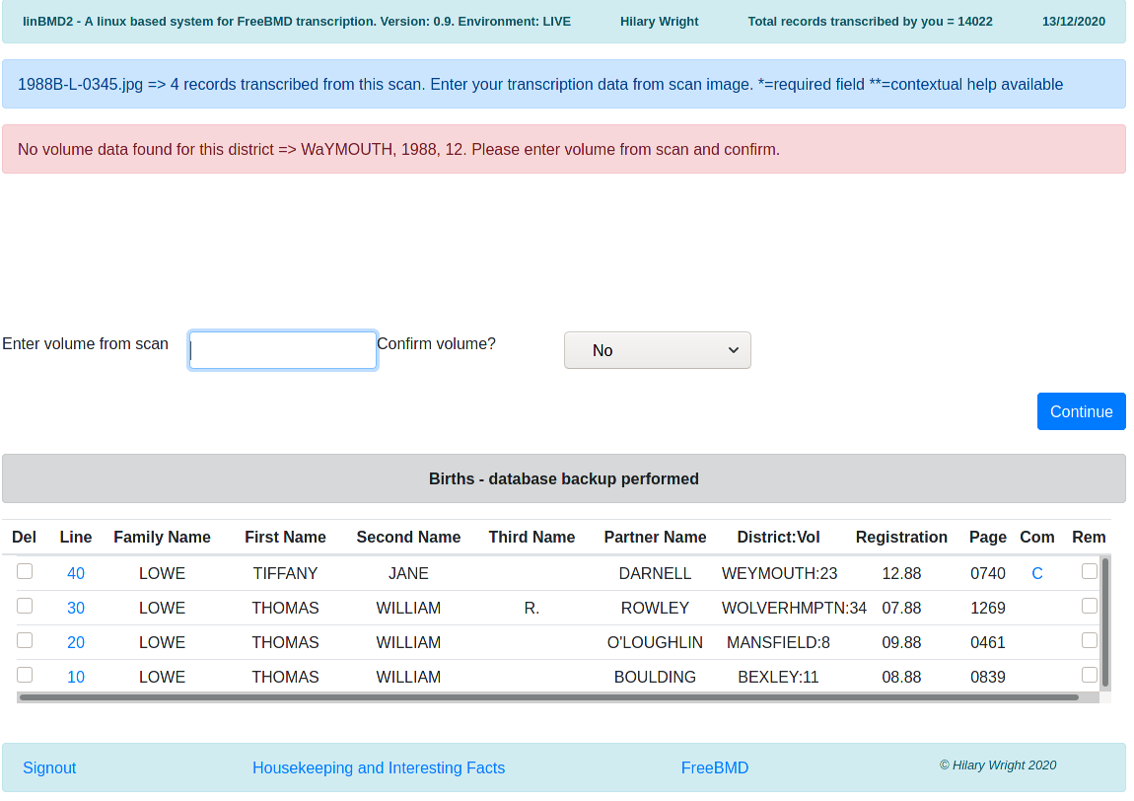
You will see that the message in pink shows you the district, year and month, check these, make sure they are what you entered from the scan.
If everything is correct, enter the volume number from the scan, confirm it and press the “Continue” button. LinBMD2 will add this volume to the districts database.
When you have completed transcribing a line, either press enter or click the “Submit” button.
The transcription history will be updated with the line you just entered.

Action Buttons
Return? = return to the previous screen.
Change the image parameters = as discussed above.
Enter Comments/Theories = enter comments or theories against the last line transcribed. Here is the screen that is shown,
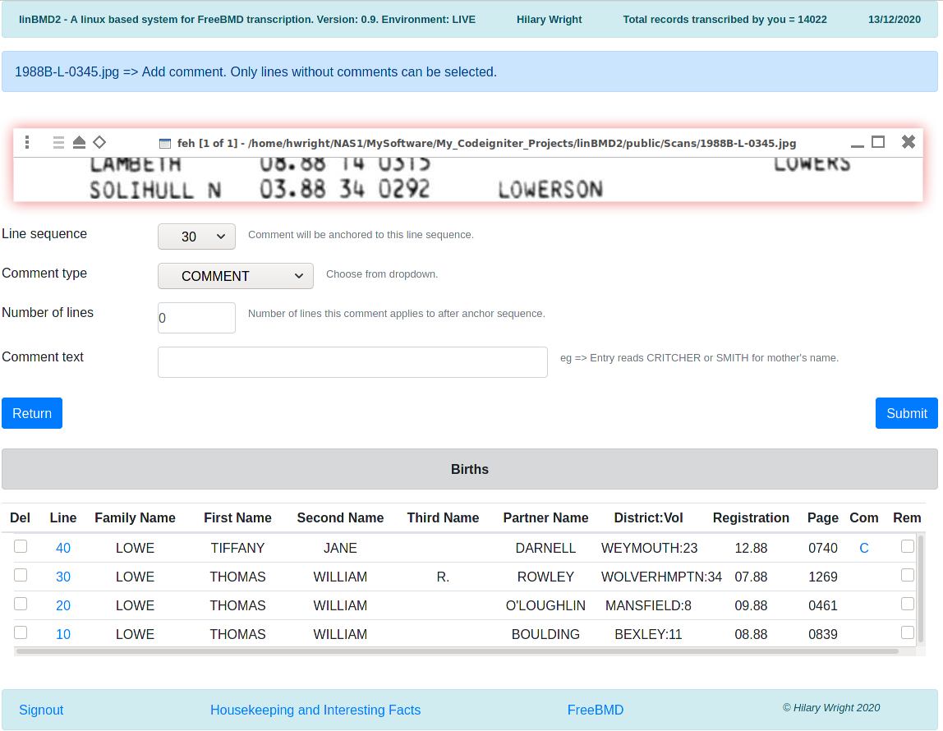
Line sequence = the line that tese commets/theories will be attached to.
The comment type = COMMENT or THEORY. Use the drop-down to select which one. See FreeBMD site for when to use COMMENT or THEORY. See here, https://www.freebmd.org.uk/comments-help.html
Number of lines = the number of lines including this one the comment refers to. So, for example if the COMMENT refers to mother's maiden name, JONE or BLACK you would enter 2 here.
Comment text = the text of the comment or the theory, ie Entry reads CRITCHER or SMITH for mother's name.
Press “Submit” button to continue.

Transcribing History
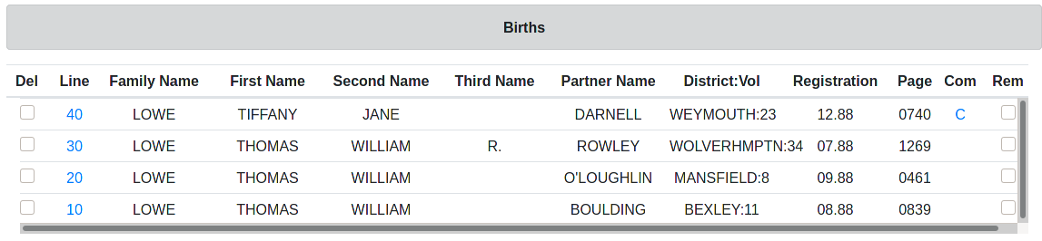
This section shows the history of the records you have transcribed so far from the scan. The title changes depending on what type of records you are transcribing. LinBMD2 performs a backup on every fifth record transcribed and when it does, the title changes to indicate that backup has been performed.
As you confirm a line transcription it is added to the history as the first record in the list, ie the list is shown in descending line sequence order. Each line is given a line sequence number.
The data shown for the line is self explanatory, however you can affect the line data by clicking or selecting different options,
Del – select the line you want to delete by clicking on the delete box against the line. This will delete the line for the transcription. Lines are not requenced so this will create a 'gap' in the sequence.
Line – click on the line to change it. Data from the line will be shown in the Data entry screen.
Com – if you entered comments a “C” will be shown here against the line. If you entered a theory, a “T” will be shown here. If you click on the “C” or “T” you will be taken to the enter Comments or Theory data entry screen.
Rem – click in the Rem box against the line to delete any remarks you made against this line.
The Line Sequence Number
The line sequence number is used by linBMD2 to sequence the lines transcribed. It is not at all used by FreeBMD and is not uploaded to FreeBMD when you upload the records from a scan. It increases in steps of 10.
If you realise that you made a transcription error on a line, you can correct it by clicking on the line number. The line data keyed will be shown in the Data Entry screen allowing you to change the data. All data entry checks will be made again.
If you inadvertently missed a line on the scan you can add it by changing the the line sequence in the Data Entry screen to something like “35” if you want to insert the line between the line 30 and 40.

Transcribing tips

- Take your time!
- Check your entries as you type.
- Use linBMD2's autocomplete.
- Key at least 3 or 4 characters in order to narrow down the autocomplete. Sometimes you'll have to type more.
- Think of the autocomplete as a “dictionary” to validate your entry.
- If the entry you are typing is not found by the autocomplete it's probably not correct. Check it!
- A good way to check an entry is to split it into 3 character sections in your mind and compare with the scan.
- Take particular care when keying and checking the page number.
- Be careful of names such as Philip and Phillip or Antony and Anthony.

