LinBMD2

A Linux based FreeBMD Transcribing Programme.

Table of Contents
Introduction 1
Licence 1
Requirements 2
Installation 2
First use 3
Architecture of linBMD2 3
Detailed Help 4
Dialogue Header 4
Dialogue Footer 4
Dialogue message area 5
The signon screen 5
Create New Identity Dialogue 6
Change your password 6
Select Header to work on 7
Create a new Transcription Header 7
Create New Allocation 8

Introduction
This document will help you to understand the structure and use of the linBMD2 FreeBMD Transcribing Programme. It is intimately linked to the FreeBMD system and its website, FreeBMD.com

Licence

Requirements
To use this programme you will need the following on your linux system,
- a linux system, eg. Debian, Fedora
- a LAMP (Linux, Apache, MariaDB, PHP)
- FEH, an image viewer
- winctrl, a window management system
- the linBMD2 software
- knowledge of the root password for your MySql or MariaDB system
If you don’t already have a LAMP installed you can find many tutorials on the web to help you install one for your distribution.
You should find FEH and winctrl in your distribution repository.
LinBLD2 software is available from the FreeBMD.com site.

Installation
Installation is simple. Follow these steps in the order they given.
- install your linux system
- make sure you have sudo priviledges
- install your LAMP
  - for Debian based systems here is a good tutorial for this, https://www.tecmint.com/install-lamp-on-debian-10-server/
  - for Fedora, https://computingforgeeks.com/how-to-install-lamp-stack-on-fedora/
  - for Ubuntu, https://www.itzgeek.com/post/how-to-install-linux-apache-mariadb-php-lamp-stack-on-ubuntu-20-04/
- make sure you secure your mariadb database server and adjust your firewall as necessary
- install FEH and winctrl using your package management system.
- download the linBMD2 software
- unpack the linBMD2 software to a directory of your choice
- Make the linBMD2.install programme executable.
- Run the programme linBMD2.install. This will,
  - Verify that the required software is installed
  - it will copy the linBMD2 software to its run directory
  - set up the database
  - initialise the database
  - create a desktop icon
- Once the above steps are done the system is ready to use.

First use
To use linBMD2 you must have an account on FreeBMD and belong to a syndicate. Go to FreeBMD.com to start the registration process. Once you are registered you will be allocated some scans to transcribe by your syndicate leader; this is called an allocation in linBMD2.
To start using linBMD2 make a note of your FreeBMD user name and password. These will be required on each signon to linBLD2.

Architecture of linBMD2
linBMD2 is designed around the concept of a scan “header”. See the diagram below,
Header
Allocation
User
Syndicate
Scans
Detail transcription records
Upload to FreeBMD

A user is you. The system asks you to register you name, email, FreeBMD user name and password. This is essential information required to interact with the FreeBMD system.
A syndicate is the syndicate you belong to. You can belong to more than one syndicate at the same time.
The allocation is the list of scans that have been allocated to use to transcribe by your syndicate leader. It will be something like, “1988 Births, pages 301 to 392, from the L surnames”. You can have multiple active allocations at any one time.
The header is created for each scan you start transcribing. It contains information about the scan, how many records you have transcribed so far from the scan; whether the transcribed data has been uploaded to FreeBMD and if so what was the upload status. You can have multiple headers open at any one time.
The detail line by line transcriptions are held in the detail transcription database.
The detail lines are used to upload the data to the FreeBMD server.
Once a header has been successfully uploaded to the FreeBMD server you can close it.

Detailed Help
Each of the linBMD2 dialogues has a header, a message area, a body and a footer.

Dialogue Header
The dialogue header looks like this,
Total records transcribed
Linbmd2 title, version and environment
Your name
Today’s date

Dialogue Footer
The dialogue footer looks like this,
Click to return to signin dialog
Go to FreeBMD

Go to housekeeping menu
Copyright

Dialogue message area
The dialogue message area has two parts, the dialogue purpose and any error messages, It looks like this,
Dialogue purpose and brief instructions

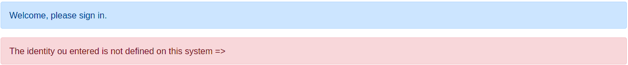
Error messages, these can be very detailed

The signon screen
When you start the system you will be asked to signon. You need to enter you FreeBMD user name and password.
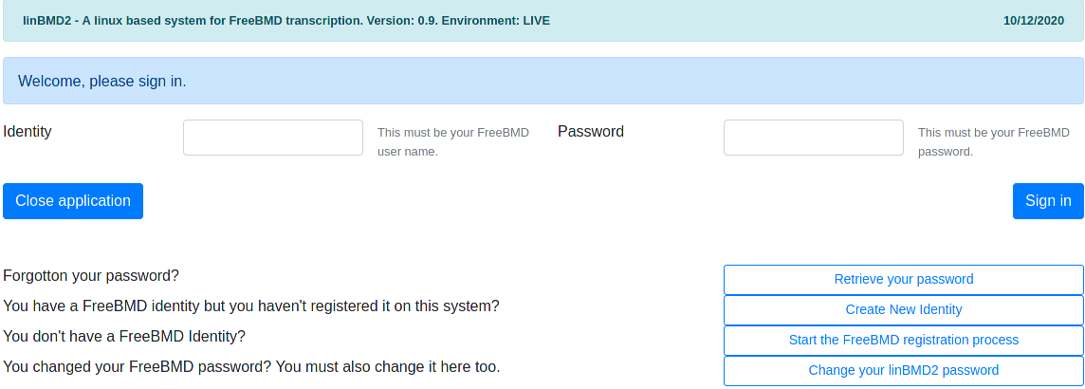
Identity = your FreeBMD user name
Password = your FreeBMD password
Press “Sign in” to complete the sign in process.
If you have forgotten your password, press the “Retrieve your password” button. You will be shown a dialogue asking you to enter your FreeBMD identity and your email. The email will be checked against the email held against the identity you created using the “Create New Identity” option. If the email entered is valid, you will be sent an email message with your password.
If this is the first time you use the system, you will need to register your identity. Do this by pressing the “Create New Identity” button.
If you changed your FreeBMD password on the FreeBMD site, you need to change it here too. To do that press the “Change your linBMD2 password” button.

Create New Identity Dialogue

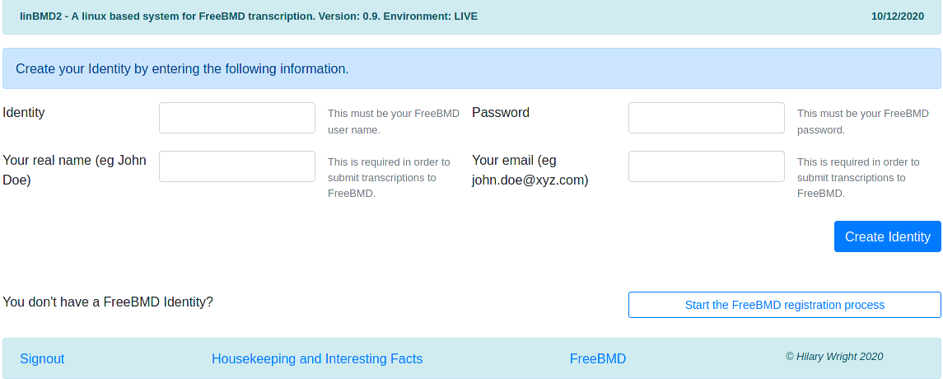
Enter your FreeBMD identity and password. These will be validated against the identity held on the FreeBMD server.
Enter your real name. This will be shown in the header and will be used to upload transcribed data to FreeBMD.
Enter your email. This is required for uploading to FreeBMD.
If you don’t yet have a FreeBMD idenity, press the “Start the FreeBMD registration process” button. You will be taken to the FreeBMD web site. You can also start this process from the signon screen.

Change your password

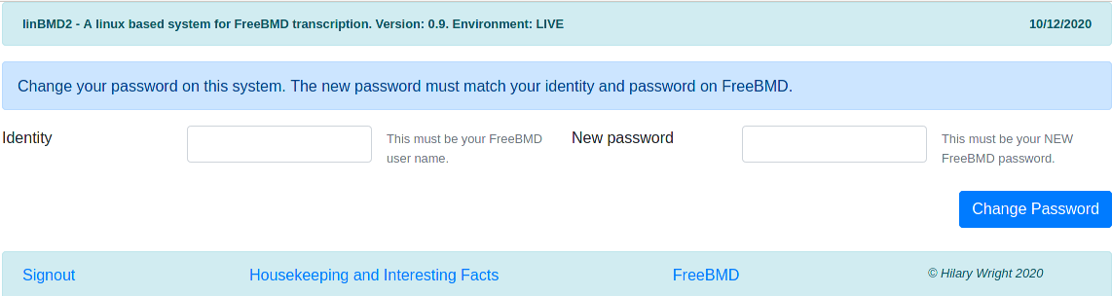
If you changed your FreeBMD password, you MUST change it in linBMD2 too. If you don’t you will not be able to signin to linBMD2.

Select Header to work on
When you have successfully signed in you will be asked to select a header to work on. If this is your first use of the system you will need to create a new header.
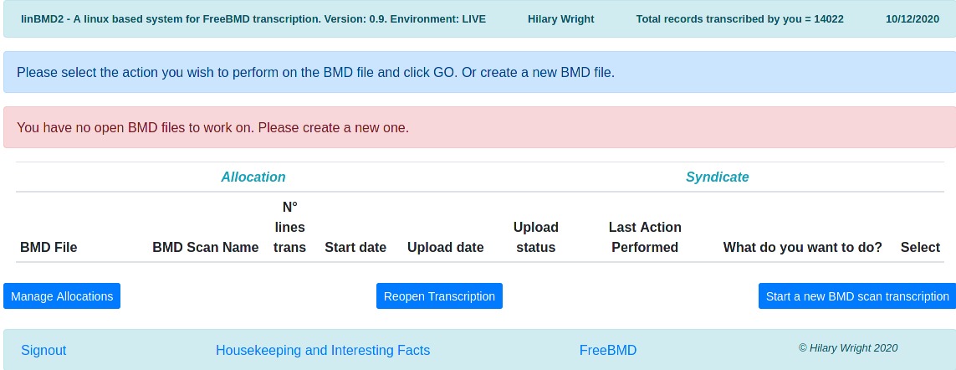
Click the “Start a new BMD scan transcription” button to create a new Header.

Create a new Transcription Header

You will notice that the system tells you the last header which you successfully uploaded to FreeBMD and its scan name.
First choose the syndicate that you are working for. Syndicate names are downloaded from FreeBMD and stored locally for faster access. You can refresh the list of syndicates by selecting the “Refresh Syndicates” button. You cannot create a syndicate; to use one it must first exist in FreeBMD. Remember that you can be working for more than one syndicate at a time.
Now choose the Allocation this header is attached to. If you are starting a new allocation received from your syndicate leader, you will need to create it first. Press the “Create new Allocation” button to do this.
Enter the page number of the header you are starting.
Generally you should leave the “Auto create scan name” and “Automatically download the scan from freeBMD” alone. If you know that your scan name is in some way particular, you can enter it manually. In this scan you should manually download the scan.
Once the required information is entered linBMD2 will create the allocation. It will verify that the scan is in the syndicate scope.
When you have successfully created an allocation you will be returned to the “Select Header to Work on” screen.

Create New Allocation

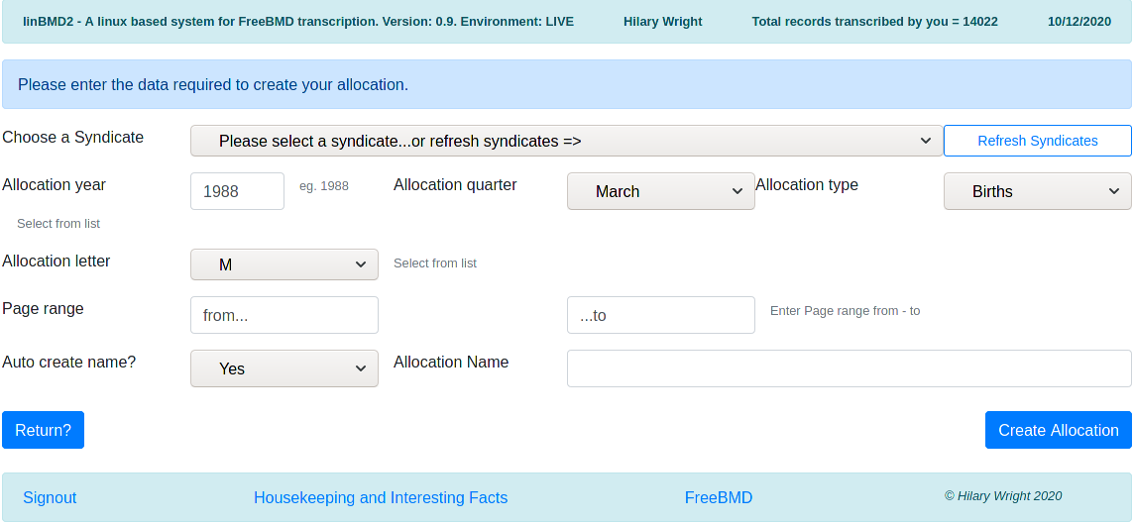
Every allocation must be attached to a syndicate, so choose the syndicate from the drop down list. You can also refresh the syndicates from here by pressing the “Refresh Syndicates” button.
Enter the year the allocation is from and the quarter.
Allocations are year based or quarter based. Scans belonging to a year based allocation are all held by the year on FreeBMD. Those that are quarter based are held by quarter on the FreeBMD server.
Allocation types are Births, Deaths, Marriages. Select the one that applies.
Select the letter. Sometimes this can be, for example, AB. More often just a single letter.
The allocation page range.
The system can automatically create the allocation name. Generally you should let the system generate the name, but if for any reason you wish to create it yourself, just enter the name you want in designated field.
Once the data entered the system will make sure that the allocation is in the scope of the syndicate and will identify the path to the scans on the FreeBMD server. If linBMD2 finds an ambiquity it will ask you to clarify from some choices. This can occur several times as the system navigates the path to the scans.
When the allocation has been created you will be returned to the Create Header dialogue.

