Linux proj.2

Pharmacy management system (shell scripting)

Lina hamad 1231412

This is a sample test cases from running the inventory menu’s options:

This is how the dialog main menu shows:

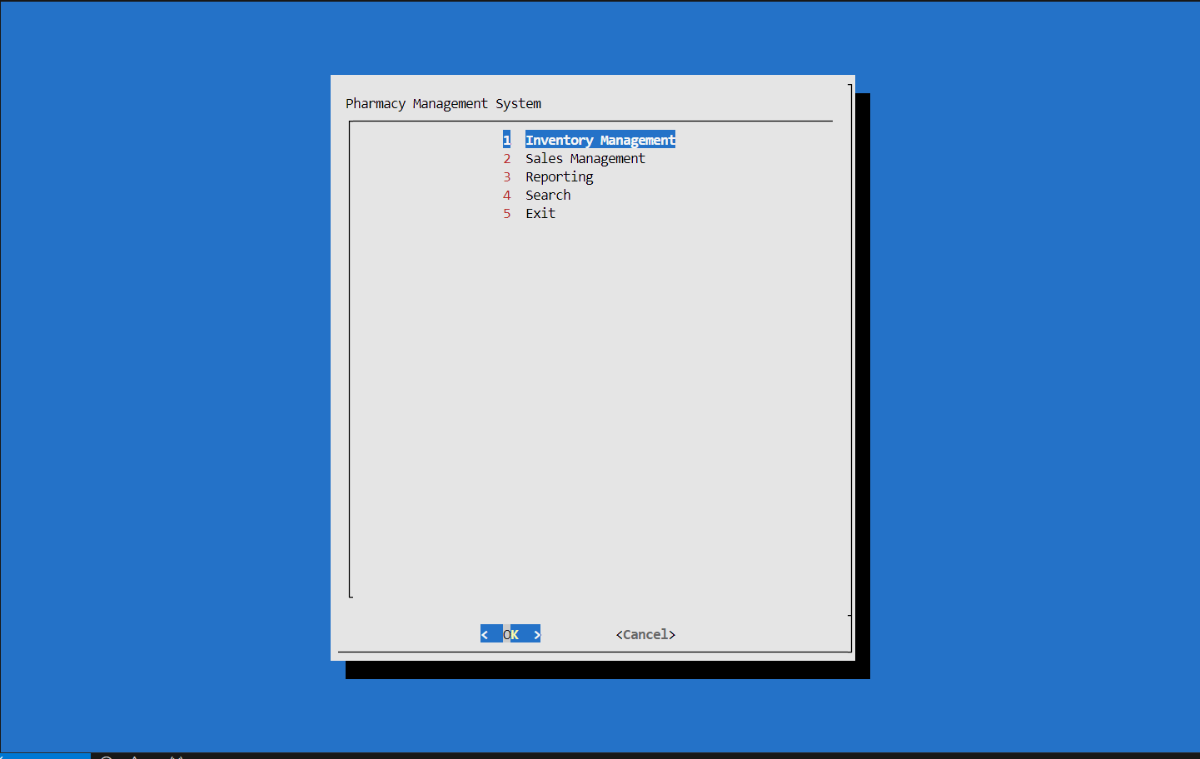

Chose tp add a medicint to the inventory file that contains 5 medicines

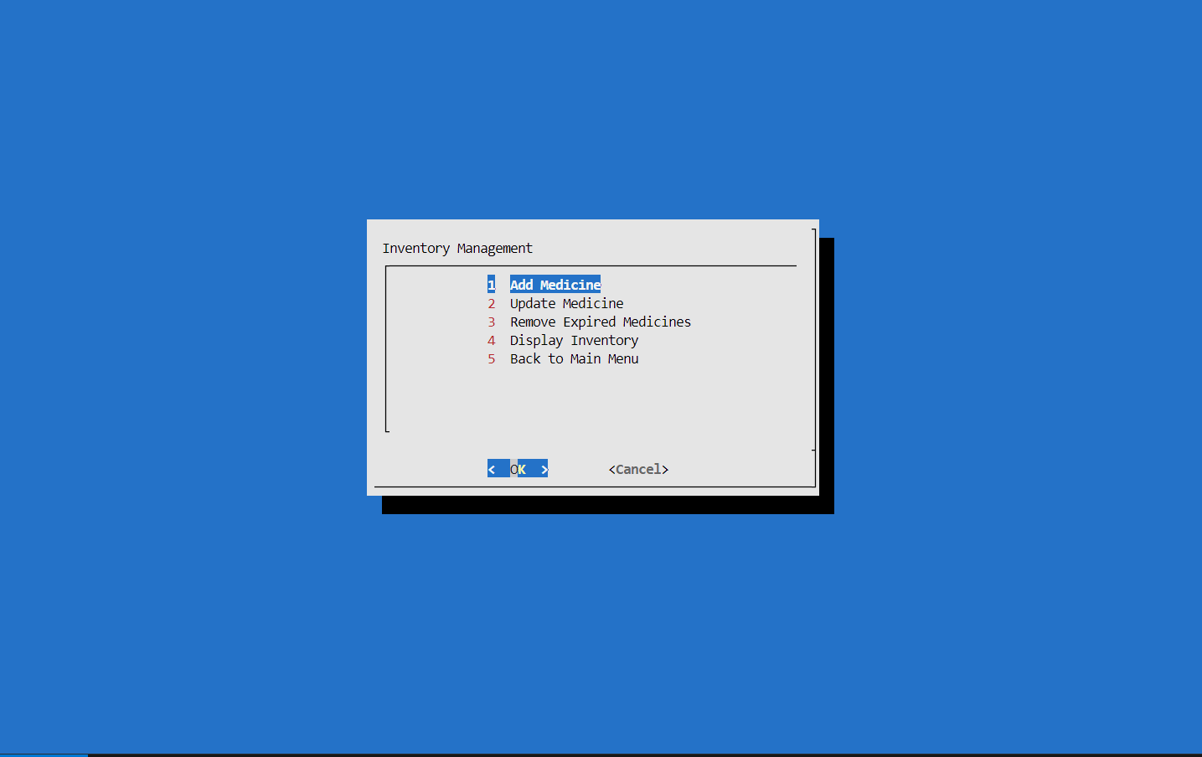

This is how the new data is being added to the file:

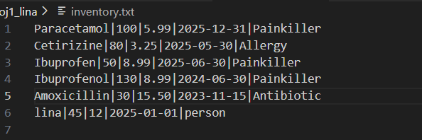

Then I chose to update the quantity and price for the new added data:

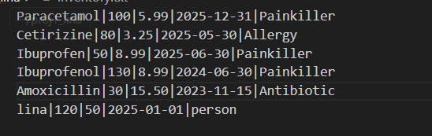

Then chose to remove the expired medicines before 2025-05-01

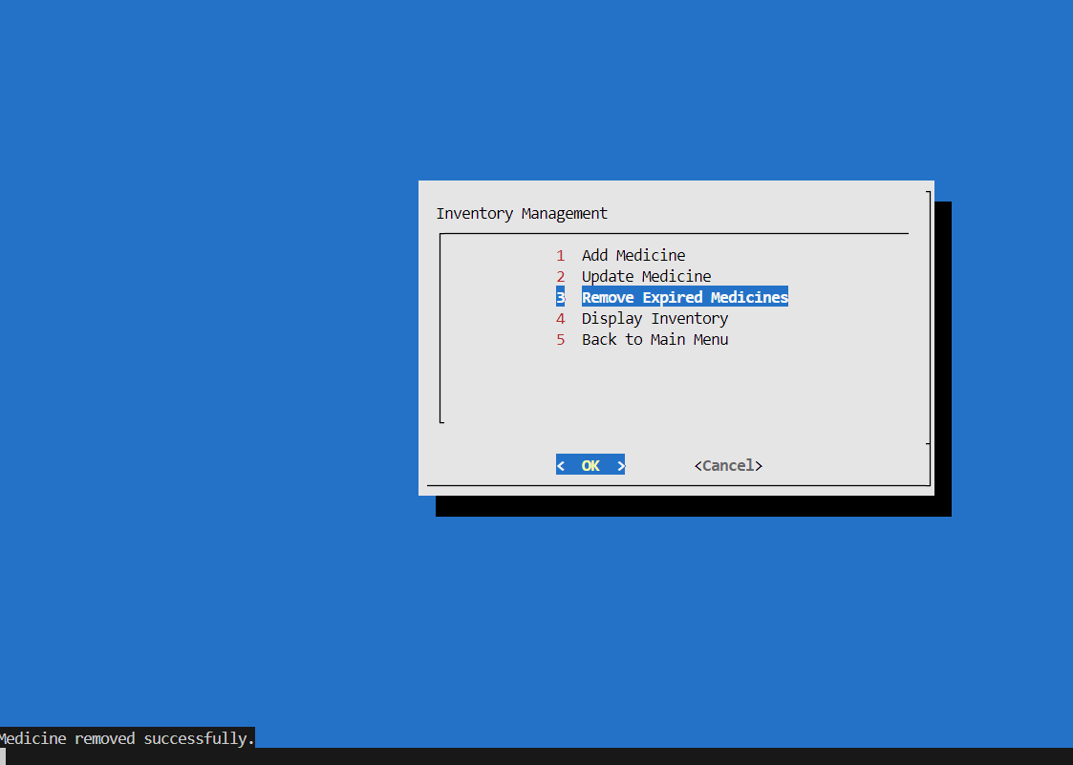

This is how they got removed from the inventory fille and added to the removed medicins file so it can be shown later on

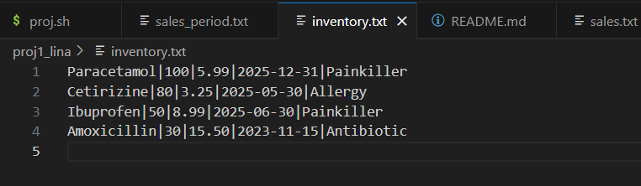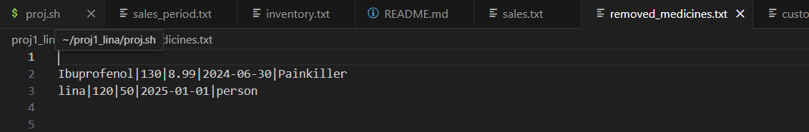

Then chose to display the current inventory medecines:

