Page 0
Exempt letter

Page 1
Thank you for participating in our study!
In this study, you will be listening to three stories one segment at a time and asked to rate your feelings on a valence (negative to positive)-by-arousal (low to high) grid. At the end of each story, you will be asked comprehension questions. The experiment will be less than an hour.

Click the arrow button to see examples of using the rating grid.

Page 2
You can rate your feelings using the valence-by-arousal grid below. The horizontal axis represents valence and ranges from negative (left) to positive (right). The vertical axis represents arousal and ranges from low (bottom) to high (top). You can click any location on the grid that you think best describes your feeling.
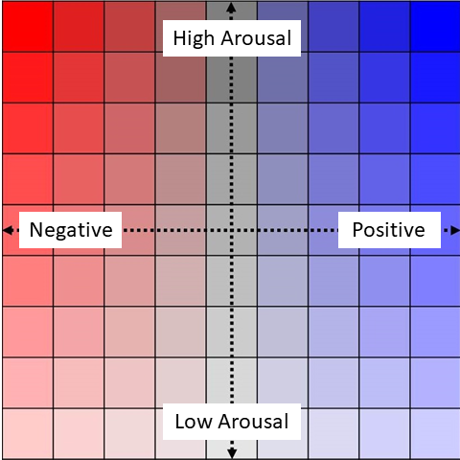
Click the arrow button to see some examples.

Page 3
You will listen to a segmented story. For example, the sentence “I was going to become the first private citizen to ever fly into space” will be divided into three segments:
- Segment 1: [I was going]
- Segment 2: [to become the first private citizen]
- Segment 3: [to ever fly into space.]
For the first segment, “I was going,” you may feel neutral and calm, as it contains no strong emotional content. In this case, you might click somewhere in the bottom-middle portion of the grid.
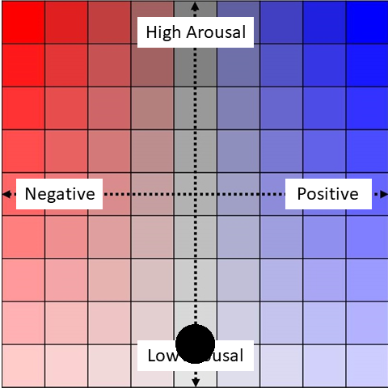
For the second segment, “to become the first private citizen,” you may feel curious and excited, as it suggests a groundbreaking achievement. You might click in the upper-right portion of the grid to reflect these positive and high-arousal emotions.
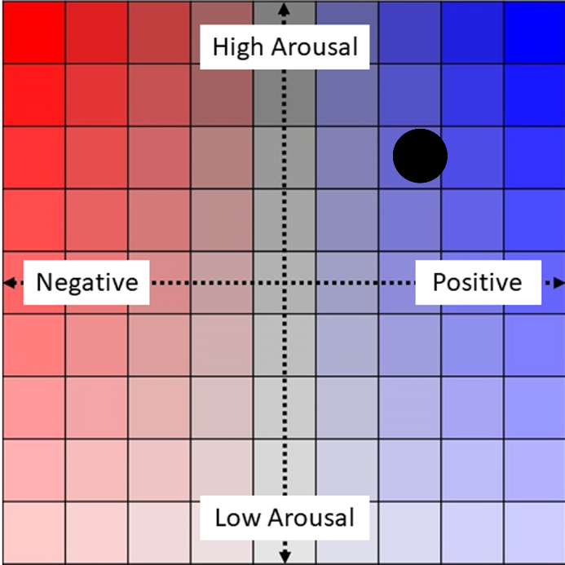
For the third segment, “to ever fly into space,” you may experience a stronger sense of thrill and excitement because of the space travel. You might click in the upper-right portion of the grid to reflect these positive and high-arousal emotions.
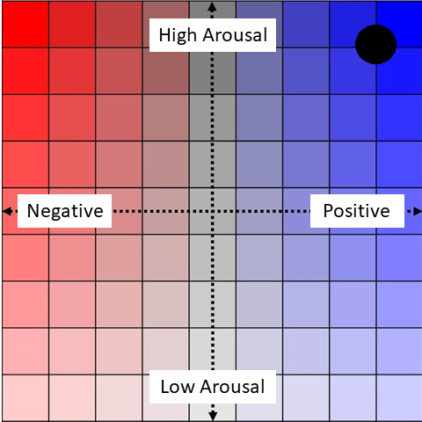
Conversely, some people may experience a sense of anxiety when listening to this segment, given the vastness and risks of space travel. In this case, you might click in the upper-middle the upper-left portion of the grid to reflect these negative and high-arousal emotions.
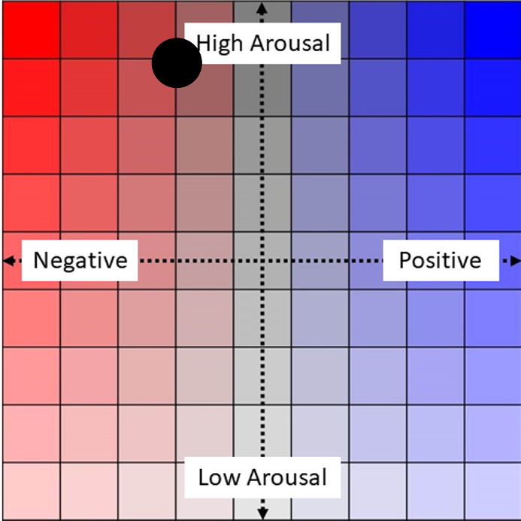

Page 4

For another example, you will listen to the sentence "Then came the 2001 internet stock market crash, and with it went all of my wealth" in segments.
- Segment 1: [Then came the 2001 internet stock market crash,]
- Segment 2: [and with it went all of my wealth.]
For the first segment, “Then came the 2001 internet stock market crash,” you may feel shocked, as it signals a sudden and significant financial downturn. You might click in the upper-left portion of the grid to reflect these negative and high-arousal emotions.
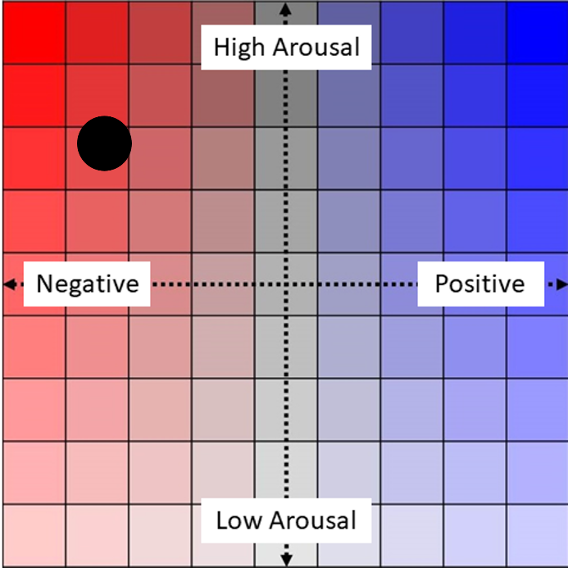
For the second segment, “and with it went all of my wealth,” you may feel devastated, sad, or hopeless, knowing that the narrator’s plans for space travel were abruptly derailed by the crash. This unexpected loss may evoke a deep sense of despair. You might click at the upper-left extreme of the grid to represent these overwhelmingly negative emotions.
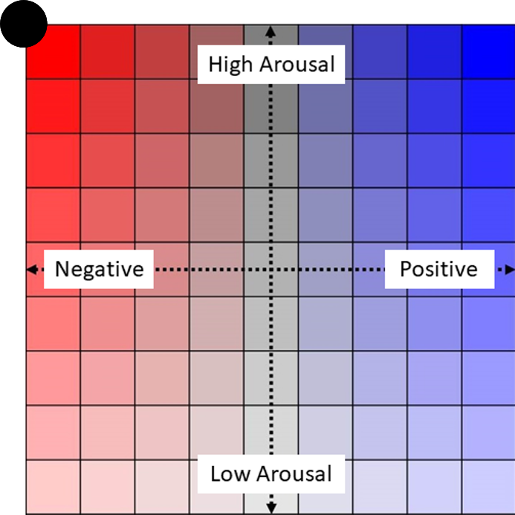

Page 5
The following paragraphs will give you an idea of the range of valence and arousal ratings that you will encounter. Please use it to calibrate your ratings so that you will use the full range of the rating scale.
Lucy was all nerves as she walked out onto the middle of the stage, where there was nothing but a microphone and her. As the curtains began to part, she thought to herself that she could not go through with this and that she was not confident enough to put herself before the judging audience.
Lucy began to sing, and all the pain and confusion that the messages had been causing inside Lucy just flowed out. When the song finished and the last note died away, Lucy opened her eyes. To see the whole audience on their feet and the hall filled with cheers and applause was not what she had expected. Lucy allowed herself to enjoy the sense of achievement and belonging that she had not felt in a very long time.

Page 6
To emphasize, different people may have different feelings when listening to the same story. Please rate based on your own feelings inside when you listen to the segment, rather than how you expect to feel or how you should feel about the segment.

Page 7
You will listen to a sentence in segments and rate your feelings as a practice session to familiarize yourself with the experiment paradigm.

