Andrew Lin

Applied Programming Concepts

**Assignment 2**

**Incremental Model**

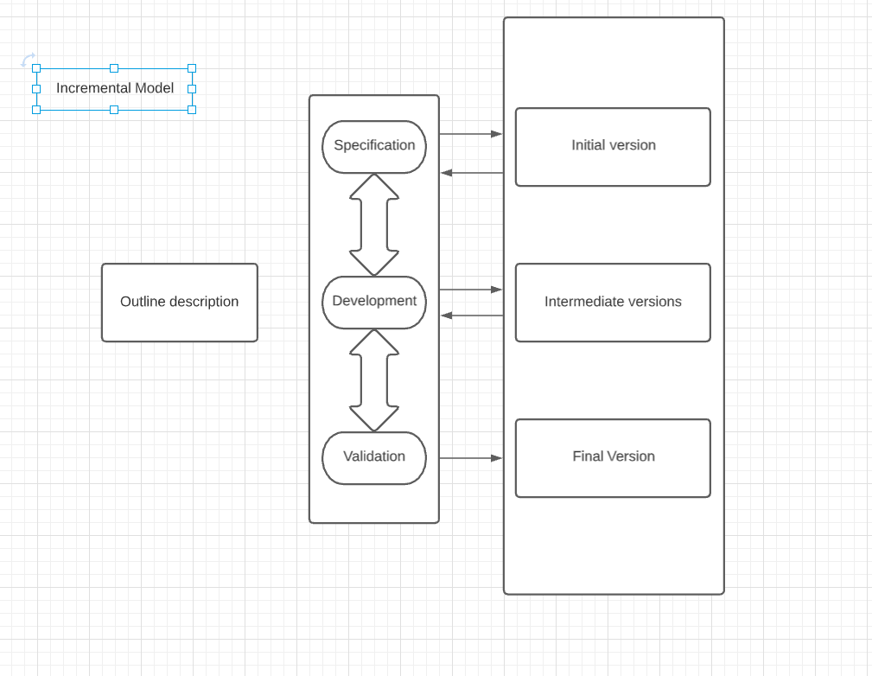

**Figure 1: Incremental Model Diagram**

Due to the nature of the incremental model, specification, development, and testing phases are interleaved instead of distinct so all of those steps will be alternated within each version.

**Initial version:** The initial version of the scheduling program, must include the database of users and course information. The student should be able to add/drop courses, search for courses, as well as view their schedule. The instructor must be able to search through their courses, see their course roster, and view their schedule as well. Finally, the admin would be allowed to add/remove users, add/remove students from a course, add/remove courses from the system, and search for rosters and courses. The initial version will start off with only one semester rather than multiple semesters. Overall, the initial version will have the just the basic functions needed for a scheduling system for a university. This version will most likely take around a month or a little bit more since it has the most work.

**Intermediate versions**: Intermediate versions will add onto the initial version with features that are not essential for a scheduling system of a university. It is within these versions that the printing out of schedules and scheduling preferences would be implemented. The admin being able to print out the rosters and the instructors being able to print out their class lists would also be implemented within these versions. These versions will most likely take 3 weeks to a month due to having multiple versions.

**Final version:** This version will include features that can only be implemented after making sure all the other parts of the scheduling system are working correctly and all the features have been added. This would include features such as making it available for multiple semesters. This final version should take the least amount of time and would be around 2-3 weeks.