Andrew Lin

Applied Programming Concepts

**Assignment 2**

**Integration and Configuration**

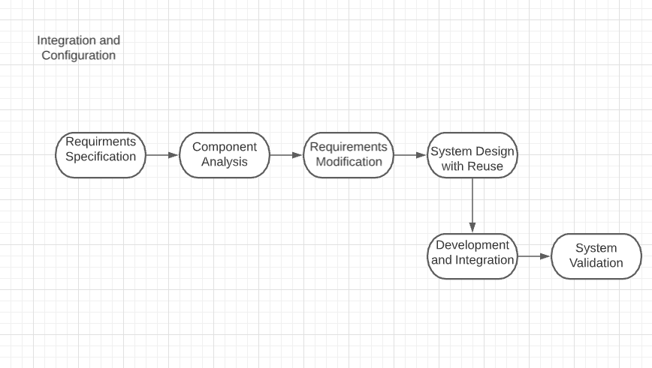

**Figure 1: Integration and Configuration Diagram**

Due to the nature of Integration and Configuration, existing software will be found online that could be used for the university scheduling program.

**Database**

An example of a COTS software that may be used within the project is QuickBase. This software can be used as a piece to create the database that would be used for containing information about the CRN, Course names, times, and instructor, as well as the database for the user. Time spent implementing the database could take anywhere from around a day to a week depending on how long it will take to have all the information needed in the database.

**UI**

When I work is a COTS software that could be implemented within the program. Since when I work is a software that helps businesses schedule, track time and attendance. Some features from this software could be used such as the scheduling system as well parts of the UI for when a user would look at their schedule. Time for this would only be about a day or 2 after purchasing the software, there will be time spent cherry picking what parts would be used in the When I Work scheduling program and the university scheduling program.

**Sources**

Quickbase. “Create a Database in Quickbase.” *Quickbase*, www.quickbase.com/lp/solutions/database?utm_medium=sponsored-content&utm_campaign=database-management&utm_content=ppc-listing&cat=database&utm_source=capterra.

“Cap: When I Work.” *Cap | When I Work*, wheniwork.com/l/cap?ref=capterra&utm_campaign=Scheduling&utm_medium=Directory&utm_source=capterra.