Andrew Lin

Applied Programming Concepts

**Assignment 2**

**Waterfall Model**

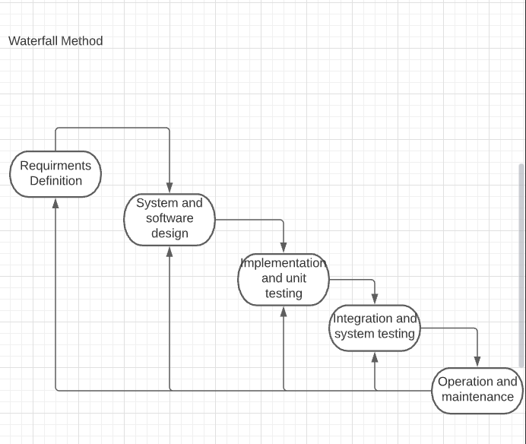

**Figure 1: Diagram for the Waterfall model**

Due to the nature of the Waterfall Method, each phase will not start until the previous phase has been finished.

Step 1: **Requirements Definition**

This step will start by establishing the services, constraints, and goals of the of the scheduling system started in Assignment 1. The service that would be provided would be a scheduling system that students, instructors, and admins can use to search for classes, add/drop classes, print schedules, add/remove courses or users from the system, add/remove a student from a course, and print class lists and rosters depending on whether the user is a student, instructor, or admin. This is similar to the system for LeopardWeb. The constraints will be that the system is limited to work for 100 students, 10 instructors, and 1 admin. However, it will be tested with fewer than that. The goal of the system is to be an effective course schedule program similar to the one on LeopardWeb. The duration of this step would only last at least about an hour to a day to finalize.

Step 2: **System and Software Design**

This step will establish the overall system architecture and define the fundamental software abstractions and relationships. The overall system architecture will have a database of the users and courses with course information. In this program, the base class will be a user class with the attributes of the first name, last name, and ID of the user. The type of user will be derived with this base class and each have functions of their own to satisfy the needs of the defined user. This step would only last about a day or two.

Step 3: **Implementation and unit testing**

This step will be when the code is written and the components will be tested. Implementation of the code is self-explanatory and the components will tested individually to make sure that each component of the program is working as intended individually. The components to be tested individually in this program will be the database, the functions of the user class and the 3 derived classes, the functionality of multiple semesters, and scheduling needs such as printing out schedules and schedule preferences. This step of the program will take much longer than the previous two steps, about 1 to 2 months.

Step 4: **Integration and system testing**

This step will be when the components are all integrated into a single system and the overall system is tested. All of the individual components of the program will be integrated together and tested to see how well each of the components work together and if any issues arise that didn’t show up when each of the individual components were tested. This may include if the database of information is able to be pulled by the classes, if the schedule with the correct information is being printed out when printing a schedule, and much more. This step may take a while depending on how many errors may arise. I would say the duration should be about 2-4 weeks.

Step 5: **Operations and maintenance**

This step will be when the program is able to be installed and used and bug fixes and updates for the program will be made. Bug fixes and updates may not be predictable for when they occur, so the duration of this step will be undefined and may be for as long as the program is used. Installation to use the program should only take a couple of minutes to an hour however.