

**System Test Report**

**System Test Report**

**Project name: LGSTX DATA VISUALIZATION**

**Date**: 11/30/2021

**TABLE OF CONTENTS**

|  |  |
| --- | --- |
| Section Testing 3  USPS Section 3  Login 3  Add Data to USPS Section 4  Search and View Data 5  Update Data 6  View Export Report 7  Export Date Selection 8  Export Data 9  Logout 10  Admin Testing 11  General Admin Testing 11  Manage Users tab 11  USPS Section 17  Access USPS data 17  Filter USPS data by date 18  Export USPS data 19  View USPS data for a specific data 20  Edit USPS data for specific date 21  Manager Testing 23  USPS Section 23  Select USPS section from the manager overview 23  View USPS chart for a specific date 24  View Chart data between specific dates 25  View Chart data for Total Hours between specific dates 26 |  |
|  |  |

# Section Testing

## USPS Section

### Login

* 1. Description: Logging into the USPS section from the login page
  2. Valid Test Inputs: Username: usps Password: 1234
     1. 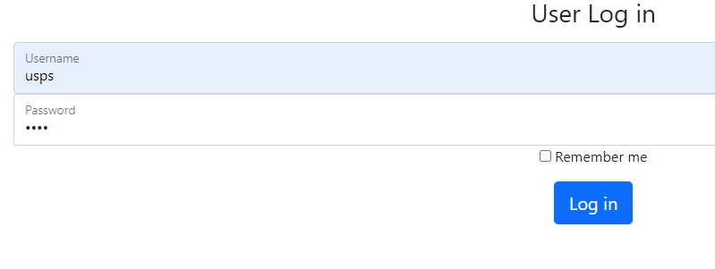
  3. In-Valid Test Inputs: Username: Sparta, Password: 1234
     1. 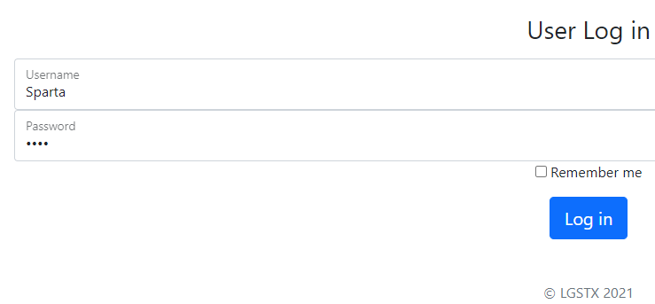
  4. Lina Albassam
  5. 12/11/2021
  6. Results
     1. Did it pass? Yes
        1. Valid input results

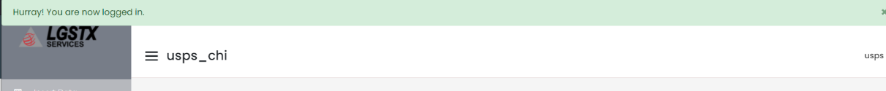

* + - 1. Invalid input results

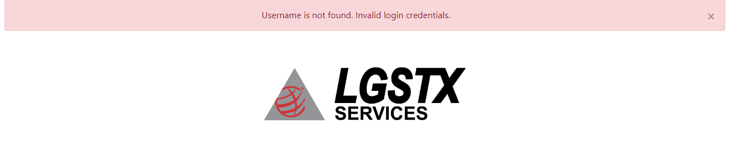

### Add Data to USPS Section

* 1. Description: Add data to the USPS section as an authorized user.
  2. Valid Test Inputs: 1 for all fields

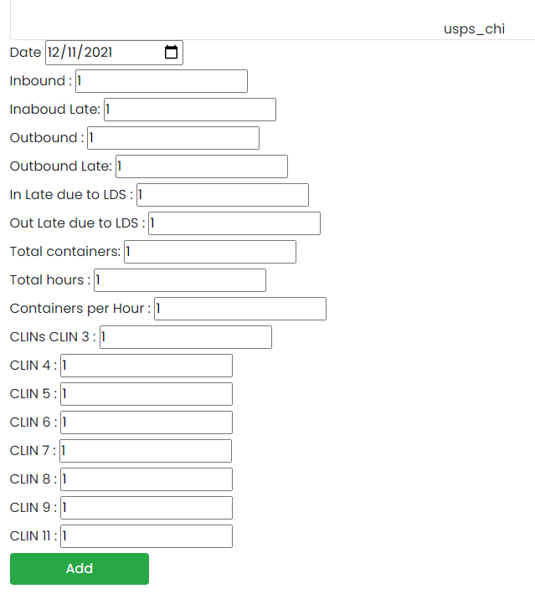

* 1. In-Valid Test Inputs: User tried to enter non number inputs
  2. Lina Albassam
  3. 12/11/2021
  4. Results
     1. Did it pass? Yes
        1. Valid input results



* + - 1. Invalid input results
         1. The non-digit inputs were not registered thus passing the test.

### Search and View Data

* 1. Description: The user tried to retrieve and view the data enter above.
  2. Valid Test Inputs: Date: 12/11/2021

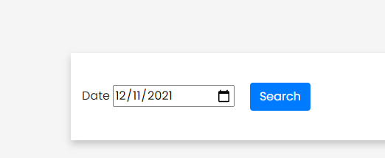

* 1. In-Valid Test Inputs: The user did not select a date

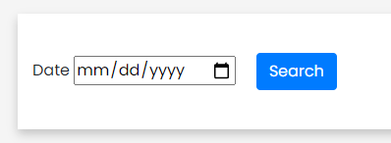

* 1. Lina Albassam
  2. 12/11/2021
  3. Results
     1. Did it pass? Yes
        1. Valid input results

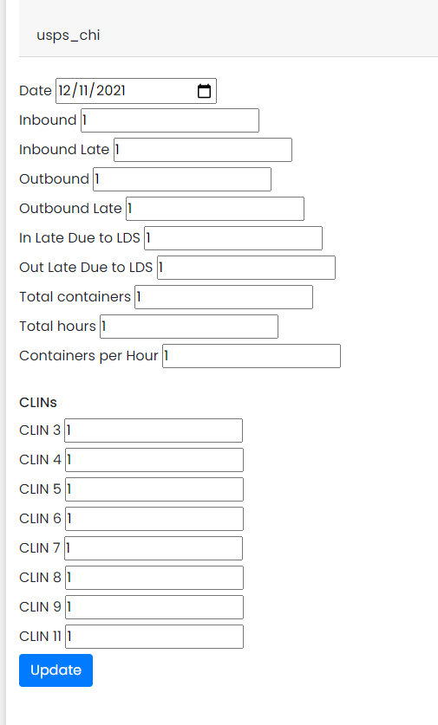

* + - 1. Invalid input results

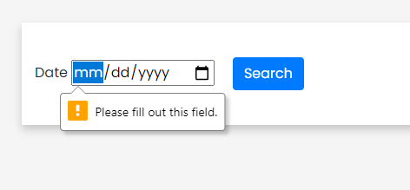

### Update Data

* 1. Description: The user retrieved the data and updated it to new values.
  2. Valid Test Inputs: replace the 1’s with 2’s

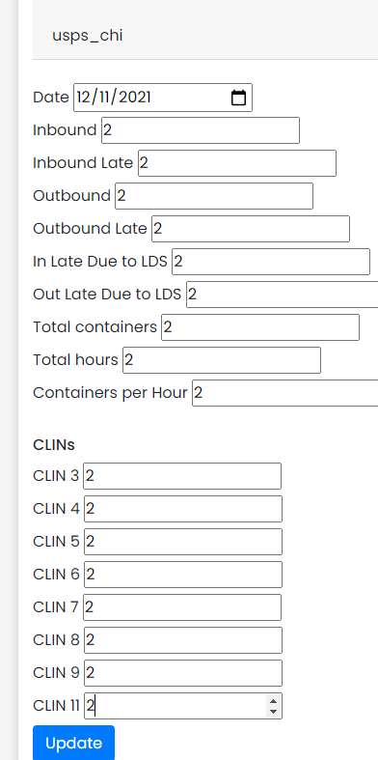

* 1. In-Valid Test Inputs: N/A
  2. Lina Albassam
  3. 12/11/2021
  4. Results
     1. Did it pass? No
        1. Valid input results

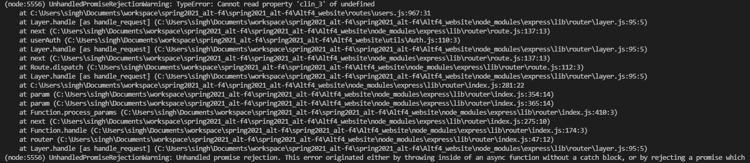

* + - 1. Invalid input results N/A

### View Export Report

* 1. Description: This test checks if the user can view all the data in the export report
  2. Valid Test Inputs: The user can click on the export report button

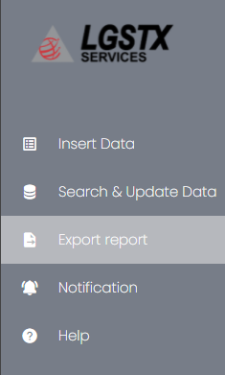

* 1. In-Valid Test Inputs: N/A
  2. Lina Albassam
  3. 12/11/2021
  4. Results
     1. Did it pass? Yes
        1. Valid input results

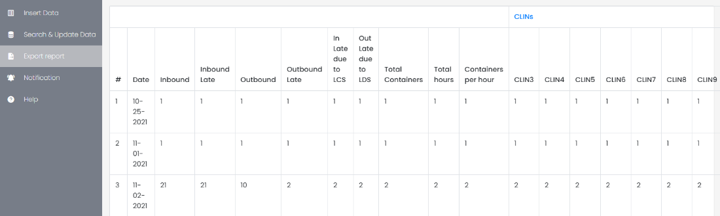

* + - 1. Invalid input results: N/A

### Export Date Selection

* 1. Description: The user can narrow the results in the export section by picking two dates
  2. Valid Test Inputs: 11/01/2021 - 1/08/2021

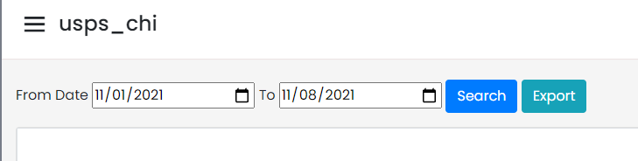

* 1. In-Valid Test Inputs: N/A
  2. Lina Albassam
  3. 12/11/2021
  4. Results
     1. Did it pass? Yes
        1. Valid input results

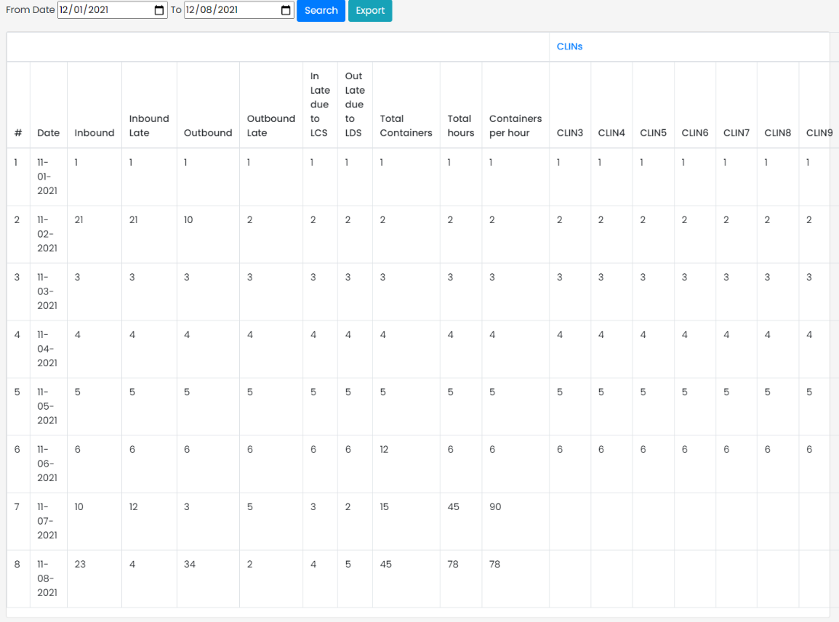

* + - 1. Invalid input results N/A

Export Data

* 1. Description: The user can export the data between two selected dates as an excel spreadsheet.
  2. Valid Test Inputs: 11/01/2021 - 11/08/2021



* 1. In-Valid Test Inputs: N/A
  2. Lina Albassam
  3. 12/11/2021
  4. Results
     1. Did it pass? Yes
        1. Valid input results

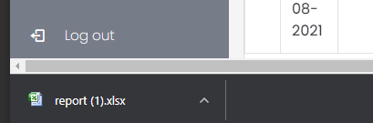

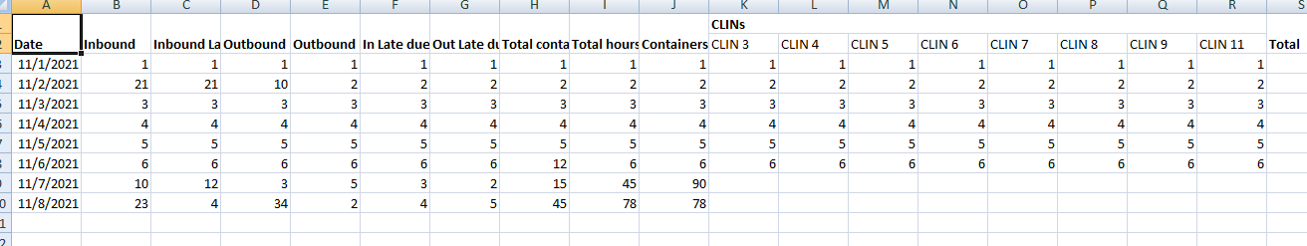

* + - 1. Invalid input results N/A

### Logout

* 1. Description: The user can successfully log out of the application and get sent to the login page
  2. Valid Test Inputs: The user is able to click the logout button



* 1. In-Valid Test Inputs: N/A
  2. Lina Albassam
  3. 12/11/2021
  4. Results
     1. Did it pass? Yes
        1. Valid input result

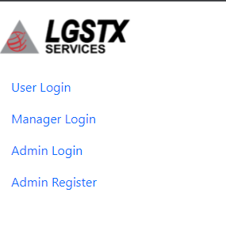

* + - 1. Invalid input results N/A

# Admin Testing

## General Admin Testing

### Manage Users tab

* 1. Description: Allow new users to be added, allow to change name and email and deleting the user of the department.
  2. Valid Input: Underlined in red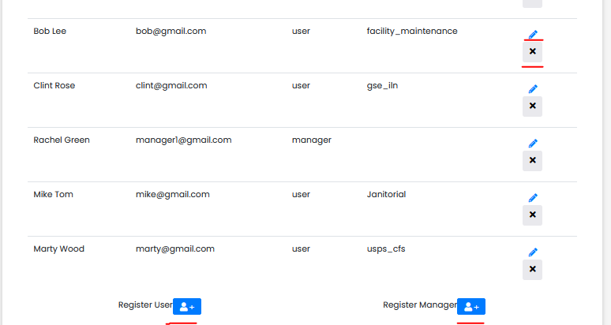
     1. Results:
        1. Did it pass? yes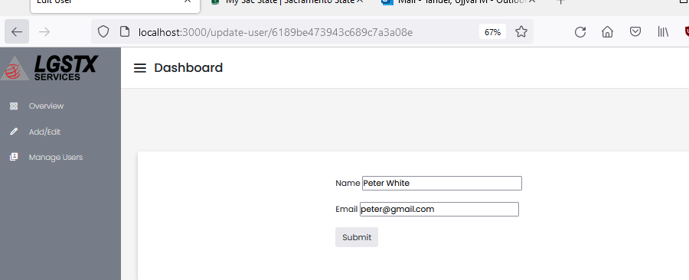
        2. Remove user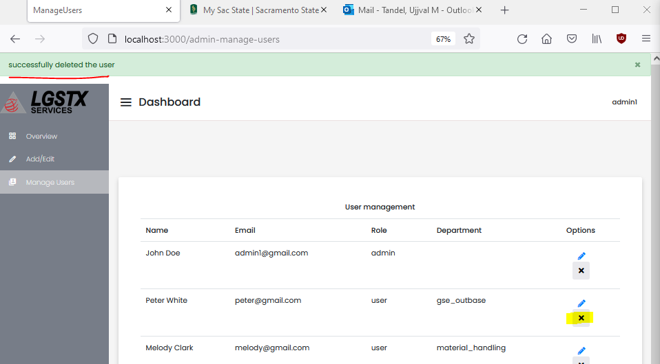
        3. User register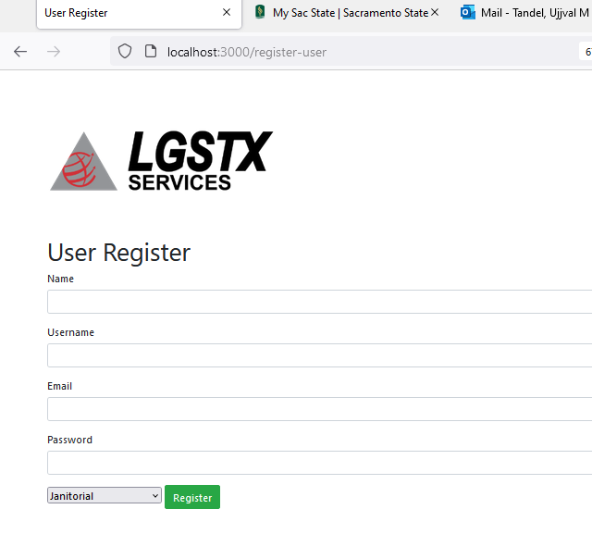
        4. Manager register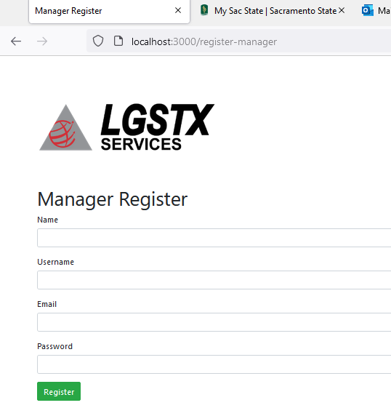
  3. Remove user
  4. Tested by: Lina Albassam
  5. 12/12/2021
     1. Results:
     2. Did it pass? Yes
     3. Valid inputs: Register form field
        1. 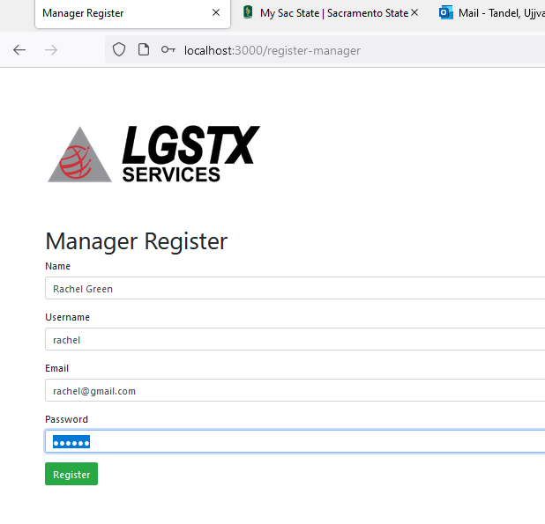
        2. 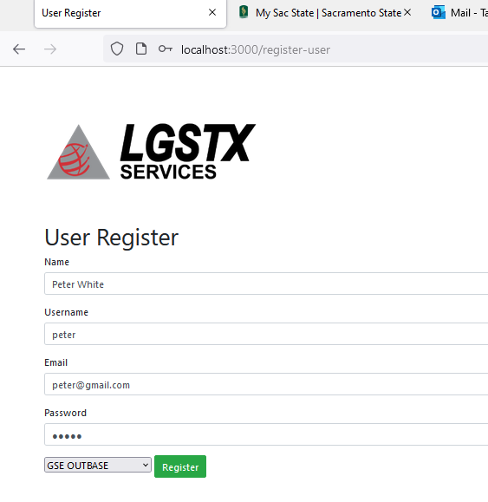
        3. Result
           1. Did it pass? Yes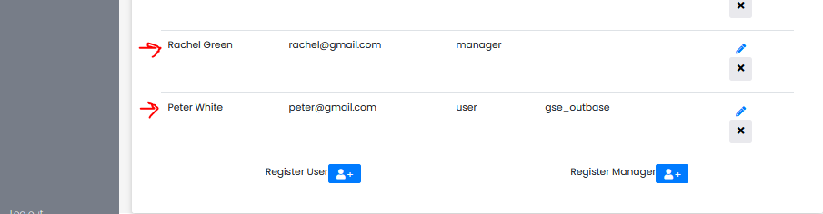
     4. In-Valid inputs: email
        1. Result
           1. Did it pass? No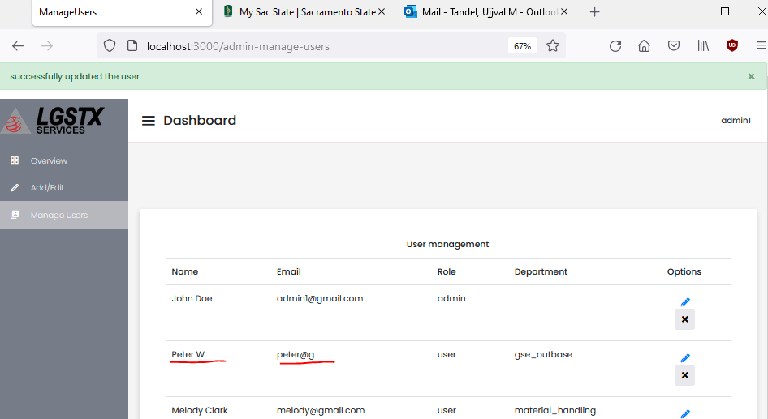

## USPS Section

### Access USPS data

* 1. Description: This is a test to see if the admin can access the data in the USPS section.
  2. Valid Test Inputs: The admin can click the USPS section

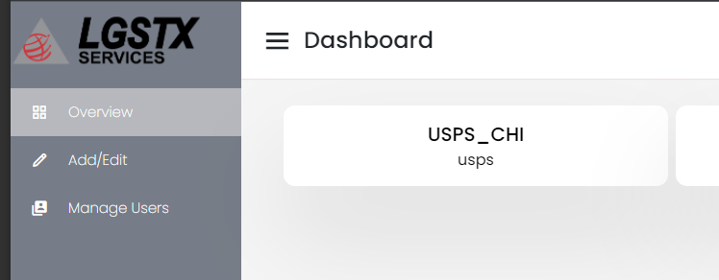

* 1. In-Valid Test Inputs: The USPS section is not clickable or visible
  2. Lina Albassam
  3. 12/11/2021
  4. Results
     1. Did it pass? Yes
        1. Valid input results

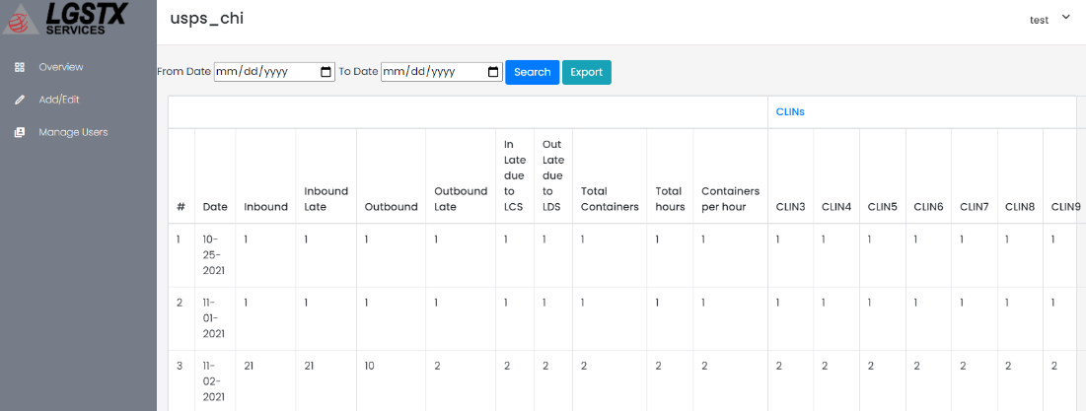

* + - 1. Invalid input results: N/A

Filter USPS data by date

* 1. Description: This test verifies if the admin can filter the usps data by date range
  2. Valid Test Inputs: 11/01/2021 - 11/08.2021

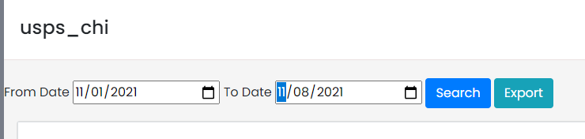

* 1. In-Valid Test Inputs: N/A
  2. Lina Albassam
  3. 12/11/2021
  4. Results
     1. Did it pass? Yes
        1. Valid input results

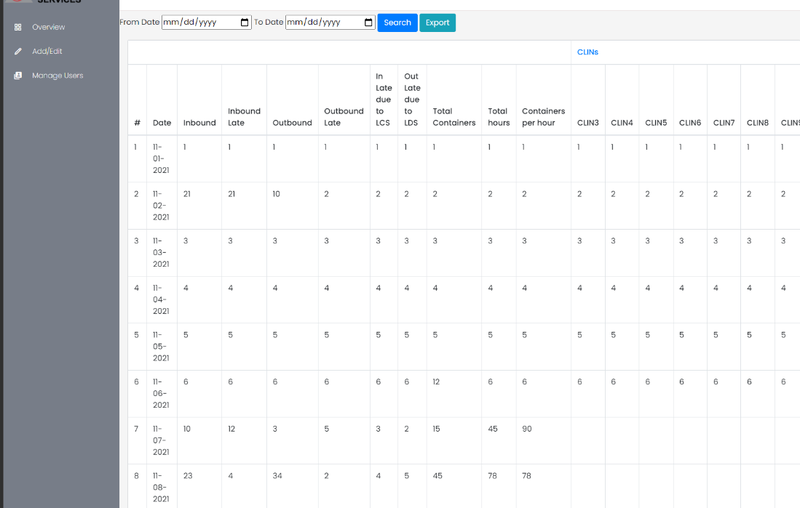

* + - 1. Invalid input results: N/A

### Export USPS data

* 1. Description: This test verifies that the admin can download the usps data in excel spreadsheet format.
  2. Valid Test Inputs: 11/01/2021 - 11/08/2021
  3. 
  4. In-Valid Test Inputs: N/A
  5. Lina Albassam
  6. 12/11/2021
  7. Results
     1. Did it pass? Yes
        1. Valid input results





* + - 1. Invalid input results N/A

### View USPS data for a specific data

* 1. Description: This is the test to verify if the admin can successfully view usps data for a specific date.
  2. Valid Test Inputs: 11/01/2021

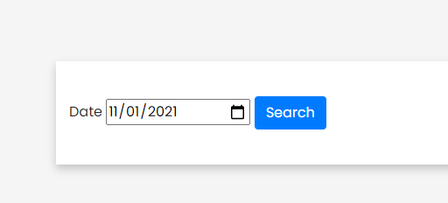

* 1. In-Valid Test Inputs: N/A
  2. Lina Albassam
  3. 12/11/2021
  4. Results
     1. Did it pass? Yes
        1. Valid input results

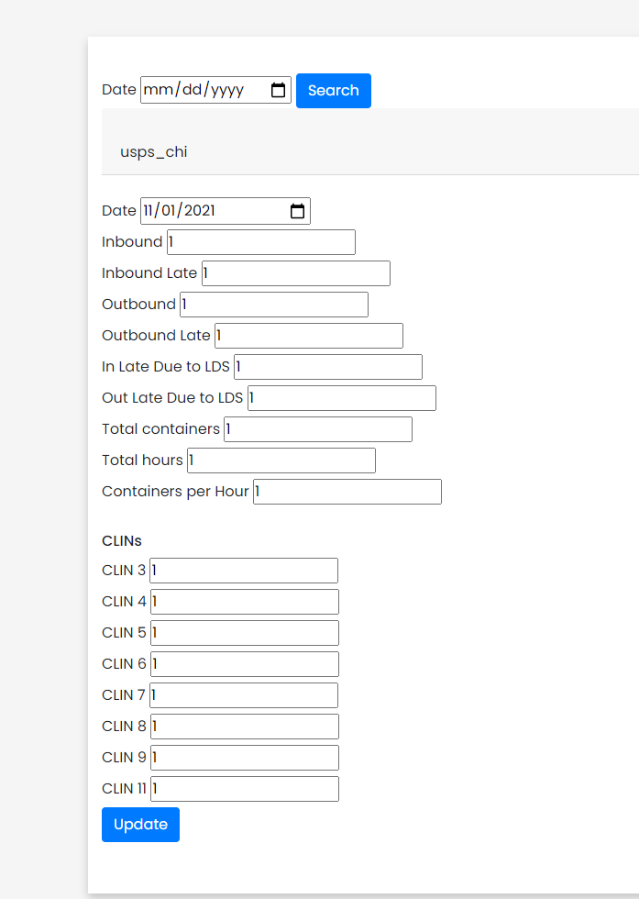

* + - 1. Invalid input results: N/A

### Edit USPS data for specific date

* 1. Description: This is a test to verify if the admin is able to edit USPS data for a specific date
  2. Valid Test Inputs: all the fields on 11/01/2021 were set to 2

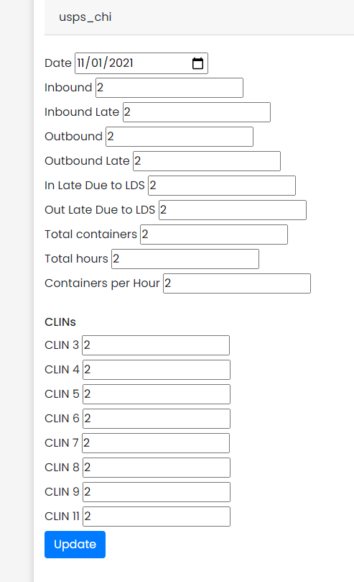

* 1. In-Valid Test Inputs: N/A
  2. Lina Albassam
  3. 12/11/2021
  4. Results
     1. Did it pass? Yes
        1. Valid input results

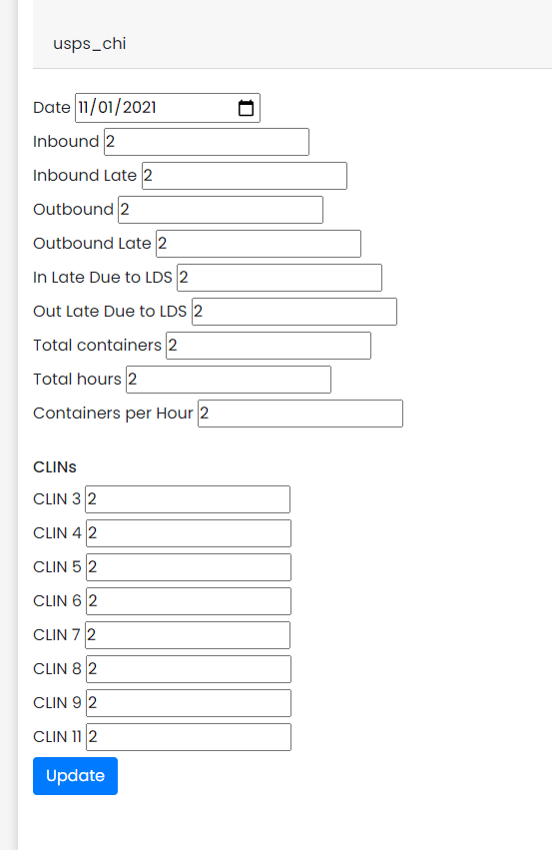

* + - 1. Invalid input results: N/A

# Manager Testing

## USPS Section

### Select USPS section from the manager overview

* 1. Description: This is a test to verify if the manager is able to select the USPS section from the overview page.
  2. Valid Test Inputs: click on the USPS_CHI section
     1. 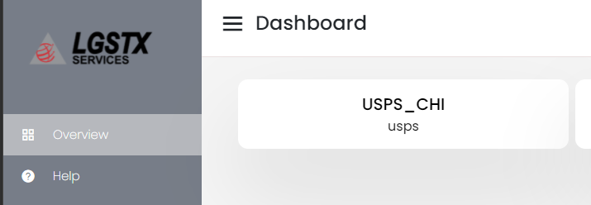
  3. In-Valid Test Inputs: N/A
  4. Lina Albassam
  5. 12/11/2021
  6. Results
     1. Did it pass? Yes
        1. Valid input results

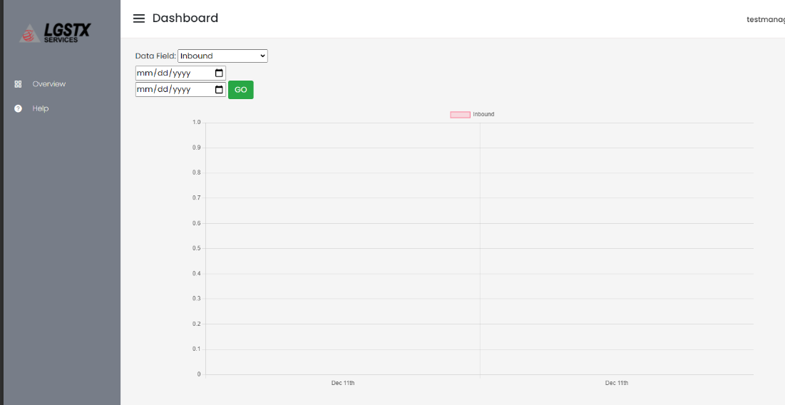

* + - 1. Invalid input results: N/A

### View USPS chart for a specific date

* 1. Description: This is a test to verify if the manager is able to view the chart for one specific date
  2. Valid Test Inputs: Data field was set to inbound and both the date fields were set to 11/01/2021

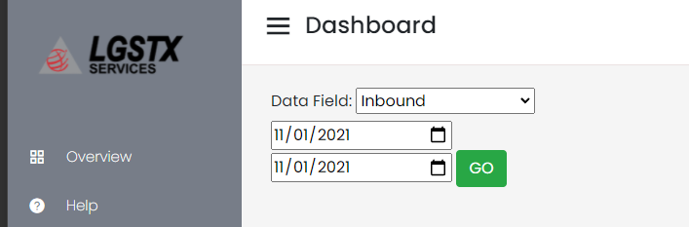

* 1. In-Valid Test Inputs: N/A
  2. Lina Albassam
  3. 12/11/2021
  4. Results
     1. Did it pass? Yes
        1. Valid input results

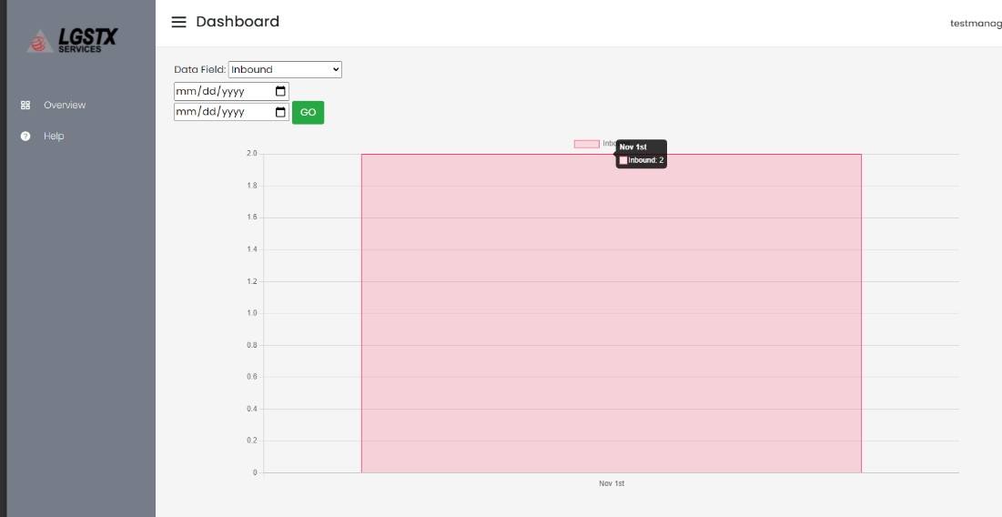

* + - 1. Invalid input results: N/A

### View Chart data between specific dates

* 1. Description: This is a test to view chart data between two specific dates
  2. Valid Test Inputs: Data field: Inbound dates: 11/01/2021 - 11/08/2021
     1. 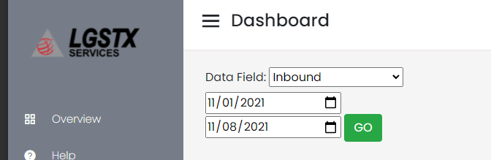
  3. In-Valid Test Inputs: N/A
  4. Lina Albassam
  5. 12/11/2021
  6. Results
     1. Did it pass? Yes
        1. Valid input results

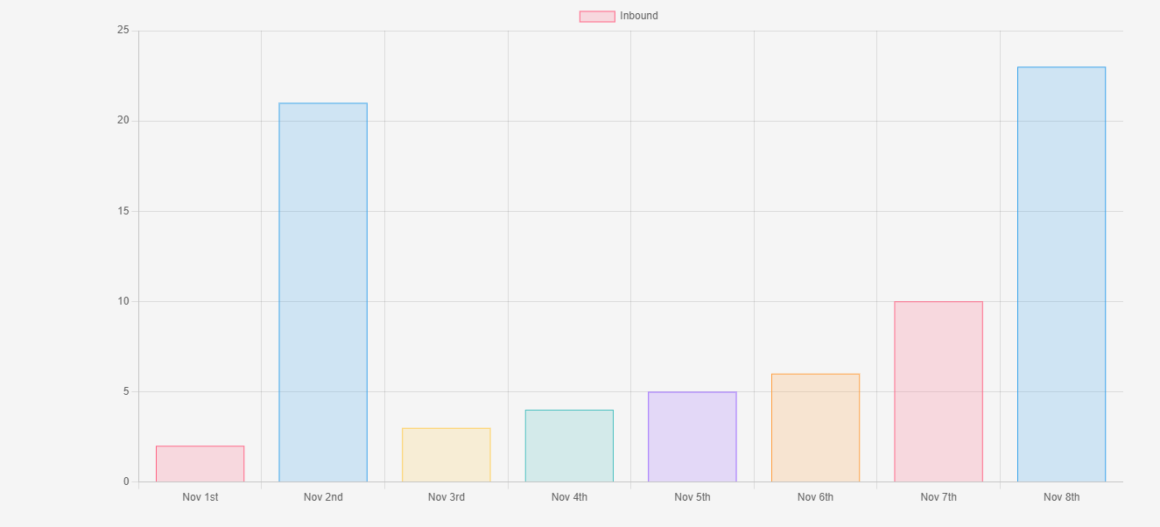

* + - 1. Invalid input results: N/A

### View Chart data for Total Hours between specific dates

* 1. Description: This is a test to view total hours chart
  2. Valid Test Inputs: Data field: Total Hours dates: 11/01/2021 - 11/08/2021
     1. 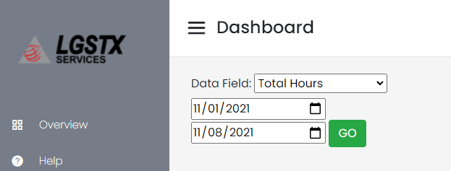
  3. In-Valid Test Inputs: N/A
  4. Lina Albassam
  5. 12/11/2021
  6. Results
     1. Did it pass? Yes
        1. Valid input results

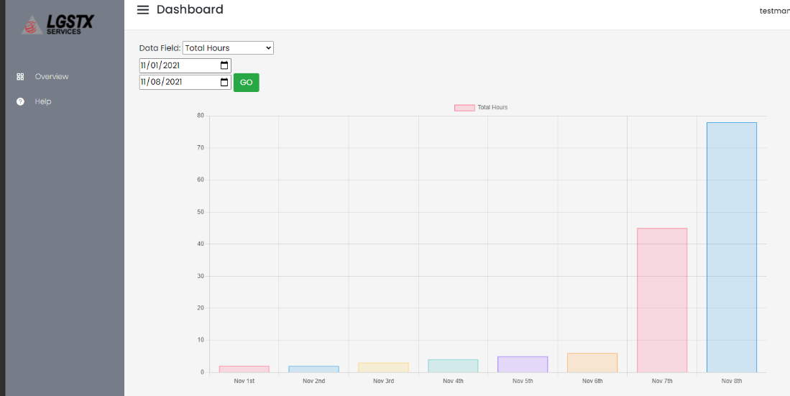

* + - 1. Invalid input results: N/A

**System Test** **Verification Completed: Date: 12/15/2021**