**Setup Project from Scratch**

**Nightwatch - Cucumber**

**Prerequests:**

Install the latest LTS (stable) version of NodeJS:  
<https://nodejs.org/en/>

Install the latest version of the Java Platform (JDK):  
<http://www.oracle.com/technetwork/java/javase/downloads/index.html>

Install a code editor (WebStorm) for JavaScript:  
<https://www.jetbrains.com/webstorm/>

**Post-installation version check:**

Launch windows command window and type below command to see if version is displayed.

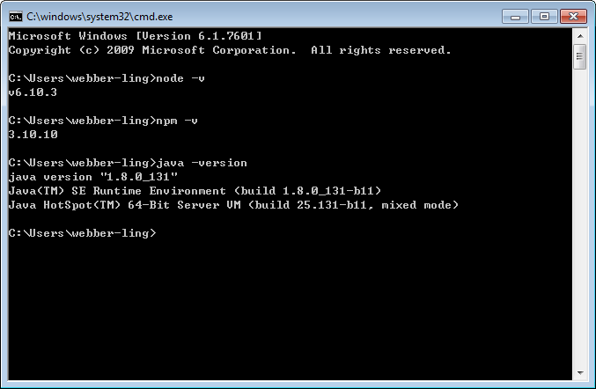

**Steps to setup project:**

1. Create a project folder, it can be anywhere

For example, C:\UAR\automation_uar

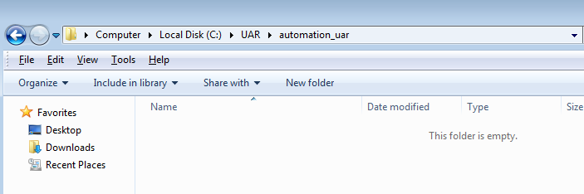

1. Start windows command window and go into this folder

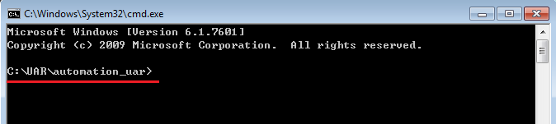

1. Run command ‘npm init’ to create Jason package

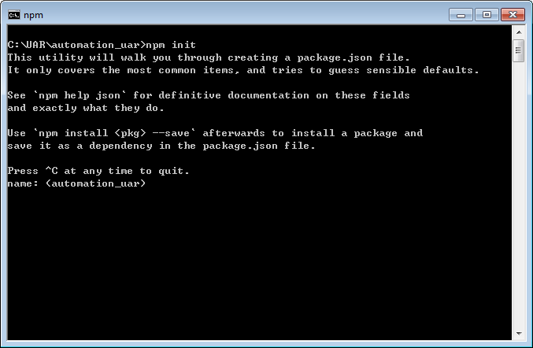

1. Type in information for the project

* Type **Enter** in line ‘name: <automation_uar>’, using the default name
* Type any description in line ‘description’, **Enter**
* Type ‘nightwatch.js’ in line ‘entry point’, **Enter**
* Type **Enter** in line ‘test command’
* Type **Enter** in line ‘git repository’
* Type **Enter** in line ‘keywords’
* Type any info in line ‘author’, **Enter**
* Type ‘MIT’ in line ‘license’, **Enter**
* Type ‘yes’ in line ‘Is this ok? <yes>’, **Enter**

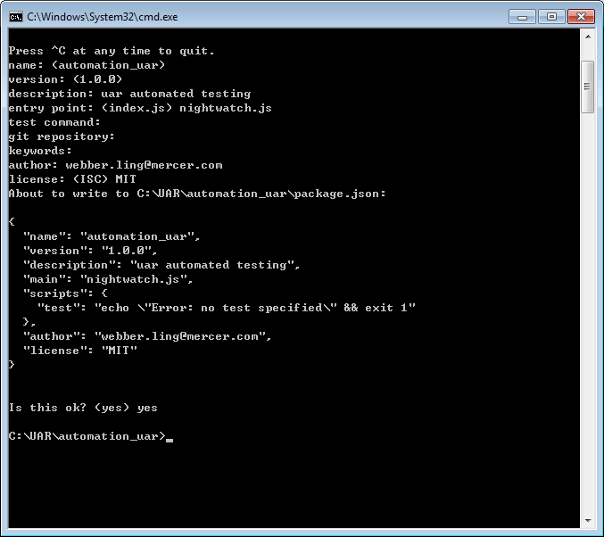

1. ‘package.jason’ is created

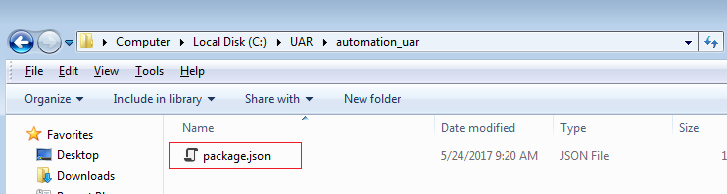

1. Install components one by one

Install nightwatch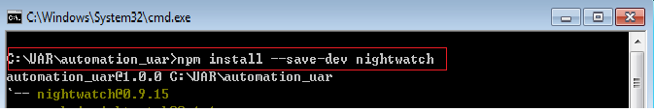

Install cucumber

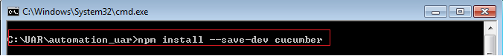

Install nightwatch-cucumber

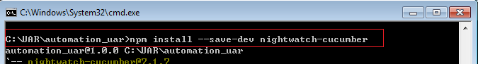

Install chromedriver

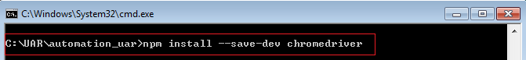

Install iedriver

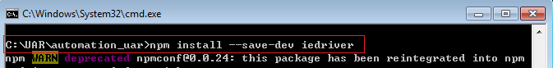

Install geckodriver

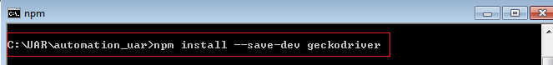

Install selenium server

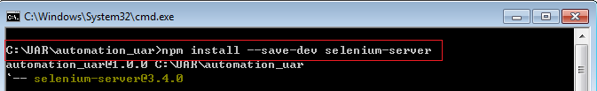

1. Open the newly created project

Launch WebStorm and open project, points to the folder where we created the package, click ok to launch the project.

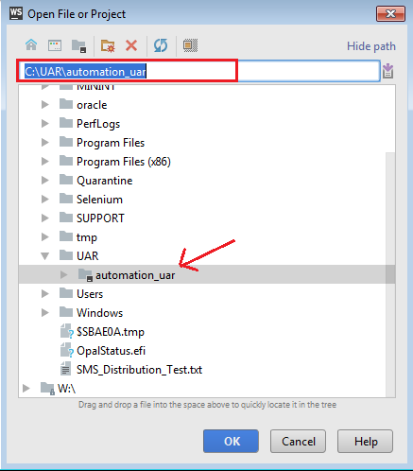

The project opened in webstorm, double click package.json file, you will see the same view as below screen.

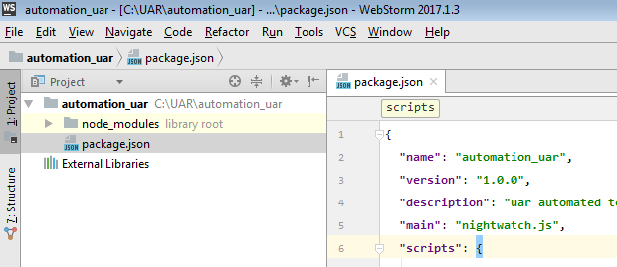

1. Add config file

Right click root folder ‘automation_uar’ and add a new javascript file, using file name as ‘nightwatch.conf.js’

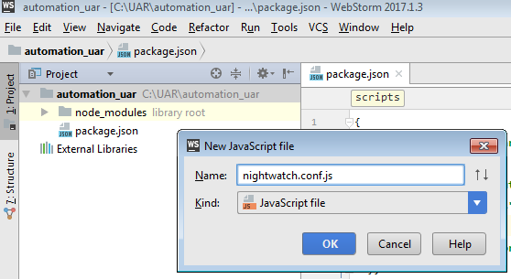

Open nightwatch.conf.js file and copy/paste contents from below attached txt file into nightwatch.conf.js



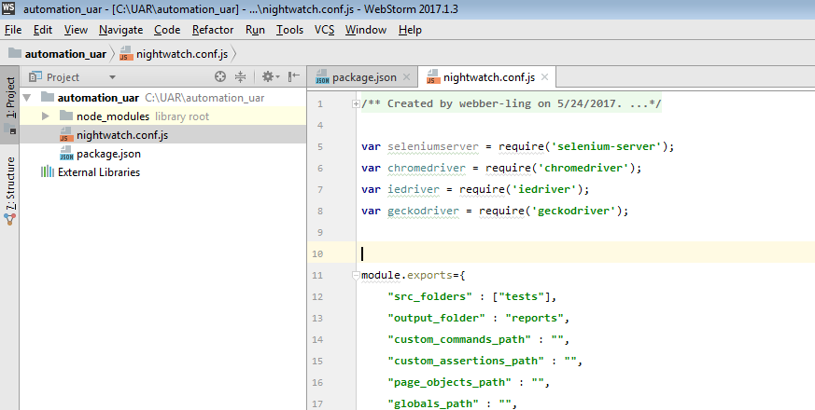

1. Add tests folder, add test script

Right click the root folder and add a new directory ‘tests’

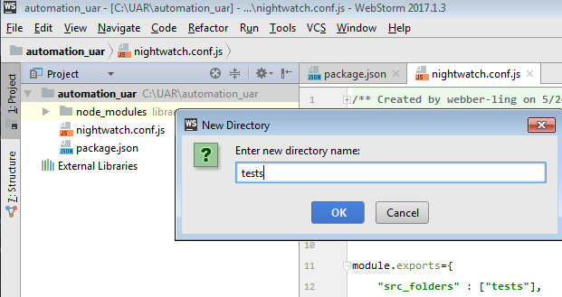

Right click the ‘tests’ folder, add a javascript file named ‘google.js’

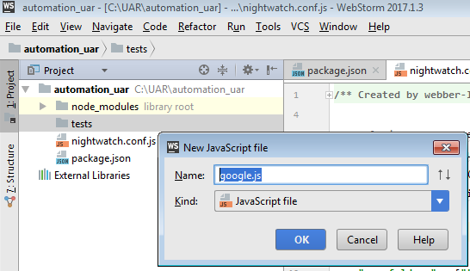

Open google.js file and copy/paste contents from below attached txt file into google.js



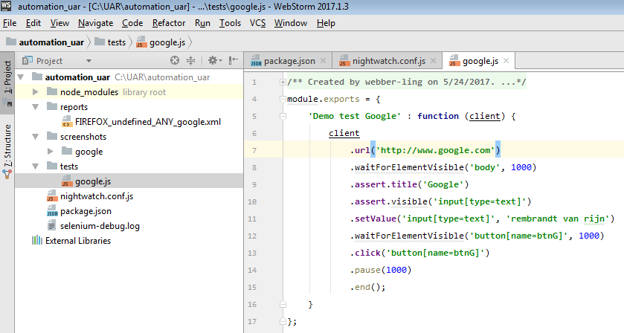

1. Run the test from terminal

Click on tab ‘Terminal’ and type ‘nightwatch’, enter, to run the test

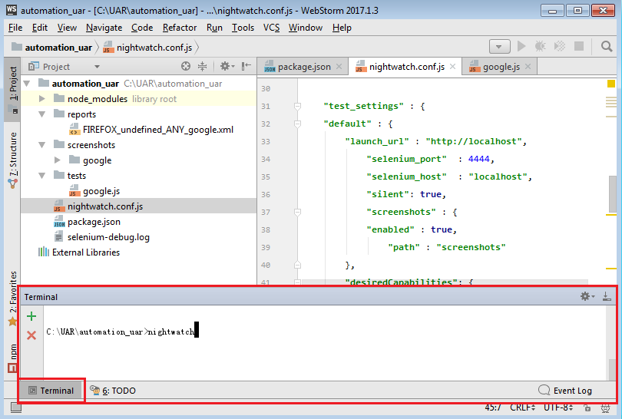

Test starts running against google.

After run completes, you shall see below outputs in terminal window.

