**Setup Project from Template**

**Protractor - Jasmine**

**Prerequests:**

Install the latest LTS (stable) version of NodeJS:  
<https://nodejs.org/en/>

Install the latest version of the Java Platform (JDK):  
<http://www.oracle.com/technetwork/java/javase/downloads/index.html>

Install a code editor (WebStorm) for JavaScript:  
<https://www.jetbrains.com/webstorm/>

Save the attached project zip locally and unzip to anywhere:



**Post-installation version check:**

Launch windows command window and type below command to see if version is displayed.

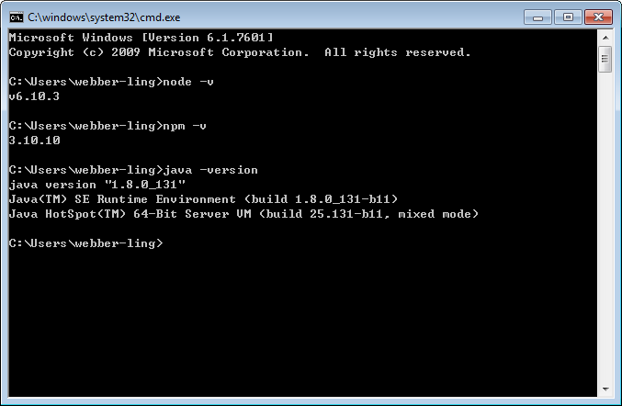

**Steps to setup project:**

1. Launch WebStorm, go to File->Open

Select the folder where you extract the sample project, and click OK to open the template project.

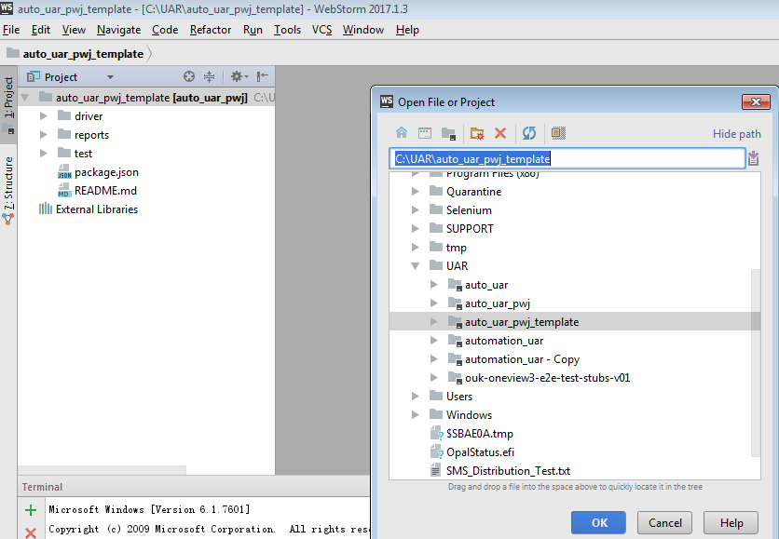

1. Click tab <Terminal> (next to TODO) under the bottom of WS window to open the Terminal window

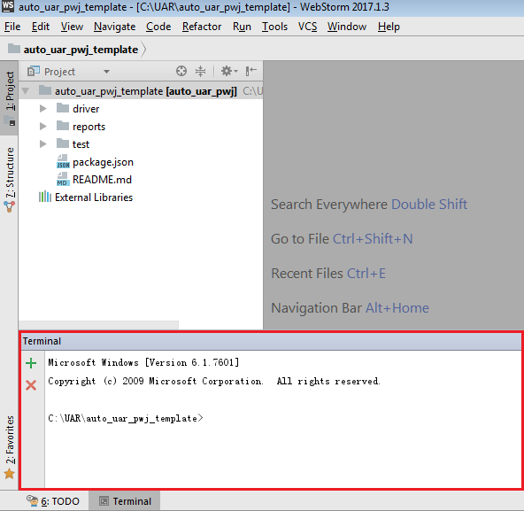

1. Run below commands in the terminal window one by one

* npm uninstall –g protractor
* npm uninstall –g webdriver-manager
* npm install –g protractor
* npm install
* webdriver-manager update

A ‘node_modules’ folder will be generated after the installation, which includes all necessary components.

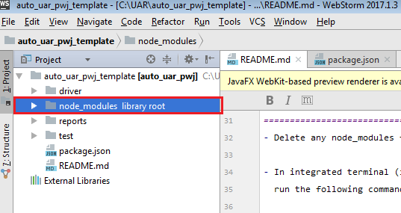

**Project walkthrough:**

Based on the protractor website, the recommended folder structure looks like below:

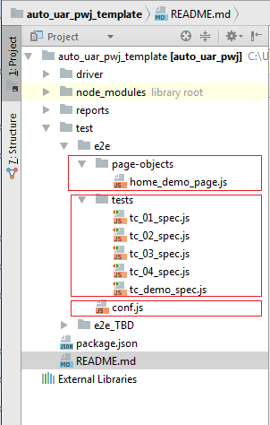

* all end to end testing related things should under folder <root>\test\e2e
* page objects should under page-objects folder, where define page elements, methods, etc
* test specs should under tests folder, where define actual test scripts with post fix “_spec.js”
* conf.js is the configuration file for protractor/jasmine settings

Reference: <http://www.protractortest.org/#/style-guide>

**Run tests:**

Before start run any tests, make sure selenium server is started:

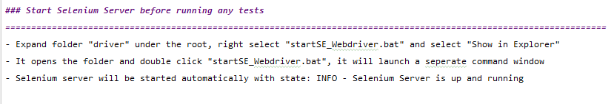

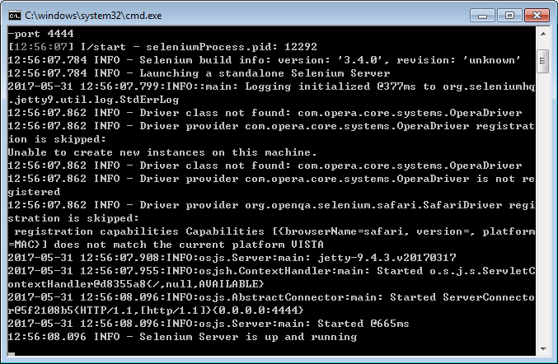

By referring to UK Wealth team sample project, the ‘suites’ feature is introduced here, which is a very nice feature to organize the tests to be run through –suite option.

In conf.js, we already defined multiple suites, in this sample project, I defined below suites:

* all: points to all tests except those under exclude
* demo: points to the demo tests only (tc_demo_spec.js)
* debug: points to the debug test only (tc_01_spec.js)
* exclude: defined the tests that should not be included in any run, even run all

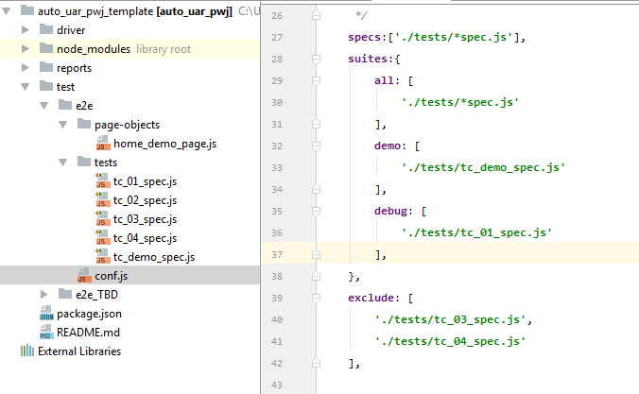

This is a very nice feature which covers that of feature file tag functionality in Nightwatch-cucumber. Tester can organize group of tests by defining suite name and put the expected tests under that suite. For example, create a smoketest suite and put smoke tests inside it, also tests can be put into different suite to meet various testing purpose.

If user wants to run the demo test here, needs to type in below command in terminal window:

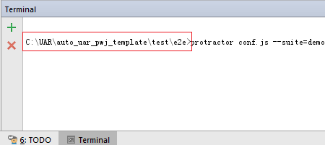

Make sure the command run under the e2e folder. By default, it is under the project folder when terminal window is first time opened C:\UAR\auto_uar_pwj_template

User needs to type cd test\e2e to go inside the folder where launches run.

When run finishes, you are able to see the report from reports folder by opening the Demo_Report.html and select any available browser to open it, e.g. IE.

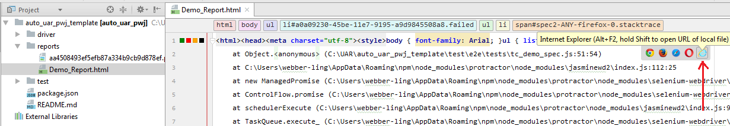

I intentionally put an expected failure step as the last step, user can click on it to open the screenshot.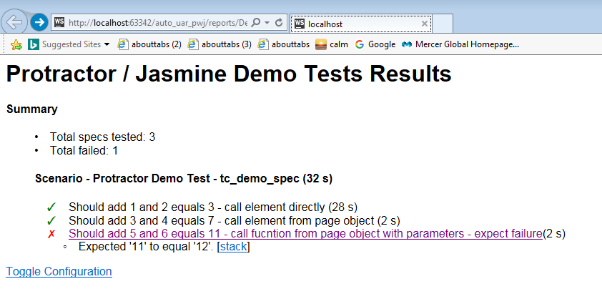

**Note:**

Most of information required to setup the project are reachable from README.md file in the project.

Any question, please reach to [webber.ling@mercer.com](mailto:webber.ling@mercer.com)