**Nightwatch – Cucumber**

**Notes**

**Run Tests:**

2 feature files:

Feature file 1: GoogleValidation.feature (tag: @TC1)

Scenario 1: Google search “<values>” (tag: @SC1)

Secnario 2: Google search 2 (tag: @SC2)

Feature file 2: GoogleValidation2.feature (tag: @TC2)

Scenario 1: Google search 2 (tag: @SC2)

Secnario 2: Google search 3 (tag: @SC3)

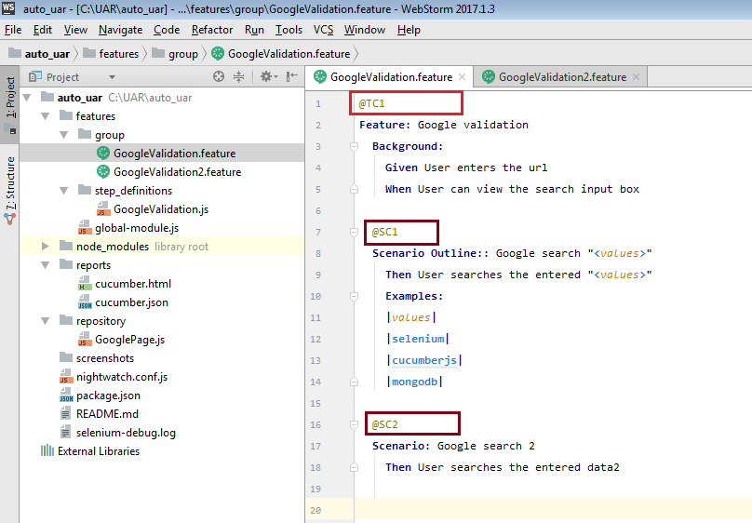

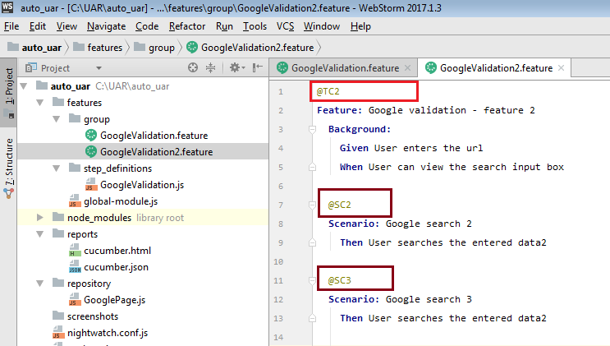

1. Run all

>nightwatch

It will run all features, run everything.

1. Run specifc tag (TC)

>nightwatch --tag TC1

It will run all tests tagged as TC1, in this case, it will run SC1, SC2 in TC1 (feature file 1)

1. Run specific tag (SC)

>nightwatch --tag SC2

It will run all tests tagged as SC2, in this case, it will run SC2 in TC1 (feature file 1) and SC2 (feature file 2)

.

1. Run specific feature

>nightwatch --filter GoogleValidation.*

It will run specified feature, in this case, it all tests in feature 1 (GoogleValidation.feature)

1. Run any combination of tests

>nightwatch --tag TC2 –tag SC1

It will run specified tag, in this case, it all tests in feature 2 (GoogleValidation2.feature) and scenario SC1 in feature 1 (GoogleValidation.feature)

1. Run on multiple browsers

>nightwatch -e chrome, firefox

It will run all tests on chrome first and then on firefox.

**Parameterize feature file:**

Replace the text content in scenario with parameter, e.g. “<values>”

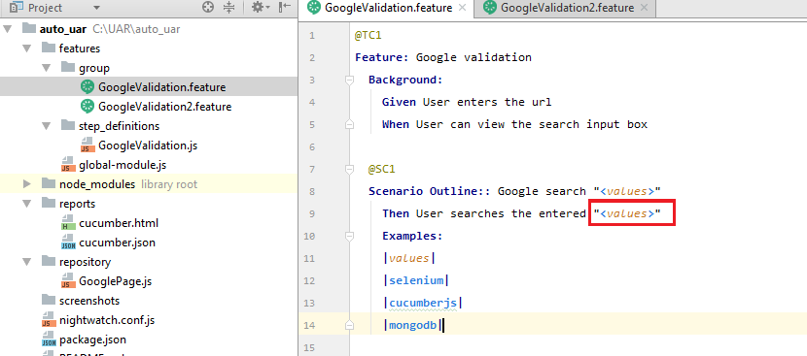

Go to the .js file, replace the test content using regular expression, “([^”]*)”

Add a parameter “val” to the function call after it, and replace the hard coded text in sendkeys code with val.

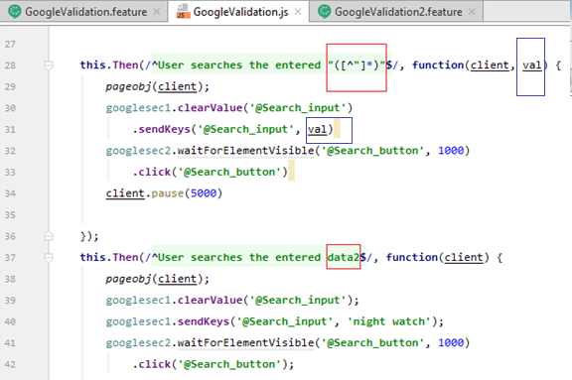

Below is the sample for multiple parameters passed into the function.

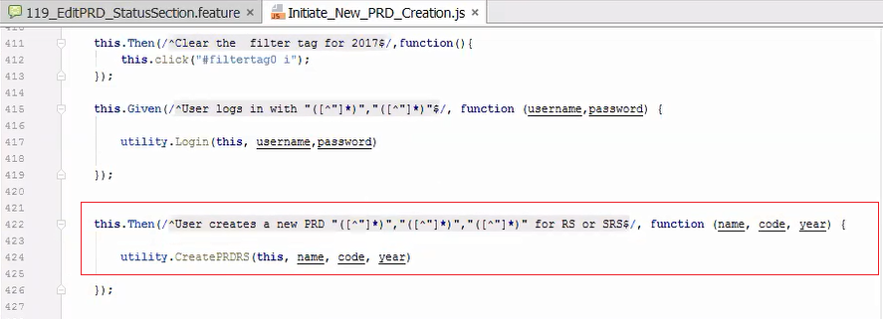

**Data Driven:**

Change Scenario to Scenario Outline using the format as below.

Add below parameters to pass to values, so the tests will run through all values.

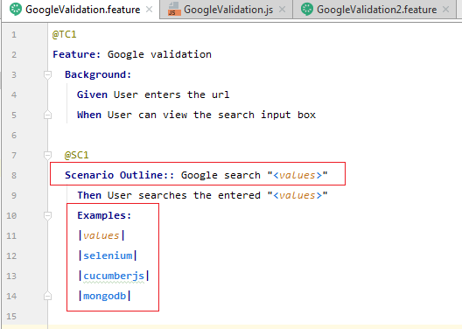

Below is the example of multiple parameters with data driven.

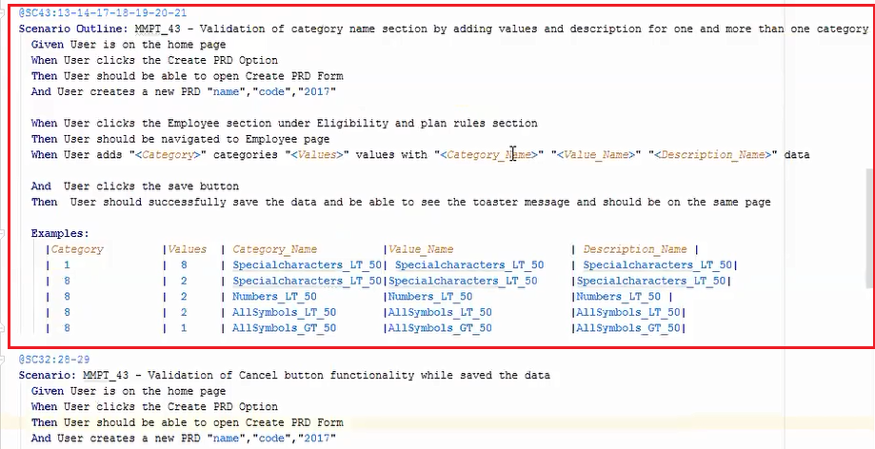

**Background:**

By defining background codes under Feature keyword, it will be executed in each scenario, before the first line of scenario codes starts to run.

Arrow points to the place it will run for background.

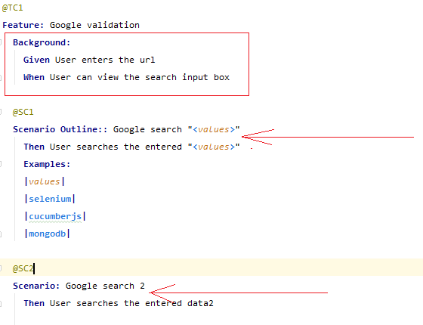

**Launch URL, delete cookies, maximize window:**

A typical launch browser, go to URL function.

