First time user

Install Git-2.10.2-64-bit.exe from below location:

(use default configuration during installation)

\\cnshaelc9pfkx1\QA_Softwares\MercerOS

After Git installed successfully, open the command line window by double click “Git Bash” shortcut on desktop, or go to Start >> All Programs >> Git >> Git Bash.

In the command line window, go to the folder where you want to put the project into, for example, I put it at c:/src/uar, so I type command cd c:/src/uar and press enter

And then type git clone <repository address from bitbucket>

For example, below is mine:

$ git clone <https://webber-ling@bitbucket.org/oliverwymantechssg/ngpd-merceros-uar-fe.git>

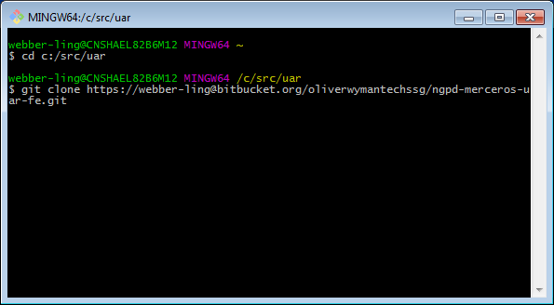

It will download the whole project which I uploaded.

Where to get your own bitbucket address?

Go to below site and click “[ngpd-merceros-uar-fe](https://bitbucket.org/oliverwymantechssg/ngpd-merceros-uar-fe)”

<https://bitbucket.org/account/user/oliverwymantechssg/projects/MCW>

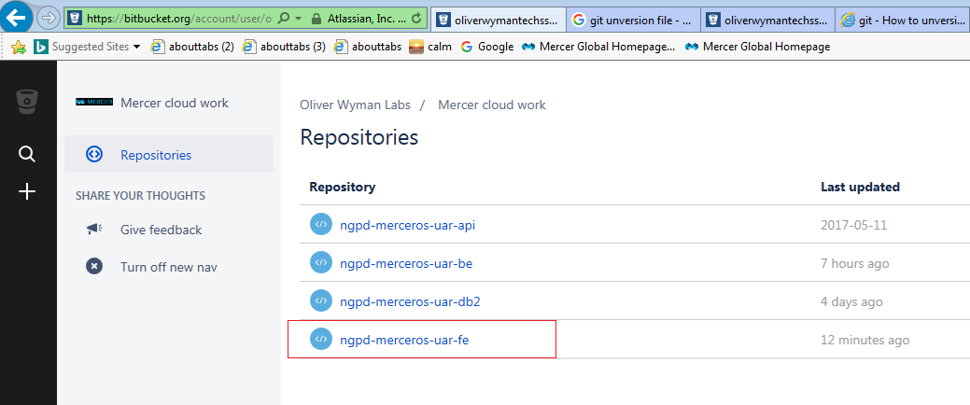

Inside the “[ngpd-merceros-uar-fe](https://bitbucket.org/oliverwymantechssg/ngpd-merceros-uar-fe)” page, copy the link in red, that’s your bitbucket link which is used in the git clone command.

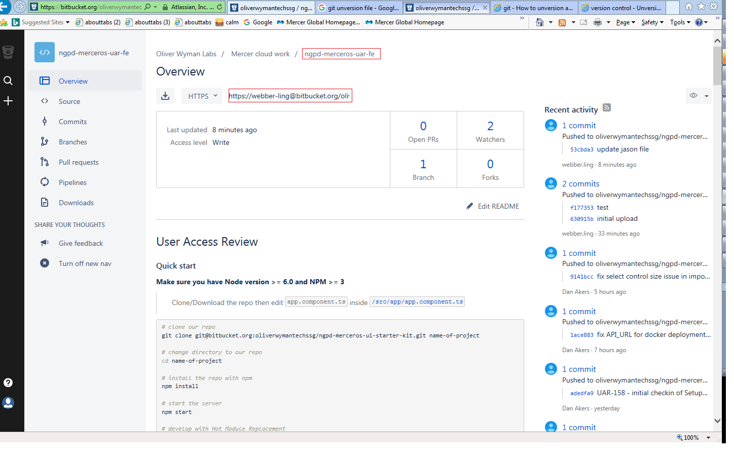

Later on

After you sync the whole project from bitbucket, you can do version control inside WebStorm.

Note: need to re-start computer after git installation before it can be used in WebStorm.

Open the qa automation project from <directory where project is downloaded>, for example, I open project “c:\src\uar\ngpd-merceros-uar-fe\src\automation” from Webstorm.

And then you can use Version Control to commit/push changes, it is similar to other source/version control tools.

